Applicable Laboratory(s):

☒ North Carolina Baptist Hospital (NCBH)
☐ Lexington Medical Center (LMC)
☐ Davie Medical Center (DMC)
☐ Wilkes Medical Center (WMC)
☐ High Point Medical Center (HPMC)
☐ Westchester
☐ Clemmons

Purpose

The purpose of this procedure is to describe the steps taken to enter blood products received into the computer and to perform ABO confirmation on red cell containing products and enter results into the computer to make the products available for use.

Scope

This procedure applies to Blood Bank Staff and Management

Definitions

- Procedure: A process or method for accomplishing a specific task or objective.
- WFBH Lab System: Wake Forest Baptist Lab System is a health system that includes Wake Forest Baptist Medical Center and all affiliated organizations including Wake Forest University Health Sciences (WFUHS), North Carolina Baptist Hospital (NCBH), Lexington Medical Center (LMC), Davie Medical Center (DMC), Wilkes Medical Center (WMC), High Point Medical Center (HPMC), Lab at Westchester and Lab at Clemmons.
- SCC: Soft Computer System – Blood Bank Information System
- Ag: antigen
- Ab: antibody
- Plt: platelet
- Inventory>In/Out: blood product computer entry function
- Delivery: single unit entry
- Batch Delivery: batch unit entry
- Results – Unit test worksheet computer entry of results for unit retypes
- Results – Test Verify verification of interfaced unit retypes
- Sterility Sterility of the component shall be maintained during the processing by use of aseptic methods and sterile pyrogen free equipment and solutions. Equipment that allows transfer of components without breakage of the seal is preferred.
- Mannitol free units: AS3 and CPDA1 blood units
- TFAIL Temperature failed
- VFAIL Visual Inspection

Sections

I. Entering Units into SCC
II. Printing Received Units Report
III. Unit ABO Confirmation Testing and Computer Entry
IV. Correcting or Adding Blood Product Information (Incorrect Source Code, Volume, Antigen,
Attribute)
V. Correction of Scanning Errors That Cannot be Edited
VI. Holding and Unholding Units
VII. Retype of Units on Ortho Vision Max Analyzers

Supplies/Materials

See individual sections

Procedure Guidelines

I. Entering Units into Inventory

Chemical Risk Assessment: low
Biological Risk Assessment: low
Protective Equipment: Lab coat, gloves
Supplies: N/A
Reagents: N/A
Equipment: N/A
Specimen Requirements: Units cannot be at room temperature for more than 20 minutes!

STEPS | INSTRUCTIONS
1.0 | Enter SCC
2.0 | Check product invoice for date and time received and initials indicating acceptable appearance or comments if unacceptable.  2.1 Obtain blood product units.  2.2 Verify blood product number and any special attributes, antigens or requests for unit.  2.3 Place a check beside each unit on the invoice indicating unit was received.
3.0 | Click on Inventory>In/Out.
4.0 | Select Batch Delivery or Delivery.  Function Definition Examples  Delivery Single unit entry for use with special order products or products with more than 5 antigens or attributes Antigen negative Autologous Directed CMV negative  Batch Delivery Multiple unit entry. Common information can be entered and saved once and then multiple units scanned prior to saving. 10 A positive red cells  3.1 Go to Section I.A. for Delivery and Section 1.B. for Batch Delivery.

A. Delivery

STEPS | INSTRUCTIONS
1.0 | Click on Inventory>In/Out> Delivery.
2.0 | Select Source Code from the drop down box.
3.0 | Using Bar Code Reader, Scan when you can!  3.1 Proceed to step 4.0 to enter unit information.  3.2 If unit scanning is complete, click F12 from right menu or press F12 to save.  3.3 When scanning of donor number is not possible:  - ISBT: type W plus the numbers under the #1 ISBT bar code in Attachment 1  - Codabar: type the donor number as stated above the #3 Codabar bar code in Attachment 1  3.4 Double entry is required for all manual entry of product information.  Refer to Attachment 1: ISBT and Codabar Bar Code Fields to Scan.
4.0 | Scan in the unit number in the Collection Center field.  4.1 The system will fill in the correct Collection Center and unit number.  4.2 NOTE: DMCBR move cursor to Orig Unit# field to begin scanning.
5.0 | Scan in the Product Code.
6.0 | Scan in the ABO/Rh.
7.0 | Edit the volume of the unit, if needed.
8.0 | Scan in the expiration date or enter the date manually.
9.0 | Enter the expiration time of the unit or system will default to 23:59 internally.
10.0 | Enter Location (Row A to Row H) for frozen red cells.
11.0 | Enter the Invoice number.  11.1 Invoice number = shipping document number  11.2 Red Cross bar code will scan.
12.0 | Add unit attributes or antigens if present on unit at receipt.  12.1 P = positive, N = negative  12.2 Irradiation and leukoreduced attributes are already defined in the setup of ISBT  units so do not need to be added if received as leukoreduced or irradiated from  a blood supplier.  - CDIE attribute (Credit Due If Expires)  - In addition to the attribute, place a green dot (sticker) on the front of the unit in a place that does not cover information.  - Use non CDIE units (that expire on the same date as CDIE units) first.  12.3 Units transferred to DMCBR and brought into inventory should have any  antigens or attributes already entered on unit.  12.4 Change Labels to 1 to automatically generate an antigen label for units that are  antigen screened by the blood supplier.  Refer to Attachment 2: Attribute and Antigen Entry
13.0 | Verify autologous and directed units correctly default by checking the “Donated for” box.  - Allogeneic should be O.  - Autologous should be A.  - Directed should be D.  13.1 Enter MRN or patient’s first and last name in the patient search window for  autologous and directed units.  13.2 Click F12.  13.3 Determine if patient has an MRN (already in system) or does not have an MRN  (New patient).  Patient Status Steps  In system - Patient is found. - Verify information. - Enter to - Select patient. - Click F12.  New Patient - Patient not found. - System displays: “Create new patient record? - Click Yes if MRN is available. - Enter as much information as possible. - Look up patient Auto/Dir Pending form in “Incomplete folder” for surgery date. - Add to microsoft Calendar Day Before need to check on patient and MRN number to connect auto/dir unit to patient in SCC. - Notify management.
14.0 | Verify that the condition of the units was satisfactory upon arrival:  14.1 Do visual examination and enter into SCC.  a. The default is S for satisfactory.  b. Routinely Visual examination is required.  c. In these cases, temperature is not required.  14.2 If units arrive not properly packed or questionable.  a. Take the temperature and enter in the temperature field in SCC.  b. Delete the S from the condition box in SCC and select from the drop down  box.  TFAIL = Temperature failed  VFAIL = Visual Inspection failed  c. Units will be quarantined by the system if they are received at an incorrect  temperature or if VFAIL is entered.  Refer to: BB-POL-0048 Receiving Blood Products into Inventory
15.0 | Click F8 to add a comment to unit.  15.1 Free text comment.  15.2 Click F6 to add date; F7 to add Time and F8 to add Tech.
16.0 | Click F12 once all data has been entered.
17.0 | Answer Yes to “Next Unit” if another unit to enter or No if complete.
18.0 | Repeat steps 2-17 for all units for Delivery of all units.
19.0 | Click No at “Next Unit” when all units are entered.
20.0 | Check List of delivered unit for number of units delivered and unit numbers.  20.1 Click Esc.
21.0 | Print Received Units report.  Go to Procedure II: Printing Received Units Report
22.0 | Store the segment rack and invoice/Received Units Report on the central work area if not able to perform retypes.
23.0 | Perform ABO confirmation testing on all red-cell containing units.  23.1 Packed Red Cells, Whole Blood, Granulocytes, Platelets containing ≥2% red  cell contamination.

B. Batch Delivery

STEPS | INSTRUCTIONS
1.0 | Click on Inventory>In/Out> Batch Delivery.
2.0 | Select Source Code from the drop down box.
3.0 | Enter any common information for units:  a. Expiration time  b. Volume  c. Invoice number (Invoice number = shipping number)  Red Cross invoice number bar code will scan.  d. Temperature (if taken)  e. Condition (if needs to be changed)  f. Comments  3.1 Click F12 to Accept common information.  a. Click Yes to Accept common data for delivered units.  b. Begin scanning in the Batch unit delivery screen.
4.0 | Take temperature:  4.1 If units arrive not properly packed or questionable and enter the  temperature in the Temp field.  a. Units will be quarantined by the system if they are received at an incorrect  temperature.  4.2 Routinely, when shipping is documented as satisfactory, skip temperature field.  Refer to: BB-POL-0048 Receiving Blood Products into Inventory
5.0 | Using Bar Code Reader, Scan when you can!  5.1 Proceed to step 6.0 to enter unit information.  5.2 If unit scanning is complete, click F12 from right menu or press F12 to save.  5.3 When scanning of donor number is not possible:  - ISBT: type W plus the numbers under the #1 ISBT bar code in Attachment 1  - Codabar: type the donor number as stated above the #3 Codabar bar code in Attachment 1  5.4 Double entry is required for all manual entry of product information.  Refer to Attachment 1: ISBT and Codabar Bar Code Fields to Scan.
6.0 | Scan in the unit number in the Collection Center field.  6.1 The system will fill in the correct Collection Center and unit number.  6.2 If the collection center is entered incorrectly and units are accepted, go to Procedure IV. Correcting or Adding Blood Product Information (Incorrect Source Code, Volume, Antigen, Attribute)
7.0 | Scan in the Product Code.
8.0 | Scan in the ABO/Rh.
9.0 | Scan in the expiration date or enter the date manually as month, day, year.
10.0 | Enter volume if it does not default to correct volume (mls).
11.0 | Enter location (Row A to Row H) for frozen red cells.
12.0 | Click F12 to accept unit list when all units are entered.
13.0 | Enter any attributes or antigens or comments or edit volume in Batch unit delivery edit screen that appears.  13.1 Use F8 to Copy above field for subsequent units or Shift F8 to copy above line  information.
14.0 | Add unit attributes or antigens if present on unit at receipt.  14.1 P = positive, N = negative  14.2 Irradiation and leukoreduced attributes are already defined in the setup of ISBT  units so do not need to be added if received as leukoreduced or irradiated from  a blood supplier.  Refer to Attachment 2: Attribute and Antigen Entry
15.0 | Verify autologous and directed units correctly default by checking the “Auto/Dir” section.  - Allogeneic should be O.  - Autologous should be A.  - Directed should be D.  15.1 If auto or directed unit that did not default correctly, then select the correct type  from the drop down menu under the Auto/Dir column.  15.2 Enter MRN or patient’s first and last name in the patient search window for  autologous and directed units.  15.3 Click F12.  15.4 Determine if patient has an MRN (already in system) or no MRN (New patient).  Patient Status Steps  In system - Patient is found. - Verify information. - Enter to - Select patient. - Click F12.  New Patient - Patient not found. - System displays: “Create new patient record? - Click Yes if MRN is available. - Enter as much information as possible. - Look up patient Auto/Dir Pending form in “Incomplete folder” for surgery date. - Add to microsoft Calendar Day Before need to check on patient and MRN number to connect auto/dir unit to patient in SCC. - Notify management.
16.0 | Click F8 to add a comment to unit.  16.1 Free text comment.  16.2 Click F6 to add date; F7 to add Time and F8 to add Tech.
17.0 | Click F12 once all data has been entered.
18.0 | Answer Yes to “Accept Unit list” if complete.
19.0 | Print Received Units report.  19.1 Refer to Procedure II: Printing Received Units Report.
20.0 | Print an Antigen Label for units antigen typed by blood supplier.  20.1 A print box will display. After answering Yes in Step 18.0. If all units in batch have antigen testing from blood supplier, click W05_LBL_AG2.  20.2 OR you can: Go to Inventory>Edit>Label and scan or enter unit number.  a. Verify correct unit and Escape.  b. Click beside Unit (antigen) Label and F12 to accept.  c. Select correct printer and Enter-Select.
21.0 | Store the segment rack and invoice/Received Units on the central work area if not able to perform retypes.
22.0 | Perform ABO confirmation testing on all red-cell containing units.  22.1 Packed Red Cells, Whole Blood, Granulocytes, Platelets containing ≥2% red  cell contamination.

Section C. Flow Charts

II. Printing Received Units Report

STEPS | INSTRUCTIONS
1.0 | Enter SCC.  - Select Inventory>Reports>Received Units  - Select Source Code.  - Enter Invoice number.  - Enter Donation type or date range if needed.
2.0 | Click F12 to accept.
3.0 | Select printer # at the PRINTER: prompt, press Enter  3.1 Printer W17_RPT_BKRORDERS – FD printer  3.2 Printer W03_RPT_BB1 – back printer
4.0 | Retrieve report from printer
5.0 | Check the information on the printed report against the shipping invoice  Items to check include:  - Donor number  - Unit ABO/Rh  - Unit expiration  5.1 Place check mark next to unit number on report as information is confirmed.
6.0 | Staple completed Received Units report to the Shipping Invoice and place with Invoices for reconciliation.  6.1 Both Received Units report and Shipping Invoice are scanned to keep  electronically.
7.0 | Alternatively Printing list of units with RETYP completed.  7.1 See attachment 4: List of units with RETYP completed.

III. Unit ABO Confirmation Testing and Computer Entry
(Manual Method: Hemagglutination by tube testing)

STEPS | INSTRUCTIONS
1.0 | Obtain segment(s) from unit(s) to be ABO Confirmed.  - Incoming Red Cell containing donor units (packed red cells, whole blood, granuloctyes):  - Place BARCODED donor number label vertically on a 12x75 tube  - Remove one (1) to two (2) segments from unit and place in labeled 12x75 tube.  - Label two (2) segments with unit label to be retained segment. Segments are retained for 56 days and stored by day of receipt.  - Complete computer entry of products  - Print SCC Received Units Report  - Washed Red Cells and Deglyced units  - Label 12x75 tube with complete donor number  - Remove segment from washed / deglyced unit, place in tube
2.0 | For manual typing : Access Blood Bank SCC Computer System: Results  2.1 Select “Unit Test Worksheet”.
3.0 | Build Units to a Worksheet.  Type of Process Do  Worksheet: - Select Retype from drop down box. - F12 to accept. - Scan or Click each unit that is being confirmed. - F12 to accept. - Click Yes to accept the choice or No if error. - Click on Rack using for QC beside Default rack#.  3.2 Leave screen up and proceed with testing
4.0 | Place labeled segment tubes in a testing rack, label(s) facing forward.  4.1 This tube will be used as the segment suspension tube. (see Step 6.0)
5.0 | Label 10x75 test tubes with a minimum of the LAST 5 number of the donor number and testing to be performed using a permanent marker. Place test tubes in rack in spaces adjacent to corresponding segment tube.  5.1 Weak D testing is not required on RhD negative donor units  5.2 A saline control is not required for AB Positive units  5.3 Refer to the chart for required manual donor testing:  Unit ABO/Rh Required Testing Label Test Tube with Antisera Used  A POS B POS AB POS Anti-A and Anti-B A B  O POS Anti-A,B AB  A NEG B NEG AB NEG Anti-A and Anti-B and Anti-D A B D  O NEG Anti-A,B and Anti-D AB D
6.0 | Prepare a 3-5% cell suspension of the donor red cells for manual testing.  6.1 Add 1-2 drops of packed donor red cells from obtained segment into a properly  Labeled tube using a TypeSafe device.  Refer to BB-SOP-0151: Typesafe Device  6.3 Add 0.9% saline to produce a red cell suspension.  6.4 Mix red cell suspension.  6.5 Compare color of suspension with that of a commercial reagent red cell  suspension.  - If suspension appears <3%, add sufficient patient red cells to achieve a 3-5% suspension.  - If suspension appears >5%, add sufficient saline to suspension to achieve a 3-5% suspension.
7.0 | Add one drop of the appropriate antisera to each of the labeled 10x75 test tubes  7.1 Read vial label carefully each time of use before dropping antisera to confirm  correct antisera.  7.2 Read test tube label with antisera before dropping.  7.3 Label tubes and drop antisera  Tube label Vial # Drops  A Anti A 1  B Anti B 1  AB Anti A,B 1  D Anti D 1
8.0 | Add one drop of 3-5% donor red cell suspension to the tubes containing appropriate antisera.  8.1 Reconfirm identifying information on donor suspension tube with test tube(s)
9.0 | Mix tube gently, centrifuge immediately at room temperature, 3400-3600 RPM for the immediate spin (IS) calibrated time as noted on centrifuge.  Refer to BB-SOP-0146: Centrifuge Operation
10.0 | Carefully remove 2-3 tubes from centrifuge at a time
11.0 | Dislodge / resuspend cell button from bottom of tubes gently over an approved agglutination lamp.  11.1 Observe agglutination strength  Reaction Explanation Interpretation  3+ to 4+ agglutination Expected Reaction for presence of antigens Positive  No agglutination Absence of an antigen/antibody reaction Negative  ≥2+ with or without mixed field agglutination Valid positive reaction indicating presence of antigens Positive  Weak (<2+) reactions Weaker than expected reaction. Examine for mixed field. Reactions may be enhanced by RT incubation for up to 20 minutes Refer to Routine: Refer to: BB-POL-0004: Grading of Positive and Negative Reactions
12.0 | Document reactions and make ABO (Rh) interpretation IN COMPUTER as they are performed.  12.1 Confirm donor number on test tube with donor number on computer screen  12.2 Observe agglutination strength in tube, key in reactivity strength into  ABO/RH(D) grid for each antisera tested. Cursor will advance across grid as  Reaction Strength Computer Code  4+ 4  3+ 3  2+ 2  1+ 1  Neg 0  Not Tested N  reactions are entered.  12.3 Cursor will advance automatically to the Interpretation field upon completion of the ABO/RH(D) grid. Make interpretation of testing results.  Cells with Anti-A Cells with Anti-B ABO group Interpretation  NEG NEG O  2-4+ NEG A  NEG 2-4+ B  2-4+ 2-4+ AB  - RH Positive Units  - Type interpretation of ABO and Rh even though Rh was not resulted.  - Click F12 to accept results.  - RH Negative Units  - Type interpretation of ABO and Rh.  - Click F12 to accept results.  12.4 Click F12 when all results have been entered and interpreted.  12.5 A Batch results box will appear showing that product test results with a status  of C for completed.  a. Status can be changed to “In Process” or to “Repeat” if test needs to be  repeated.  12.6 Click F12 to accept and complete the unit transaction.  12.7 Answer the message “There are ( ) tests done and to be confirmed. Confirm?”  with Yes to confirm the test results.  a. Click NO if results should not be confirmed.  12.8 Click F12 to accept.  12.9 Clear the completed test from worksheet by clicking Yes when message  Appears “Test(s) from () line of () has been completed. Clear the completed test  from worksheet?”  a. Unit is removed from worksheet.  12.10 Obtain ABO Group Confirmed label that prints automatically for each unit  typed.  12.11 ABO (Rh) confirmation of WASHED units is documented in the computer.  a. Order a Retype on Washed unit and result in computer.  b. During downtime document on the Cobe/IBM Component Preparation  Worksheet.  c. Reactions and interpretation must be documented BEFORE tubes are  discarded.  12.12 ABO (Rh) confirmation of deglyced units is documented immediately in the  computer.  a. During downtime document on the Cobe/IBM Component Preparation  Worksheet.  b. Reactions and interpretation must be documented BEFORE tubes are  discarded.  12.13 Discrepant results or units with reaction results <2+ must be investigated  - Quarantine unit  - Notify management / write QA  - Return unit(s) to supplier
13.0 | Confirm unit Donor number(s) and ABO/Rh type on bag label by comparing printed Received Units Report or List of units with RETYP completed report with blood bag label(s).  13.1 Take Report corresponding to units tested to refrigerator  13.2 Compare donor numbers and ABO/Rh on Report with bag  Labels  13.3 If identical, apply a ABO Group Confirmed sticker next to the blood group  on the blood bag label.  ABO GROUP CONFIRMED  Tested: by:  Wake Forest Baptist Medical Center  ABO Group Confirmed Sticker  13.4 Move units to appropriate storage.
14.0 | Initial Received Units/RETYP completed report and file with Shipping Documents.

IV. Correcting or Adding Blood Product Information (Incorrect Source Code, Volume, Antigen, Attribute. Etc.)

STEPS | INSTRUCTIONS
1.0 | Enter SCC.  - Select Inventory>Edit and appropriate SCC Function from table below.  CORRECT or ADD SCC FUNCTION Steps  Invoice Number UNIT - Scan or type in unit number and product code - F12 to accept - Type in the correct information. - F12 to accept. - Exception appears – give reason.  ABO/Rh Type UNIT Same as above  Expiration Date UNIT Same as above  Volume UNIT Same as above  Comment UNIT Same as above  Autologous UNIT - Scan or type in unit number and product code - F12 to accept - Select autologous from drop down beside “donated for”. - F12 to accept. - Search for patient by either MRN or first and last name. - Refer to Delivery or Batch Deliver for additional information.  Directed UNIT Same as above except select directed.  Location Location Same as above except modify location.  Antigens ANTIGEN - Scan or type in unit number and product code - F12 to accept - Highlight correct option : Add, Edit, Display or Delete - Enter to select. - To add – select antigen from drop down and type P for Positive or N for Negative beside antigen.. - To delete – highlight attribute to delete. - To edit – select antigen and change P or N. - F12 to accept.  CORRECT or ADD SCC FUNCTION Steps  Attributes ATTRIBUTE - Scan or type in unit number and product code - F12 to accept - Highlight correct option : Add, Edit, Display or Delete - Enter to select. - To add – select attribute from drop down and click in box. - To delete – highlight attribute to delete. - F12 to accept.  Temperature Or Appearance Or Source/Collecting facility Cannot be edited Refer to Section V: Correction of Scanning Errors Delete unit number (s) that were entered with incorrect temp or appearance and/or incorrect source/collecting facility and then re-enter units with correct information IF the unit retype has not been resulted. - Select Inventory>In/Out>Unit Delete - Type in the incorrect unit number carefully. - Verify information and then Click Esc. - Click Yes to the Message “Delete Unit”. - Type in reason when Exception box appears. - F12 to save. If unit retype has been completed, then unit cannot be deleted and a comment should be entered under each unit indicating the correct information.

V. Correction of Scanning Errors That Cannot be Edited

STEPS | INSTRUCTIONS
1.0 | Delete any incorrect unit number that is accepted before realizing the scan was incorrect AND the unit retype has not been resulted.
2.0 | Select Inventory>In/Out>Unit Delete  2.1 Type in the incorrect unit number carefully.  2.2 Verify information and then Click Esc.  2.3 Click Yes to the Message “Delete Unit”.  2.4 Type in reason in Exception box.  2.5 F12 to save.  Refer to Attachment 3: Deleting a Unit in SCC
3.0 | If the retype has been resulted, then the status of the unit will need to be changed to discarded with a comment.  3.1 Go to Inventory> Edit > Status.  3.2 Type in incorrect unit number carefully.  3.3 Verify correct unit displays.  3.4 Click Esc.  3.5 Select discarded from the drop down beside status.  3.6 F12 to accept.  3.7 Enter reason from drop down when box appears.  3.8 F12 to save.

VI. Holding and Unholding Units

VII: Retype of units on Ortho Vision Max Analyzers

STEPS | INSTRUCTIONS
1.0 | Obtain segment(s) from unit(s) to be ABO Confirmed.  - Incoming Red Cell containing donor units (packed red cells, whole blood, granuloctyes):  - Place BARCODED donor number label vertically on a 10x75 or 12x75 tube  - Remove segment(s) from unit and place in labeled tube.  - One segment needed for 10 x 75 tube  - Two segments needed for 12 x 75 tube  - Label two (2) segments with unit label to be retained. Segments are kept for 56 days and stored by day of receipt into SCC.  - Complete computer entry of products  - Print SCC Received Units Report or after completion of RETYP print List of units with RETYP completed report.
2.0 | Manually ordering Retypes for Rh positive units to utilize A,B and A/B Cards  2.1 Before loading samples onto the instruments select “Create Order”  If samples are loaded before orders are created the instrument will query and  run test: REYTP in A/B/D Monoclonal Grouping card.  2.2 Scan unit number  2.3 Select “packed cells” as sample type  2.4 Select test:  Test Unit ABORH Card used  RETYPOP O positive A,B Monoclonal Grouping  RETYPRHP A or B positive A/B Monoclonal Grouping  2.5 Repeat for all units in rack  2.6 Load Rack  2.7 Results will automatically cross into SCC  2.8 Promptly remove sample from analyzer to prevent the instrument from querying
3.0 | Retypes for Rh negative units or Rh positive units to utilize A/B/D Cards  3.1 Load units onto the instrument. The system will automatically run test: RETYP in  an A/B/D Monoclonal Grouping Card.  3.2 Results will automatically cross into SCC
4.0 | Confirm unit Donor number(s) and ABO/Rh type on bag label by comparing printed Received Units Report or List of units with RETYP completed report with blood bag label(s).  13.1 Take Report corresponding to units tested to refrigerator  13.2 Compare donor numbers and ABO/Rh on Report with bag  Labels  13.3 If identical, apply a ABO Group Confirmed sticker next to the blood group  on the blood bag label.  ABO GROUP CONFIRMED  Tested: by:  Wake Forest Baptist Medical Center  ABO Group Confirmed Sticker  13.4 Move units to appropriate storage.
5.0 | Initial Received Units/RETYP completed report and file with Shipping Documents.

Literature References:
Technical Manual, American Association of Blood Banks (AABB). Revised periodically
Standards for Blood Banks and Transfusion Services. Revised periodically

Related Procedures/Policies in Navex: NA

Attachments/Linked Documents in Title 21:
Attachment 1: ISBT and Codabar Bar Code Fields to Scan
Attachment 2: Attribute and Antigen Entry
Attachment 3: Deleting a Unit in SCC
Attachment 4: List of units with RETYP completed Report
BB-POL-0048 Receiving Blood Products into Inventory
BB-SOP-0146: Centrifuge Operation
BB-SOP-0151: Typesafe Device
BB-POL-0004: Grading of Positive and Negative Reactions

Revision Dates: Review Change Summary as represented in Title 21.

Attachment 1: ISBT and Codabar Bar Code Fields to Scan
ISBT | FOR | SCAN  BARCODE # | 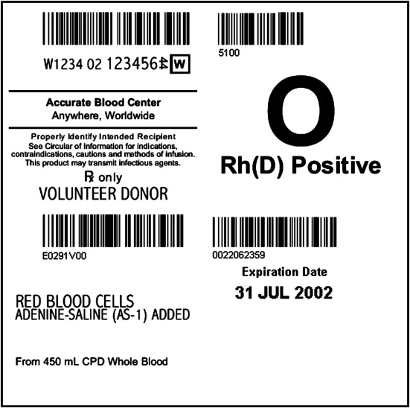  4  3
 | Supplier  Supplier unit # | 1  1
 | Component, Division #  Container, Volume  - For platelets, plasma, and apheresis rbcs key in volume from label | 21  2
 | ABO/RH | 3
 | Expiration Date, Time  Draw Date, Time  Received Date, Time | 4
Codabar | Supplier | 1  3  2 | 5  4  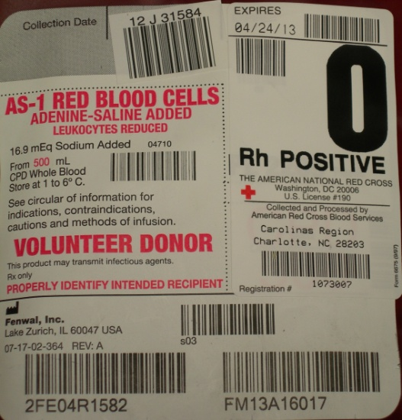  1

Attachment 2: Attribute and Antigen Entry
For | Click | Select from Drop Down | Info to Enter | To “Add” specific unit info
Attributes | Attributes | Plt ct 3.0  Plt ct 3.1  Plt ct 3.2  Plt ct3.3  Plt ct3.4  Plt ct 3.5  Plt ct 3.6  Plt ct 3.7  Plt ct 3.8  Plt ct 3.9  Plt ct 4.0  Plt ct 4.1  Plt ct 4.2  Plt ct 4.3  Plt ct 4.4  Plt ct 4.5  Plt ct 4.6  Plt ct 4.7  Plt ct 4.8  Plt ct 4.9  Plt ct 5.0  Plt ct 5.1  Plt ct 5.2  Plt ct 5.3  Plt ct 5.4  Plt ct 5.5  Plt ct 5.6  Plt ct 5.7  Plt ct 5.8  Plt ct 5.9  Plt ct 6.0+  Plt ct less than 3.0  Double bag plateletpheresis  CMV negative  Credit Due if Expires  Nonleukoreduced Product  Neonate Platelet  Sickle negative  HLA matched  IgA deficient  Irradiated  Leukoreduced  Anti-A & -B titers less than 200  Anti-A &-B titers over 200  Washed Platelet  Washed RBC | Select Y or N  Y = Yes  N = No | F12 to accept  Note: For subsequent units in Batch Delivery you may use  F8 to copy the information from the field above  OR  Shift F8 to copy the above line.
Antigens | Antigens | Select antigen code from drop down box | Select P or N  P = Positive  N = Negative | F12 to accept  Note: For subsequent units in Batch Delivery you may use  F8 to copy the information from the field above  OR  Shift F8 to copy the above line.

Attachment 3: Deleting a Unit in SCC

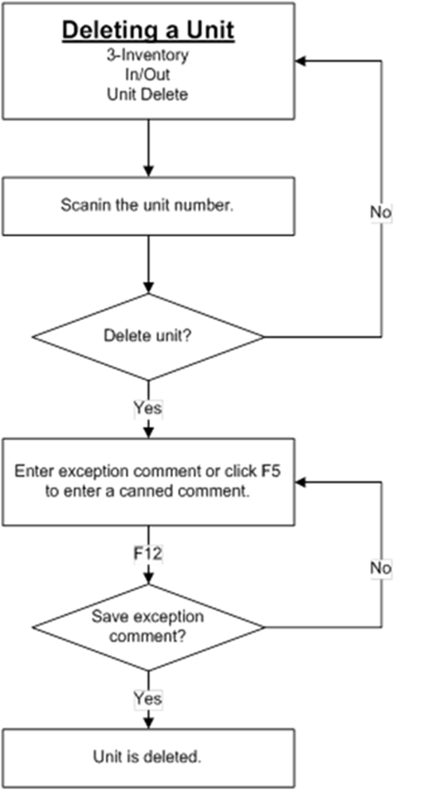

Attachment 4:
List of units with RETYP completed.
For use when checking units when adding the unit confirmation sticker.
- Go to Management > Testing history > Units
- Change date range: change the “from” to current date and the time should be before the units were placed on the instrument for testing. Keep “to” as the current date/time.
- Uncheck the Summary box. This is important otherwise you will not see the unit #s.
- Keep the status of “Tests” as C (for complete)
- Select RETYP from the dropdown menu under Codes.
- For “Instructions” remove the C so it is blank.

