Applicable Laboratory(s):

☒ North Carolina Baptist Hospital (NCBH)
☐ Lexington Medical Center (LMC)
☐ Davie Medical Center (DMC)
☐ Wilkes Medical Center (WMC)
☐ High Point Medical Center (HPMC)
☐ Westchester
☐ Clemmons

Purpose

The purpose of this procedure is to describe steps necessary to prepare QC material.

Scope

This procedure applies to Blood Bank Staff and Management

Definitions

- Procedure: A process or method for accomplishing a specific task or objective.
- WFBH Lab System: Wake Forest Baptist Lab System is a health system that includes Wake Forest Baptist Medical Center and all affiliated organizations including Wake Forest University Health Sciences (WFUHS), North Carolina Baptist Hospital (NCBH), Lexington Medical Center (LMC), Davie Medical Center (DMC), Wilkes Medical Center (WMC), High Point Medical Center (HPMC), Lab at Westchester and Lab at Clemmons.

Supplies/Materials

See Individual Sections

Sections

- Preparation of DAT Controls
- Preparation of Dilute QC Antisera
- Preparation of Panel QC Antisera

Procedure Guidelines

- Preparation of DAT controls

Chemical Risk Assessment: low
Biological Risk Assessment: low
Protective Equipment: Lab coat, gloves
Supplies: 12x75 test tubes, pipettes, scissors
Reagents: Anti-D, Unit segments
Equipment: 37 C incubator, centrifuge
Specimen Requirements: NA
STEPS | INSTRUCTIONS
1.0 | Obtain 2 O positive units with the longest expiration date.
2.0 | Obtain 2 12x75 glass tubes and label one with the QC DAT POS sticker and one with a QC DAT NEG sticker. See examples.  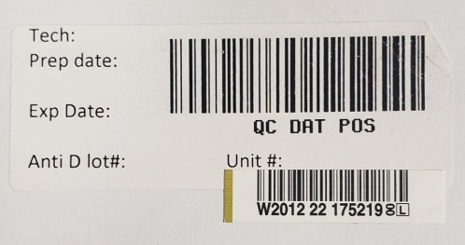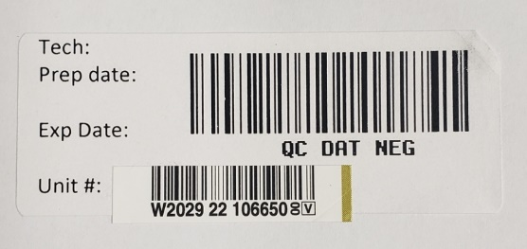  Refer to BB-LABEL-0064: QC DAT NEG (sticker)  Refer to BB-LABEL-0065: QC DAT POS (sticker)
3.0 | Pull 3 segments from each unit and empty contents into appropriately labeled tubes.
4.0 | And 5 drops of Anti D antisera to the QC DAT POS tube and document the lot number of Anti-D on the label.
5.0 | Incubate the QC DAT POS tube for 10 minutes at 37+2.
6.0 | After incubation mix QC DAT POS tube well.
7.0 | Finish labeling the tubes with tech initials, preparation date, expiration date (unit number or Anti-D expiration date. Whichever comes first.)
8.0 | Once they are ready for use, document the following information on the DAT QC and Antibody Panel QC Log.  7.1 DAT pos: Unit number, Unit expiration date, Anti-D lot number and expiration date, date and time of preparation, and tech initials  7.2 DAT neg: Unit number, Unit expiration date, Date and time of preparation, and tech initials  Refer to BB-FORMS-0250: DAT and Panel QC Log
9.0 | Remove old DAT controls from use and document date, time, and tech initials under Out of Use on the DAT QC and Antibody Panel QC log.  Refer to BB-FORMS-0250: DAT and Panel QC Log
10.0 | Run QC to ensure proper preparation. If results are not as expected, discard, and start over with new unit numbers.  10.1 If QC DAT NEG results are positive, pull a new segment, run a Poly Gel DAT on the instrument to confirm. If unit is still positive, report unit to management and place the unit in quarantine.  10.2 Blood Center will need to be contacted and credit requested for the unit.

- Preparation of Dilute QC Antisera

Chemical Risk Assessment: low
Biological Risk Assessment: low
Protective Equipment: Lab coat, gloves
Supplies: 12x75 test tubes, pipettes, labels, gel cards
Reagents: Anti-D, Anti-c, Saline
Equipment: 37 C incubator, centrifuge
Specimen Requirements: NA

STEPS | INSTRUCTIONS
1.0 | Titer selected antisera.  For daily QC: Anti-D and Anti-c are needed.  Refer to BB-SOP-0066: Titrations
2.0 | Test diluted antisera in gel and/or tube as following:  2.1 Use anti-D for Screen cells 1 and 2.  2.2 Use anti-c for Screen cell 3.  2.3 Document reactions on Preparation of Diluted Antisera for Daily QC form.  Refer to BB-FORMS-0046: Preparation of Diluted Antisera for Daily QC form.
3.0 | Select a dilution that results in a 1-3+ reaction. (Preferably 2+)  3.1 Separate dilutions are needed for gel (0.8%) and tube (2-4%) testing.  3.2 Make roughly 50 mls to aliquot.
4.0 | Aliquot by filling 12 x 75 tubes equally and cap tubes.
5.0 | Label reagent aliquots with the following:  - Initials  - Date Prepared  - Dilution  - Lot# of antisera  - Expiration Date (1 year from preparation date OR expiration of antisera used, whichever is shorter)  - Concentration use: 0.8% or 2-4%
5.0 | Store diluted antisera in Freezer in appropriately labeled tube.

- Preparation of Panel QC Antisera

STEPS | INSTRUCTIONS
1.0 | Panel QC should be prepared by combining equal amounts of thawed 0.8% dilute Anti-D and 0.8% dilute Anti-c. Label as following:  - Tech Initials  - Date Prepared (Date mixed)  - Expiration Date (choose exp date of soonest expiring dilute QC antisera)  - Dilution (example: D:64 x c:128)  - Lot# of antisera (example D01234c23456)  - Concentration use: 0.8%  Refer to BB-LABEL-0063: Panel QC (sticker)
2.0 | Document Reagents used on DAT and Panel QC Log  Refer to BB-FORMS-0250: DAT and Panel QC Log

Literature References: NA

Related Procedures/Policies in Navex: NA

Attachments/Linked Documents in Title 21:

BB-FORMS-0046: Preparation of Diluted Antisera for Daily QC form.
BB-FORMS-0250: DAT and Panel QC Log
BB-LABEL-0063: Panel QC (sticker)
BB-LABEL-0064: QC DAT NEG (sticker)
BB-LABEL-0065: QC DAT POS (sticker)
BB-SOP-0063: Daily Quality Control Using SCC
BB-SOP-0066: Titrations

Revision Dates: Review Change Summary as represented in Title 21.

