**Make sure you do the following before taking the test in MedTraining Solutions (MTS):**

1. Log on to the Department of Pathology document control system, Title 21. The link to access Title 21 is <https://wfdc.title21.com/Login/Login>
2. Read all the policies and procedures shown below that are within the Immu**PCR Laboratory** eBinders:
3. **Equipment Manual**

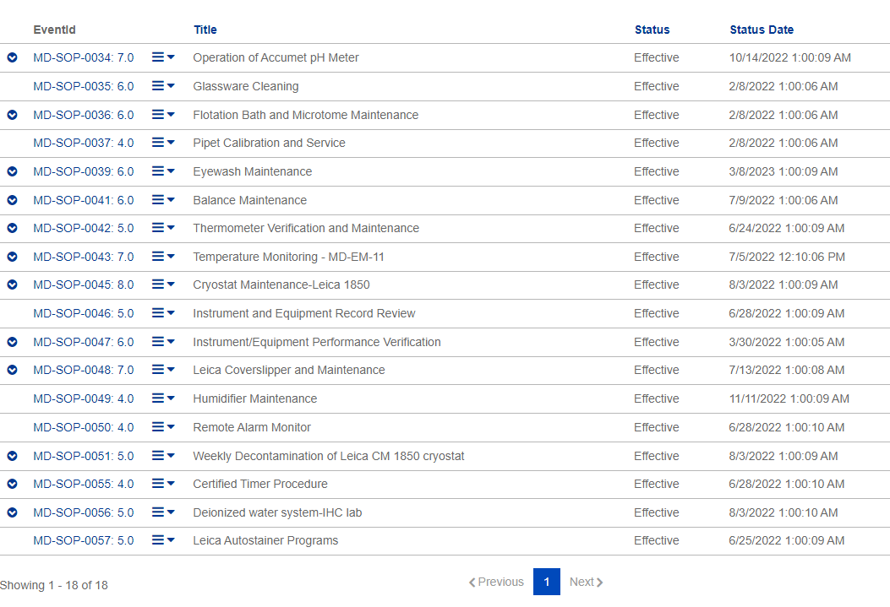

1. **Forms**

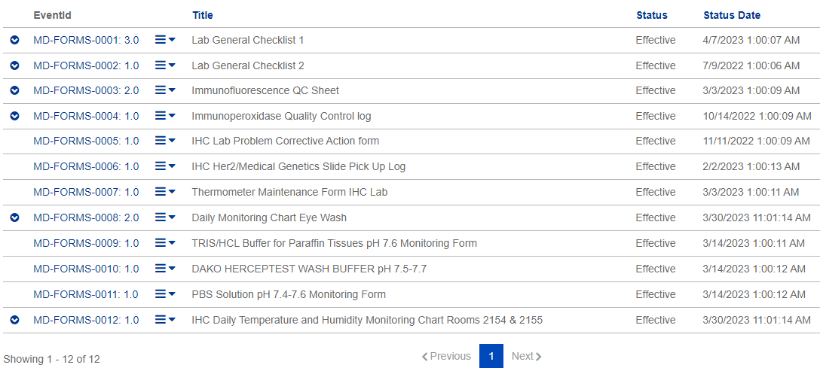

1. **Molecular IHC Procedure Manual**

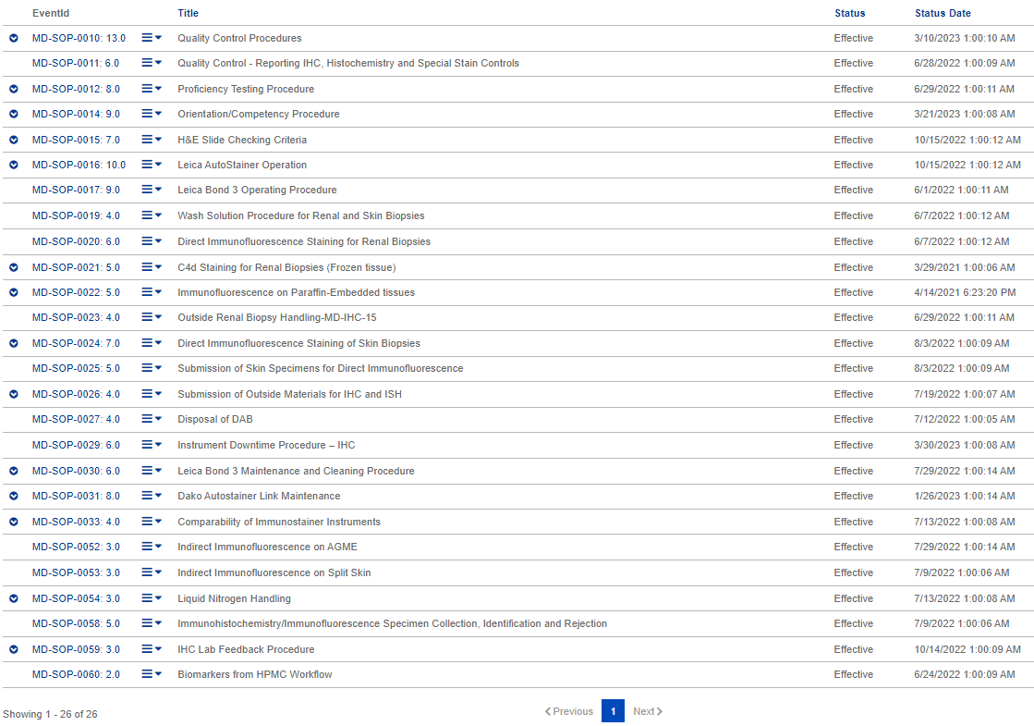

1. **Molecular Procedure Manual**

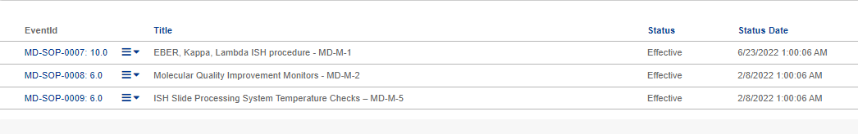

1. **Steroid Receptor Procedure Manual**

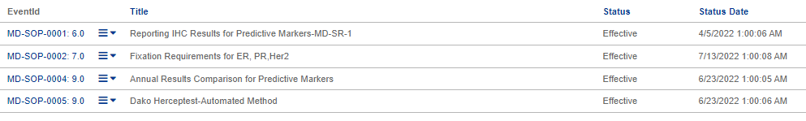

1. Read the policies and procedures found in the Quality eBinders listed below:
2. **Policy**

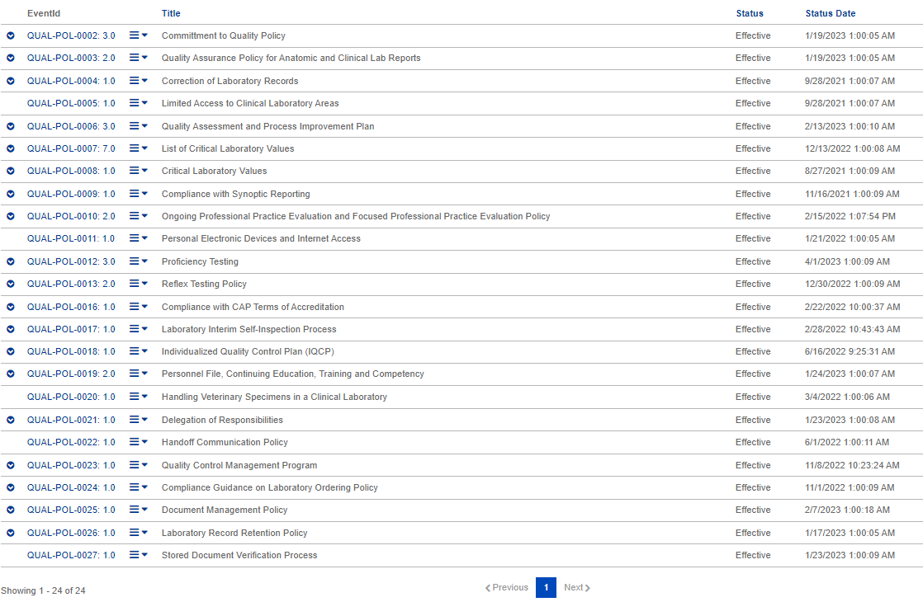

1. **SOP**

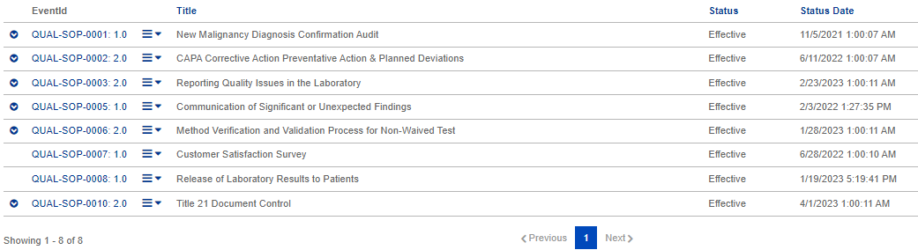

1. **FORMS**

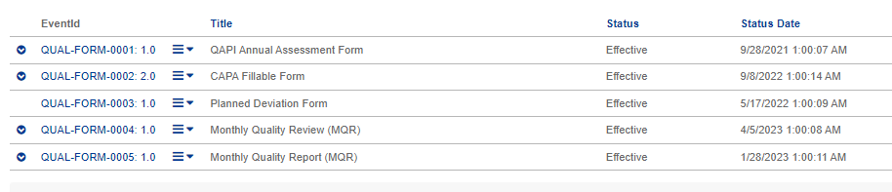

1. **LISTS**



1. Read the policies and procedures found in the **Safety eBinders** listed below:
2. **Policy**

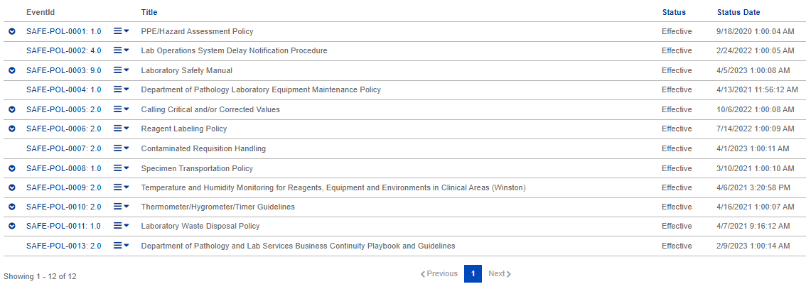

1. **SOP**

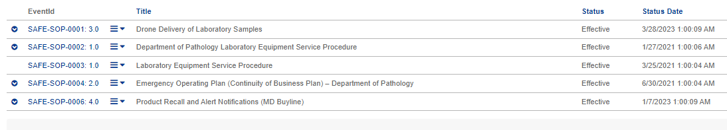

1. **FORMS**

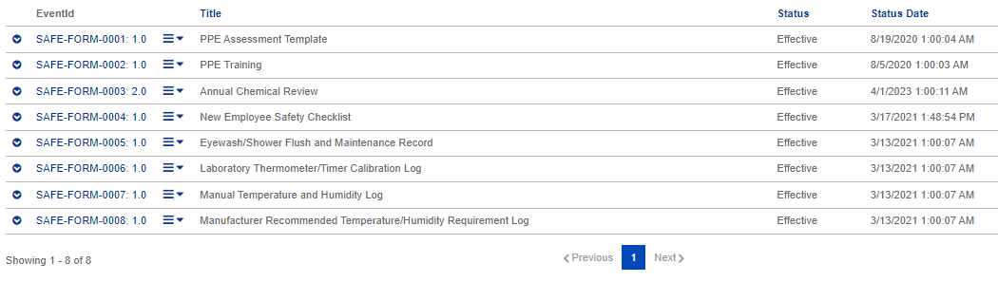

1. Log-in to MTS at <https://www.medtraining.org/ltac3/Secure/Login.aspx> and take the TEST to attest that you have reviewed applicable policies and procedures for the current year.