Applicable Laboratory(s)):

☒ North Carolina Baptist Hospital (NCBH)
☐ Lexington Medical Center (LMC)
☐ Davie Medical Center (DMC)
☐ Wilkes Medical Center (WMC)
☐ High Point Medical Center (HPMC)
☐ Westchester
☐ Clemmons

Purpose

Although there are numerous methods for measuring low levels of hemoglobin in plasma, serum, and aqueous solutions, there is no widely accepted method and results can vary considerably between different methods. The HemoCue Plasma/Low Hb System is calibrated against the HiCN reference method according to the International Council for Standardization in Hematology (ICSH) and needs no further calibration. The hemoglobin concentration is determined as azidemethemoglobin, utilizing a microcuvette with a dry reagent system and a dual wavelength photometer. When present, the membranes of erythrocytes are disintegrated by sodium deoxycholate, releasing hemoglobin. Sodium nitrate coverts the hemoglobin iron from the ferrous to the ferric state to form methemoglobin, which then combines with sodium azide to form azidemethemoglobin. Measurements are taken at 570nm and 880 nm, the latter to correct for turbidity. This test will be used to monitor free hemoglobin in the plasma of patients on ECMO. Current ELSO guidelines suggest Plasma free hemoglobin be monitored daily for patients on ECMO. ELSO guidelines state the plasma hemoglobin should be less than 10 mg/dl under most conditions and that if the level exceeds 50 mg/dl, the cause should be investigated.

Scope

This procedure applies to Blood Bank staff and Management.

Definitions

- Procedure: A process or method for accomplishing a specific task or objective.
- WFBH Lab System: Wake Forest Baptist Lab System is a health system that includes Wake Forest Baptist Medical Center and all affiliated organizations including Wake Forest University Health Sciences (WFUHS), North Carolina Baptist Hospital (NCBH), Lexington Medical Center (LMC), Davie Medical Center (DMC), Wilkes Medical Center (WMC), High Point Medical Center (HPMC), Lab at Westchester and Lab at Clemmons.
- ECMO: Extracorporeal Membrane Oxygenation
- ELSO: Extracorporeal Life Support Organization
- Hb: Hemoglobin
- PFHgb: SCC test for Plasma Free Hemoglobin

Reagents/Media
EuroTrol Plasma/Low Hb Controls: store unopened in refrigerator at 2-8°C until expiration on box. After opening the vial, it is stable for one month when properly recapped and stored at 2-30°C.
HemoCue Plasma/Low Hb Microcuvettes: store 15-30°C. Do not refrigerate. Use the microcuvettes prior to the expiration date. Once the seal of the vial is broken, the microcuvettes are stable for 3 months. Keep the vial closed. All unused microcuvettes should remain in the original package.

Supplies/Materials
Transfer pipettes
Lint free wipes (Kimwipes)
Parafilm
PPE: Lab Coat, gloves, face shield or equivalent

Equipment
HemoCue Plasma/Low Hb Photometer: Store between 0-50°C. The operating temperature is 15-40°C. Allow the photometer to reach ambient temperature before use. The analyzer should not be operated at high humidity (>90%).

Sample Requirements
Na Heparin or Li Heparin (green top) tube. Care should be taken to avoid traumatic blood draw. Spin sample at 22rpm for 10 minutes. Immediately separate plasma from red cells, taking care not to contaminate plasma with red cells. Test immediately or store in the refrigerator at 2-8°C for up to 3 days. Visibly turbid samples should be filtered with a 0.2um filter before testing.

Specimen Acceptability and Rejection Criteria
Visibly turbid samples should be filtered with a filter having a pore size of 0.2um.
Samples collected in tubes other than green top should be rejected.

Calibration
HemoCue Plasma/Low Hb Photometer is calibrated against the HiCN reference method according to ICSH and needs no further calibration.

Quality Control
EuroTrol Plasma/Low Hb Controls. Two levels of controls should be tested each day of use.

Steps | Instructions
1.0 | Allow the vials to stand for 15 minutes at room temperature (15-30°C)
2.0 | Gently Mix the vials 8-10 times or until a homogenous solution is attained before sampling.
3.0 | Dispense a drop of the control material onto a hydrophobic surface (parafilm). Do not fill the cuvette directly from the vial.
4.0 | Fill the cuvette by placing the tip of the cuvette in the drop of control. The cuvette will fill via capillary action.
5.0 | Wipe any excess material from the vial and cap with a clean tissue and recap the vial tightly.
6.0 | Insert the cuvette into the photometer and document the result before opening the photometer. The result will display until the photometer is opened.
7.0 | If the control does not perform as expected, review the instructions for use of the instrument to see if the test was performed correctly. Check the expiration date and storage conditions for the control and cuvettes. Repeat the test. If the control still does not perform as expected, contact technical assistance at 1-866-234-5754 officeUSA@eurotrol.com

Corrective Action
See step 7 above.

Procedure Guidelines

Steps | Instructions
1.0 | Turn on the photometer using the switch in the back.  - The letters “LHb” should now be seen on the display. If not, check the connections to the photometer and to the main power supply.
2.0 | Pull the cuvette holder into the loading position. This is noted by a distinct stop.  - The cuvette holder, which is used to move the cuvette in and out of the photometer has 3 positions: completely pushed in—measuring position, pulled out—loading position, completely withdrawn—for cleaning.
3.0 | After 15 seconds “READY” with 3 dashes should be visible on the display. The photometer is now ready to perform a measurement.
4.0 | Let sample come to room temperature and mix by inverting approximately 8 times. (Refer to Sample Requirements)  - Visibly turbid samples should be filtered using a filter with a pore size of 0.2um.
5.0 | Open a vial of Plasma/Low Hb microcuvettes, removing only the number of cuvettes for immediate use. Recap the vial.
6.0 | Use a pipette to drop a large drop of a well-mixed sample on a piece of parafilm.
7.0 | Introduce the cuvette into the middle of the drop in such a way that the cuvette is filled in one step. It should never be topped up.
8.0 | Using a Kim wipe or other lint free tissue, carefully wipe off the excess sample on the outside of the cuvette. Make sure none of the sample is drawn out of the cuvette during this step.
8.0 | The filled cuvette should be visibly inspected to check that the cuvette is properly filled (completely filled and lacking air bubbles in the optical eye). If air bubbles are present, discard the cuvette.
9.0 | Place the cuvette into the cuvette holder and carefully push it in to the measuring position. The display screen will show “MEASURING”. The filled cuvette should be analyzed immediately and at the latest 1 minute after filling.  - Slamming the cuvette holder into place with undue force will cause splashing of the sample material onto the optical surfaces.  - It is important that the cuvette holder is completely dry since the fluid between the holder and the cuvette can withdraw sample from the cuvette by capillary action.
10.0 | The test result will be displayed in less than 1 minute. The result will remain on the display as long as the cuvette holder is in the measuring position.  - Results should be documented before opening cuvette holder.  - The cuvette should never be remeasured. Discard the used cuvette after results are documented.
11.0 | Proceed to Interpretation of Results and Results Reporting.

Dilution or Concentration (if applicable): NA

Calculations (if applicable): NA

interpretation of results

Steps | Instructions
1.0 | Results will be visible on the display.  - The photometer rounds the results to the nearest value of 10. (Values of 25 and 34 will display as a value of 30).  - Values less than 30 should be reported as <30.  - Values of ≥ 50 are considered high.  - Values of ≥ 100 are considered critical.  - Values greater than 150 will be reported as >150.

Results Reporting

- Reportable Range: 0-3000 mg/dl
- Clinical Reportable Range: <30-<150 mg/dl
- Reference Interval
- Critical Values: ≥50 mg/dl = high. ≥100 mg/dl =Critically High Value
- Expected Results: ≤30 mg/dl
- System of Reporting: SCC

Steps | Instructions
1.0 | In SCC: Patient>Orders>Results: Select test “PFHgb”
2.0 | Choose Test results based on the below values: (choose specials rack)  PFHgb PFHgb PFHIn  < <30* NORML  30 30 NORML  40 40 NORML  50 50 HIGH  60 60 HIGH  70 70 HIGH  80 80 HIGH  90 90 HIGH  10 100 CRIT  11 110 CRIT  12 120 CRIT  13 130 CRIT  14 140 CRIT  15 150 CRIT  > >150** CRIT  *Values of 0, 10, and 20 should be reported in SCC as <30  **Values of 160 and greater should be reported in SCC as >150
3.0 | Values of 100 or greater are considered Critical and will trigger an exception in SCC.  - These values should be called to the care team per Critical Value policy.  Refer to BB-POL-0034 Critical Value Notification
4.0 | Complete SCC exception with Name, date, and time of person contacted.  - Use canned comment “CALL”  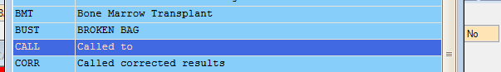  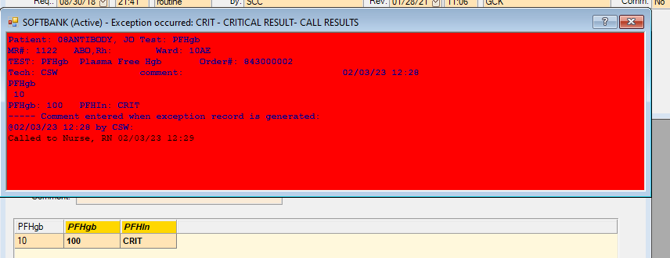  - Save exception and F-12 to save result.

Interfering Substances/Test Method Limitations
- Air bubbles in the optical eye of the microcuvette may cause false results.
- Holding the microcuvette by the optical end can result in contamination of the optical eye.
- Values >3000 mg/dl should be analyzed using an alternate method.
- Sulfmethemoglobin is not measured with this method.
- The test should not be used on uremic patients as performance characteristics of this system have not been determined.
- Samples that are visibly turbid should be filtered using a filter with a pore size of 0.2um.
- Contamination of intact red cells will result in falsely elevated results.

Downtime
Samples are stable for three days if refrigerated between 2-8°C. Samples should be centrifuged at 2200rpm and plasma should be carefully separated from red cells prior to refrigeration. If the test system become inoperable for extended periods of time, notify management. This is a STAT test and sending the test out to LABCOR is not desirable.

Literature References:
HemoCue Plasma/Low Photometer Operating Manual
HemoCue Plasma/Low Microcuvette package insert.
EuroTrol Plasma/Low Hb Controls package insert.
Beturs, C., et al. (2007). Enhanced Hemolysis in Pediatric Patients Requiring Extracorporeal Membrane Oxygenation and Continuous Renal Replacement Therapy. Ann Thorac Cardiovasc Surg. 13(6).

Related procedures/policies in Navex/Policy Tech: NA

Attachments/Linked documents in title 21:
BB-POL-0034: Critical Value Notification
BB-FORMS-0261: HemoCue Log

Revision Dates: Review Change Summary as represented in Title 21.

