Applicable Laboratory(s)):

☒ North Carolina Baptist Hospital (NCBH)
☐ Lexington Medical Center (LMC)
☐ Davie Medical Center (DMC)
☐ Wilkes Medical Center (WMC)
☐ High Point Medical Center (HPMC)
☐ Westchester
☐ Clemmons

Policy Purpose

The purpose of this policy is to outline protocols and processes for patients enrolled into the Trauma Resuscitation with Low-Titer Group O Whole Blood or Products (TROOP) clinical trial. The TROOP trial is an exception from informed consent (EFIC) study where patients are identified in the emergency department/trauma bay by applying inclusion and exclusion criteria stipulated in the protocol. The study aims to compare groups of trauma patients who received LTOWB vs those that received blood components during trauma resuscitation.

Scope

This policy applies to

Definitions

- Policy: As defined in the Policy on Creating and Amending Policy, a statement of principle that is developed for the purpose of guiding decisions and activities related to governance, administration, or management of care, treatment, services or other activities of WFBH. A policy may help to ensure compliance with applicable laws and regulations, promote one or more of the missions of WFBH, contain guidelines for governance, and set parameters within which faculty, staff, students, visitors and others are expected to operate.
- WFBH Lab System: Wake Forest Baptist Lab System is a health system that includes Wake Forest Baptist Medical Center and all affiliated organizations including Wake Forest University Health Sciences (WFUHS), North Carolina Baptist Hospital (NCBH), Lexington Medical Center (LMC), Davie Medical Center (DMC), Wilkes Medical Center (WMC), High Point Medical Center (HPMC), Lab at Westchester and Lab at Clemmons.

Policy Guidelines

- Screening and Enrollment/Randomization

- Patients are screened in the emergency department/trauma bay.
Refer to Attachment 1: Manual of Procedures for inclusion and exclusion criteria, rationale, and application.
- Clinical teams will be blinded to patients’ allocation for as long as possible, until the point of breaking the seal and cooler opening. Coolers must therefore be made to look the same, regardless of whether they contain LTOWB or components. Additional coolers needed AFTER the primary blinded cooler do not need to be blinded.
- Blood Bank should be notified at the time of MTP activation if the patient is eligible for the TROOP trial.
- Research coordinators will determine eligibility.
- MTP is activated by a doctor and blood bank notification called by a nurse.
- Research coordinators should be in close contact with the care team so that TROOP eligibility is relayed at the same time as MTP activation.
- Notify management (email) if notification of TROOP eligibility comes after MTP activation.
- If TROOP eligibility is determined after MTP activation and the cooler has not been released to the clinical team, set up a new cooler per the following protocols. If the MTP cooler has already been issued, notify the care team that this patient is not a part of TROOP.
- On receipt of notification, the blood bank technologist will retrieve the “TROOP Trial Randomization Binder” which contains detailed instructions and all necessary forms.
- This is a confidential binder that should not leave the blood bank.
- Binder will be made available to sponsor personnel for periodic review/monitoring purposes.
- The binder contains sequentially numbered randomization sheets.
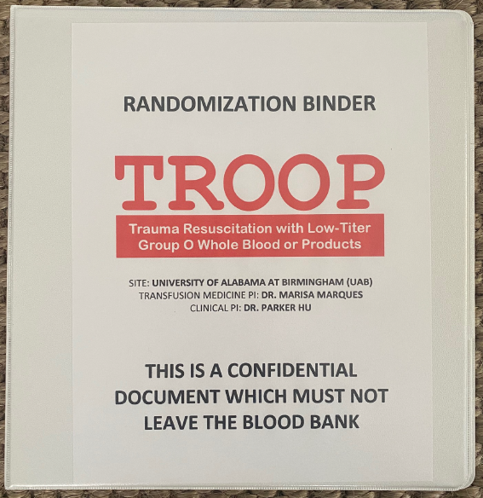
- The Tech will assess the availability of LTOWB in stock and record the result on Randomization sheet.
- If there is enough LTOWB (≥8 units), steps 2-4 should be completed.
- If there is not enough LTOWB (< 8 units), step 3 should be completed along with a tag that the patient is not included in TROOP (see below).
- NOTE: 8 units MINIMUM of LTOWB must be available in blood bank to randomize/enroll
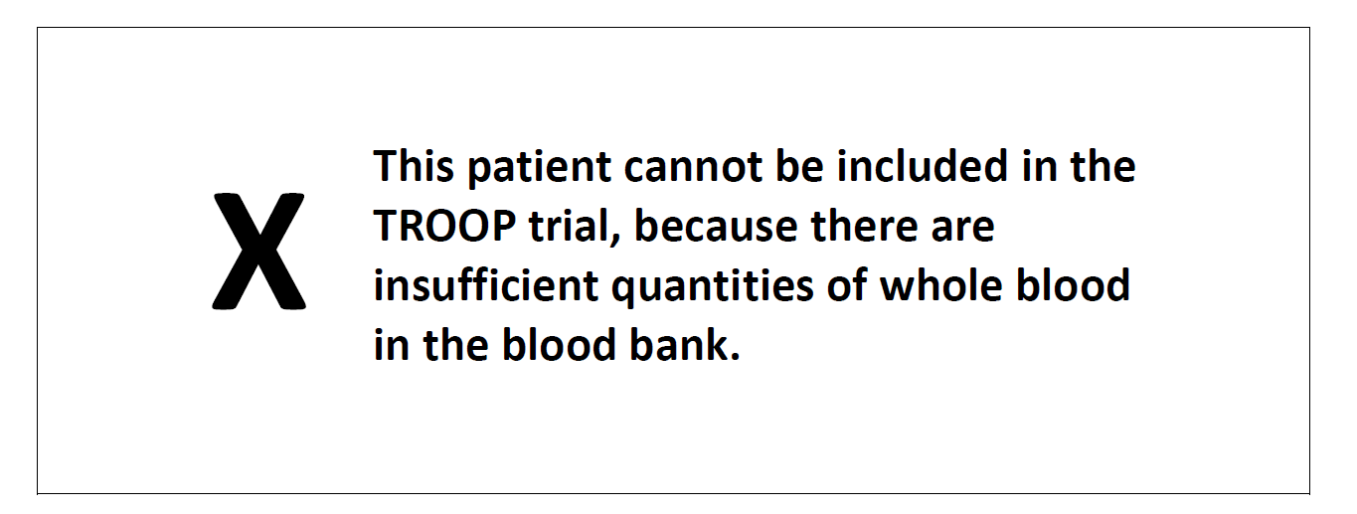
- Pre-Randomization: If there are at least 8 units of LTOWB available, the blood bank technologist will proceed to “scratch off” the latex covering on the Randomization form (step 2) to reveal the patient’s allocation (LTOWB vs component therapy).
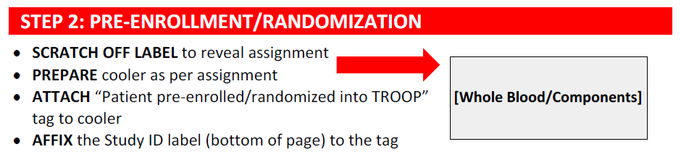
- The blood bank technologist will proceed to prepare the cooler (bio fridge) as per the allocation (LTOWB or component therapy cooler).
- ONLY bio fridges should be used for initial coolers for TROOP trial patients.
- Coolers must all look identical regardless of the contents of the cooler.
- Platelets must be placed under the opaque lid, not the clear lid.
- Subsequent coolers can be a mixture of other available BB coolers as needed as the randomization arm is no longer a secret.
- The cooler should be sealed with “TROOP Trial Patient” tape (to indicate whether the cooler was opened or not).
- The cooler shall be flagged with a tab indicating the patient has been pre-enrolled into the TROOP Trial.
- The tag will include the patient’s study ID (found on randomization sheet)
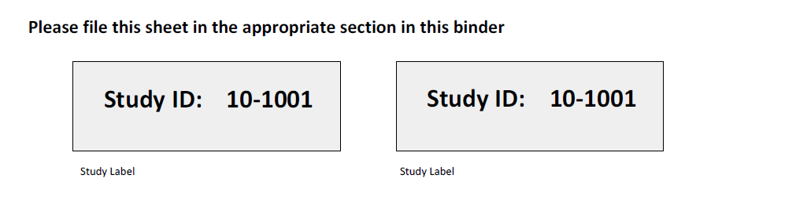

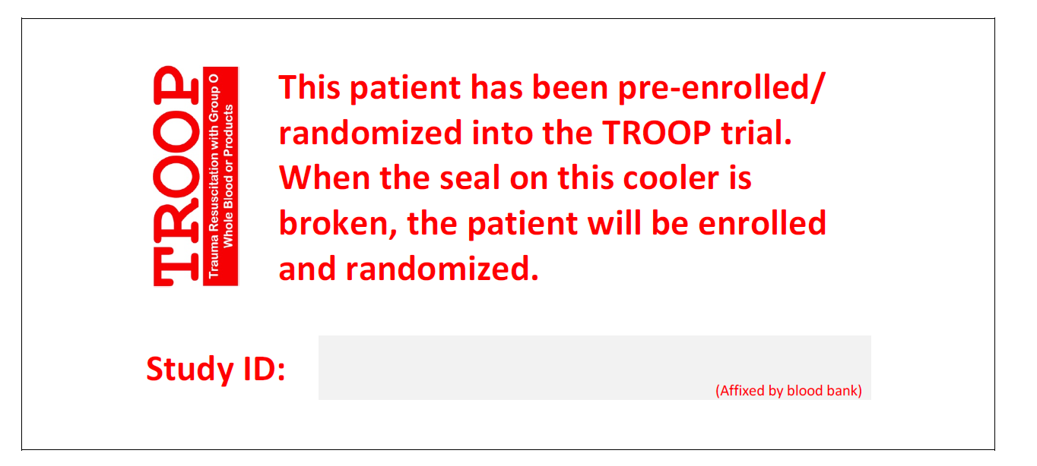
- Blood Bank will issue the cooler to the care team per SOP.
- Enrollment and Randomization are the same. Patients will not be enrolled until the tape is broken and the cooler is opened.
- Once the seal has been broken, patients will be in the trial, regardless of whether the products contained within the cooler were given or not.
- If an opened cooler is returned to blood bank, the technologist records the information on the randomization sheet (step 4).

- unopened coolers that are returned to blood bank should be noted on the randomization sheet (step 4). 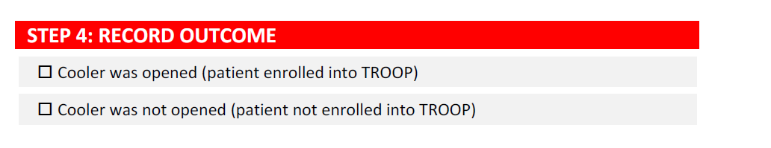
- Completed randomization sheets are filed in the relevant section of the randomization binder.
- Cooler Contents: Coolers should follow current MTP quantities (example: 4 LTOWB or 4 Red Cells, 4 plasma, 1 plt).
- once a patient has been allocated to LTOWB, they should continue to receive LTOWB if at all possible.
- 8 is the minimum number of LTOWB that must be available in order to randomize but there is no limit in the amount of LTOWB that a patient in the LTOWB arm can receive.
- Once LTOWB inventory has been exhausted, revert to components.

Literature References: NA

Related Policies/Procedures in Navex: NA

Attachments/Linked Documents in Title 21:
Attachment 1: Manual of Procedures
Attachment 2: Randomization sheet sample

Revision Dates: Review Change Summary as Represented in Title 21.

