# Organization(s):

North Carolina Baptist Hospital (NCBH)

Lexington Medical Center (LMC)

Davie Medical Center (DMC)

Wilkes Medical Center (WMC)

High Point Medical Center (HPMC)

Wake Forest Health Network (WFHN)

Wake Forest University Health Sciences (WFUHS)

Wake Forest University School of Medicine

NCBH Outpatient Endoscopy

Wake Forest Baptist Imaging, LLC (WFBI)

# Purpose

The purpose of this policy is to define the proficiency testing (PT) program to include the following areas: selection of approved PT materials for regulated analytes, appropriate handling of samples, sample analysis, results reporting, event results review and employee training/competency assessments. For purposes of photograph/image identification in CAP PT Programs, it is strongly recommended that current educational resources be available to the bench technologist. Examples include bench top resource guides, color atlases and glossaries provided as part of the survey.

# Scope

This procedure applies to all WFBMC Department of Laboratory Medicine and Pathology employees, faculty and staff.

# Definitions

1. ***Alternative performance assessment***: A system for determining the reliability of laboratory examinations for which no commercial proficiency testing products are available, are not appropriate for the method or patient population served by the laboratory, or participation is not required by the accrediting organization.
2. ***Policy:*** A statement of principle that is developed for the purpose of guiding decisions and activities related to governance, administration, or management of care, treatment, services or other activities.  A policy may help to ensure compliance with applicable laws and regulations, promote one or more missions, contain guidelines for governance, and set parameters within which faculty, staff, students, visitors and others are expected to operate.
3. ***Proficiency Testing (PT): Evaluation of participant (laboratory or individual) performance*** against pre-established criteria by means of interlaboratory comparisons. In some countries, the PT programs for clinical laboratories are called "external quality assessment" programs
4. ***Regulated Analytes:*** Analytes, that according to CLIA federal regulations require a laboratory to enroll in and successfully participate in a CMS approved proficiency testing program.
5. ***Unregulated Analytes:*** Analytes performed by a laboratory that are not included in the regulated listing found in the Federal Regulations Subpart I.
6. ***PT Event:*** May contain one or more test samples from different analyte samples or multiple samples for the same test.
7. ***Sample:*** One part of an entire PT event that should be tested by one individual when possible unless routine patient testing requires more than one tech to complete the result.
8. ***WFBH Lab System:*** Wake Forest Baptist Lab System is a health system that includes Wake Forest Baptist Medical Center and all affiliated organizations including Wake Forest University Health Sciences (WFUHS), North Carolina Baptist Hospital (NCBH), Lexington Medical Center (LMC), Davie Medical Center (DMC), Wilkes Medical Center (WMC), High Point Medical Center (HPMC), Lab at Westchester and Lab at Clemmons.

# Policy Guidelines

It is the policy of the Department of Pathology and any other laboratory area performing lab testing subject to proficiency testing requirements under CLIA (Clinical Laboratory Improvement Amendments), to adhere to all proficiency testing standards or regulations of CLIA and/or other accrediting laboratory agencies such as: College of American Pathology (CAP), American Association of Blood Banks (AABB), American Society of Histocompatibility and Immunogenetics (ASHI), Commission on Office Laboratory Accreditation (COLA) and The Joint Commission (TJC).

1. **PT Participation (*CAP COM.01300*) - Selection of Materials:**

PT materials are to be ordered from CMS approved PT Programs. These programs are evaluated and re-approved by the Centers for Medicare & Medicaid Services (CMS) annually. A detailed listing of the current approved PT programs along with their contact information and the tests for which they are approved is available in the CMS CLIA website. Click on the link [CLIA Approved Proficiency Testing Programs](https://www.cms.gov/Regulations-and-Guidance/Legislation/CLIA/Proficiency_Testing_Providers).

The primary PT Program(s) that the AH WFBMC Department of Pathology subscribe to is the College of American Pathologist (CAP) and American Society for Clinical Pathology (ASCP).

1. **Regulated Analytes:**

These are analytes that according to CLIA require a laboratory to enroll in and successfully participate in a CMS approved proficiency testing program. For the list of regulated analytes, refer to *Attachment C: List of Non-Waived Testing for Which PT is Required*.

***\*\*\*If PT materials are available to be purchased for regulated analytes, then purchase is required vs. an alternative assessment.***

1. Annually (by December 1) all purchased PT materials for regulated analytes will be reviewed by Section Managers and Section Medical Directors to ensure ALL tests performed are accounted for.
2. **Unregulated Analytes:**

PT providers or PT Programs may offer purchased materials for some unregulated analytes as well. If any areas choose to purchase these materials for unregulated tests they may do so at the same time.

1. **PT order forms:**
2. All purchased PT orders will be prepared by the Section Manager.
3. After order forms are completed, they should be forwarded to the Senior Administrative Assistant in Lab Administration. She will be responsible for processing the requests for payment and ensuring that each order is applied to the appropriate lab department for budget purposes.
4. Section Manager will review the order for accuracy and completeness after the orders has been placed and will provide a copy of the completed PT order form to the Quality, Safety & Accreditation Director, or their delegate.
5. For Predictive Marker testing using immunohistochemistry and in situ hybridization

methods, refer to CAP Standard *COM.01520* for PT or alternative performance assessment requirements, see*section B #**6* below*.*

1. **Acceptable Alternative PT methods (*CAP COM.01500*):**

Semiannual alternative performance assessment must be performed on tests for which external PT is not available. This requirement applies to both waived and nonwaived tests. Acceptable alternative assessment includes:

1. **Duplicate/Split Sample testing** – In which a single sample is divided into aliquots where one aliquot is tested on a particular assay system or by a particular analyst, other aliquots are tested on other instruments or by other analysts and the results are compared.
2. **CLIA Certified Lab to Lab Comparison**

Every six months, the laboratory sends five specimens to a CLIA-certified reference laboratory to compare results with its own laboratory.

1. **Interlaboratory Quality Control comparison**

Interlaboratory quality control results are used to verify the continuing reliability of the tests not included in the proficiency testing program (for example, peer comparisons).

1. **Microscopic Testing**

The technical supervisor of the lab retests random samples throughout the year to cover all testing staff.

1. **Anatomical Pathology**
2. Peer review of interpretation of slides
3. Peer review at case level including diagnosis
4. **IHC and ISH Predictive Marker PT and Alternative Performance Assessment (*CAP COM.01520*):**

The term predictive marker is used to refer to immunohistochemical (IHC), immunocytochemical, and in situ hybridization (ISH) tests used to predict responsiveness to a specific treatment independent of other histopathologic findings. Rather than confirming a specific diagnosis, these tests differentiate predicted responsiveness to a target therapy.

The following requirements for participation in proficiency testing or alternative performance assessment must be followed:

1. Predictive marker IHC interpretation - For analytes where participation in CAP

Surveys or CAP-accepted PT programs is required, IHC slides may be sent to another facility for staining only (if needed) and be interpreted at the originating laboratory.

1. Predictive marker ISH interpretation - For analytes where participation in

CAP Surveys or CAP-accepted PT programs is required, hybridization (ISH)

must be performed at the same laboratory performing the interpretation. If hybridization and interpretation are performed at different laboratories, the interpreting laboratory must perform alternative performance assessment at least semiannually and must not participate in formal (external) PT.

1. HER2 breast predictive marker ISH interpretation Participation in CAP Surveys or CAP-accepted PT programs is required, unless hybridization (ISH) is performed at a different laboratory (different CAP/CLIA number). If hybridization and interpretation are performed at different laboratories, the interpreting laboratory must perform alternative performance assessment at least semi-annually and must not participate in formal (external) PT.
2. HER2 PT for breast predictive marker testing is method specific. Laboratories interpreting HER2 results performed by multiple methods must participate in the required PT or perform alternative performance assessment as described above for each method.
3. Semiannual alternative performance assessment is required for other predictive marker tests for which CAP does not require proficiency testing.

Examples of alternative performance assessment include but are not limited to:

1. Participation in a PT or external assessment program if available (e.g., PD-L1);
2. Split sample analysis with another method or another laboratory;
3. Use of assayed materials, or clinical validation by chart review.
4. For predictive markers performed by methods other than IHC, immunocytochemistry, and ISH, refer to *COM.01300 and COM.01500*.
5. Documentation of the unregulated test and method of alternative PT being utilized must clearly be documented in writing and held in each section.

*** *Alternative Performance Assessment (APA) Test List* developed by CAP may be used to help laboratories keep track of this information, refer to *CAP COM.01500*. This form can be found located on the CAP.org website under e-LAB Solutions Suite and will serve as appropriate documentation.

1. Documentation of alternative assessments chosen should be documented in the procedure manual along with a method of evaluation of results and defined limits of acceptability for the performance. Corrective actions in response to unacceptable performance to alternative assessments must also be documented and maintained in the same manner as purchased PT surveys.
2. The CLIA Lab Director in conjunction with the Section Medical Director will be responsible for determining the acceptable differences allowed when evaluating the results obtained using alternative assessment methods.
3. Assessment of the results can take place by utilizing various methods, but a commonly suggested method paired with split sample testing would include: agreement across the range of results by plotting results on a two dimensional graph. The lab referenced to would represent the X axis and your lab the Y axis. A line of agreement is drawn in the body of the graph (Y=X). Upon visual assessments of the graph any trends or bias should be easily identified. Documentation of the acceptability of the results should be performed by the section and reviewed, signed and dated by the Medical Director and/or the CLIA Lab Director. If the results are not acceptable, corrective actions and documentation will be necessary using the Corrective Action Preventative Action (CAPA) process; see Q*UAL-SOP-0002 CAPA Corrective Action Preventative Action & Planned Deviations* procedure.
4. For in situ hybridization testing other than predictive marker testing, and other complex molecular and sequencing-based tests (including but not limited to microarray-based tests, multiplex PCR-based tests, and next generation sequencing-based tests), alternative performance assessment may be performed by method or specimen type rather than for each analyte or tested abnormality.
5. For tests such as allergen testing, alternative performance assessment may be performed in batches of analogous tests.
6. **Proper Handling and Analysis of PT Materials**

It is the responsibility of every laboratory employee to know the proper and improper handling of proficiency samples.

Every laboratory employee must understand the importance of following the policies and procedures in proper handling and communication of proficiency testing samples and that *improper handling* *of the samples* and *improper communication* *of proficiency testing reports* may result in sanction, limitation, suspension, or revocation of the laboratory’s CLIA certificate (CLIA 493.801(b), 493.1804, 493.1840).

1. **PT Sample Identification**

A Proficiency testing sample container is typically labeled with the PT program provider name and logo, the name of the test, sample number, testing event, etc. Laboratories often name the PT samples with information that is traceable to the identification printed on the label. The naming format is usually a combination of letters and numbers. For example, a CAP Hematology sample for Urine may be ordered in Beaker as *CAP,UA-01, HEME,UA-01 or HEME,CAP UA-01*. Likewise, an API sample for Urine may be ordered in Beaker as *API, UA-01*. Laboratory personnel must be familiar with PT sample naming formats and recognize a possible PT sample upon receipt.

* Proficiency samples should only be processed at the request of the Lab Manager. If a team member is not clear or has any questions regarding a sample, do not proceed with processing the sample until all questions have been answered by the Lab Manager.
* Central Processing should not order PT nor should any order be placed by Central Processing without an appropriate requisition.
* American Proficiency Institute (API) is not used by AH WFBMC. If a PT sample from API arrives at any AH WFBMC laboratory the sample should be given to the Lab Manager immediately. If the Lab Manager is not available (afterhours or out of office for other reasons) the API sample should NOT be processed but held until any lab manager is available to take the sample.
* The Manager, CLIA Laboratory Director and the Quality, Safety & Accreditation Director must be notified immediately.
* Examples of PT samples that should **NOT** be processed at an AH WFBMC laboratory:





1. **PT Interlaboratory Communication *(CAP COM.01800)* –** *Do not discuss PT results with personnel who works for another laboratory.*

Proficiency testing records **MUST NOT** be shared with and should be inaccessible to personnel of other laboratories, including an affiliated laboratory until after the deadline for submission of results. Laboratories that share a common computer system must take appropriate steps to ensure that records are not readily accessible by other laboratories.

1. **PT Referral** **(CAP COM.01900) *–*** *Do not refer PT specimen to another laboratory or accept PT specimen from another laboratory.*

This policy strictly prohibits referral or acceptance of proficiency testing specimens for analysis from other laboratories. This prohibition takes precedence over the requirement that proficiency testing specimens be handled in the same manner as patient specimens.

For example, a laboratory's routine procedure for review of patient abnormal CBC blood smears might be referral of the smear to a pathologist located at another site. (Different CAP/CLIA number). For proficiency testing specimens, the laboratory **MUST** **NOT** follow its routine procedure to refer the specimen. If the PT sample meets laboratory-defined criteria for referral to a pathologist prior to reporting and the pathologist is at another site, the pathologist must review the PT sample at the physical location of the laboratory performing the PT. Alternatively, the laboratory must refer to the PT provider kit instructions on how to record a result for a test not performed by the laboratory.

Laboratories that perform testing using a distributive testing model where portions of the process are performed at another laboratory with a different CAP/CLIA number must not participate in formal PT, as this is considered PT referral by CMS and is strictly prohibited. An alternative performance assessment must be performed at least semiannually in lieu of formal PT in these situations. Common examples of distributive testing include:

1. In situ hybridization and slide interpretation performed at separate laboratories
2. Next generation sequencing wet bench process, bioinformatics processes, and/or interpretation performed at different laboratories
3. Leukemia/lymphoma flow cytometry panels and pathologist interpretation of the data at different laboratories.
4. Immunohistochemistry (IHC) slides are permitted to be sent to another facility for staining only.

It is the responsibility of every laboratory employee to understand that the referral (receiving or sending) of any proficiency samples while the testing event is still in progress (before the due date) is prohibited. In the event any employee should be asked to engage in such practice, they are required to immediately notify their Manager, CLIA Laboratory Director and the Quality, Safety & Accreditation Director.

1. The laboratory (which is subject to regulation by the Centers for Medicare and Medicaid Services (CMS) do not test the same analytes from the same PT product on more than one instrument or method unless that is how the laboratory tests patient specimens. If the laboratory (under one CLIA license) uses multiple methods for an analyte, proficiency samples must be analyzed by the **primary method** at the time of the PT event or rotated among primary methods for each PT shipment. *Refer to CAP COM.01600*.
2. Laboratories subject to CMS regulation are not allowed to order multiple PT kits for the purpose of testing the same sample/analyte on multiple instruments or methods prior to the due date for submitting results to the provider. *Refer to CAP COM.01600.*

Samples are to be run on a single analyzer, yielding a single result, which is reported. (To prevent duplicate testing and comparison of results).

1. The laboratory integrates all proficiency testing and alternative performance assessment specimens within the routine laboratory workload, where applicable, and those specimens are analyzed by personnel who routinely test patient/client specimens, using the same primary method systems as for patient/client/donor specimens. Specimens may be repeated, diluted, etc. in the same manner as a patient sample. *Refer to CAP COM.01600*.
2. Every attempt will be made to have all testing employees participate in purchased PT surveys or an alternative method.
3. Except in limited circumstances (e.g., in the microbiology lab where cultures and testing can take longer than one shift or in coagulation lab where Factor XIII screen is read at 24hrs), all samples contained in a single test event should be tested by a single person to whom the event will be assigned by laboratory management and will be completed as soon as practicable following assignment.

1. In circumstances where the PT event has more than one sample, the testing can be performed by more than one person and should follow the same workflow as patient testing. Each personnel participating in PT testing must sign the PT attestation page and must write the details of the testing performed (e.g. PT sample identification, test(s) performed,
2. Documentation of testing details such as method and instrument used if applicable will be retained with the PT event.
3. Once PT testing has begun every attempt should be made to complete the testing in the assigned shift.
4. Individual test events should be rotated, amongst all competent testing personnel while respecting patient workload.
5. Prepare PT samples according to the PT kit instructions.
6. If patient samples are written on a daily log or patient worksheet, PT results should also be documented on a daily log or patient worksheet.
7. **Reporting of PT Results**
8. For purchased PT materials, results are recorded and submitted as directed per kit instructions, within the allotted time frame indicated for that event. Completed reports are filed with pertinent work sheets, QC documentation, instrument data, etc. and are maintained for at least 2 years (five years for transfusion medicine) (*COM.01700)* within each lab section.
9. PT Attestation Statement (*CAP COM.01400*) - The attestation sheet must be signed by the analyst(s) and the Medical Director (or designee)*.*
10. All recorded information is checked for accuracy and completeness by the manager prior to submission.
11. Results are submitted to the appropriate agency for evaluation via fax, mail or electronically.
12. The laboratory must document the handling, preparation, processing, examination and each step in the testing and reporting of results for all PT samples. The laboratory must maintain a copy of all records, electronic or paper, including copies of the PT program report forms and the attestation statement provided by the PT program for two years (five years for transfusion medicine) *(COM.01700) see* *Documentation* *section.* These are maintained in each lab section.
13. **Results Review (*CAP COM.01700*):**
14. As delegated by the CLIA Lab Director, the Section Medical Director, Section Manager/Assistant Manager or Laboratory Specialist will review all results (graded, ungraded, educational, etc.) represented within the testing event. During the event review process, all ungraded and educational responses must be assessed for acceptable performance in addition to graded responses. In the event the ungraded or educational result is found to be unacceptable based on peer data review, corrective action process will be required and documented (*refer to* *Documentation* *section*).

**Ungraded PT Challenges** ***(COM.01100)*** - If a PT challenge was intended to be graded, but was not, for reasons such as:

1. The laboratory submitted its results after the cut-off date,
2. The laboratory did not submit results,
3. The laboratory did not complete the result form correctly (for example, submitting the wrong method code or recording the result in the wrong place).
4. The laboratory result was not graded because of lack of consensus.

Then the laboratory should perform their own assessment of the PT challenge. The PT assessment for ungraded challenges including educational challenges, must include an assessment/conclusion from the Medical Director (or designee) as to whether the laboratories response was acceptable or not (*refer to* *Documentation* *section*).

1. Acceptable participation in the event means you received a passing score of 80% or more on the testing event.
2. For any results that did not receive a passing score in the event, the manager must evaluate and document (refer to *Documentation* section) possible reasons for failure and any corrective action that may be necessary.
3. Exception codes – CAP uses exception reason codes to signify that an analyte has not been graded. Refer to *Attachment A:* *CAP PT Exception Code* for the list of codes, description and recommended corrective action.
4. Review each exception codes and document the laboratory’s evaluation (refer to *Documentation* section).
5. If results are unacceptable based on peer data review, evaluate possible sources of error and initiate corrective action process. Write a summary describing the cause of the unacceptable PT result and any corrective actions taken. The write-up must include a conclusion from the Medical Director (or designee) as to whether the laboratory’s response was acceptable or not. Lab can use *Attachment B: PT Exception Investigation Worksheet* to investigate PT failures and document corrective actions taken.
6. An internal CAPA must also be completed if the score on the entire event is below 80%. The *PT Exception Investigation Worksheet* can be used to aid in the investigation. If a CAPA is initiated, document conclusion and corrective action in the CAPA form.
7. Depending on the PT provider utilized, additional documentation submission back to the PT provider may be necessary. Consult the PT provider instructions and follow their guidance as necessary in addition to section specific documentation.
8. Accreditation agency (e.g. CAP) may instruct the laboratory to cease patient testing for an analyte or subspecialty due to repeat unsuccessful proficiency testing. Follow the accreditation agency guidance in order to resume patient testing (COM.01950).
9. PT performance for regulated analyte:
10. CMS monitors performance of regulated analytes and will issue a Statement of Deficiencies for Unsuccessful PT Performance. “Unsuccessful proficiency testing performance“ is failure to achieve satisfactory performance for the same analyte, test, subspecialty, or specialty in two consecutive events or two out of three consecutive testing events. For the first unsuccessful performance, CMS may direct the laboratory to undertake training of its personnel or to obtain technical assistance, or both, rather than imposing sanctions. The laboratory will be required to submit an acceptable plan of correction to CMS or evidence that it has taken steps to correct the problem identified by the unsuccessful PT performance (CLIA 493.803).
11. Repeated unsuccessful PT performance for the same analyte, subspecialty, or specialty may result in the laboratory no longer being allowed to perform the failed testing. Laboratories may decide to **voluntarily stop testing** as soon as the PT results are received and immediately notify CMS. The notification must be made before receiving a letter from CMS imposing a cease testing sanction. If the lab voluntarily cease testing and then successfully perform two consecutive PT events, the Medicare and Medicaid reimbursement may not be affected.
12. If sanctions have been imposed, the Medicare and Medicaid reimbursement and the CLIA certificate will be suspended or limited for a six month period. To be able to resume testing, the laboratory must demonstrate that it has identified and corrected the reasons for the unsuccessful performance, purchase re-instatement PT samples and must perform two consecutive PT events successfully (CLIA 493.807).
13. **Documentation – *CAP COM.01700***
14. Alternative performance assessment - Documentation of the acceptability of the results should be performed by the section and reviewed, signed and dated by the Medical Director and/or the CLIA Lab Director.
15. PT Survey results – Documentation of the acceptability of the PT results should be performed, signed and dated by the Medical Director (or designee).
16. For exception codes that do not require corrective action (i.e. self-evaluation of ungraded results are comparable to the results supplied in the Participant Summary), document the review directly on the PT Evaluation Report form beside each exception code.
17. For unacceptable PT results, *Attachment B: PT Exception Investigation Worksheet* can be used to document investigation and corrective action.
18. For unacceptable PT results that meet the criteria for a CAPA (less than 80% for the entire event), document corrective action in the CAPA form.
19. PT, alternative performance assessment testing, and unacceptable PT investigation and corrective action records are retained for at least two years (five years for transfusion medicine). These include all instrument tapes, patient worksheets, work cards, computer printouts, Attestation page, evaluation reports, evidence of review, and records of unacceptable PT investigation, follow-up, and corrective action.
20. **Training/Competency Assessment**
21. Employees within the laboratory will receive specific training on the handling and testing of PT samples and events at the following intervals:
22. Initial new employee laboratory orientation (new employee checklist)
23. New employee end of probation review (at 90 days) or as part of the 6 months lab specific competency assessment, whichever is applicable.
24. Annually thereafter as part of every team members yearly lab specific competency assessment.
25. Orientation/Competency Assessment procedures may vary between sections. See Section specific procedures for checklists and procedure.
26. Review attachment D: Proficiency Testing PowerPoint Education Module and complete the on-line test (go to the Title 21 system “Attachment” section for the PowerPoint presentation).

# References:

1. CLIA Regulation *Subpart H - Participation in Proficiency Testing for Laboratories Performing Nonwaived Testing*, Condition 493.801 - 493.865.
2. CLIA Regulation *Subpart I – Proficiency Testing Programs for Nonwaived Testing, Standard* 493.901 – 493.959.
3. CLIA Regulations *Section 493.1236 Standard: Evaluation of proficiency testing performance*.
4. CLIA Brochure, *Proficiency Testing and PT Referral – Dos and Don’ts*, September 2017. <https://www.cms.gov/Regulations-and-Guidance/Legislation/CLIA/Downloads/CLIAbrochure8.pdf>
5. 2019.Analyte List from CLIAProfTestingBookletFINALNov2017 for *List of Non-Waived Testing for which PT is Required,* accessed 12.2022. <https://www.cms.gov/Regulations-and-Guidance/Legislation/CLIA/Proficiency_Testing_Providers>
6. 2022 PT list for list of *CLIA Approved Proficiency Testing Programs*, accessed 12.2022.

<https://www.cms.gov/Regulations-and-Guidance/Legislation/CLIA/Proficiency_Testing_Providers>

1. College of American Pathologist (CAP), *All Common Checklist Standards* under the section for Proficiency Testing, 10/24/2022, 325 Waukegan Road Northfield, IL.

# Related policies/procedures in navex:N/A

# Attachments/Linked documents in title 21:

1. Attachments:
2. Attachment A: CAP PT Exception Code
3. Attachment B: PT Exception Investigation Worksheet (*a fillable PDF version is available. Go to the Title 21 system “Attachments” section*)
4. Attachment C: List of Non-Waived Testing for Which PT is Required
5. Attachment D: Proficiency Testing Education Module (go to the Title 21 system “Attachment” section for the PowerPoint presentation).
6. Linked Documents:
7. QUAL-SOP-0002: CAPA Corrective Action Preventative Action & Planned Deviations
8. BB-SOP-0001: Proficiencies Blood Bank CAP Surveys & Internal Assessments
9. CCL-SOP-0004: CCL Proficiency Testing
10. CHEM-POL-0006: Proficiency Testing Procedure
11. CP-SOP-0014: Proficiency Testing
12. CYTO-POL-0053: Proficiency Testing
13. HEME-POL-0002: Proficiency Testing Procedure
14. HIST-SOP-0032: Proficiency Testing Guidance for Histology-QIP
15. MB-SOP-0055: MB56 Proficiency Testing
16. MD-SOP-0012: Proficiency Testing Procedure
17. PCR-SOP-0040: Molecular Diagnostics PCR Laboratory Quality Management Policy
18. POCT-SOP-0004: Point of Care Testing (POCT) Using the i-STAT Analyzer System
19. QUAL-POL-0002: Commitment to Quality Policy

# Revision Dates: Review Change Summary as represented in Title 21.

January 23, 2017, May 15, 2017, March 16, 2018, November 13, 2019, February 14, 2020

# 5/23

**Attachment A: CAP PT Exception Code**

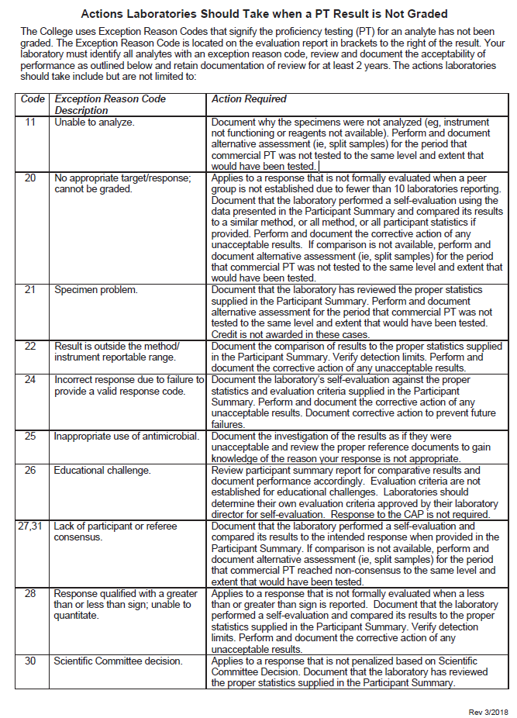

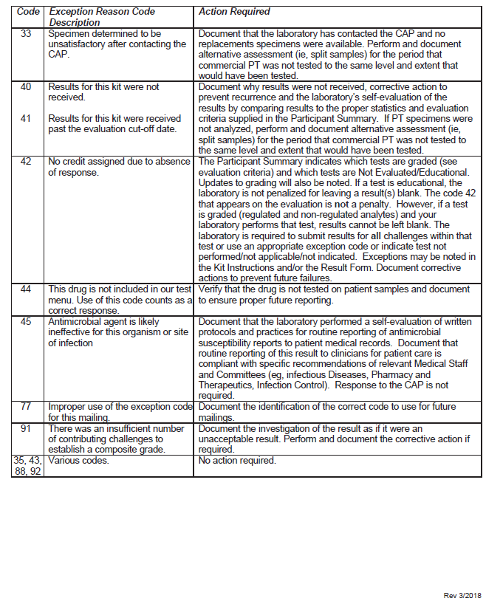

**Attachment B**: PT Exception Investigation Worksheet

A fillable PDF version is available. Go to the Title 21 system “Attachments” section.

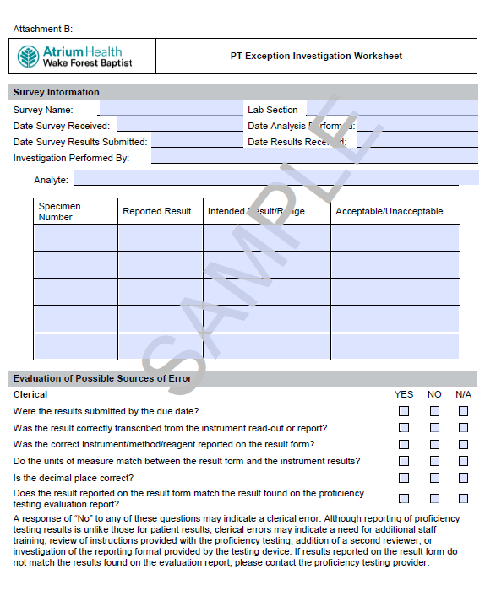

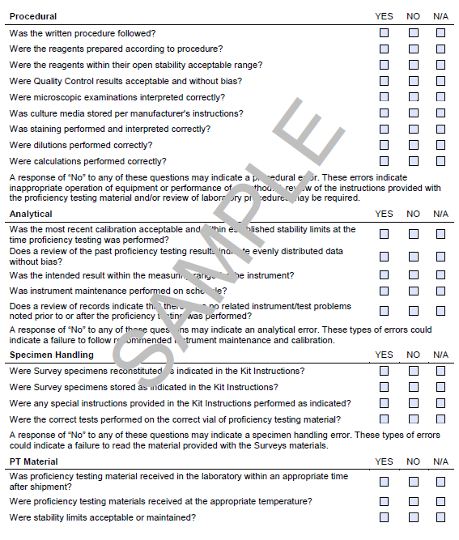

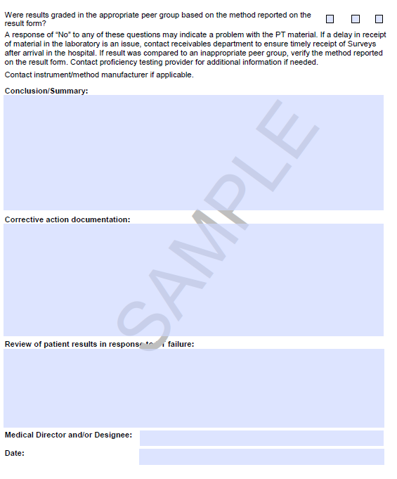

**Attachment C:** List of Non-Waived Testing for Which PT is Required

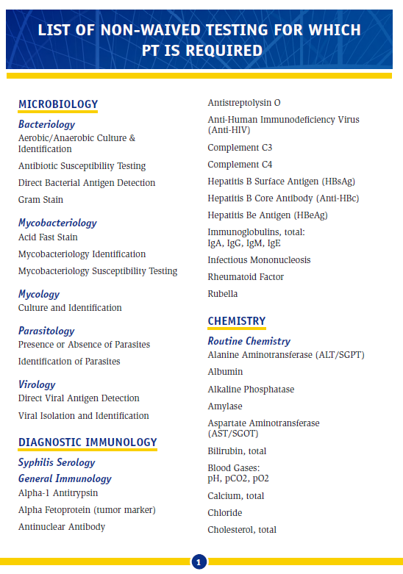

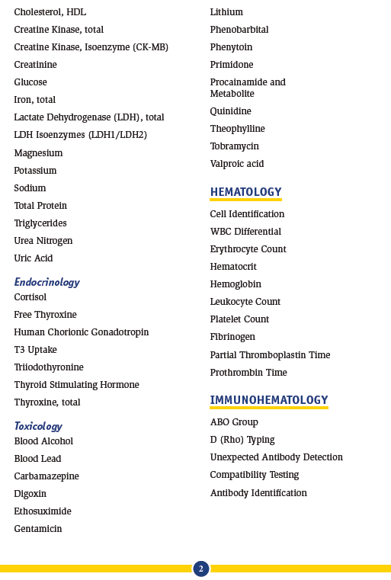

**Attachment D:** Proficiency Testing Education Module *(go to the Title 21 system “Attachment” section for the PowerPoint presentation)*.