Applicable Laboratory(s):

☒ North Carolina Baptist Hospital (NCBH)
☐ Lexington Medical Center (LMC)
☐ Davie Medical Center (DMC)
☐ Wilkes Medical Center (WMC)
☐ High Point Medical Center (HPMC)
☐ Westchester
☐ Clemmons

Purpose

- The purpose of this procedure is to detail how to receive blood bank specimens in Epic Beaker and Sunquest. Specimens are received in Blood Bank through the tube system, hospital staff members, and couriers from outside clinics.

Scope

This procedure applies to Blood Bank Staff and Management

Definitions

- Procedure: A process or method for accomplishing a specific task or objective.
- WFBH Lab System: Wake Forest Baptist Lab System is a health system that includes Wake Forest Baptist Medical Center and all affiliated organizations including Wake Forest University Health Sciences (WFUHS), North Carolina Baptist Hospital (NCBH), Lexington Medical Center (LMC), Davie Medical Center (DMC), Wilkes Medical Center (WMC), High Point Medical Center (HPMC), Lab at Westchester and Lab at Clemmons.

Supplies/Materials

List supplies needed

Protocols

- In order for results to post back to Epic, tests must be ordered, collected and received in Beaker first.
- Collector’s identification, date and time of collection must be available for the sample.
- Wake Main Campus (inpatient) collections require use of PPID or second individual verifying collection information prior to sending to blood bank.
- Samples collected at outreach offices that use CareEvolve will NOT have a usual MRN. The MRN will have a “U” instead of a MRN. These are already received by Central Processing and ready to be received in Sunquest.
- These will appear to not cross into Sunquest because scanning the beaker label will not pull up the patient. You must use the patient’s name to both receive and test in Sunquest.
- Outpatients that are not registered with an encounter for a sample received should have the paperwork emailed to Lab_custserv_dl@wakehealth.edu
- Customer service will create and encounter and notify Blood Bank

Procedure Guidelines

- Receiving Specimen in Epic

STEP | ACTION
1 | Verify the requisition and the information on the specimen match.  - An order requisition will print in the blood bank prior to samples being received.  - Upon sample receipt, locate pre-printed order and compare information.
2 | Open the Receiving activity by clicking the symbol or searching “receiving” in the top right corner of the screen.  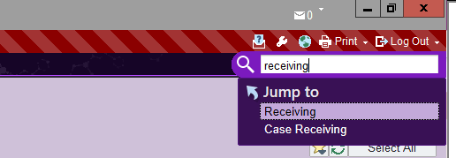
3 | Using: Scan the label for each specimen that will be received into the lab.  - The collection information entered by the nurse or phlebotomist appears in the center of the screen.  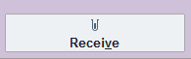  - Highlight the specimen, check the collection information, click Receive.  - Enter a no-scan override reason and click Accept.  This is necessary when Blood bank Sunquest scanner is used instead of a dedicated Beaker scanner.  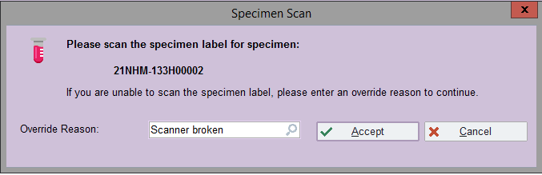  - The tests for the specimens you received now appear on the Outstanding List or on the Sendout Bench if the test cannot be performed in your lab.
4 | If the barcode is not scannable or the scanner is not working:  - Click Specimen Lookup and either enter in the Specimen ID in the Specimen box or enter the patient’s name or MRN in the Patient Box  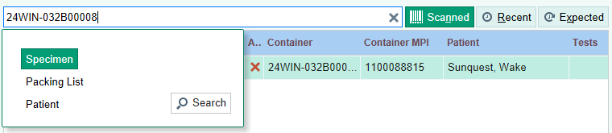  - Highlight the specimen, check the collection information, click Receive.  - Enter a no-scan override reason and click Accept.

- Receiving a Blood Bank Specimen without PPID

- If a specimen has this error during receiving, follow the steps below to override the error.
Refer to BB-POL-0074: Second ABO Testing for No History Patients

STEP | ACTION
1 | Chart search “specimen update” to open the specimen in Specimen Update activity  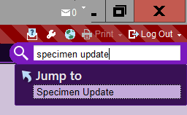
2 | In the Specimen Flags field, select Patient ID verified with two signatures or search “PPID”  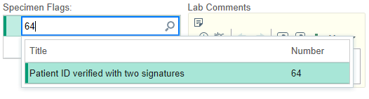
3 | Click Receive

C. Rejection of an Unacceptable Specimen

Chemical Risk Assessment: low
Biological Risk Assessment: low
Protective Equipment: Lab coat, gloves
Reagents: NA
Supplies: NA
Equipment: NA
Specimen Requirements: EDTA 5-7ml (lavender or pink top) or Red 5-10ml (red top tube – no gel separator)

STEPS | INSTRUCTIONS
1.0 | Request a new sample if:  - Inpatient sample is not collected with PPID or by using two verifiers.  - Identifying information is not identical on ALL items (patient last name, first name, MRN)  - double labeling has occurred and not identical for patient name and MRN#.  - sample is hemolyzed after centrifugation.
2.0 | Inform the patient’s nurse that a new sample is required.  - NOTE: If initial sample from ED or ordered STAT from anywhere in Medical Center, offer emergency release blood as an option.  - Document on the BB requisition or rejected unit log the name of the person receiving the information, your initials, date/time and whether they accepted or declined the emergency release units.
3.0 | Receive and/or order test, then credit test to document receipt and rejection.  - In Encompass, send the test back for recollection if the sample was not received.  - Open Specimen Inquiry and enter or scan specimen label  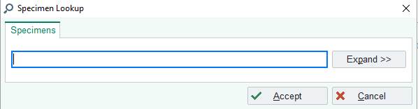  - Click Redraw  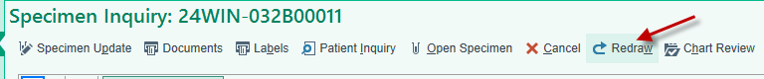  - Complete Reason for redraw  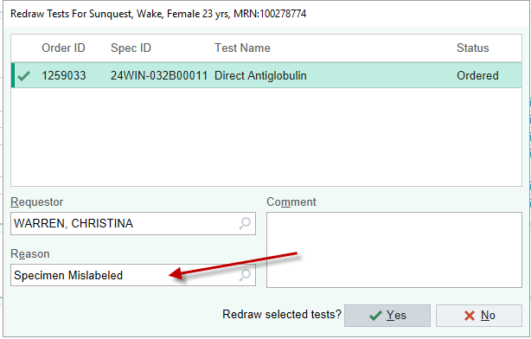  - If the sample was received, the test can be cancelled, and a new order must be placed.
4.0 | Document information in Merge/Rejection Log.  - Enter into RL6.
5.0 | Place an “ALERT sample not satisfactory for use” sticker on sample and file sample in day’s rack.
6.0 | File requisition on day of collection. Do not discard.

Literature References:

Related Procedures/Policies in Navex:

Attachments/Linked Documents in Title 21:

Revision Dates: Review Change Summary as represented in Title 21.

