Applicable Laboratory(s):

☒ North Carolina Baptist Hospital (NCBH)
☐ Lexington Medical Center (LMC)
☐ Davie Medical Center (DMC)
☐ Wilkes Medical Center (WMC)
☐ High Point Medical Center (HPMC)
☐ Westchester
☐ Clemmons

Purpose

The purpose of this procedure is to outline the policy and procedure for blood and blood product issue.

Scope

This procedure applies to Blood Bank Staff and Management.

Definitions

- Procedure: A process or method for accomplishing a specific task or objective.
- WFBH Lab System: Wake Forest Baptist Lab System is a health system that includes Wake Forest Baptist Medical Center and all affiliated organizations including Wake Forest University Health Sciences (WFUHS), North Carolina Baptist Hospital (NCBH), Lexington Medical Center (LMC), Davie Medical Center (DMC), Wilkes Medical Center (WMC), High Point Medical Center (HPMC), Lab at Westchester and Lab at Clemmons.

Procedure Guidelines

- Routine Issue

Chemical Risk Assessment: N/A
Biological Risk Assessment: N/A
Protective Equipment: Gloves
Supplies: downtime paperwork if necessary
Reagents: N/A
Equipment: Computer
Specimen Requirements: N/A

STEPS | INSTRUCTIONS
1.0 | Obtain Blood Bank Pick Up Slip from EPIC or Accept a complete Blood Bank Issue Slip from requesting personnel  1.1 The Blood Bank Issue Slip must have, at minimum, the following documentation:  a. Patient’s full name  b. Medical Record number (MRN)  c. Product requested and number of units  d. Signature (Legible) of person picking up blood product  1.2 If Blood Bank Issue Slip is not complete, return it to the person requesting the product and request they obtain the correct information. Blood Bank staff must not provide patient information.  a. If EPIC pick up slip or Blood Bank Issue slip cannot be completed, offer  emergency release blood product
2.0 | Go to Blood Product Issue  
3.0 | Type or scan the patient’s MRN in the Blank area click Search.  3.1 The MRN must be transcribed or scanned directly from the delivered Blood Bank Issue Slip into the MRN area.  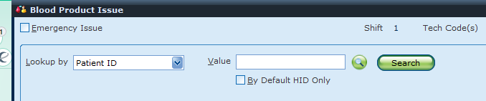
4.0 | Compare patient name and MRN on Blood Bank Issue Slip with the information that appears on the computer screen.  4.1 Name and MRN must be identical on computer screen and issue slip.  4.2 Select Billing Account # that matches the EPIC Blood Bank pick up slip.
5.0 | Type in the Component(s) being Issued and click Add then Select  Component Code  Red Cells RC  Platelets PLTG  Plasma PLAS  Cryo CRYOG  Granulocytes GR
6.0 | Review all information in the BAD file before issuing.  6.1 This screen will have all eligible units displayed for the patient, along with the patient demographic information and the patient’s BAD file detailing any special transfusion requirements.  6.2 Use arrows to scroll or select More to view complete BAD file.  6.3 Select Less to go back to issue screen.
7.0 | Retrieve requisition corresponding to product requested.  7.1 Current crossmatch requisitions for red cell containing products will be found filed in the requisition box at the Front Desk.  7.2 Requisitions prepared and selected components  a. Plasma and Cryoprecipitate will be found in magnet clips on the side of the  tube system.  b. Platelets will be found in magnet clip on side of platelet rotator.
8.0 | Compare all patient information on the requisition obtained with the information on the computer screen and on the Blood Bank Issue Slip. Assure that all criteria have been met for the blood / blood component being issued.  8.1 Information requiring comparison:  a. Patient full name  b. MRN  c. Patient ABO/Rh and Product ABO/Rh and compatibility  d. Product Type  e. Product DIN number and Ecode on tag must match unit.  e. Patient antibody information, Special transfusion requirements and attribute information  - Check BAD file for Antigens/Antibodies, Problems and/or the Transfusion Attributes.
9.0 | Take the issue slip and retrieve product requested from storage by locating the patient name/MRN on unit tags.  9.1 Red Blood Cells will be stored in the crossmatched refrigerator on labeled ABO/Rh specific shelves.  9.2 Platelets will be stored in the platelet rotator in the Front Desk area in alphabetical order by patient’s last name  9.3 Plasma will be stored in the crossmatched refrigerator on a specifically labeled shelf  9.4 Cryo and granulocytes will be stored, unagitated, at 20-24°C at the bottom of the platelet rotator at the Front Desk.
10.0 | Scan Unit number and product code for all units being issued.  10.1 Do not select from the list, product must be scanned whenever possible.  10.2 If DIN cannot be scanned, type DIN number from bag into Unit number field.  10.3 Once all units have been scanned, click continue
11.0 | Verify ALL information on unit tag with product bag label, Blood Bank Issue Form, BB requisition or equivalent and computer screen.  12.1 Any information discrepancy on any required documents / labels must be resolved before issue of product can proceed.  12.2 If all documentation is in agreement, continue  12.3 Initial the Issued By: area on the Blood Bank Issue Form
12.0 | Perform Visual Inspection and click Pass All.  12.1 If Visual Inspection does not pass, do not issue unit.  12.2 click on the yellow highlighted field under Vis Insp. And click Inspect Unit button. At this prompt, click no for visual inspection. Click quarantine or discard for the new status. In the reason for failure field, type in the correct code or free text a reason. Click ok.  12.3 if all units or patient testing has not been completed the system will throw a QA failure. QA failures require the entry of your personal access code and password to override and continue with issue.  QA failures should NOT be overridden Except in Emergencies or Truly Justified situations!  12.4 To override a QA failure do the following:  - At the prompt click the boxes beside each unit. A check mark will appear.  - Click the override button. A screen will display asking for your personal access code and password. Fill in each field. At the reason code field, use the following codes as applicable:  - EIS = Emergency Issue  - BOK = Blood Type Ok to give this patient  - OKP = OK’d by pathologist  - AU = Autologous unit  - BBR = Free text reason
13.0 | Edit the Issue date/time if needed.  13.1 Type issue date in MMDDYY format if different from current date, tab or use shortcut “T” key for today.  13.2 Enter issue military time. Shortcut keys for Time: “N”=now, “-5”=5 minutes ago, etc.  13.2 Document issue date on Blood Bank Issue form.
14.0 | Confirm Issue location.  14.1 Edit location, if different from location appearing in field.
15.0 | Type in last name of person picking up unit in SCC or scan badge when badge scanner is available.  16.1 Pickup person must sign issue form if not already done so.  16.2 Name on Blood Bank Issue form must be that of person picking up product. If not, request that person picking up product sign legibly Blood Bank Issue form.
16.0 | Click Save.
18.0 | If blood is being issued in a cooler:  Refer to BB-POL-0027 Blood Cooler Protocol  Refer to BB-SOP-0049 Blood Cooler Issue  18.1 For deglyced units, perform a hemolysis check of the spun segment, enter  hemolysis grade (1-4) by adding a comment to the unit. Blood Product Entry >  modify unit > Enter Hemolysis grade
19.0 | Separate front / back copies of Blood Bank Issue Form  19.1 Place top, white copy of issue slip in the designated box.  - If cooler used, staple cooler flag to white copy before placing on clip  - If bottom, pink copy does not have patient information on it, retain top, white copy for use in step 20. Place in designated box upon completion of issue.  19.2 Keep pink copy to be sent with product to the issue location.
20.0 | Have person picking up component read back unit tag information.  Note: For offsite courier pick-ups: Refer to BB-SOP-0049: Blood Cooler Issue  20.1 Request person pick up RED relay phone for read back confirmation.  - Answer ring, hold unit up to window with bag label facing YOU and unit tag facing person picking up unit.  - Person picking up unit must read aloud to you FROM TAG:  - Patient FULL name  - Medical Record Number  - Blood Donor Identification Number  - Blood Product E code (if printed on tag)  - While person is reading, Blood Bank tech compares information being read with the blood bank issue slip and unit blood label.
21.0 | Pass unit through window to transport container provided by issuing location.  21.1 If no container provided, place unit in plastic Ziploc bag before passing through  window.  a. Use plastic Ziploc bag internally if no cooler available. DO NOT  use for issue to external facilities.  b. Issue only one unit if no cooler (Except Emergency)  21.2 If blood issued in cooler, place pink copy of issue slip on top of the cooler with  the patient information facing up, then place in Sally Port and push to pass  cooler to the outside of the lab for pick up. Each cooler must have a pink copy  with patient information on top of the cooler.  - The SPOT Tracking System will begin tracking the cooler once it leaves the Blood Bank  Refer to BB-SOP-0058: FD SPOT (Insites) Tracking System

- Emergency Issue of Group O RBCs, A/AB Plasma, and Any Group Platelets and Cryo

STEPS | INSTRUCTIONS
1.0 | Receive request for Emergency Release of blood / blood products  - Obtain as much unique identifying patient information as possible – (name,  MRN, gender, location, weight, etc)
2.0 | Select appropriate blood for patient based on availability of current records, patient age, gender, and weight.  Refer to BB-POL-0052: Selection of Blood and Blood Components  Refer to BB-POL-0038: Emergency Blood Protocols  2.1. Complete Issue of Units following downtime processes to ensure there is no  delay in blood reaching the patient if using the computer system will delay the  process.  2.2. Refer to BB-SOP-0062 Computer Systems Interfaces Downtime Protocols and  Procedures
3.0 | Go to Beaker and place orders as requested if physician has not already done so.  - MTP order includes: 4 WB, 4 RBCs, 4 Plasma, 1 Plt  - MOH order includes: 4 RBCs, 4 Plasma, 1 Plt, and 5 cryo in every other round  - Emergency Red Cells (ERBC)  - Emergency Whole Blood (EWB)  - Emergency Granulocytes (EGR)  - Plasma  - Platelets
4.0 | Go to Blood Order Processing  4.1 Enter MRN. Search  4.2 Select patient from list by double clicking.  4.3 Select correct order accession from Accession List  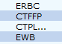  4.4 Open Patent specimen tab and update units ordered. Units ordered MUST  match the total number of units allocated.  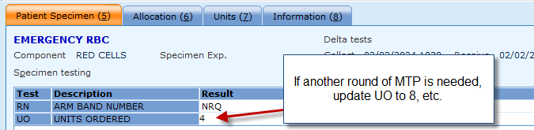  4.5 Open Allocation Tab and Scan unit and component type, press ADD  NOTE: NEVER rely on historical blood type of patient even if tested multiple times for issue of group specific packed cells. Issue group O packed cells. A new blood specimen should be collected to confirm group if current specimen not available.  4.6 Continue scanning and adding all units for the emergency issue event.  4.7 Update Transfuse Status (TS) to “OK” but leave XM pending.  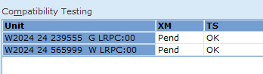  4.8 Click SAVE and acknowledge/override any exceptions with code EIS  Note: The exception to override is typically about pending crossmatches, but others may be  displayed. Ensure you understand the reason for the exception(s) before overriding!  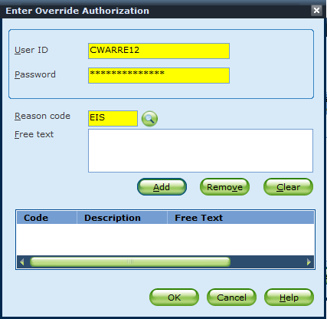  4.9 Click Issue Units in emergency mode. This will automatically take you to Blood Product  Issue – Emergency Issue
5.0 | Scan all units to be issued.  5.1. Typing unit numbers in will generate an error and prevent clinical teams from using BPAM  correctly.  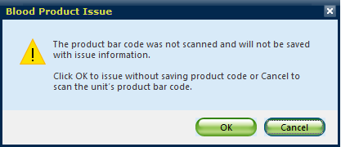  5.2. Click Continue
6.0 | Documents Visual Inspection of units  6.1. Click PASS ALL if all units pass visual inspection  6.2. Click on a specific unit under the Vis Insp field and press Inspect Unit for any unit that does not pass visual inspection. Complete Inspection of unit with appropriate code and new unit status as applicable. (Example: Hemolyzed)  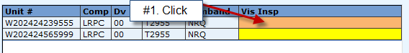  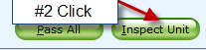  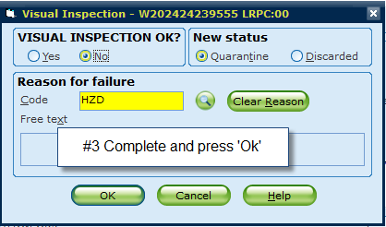  6.3. Click Continue
7.0 | Override QA failures.  7.1. Ensure understanding of reason for QA failures. Common is Unresulted tests: XM.  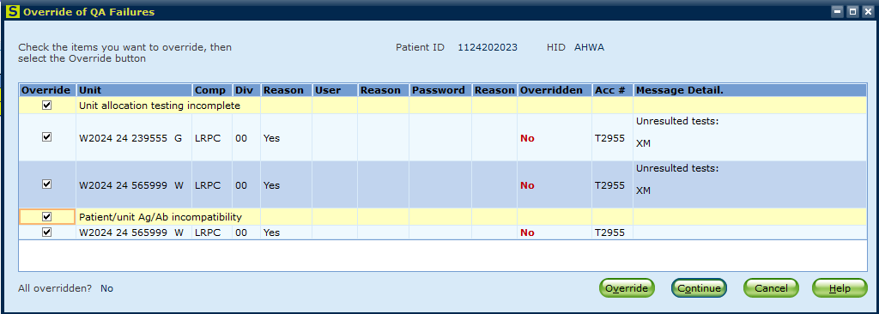  7.2. Use Reason Code EIS for Emergency Issue  7.3. Press Continue/OK
8.0 | Complete Issue by filling in Issue Date, time, and Issued to according to pick up slip or downtime issue form.  8.1. Press Save
8.0 | Result red cell crossmatch testing after sample arrives.  6.1. Units issued on Emergency orders will NOT be eligible for EXM and must be serologically crossmatched per SOP.  6.2. Open BOP>Order Selection>Select appropriate accession  6.3. Under Units tab, select Show all  6.4. Complete Crossmatch Results (IS and/or AHG per SOP) and Crossmatch Interpretations.  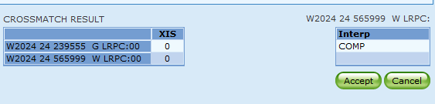  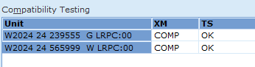  6.5. Click Save.

Literature References:

Related Procedures/Policies in Navex:

Attachments/Linked Documents in Title 21:

Revision Dates: Review Change Summary as represented in Title 21.

