Applicable Laboratory(s)):

☒ North Carolina Baptist Hospital (NCBH)
☐ Lexington Medical Center (LMC)
☐ Davie Medical Center (DMC)
☐ Wilkes Medical Center (WMC)
☐ High Point Medical Center (HPMC)
☐ Westchester
☐ Clemmons

Procedure Statement
Specimens may be sent to outside facilities for reference testing or genotyping. This procedure defines how this testing is ordered, samples submitted and results handled upon completion of testing.

Scope
Procedure Owner/Implementer: Julie H. Simmons/Christina Warren
Procedure Prepared by: Julie H. Simmons
Who Performs Procedure: Blood Bank Staff/management

Definitions
- Procedure: A process or method for accomplishing a specific task or objective.
- WFBH Lab System: Wake Forest Baptist Lab System is a health system that includes Wake Forest Baptist Medical Center and all affiliated organizations including Wake Forest University Health Sciences (WFUHS), North Carolina Baptist Hospital (NCBH), Lexington Medical Center (LMC), Davie Medical Center (DMC), Wilkes Medical Center (WMC), High Point Medical Center (HPMC), Lab at Westchester and Lab at Clemmons.
- ARC: American Red Cross
- Versiti : Formerly, Blood Center of Wisconsin
- NYBC: New York Blood Center
- Labtest: Online ordering system for VERSITI
- DARA: Daratumumab; drug used for patients with multiple myeloma
- DAT: Direct Antiglobulin Test
- BAD file: Blood Administrative Data file

Sections
- Sending Sample for Reference Testing or DNA Genotyping
- VERSITI Labtest Ordering and Adding/Deleting Users to Labtest Account
- Packaging Patient Specimens for Shipment Through Mail Services
- Receiving Results from Outside Reference Facilities

Policy Guidelines

- The following patient groups will routinely have red cell genotype performed to better manage their transfusion regimen. VERSITI test that is ordered is Red Cell Genotyping Panel.
1. Sickle cell disease diagnosis
2. Receiving Daratumumab (DARA)
3. Donor and recipient when stem cell transplant recipient has antibody(ies)
4. Drug testing for red cell/plt autoantibody

- Patients that have warm or cold autoantibodies may have red cell genotype performed.
1. VERSITI test that is ordered is Red Cell Genotyping Panel.

- Obstetric patients that give weaker D reactions (weakly positive at immediate spin or weak D positive) will routinely be sent for Rh Discrepancy testing to determine if they are candidates for Rh Immune Globulin.
        - VERSITI tests that are ordered is Weak D Analysis and Partial D Analysis. Complete BB-FORMS-0125 Reference lab tracking log.

- Patients that require testing not performed at Wake Forest Baptist may be sent to reference labs for testing. i.e. DAT negative hemolytic anemia workup, IgA DAT

- Patient specimens may be sent to reference lab for confirmation of results of tests that are being developed within the Blood Bank. i.e. Donath Landsteiner Test.

- Management will add or delete employees to the test account following the guidelines below. (note: once a user is deleted, that user ID cannot be used again.)

Function – Add Subuser | Comment
Click “User Profile”
Click “Sub Users” tab  Then click “Add New Subuser” | Create the user name and enter the generic password (Welcome1) and enter tech’s email
Check to see if new user is listed.  Click in box next to new user.  Click “Edit Menus” by the new user on right  The “portal configuration tool” box will open. | Select the following functions for the new user:  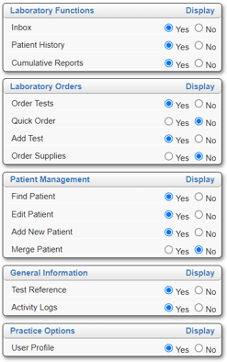
Click “Submit” | Notify new user of user name and generic password and that they will be prompted to change password at first log in.

Procedure

Biological Risk Assessment: Low
Chemical Risk Assessment: None
Protective Equipment: Lab coat, gloves
Reagents: NA
Supplies: NA
Equipment: NA
Specimen Requirements: Appropriate Requisition

    - Sending Sample for Reference Testing or DNA Genotyping

STEPS | INSTRUCTIONS
1.0 | Review Sample requirements for testing to be requested.  Refer to NYBC and ARC requisitions (located in Master Forms drawer) or VERSITI catalog (located on G drive in BB staff information folder).  - Obtain specimen requested by either requesting additional sample be collected or request sample be sent to Blood Bank from Core Lab.  - Determine if a sample is available by checking Beaker.  a. Log into Beaker/Encompass.  - Click on Chart under Epic drop down in top left corner of screen.  - Type in Patient’s medical record number and ENTER.  - Confirm correct patient and select.  - Click on ‘Order Inquiry’ on left side of screen.  - Scroll down to determine if a CBC has been collected recently.  - Record the Specimen ID number.  - Give this number to Hematology to obtain the specimen.  1.3. Order Molecular Red Cell Genotype in Epic  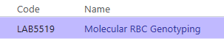  - Leave new order as “using an existing specimen” if sample available.  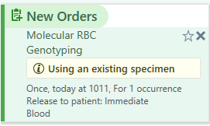  - Change to “New Collection” by clicking (i) using and exiting specimen and clicking “New Collection” and “accept”  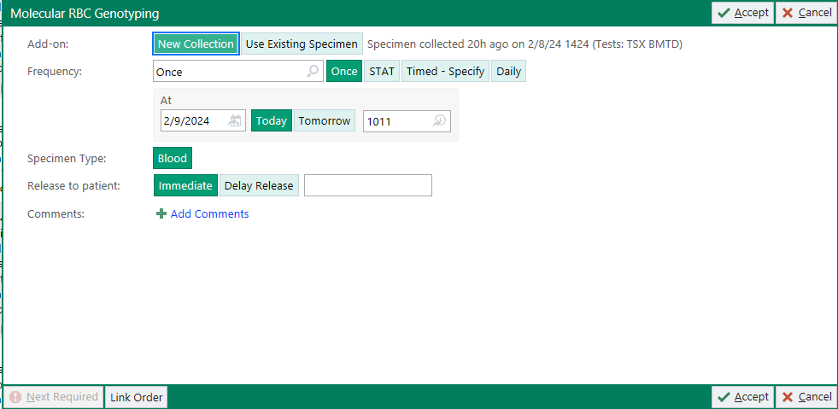  - Click Sign, complete order mode (Per Protocol), ordering provider, and click accept.  - If using existing specimen: go to specimen inquiry and click on specimen ID (TYHD or CBC, etc)  - Click Specimen Update  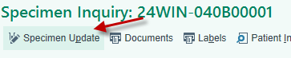  - Click Add-ons, available orders  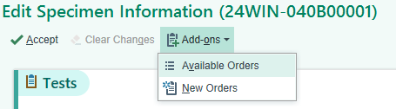  - Click on Molecular RBC Genotyping test and click + Add Orders  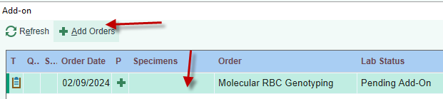  - Click Yes to add the test to the specimen. The test Molecular RBC Genotype is now pending. Leave this test pending until results arrive from reference lab.
2.0 | Obtain a Reference Lab Tracking form.  2.1 Complete Section I by writing patient information or placing a patient label in  the section.  2.2 Complete Section II by recording test(s) ordered and mailing date.  Refer to Attachment1: Reference Lab Tracking Form
3.0 | Retrieve appropriate form or log into VERSITI lab test if sending to VERSITI .  3.1  For Retrieve  - ABO analysis - Other reference testing when specified New York Blood Center Request for DNA Analysis of Blood Groups form  - Other reference testing when specified American Red Cross Immunohematology Consultation form  - RBC Genotype Panel - Partial D - Rh Discrepancy Analysis (OB patients) - Donath Landsteiner - Other reference testing when specified Go to Section II if ordering testing on line from VERSITI  3.2 Fill out physical form as completely as possible for ARC or NYBC.
4.0 | Call the Reference Lab telephone number located on the top of the form.  4.1 Record the name of the person contacted and the date and time they were  contacted for paper forms on specific line of ARC form or at top of NYBC  form.  4.2 Initial the Order by line on the Reference Lab Tracking form and check the  tests that are requested.
5.0 | Make a copy of this form and attach to the Reference Lab Tracking Form.  5.1 Store in the Reference Lab Tracking Notebook three days from date  specimen is sent.  5.2 Follow-up call for the result:  a. When the call is made, if the report is finished, make sure we have the  results.  Go to Section IV: Receiving DNA Genotyping Result  b. If report is not complete, record your initials and date called on the  Reference Lab Tracking form in the pending section.  c. Place back in the Reference Lab Tracking Notebook for next business day.  d. Continue to follow this protocol until report has been received.
6.0 | Obtain shipping box, plastic bag and absorbent material located under the specimen centrifuges.  6.1 If sending to ARC via the ARC courier, then go to Step 6.2.  a. If sending the specimen via Mail Services, go to Section III. Packaging  Patient Specimens for Shipment Through Mail Services.  6.2 Obtain a small Red Cross shipping box.  6.3 Place specimen box inside a plastic bag and use a rubber band to close the bag.  6.4 Place this bag inside the shipping box, place a small bag of ice on top of  specimen, place Styrofoam piece onto box and seal box with tape.  6.5 Tape a green return label (located in Master Forms drawer) on top of box and  Print in legible print: Charlotte Reference Lab.  6.6 Arrange transportation to ARC Charlotte

- Ordering Testing from Blood Center of Wisconsin (VERSITI ) for Reference Testing or DNA Genotyping

Biological Risk Assessment: Low
Chemical Risk Assessment: None
Protective Equipment: Lab coat, gloves
Reagents: NA
Supplies: NA
Equipment: NA
Specimen Requirements: none

STEPS | INSTRUCTIONS
1.0 | Navigate to the Labtest Login screen: www.lifepointlink.com/Versity  - Save website as a favorite when accessing the first time  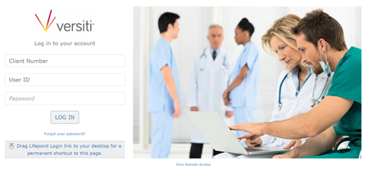  - Click the “Add to Favorites” icon while on the website. This will put the icon on your favorites bar.  - Right click and hold with the mouse on the icon created on your favorites bar and drag to your desktop to create a shortcut to the website.
2.0 | Logging In: Enter Account number, User name and Password.  - Account number is 3590.  - User name is Medical Center designation.  - Password is user specific. Change on initial login.  2.2 Click “Log In” and Versity test site displays.
3.0 | Ordering Tests and Adding on Tests: Search for the patient by clicking “Find Patient” on left to find historical results on a sample previously submitted.  3.1 Enter patient’s first and last names and/or “Client MRN” and “search” or search by date range.  3.2 If patient is found:  - If multiple matches, click the Versity MRN to open the patient history.  - If single match, patient opens automatically.  - Once patient opens, click “Order Tests” on left side of screen under Laboratory Orders to begin creating the test order.  - To add on to existing requisition, click “Add Test” on left side of screen under Laboratory Orders. Skip step 3.3 and follow steps 4 through 6 to complete the add on request.  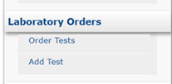  3.3 If patient is not found.  - Message displayed is: “There are no patients matching your search criteria. Please try again.”  - Create new patient by clicking “Add New Patient” under Patient Management to left of screen.  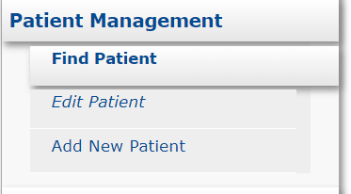  - Enter patient information.  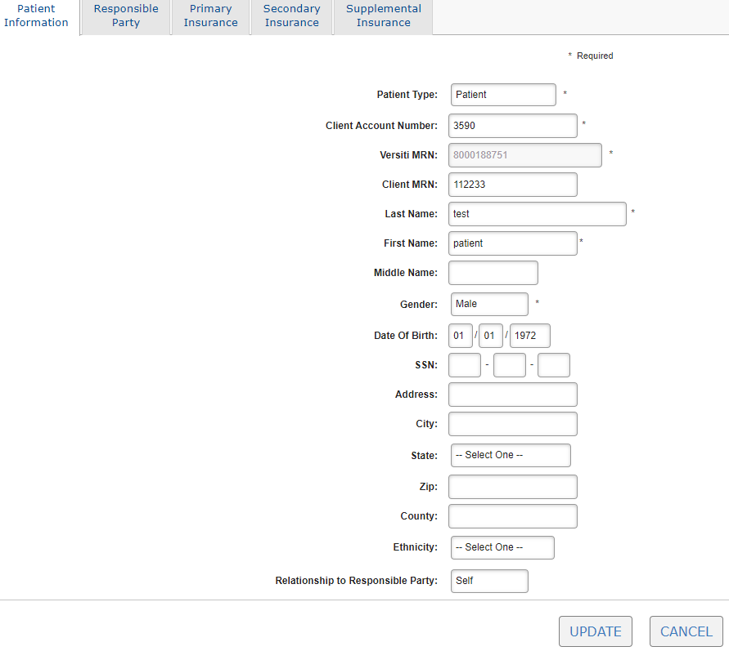  - Client MRN is WFBH MRN  - Enter Last Name and First Name  - Select Gender from drop down box.  - Enter Date of Birth.  - Enter Ethnicity from drop down box.  - Select None for Relationship to Responsible Party.  - NOTE: If ordering for a NMDP sample, record the following:  - Client MRN: none  - Last Name: NMDP Donor ID#  - First Name: NMDP  - Gender: Unknown  - Enter recipient name/MRN in comment field (Step 4.5d)  - Click “Update.” Patient record is created and test order screen opens.  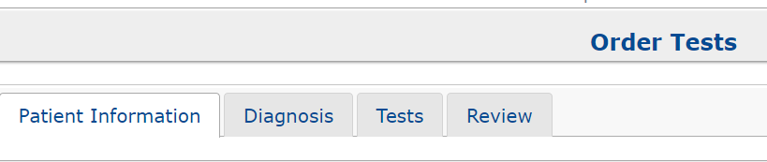
4.0 | Create Test Order  4.1 Click the “Diagnosis” tab to enter diagnosis code(s) if known.  a. Diagnosis may be left blank.  4.2 Click the “Tests” tab to order test(s) for this patient order by clicking on choices under “Immunohematology Reference”.  - The most common tests are listed. Click box(es) for desired tests  - If a test is not listed, you can search in the search text box.  - If a test is selected in error, click the red X to delete it.  - For NMDP recipient/donor, order RC Genotyping Panel.  4.3 Click the “Review” tab  4.4 Answer any required questions  a. Not all tests have questions.  4.5 Input additional information that is known.  - Select specimen type  - Enter Collection Date and Time.  - Select Dr. Fadeyi in drop down box under “Requesting Physician.”  - Enter any comments necessary in Comments box. This could be antibodies present or previous transfusion history if pertinent. Enter NMDP recipient name/MRN in this area  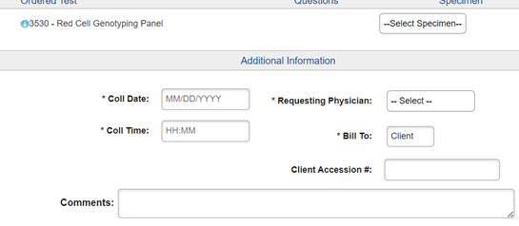
5.0 | Place the order by clicking “Order.”  5.1 Print two copies of the requisition at the prompt that appears.  a. If you forget to print two copies, then make a copy of the one that prints.
6.0 | Attach one copy to the Reference Lab Tracking Log.  6.1 Store in the Reference Lab Tracking Notebook three business days from date specimen is sent.

- Packaging Patient Specimens for Shipment through the Mail Services

Biological Risk Assessment: Low
Chemical Risk Assessment: None
Protective Equipment: Lab coat, gloves
Reagents: NA
Supplies: NA
Equipment: NA
Specimen Requirements: none

STEPS | INSTRUCTIONS
1.0 | Biological substances (patient specimens) must be shipped in a safe manner according to current federal, state, and local regulations.  - Patient specimens are considered Category B Biological substances.  - All packages must be clearly identified, properly packaged, and accurately labeled when presented to Mail Services.  - Packages must be presented to Mail Services by the same person who signs the "Hazardous Materials Shipping From."  - Refer to PPB-MC-06: Shipping and Receiving Infectious and Biological Substances
2.0 | Packing Category B Biological Substances (Patient specimens).  2.1 Primary Packaging (Plastic specimen tube)  a. Label the contents.  b. Container should be durable and leak proof.  c. Include headspace in the container.  d. Multiple primary receptacles: wrap individually or separate.  2.2 Absorbent Material  a. Sufficient quantity to absorb entire contents.  b. Place between primary and secondary containment.  c. Shock absorbent: top, bottom and sides.  2.3 Secondary Packaging  - Must be Watertight.  - If using ice or dry ice, place it outside the secondary packaging. Make sure it is leak proof.  Protective Equipment: Cryo gloves  - Never completely seal a container with dry ice, it needs to vent carbon dioxide gas.  2.4 Rigid Package (Outer package.)  a. Constructed of Corrugated Cardboard.  b. Do not use envelopes, Styrofoam coolers, or Styrofoam boxes.
3.0 | An itemized list of contents should be placed between the secondary and outer packaging. (Ex. This shipment contains: 1 plastic tube containing 3 ml of plasma.)
4.0 | Labelling Requirements:  4.1 The Outer Package should be labeled with the following:  - UN3373 Label- Biological Substances Category B  Refer to Attachment 2: BB-LABEL-0006 Biological Substances Category B  - Address label  Refer to Attachment 4: BB-LABEL-0013 Mailing Labels (Blank recipient).  - Dry Ice label with amount (if needed). Obtain label from mail services.
5.0 | Complete the Hazardous Shipping Authorization Form:  5.1 Sign and date the form.  5.2 Provide a phone number if questions.  Refer to Attachment 1 for a completed example.  BB-FORMS-0065 Hazardous Materials Shipping Form
6.0 | Complete the Wake Health Mail Room Charge ticket.  6.1 Sign and date the form.  Note: Blood Bank is Department 324311. Bone Marrow is 324316.  6.2 Tape the Charge Ticket to the package.  Refer to Attachment 3 for an example. BB-FORMS-0082 Mail Ticket for BB-FedEx
7.0 | Take properly packaged specimen, Hazardous Shipping Authorization Form and Mail Room Charge Ticket to mail room for shipment.

- Receiving Results from Outside Reference Facilities

Biological Risk Assessment: Low
Chemical Risk Assessment: None
Protective Equipment: Lab coat, gloves
Reagents: NA
Supplies: NA
Equipment: NA
Specimen Requirements: none

STEPS | INSTRUCTIONS
1.0 | Obtain paperwork from ARC, VERSITY or NYBC which consists of the DNA genotype/reference lab results and may include a charge form.  1.1 This procedure applies to either faxed copies, mailed or copies printed from  Labtest site.  - How to print results from Labtest:  a. Three business days after test was sent, check online in Labtest for result:  - Click “Inbox” to display current patients ordered by AHWFB  - Click on requisition number to see status of sample.  - If test is “ordered”, the sample has not been received yet.  - If test is “in progress”, the sample has been received.  - If testing is complete, it will say “complete”.  - Click on requisition number to navigate to results.  - Click “print” to print results.  - If report is not complete, record your initials and date on the Reference Lab Tracking form in Section III pending section.  - Place back in the Reference Lab Track Notebook under next business day’s date.  - Continue to follow this protocol until report has been received.
2.0 | Pull Reference Lab Tracking form from Reference Lab Tracking Notebook and complete Section IV.  2.1 Attach the final report to the Reference Lab Tracking form.
3.0 | Give paperwork to Management/Medical Director for review.  3.1 Management will review and give to Medical Director for review/comments.  3.2 Management will place paperwork on bridge after Medical Director review.
4.0 | Retrieve paperwork from bridge following management review.  4.1 Complete Section V. of the Reference Lab Tracking Log.  4.2 Add common variant and miscellaneous antigens to the BAD file and screen  print.  Refer to BB-SOP-0055 Updating the BAD File.  4.3 Add any special transfusion requirements that Medical Director has  indicated.  4.4 Tech entering data must initial and date in Results Entered into LIS section  on Reference Lab Tracking form.
5.0 | Submit screen print of BAD File to a second tech for verification of accuracy.  5.1 Verify tech must initial and date in Results Confirmed section of Reference Lab Tracking Log.
6.0 | Open Blood Order Processing in Sunquest and result the RBC Molecular Genotype with free text entry “reference lab results available.”  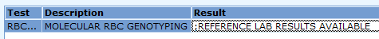
7.0 | Scan report and send to medical records  7.1 Open Salarity Scan Wake on the Computer by the color printer  7.2 Make sure Scan is selected and highlighted in orange (do not use Batches)  7.3 Load paper into scanner: top down facing the wall  7.4 Choose whether the document is black/white, color, or on legal paper  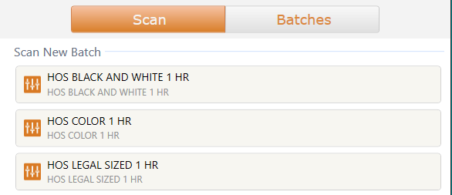  7.5 Document will automatically start scanning. The scanner will detect if each sheet is 2  sided or one sided.  7.6 After scanning is complete, check document for legibility. If ok, press send  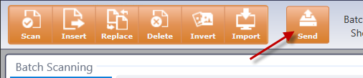  7.7 A “receipt” will print. Obtain this receipt, attach to original document and file in the  irradiator room alphabetically.

References

Related procedures/policies

Attachments/Linked documents (title 21)

Attachment 1: Reference Lab Tracking Form

Revision Dates: Review Change Summary as represented in Title 21.

