Applicable Laboratory(s):

☒ North Carolina Baptist Hospital (NCBH)
☐ Lexington Medical Center (LMC)
☐ Davie Medical Center (DMC)
☐ Wilkes Medical Center (WMC)
☐ High Point Medical Center (HPMC)
☐ Westchester
☐ Clemmons

Purpose

This protocol gives guidelines for operations during downtimes associated with laboratory computer downtimes, hospital computer (Epic) downtimes, interface downtimes and other times in which the situation warrants the use of downtime procedures.

Scope

This procedure applies to Blood Bank Saff and Management

Definitions

- Procedure: A process or method for accomplishing a specific task or objective.
- WFBH Lab System: Wake Forest Baptist Lab System is a health system that includes Wake Forest Baptist Medical Center and all affiliated organizations including Wake Forest University Health Sciences (WFUHS), North Carolina Baptist Hospital (NCBH), Lexington Medical Center (LMC), Davie Medical Center (DMC), Wilkes Medical Center (WMC), High Point Medical Center (HPMC), Lab at Westchester and Lab at Clemmons.
- AABB—Association for the Advancement of Blood and Biotherapies
- FACT—Foundation for the Accreditation of Cellular Therapy
- NMDP—National Marrow Donor Program
- CAP—College of American Pathologists
- BB—Blood Bank
- BMT—Bone Marrow Transplant
- WFBH—Wake Forest Baptist Health
- CP – Component Workstation
- FD – Front Desk
- BB LIS – Sunquest, Blood Bank Information System Sunset March 2, 2023
- MRN- Medical Record Number
- XM – Crossmatch
- CP – Component Prep
- FD - Front Desk
- IS – Immediate Spin
- PCW- Patient Caution Window
- POS – Product Order Services
- WO – Epic—old Wake Version of Epic, Now Encompass

Sections
I. General Guidelines for Blood Bank Computer System Downtime
II. Downtime/emergency: Receipt and Login of Specimens
III. Downtime/emergency: Issue and Return
IV. Downtime/emergency: Blood and Blood Product Login
V. Downtime/emergency: Type & Screen, Crossmatch, and Other Testing
VI. Downtime/emergency: Component Preparation

Supplies/Materials

See individual sections

Protocol

- Only the Blood Bank computer system is down.

  - This may be planned due to a scheduled maintenance or unexpected.
Refer to Attachment 10: Downtime Processes: Blood Bank System is down.
  - Orders can still be placed in Epic so Epic Blood Bank requisitions should print and specimens should arrive with an Epic label.
  - Downtime sheets will be utilized to document receipt of specimen and history check until BB LIS is back up.
Refer to:
1. BB-FORMS-0051: Downtime Specimen Receipt Worksheet
2. BB-FORMS-0054: Emergency/Downtime Sign-Out Sheet
3. BB-FORMS-0050: Downtime Donor Testing Worksheet
4. BB-FORMS-0049: Component Preparation Downtime Worksheet
5.BB-FORMS-0216: Label Check Tag
6. BB-FORMS-0215: Transfusion Product Tag

  - Test reactions will be recorded manually or by instrument print outs until BB LIS comes back up:
Handwritten on downtime sheets for manual testing
  - ABO/Rh, Antibody Screen, Crossmatches on WFBH Blood Bank Downtime Requisition or Epic requisition
  - Donor Testing on Downtime Donor Testing Worksheet
- Instrument print outs if run on instruments
  - Patient testing – one patient per printout and keep with requisition
  - Unit Testing – one unit per printout and keep with downtime forms
  - Unit tags will be handwritten for products crossmatched during downtime and carefully verified prior to attaching to units until BB LIS comes back up.
  - Modification of components (thawing, irradiation, washing, deglycing) will be documented on Component Preparation Downtime worksheet and component label tags will be used for manual label verification until BB LIS comes back up.
Refer to BB-SOP-0040: Label Verify (Check)
  - Blood product inventory that is received into the Blood Bank will not be utilized unless absolutely necessary. Store on unprocessed shelves in storage refrigerators.. If inventory is needed, then the Downtime Donor Testing Worksheet will be utilized to record products received.
- Instrument printouts can be used if retypes were performed on the instrument.
Refer to BB-FORMS-0050: Downtime Donor Testing Worksheet
  - Blood Product Issue will be documented on the Downtime Sign-out Sheets and issued once BB LIS is back up.
Refer to BB-FORMS-0054 Crossmatched Blood Product Downtime Sign-Out Form
Refer to BB-FORMS-0086 Uncrossmatched Emergency Blood Product Sign-Out Form
  - Information will be entered into Blood Bank computer system from the downtime sheets when computer is back up.
  - Tech entering data will initial downtime form as entered into BB LIS.
  - When BB LIS comes back up, then the receipt and entry of specimens and results and issue of units should be coordinated in the following order:
  - Specimens should be received in EPIC first.
  - Test results should be entered into BB LIS.
  - Products received and used during downtime are entered into BB LIS.
  - Red cell units are selected in BB LIS.
  - Component Prep is completed in BB LIS.
  - Units are issued/emergency issued in BB LIS.

2.0 Only the hospital system (Epic) is down.
2.1 This may be planned due to a scheduled maintenance or unexpected.
Refer to Attachment 10: Downtime Processes: Epic/Beaker is down.
2.2 Orders cannot be placed in Epic so specimens should arrive with a Epic Blood Bank Downtime requisition.
Refer to BB-FORMS-0128: WFBH Blood Bank Downtime Requisition

  - Patient demographics will not come over to computer system or update any patient until Epic (beaker) is back up.
  - Instrument will not receive orders from BB LIS, Tests will have to be manually ordered on instrument.
- Enter patients name and MRN for each sample
- Order tests and run
- Print one report per patient.
  - Patient testing – one patient per printout and keep with requisition
  - Unit Testing – One unit per printout
- Enter ABO/Rh and antibody screen interpretation on requisition (scan the barocode!)
- Attach printout(s) to requisition
  - Results will not be available in Epic, so all STAT orders for blood products should be called to the appropriate floor when ready.
  - Test Results
  - Test Interpretations when needed, forward/fax/etc. copy of downtime requisition to provider when requested.
  - Once Epic is back up:
- Receive sample in Epic
- Enter downtime results

3.0 Instrument Interface is down
3.1 Instrument may not display all patient data when sample is loaded.
3.2 Consult with management or charge tech to determine if instrument should be
utilized during instrument interface downtime if patient name and medical record
number do not display when bar code is scanned to load instrument.
  - Print each patient on a separate report if management allows instrument use during downtime.

4.0 Interface between Lab System and Hospital System is down.
4.1 This may be planned due to a scheduled maintenance or unexpected.
4.2 Orders can be placed in Epic so specimens should arrive appropriately labeled.
Refer to BB-FORMS-0128: WFBH Blood Bank Downtime Requisition
  - Orders will not come across from Epic if interface is down.
  - Results will not be available in Epic if interface is down, so all STAT orders for blood products should be called to the appropriate floor when ready.
  - Once Epic is back up:
- Receive sample in Epic
- Enter downtime results

Procedure Guidelines

Chemical Risk Assessment: none
Biological Risk Assessment: none
Protective Equipment: Lab coat, gloves
Supplies: n/a
Reagents: n/a
Equipment: n/a
Specimen Requirements: n/a

- General Guidelines for Blood Bank Computer System Downtime

STEPS | INSTRUCTIONS
1.0 | Obtain Downtime forms from Title 21 or forms drawer.
2.0 | Distribute downtime forms to appropriate areas for use.  Forms Area  Receive Downtime Worksheet Front Desk  Emergency/Downtime Sign-Out Sheet Front Desk  Downtime Donor Testing Worksheet Processing  Component Preparation Downtime Worksheet Component Prep  Component Label Tag Component Prep  Unit Tag Crossmatch and automation  Emergency Unit Tag Crossmatch  Component Label Tag (manual verify form) Component Prep
3.0 | Fill in information as specimen received and tested and completed on forms specified in previous step.
4.0 | Proceed to enter processes/tests from each worksheet when Blood Bank Computer System is restored.  4.1 The following order is recommended to ensure testing is completed prior to issue of units to ensure test is ordered and resulted prior to attempting to issue.  - Downtime Receive Worksheet  - Patient Test Results from BB Requisition received from Epic  - Component Prep Worksheet  - Emergency/Downtime Sign-Out Sheet
5.0 | Validate that all product orders that print off from Epic have been prepared by matching printouts to downtime sheets.

- Downtime/Emergency: Receipt and Login of Specimens
STEPS | INSTRUCTIONS
1.0 | Process samples received according to the standard procedure.  Refer to BB-SOP-0053: Specimen Labeling and BBID Numbers
2.0 | Record all request forms received on the “Receive Downtime Worksheet”.
3.0 | Perform a History Check for prior records.  3.1 If the computer or BB LIS system is down, check patient history from data backup.  - Open Blood Type Listing and Patient Problem Summary (if applicable)  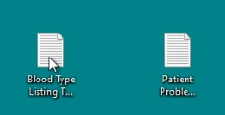  - Time of the last backup is displayed at the top left of the screen. Patients are listed alpahabetically and can be searched.  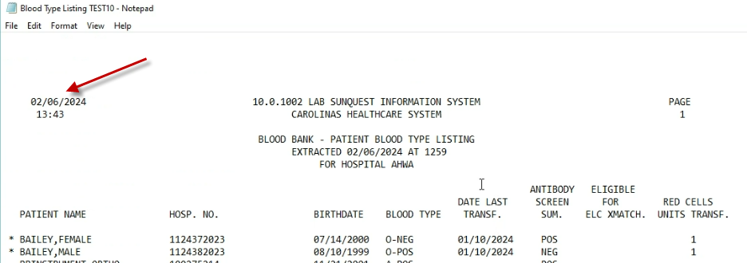  - When searching, ensure you have you cursor at the top of the document as the search allows you to search ‘up’ or ‘down’. Go to file > Find enter name and find next.  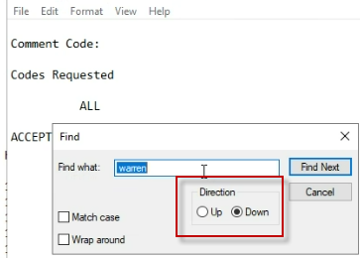  - An asterisk next to the name indicates there is more information on this patient in the Patient Problem Summary. You must also open this file and search for the patient.  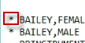  - Open the Patient Problem Summary and View Antibody/Antigen, and other important information.  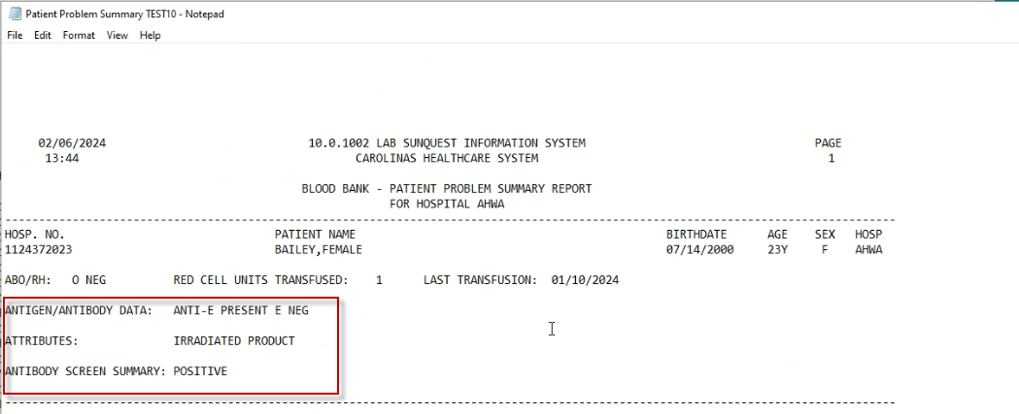  3.2 If the patient has information document on the requisition.
4.0 | Take the request to the appropriate bench to process the order.
5.0 | Place all requisitions that were received and processed during downtime together in a separate location until the computer is available again.
6.0 | After the computer comes up, receive all samples/component orders in Epic using the “Receive Downtime Worksheet” information.
7.0 | Initial on the “Receive Downtime Worksheet” when the order has been accessioned.
8.0 | Result all downtime tests in the computer after the order is received.
9.0 | Allocate any components that were ordered on downtime.  9.1 Perform any component prep functions that were done on downtime.  9.2 Perform label verify (check) in BB LIS/manually as per SOP.  9.3 If units were issued on downtime, select and issue in the computer from the  Downtime sign-out sheet.
10.0 | Place the completed “Receive Downtime Worksheet” in the emergency downtime tray.

- Downtime/ Emergency: Issue and Return
STEPS | INSTRUCTIONS
1.0 | When a Blood Bank Issue form is received, retrieve the requisition for the patient.  - Carefully match the patient information on the Issue form with the requisition.  NOTE: In an emergency when NO patient information provided:  - Patient Name or MRN may not be known to the person picking up products.  - Do not press person picking up blood in an emergency situation.  - Request name of person picking up and location of patient.  - Provide Group O packed cells/WB immediately and log whatever information has been obtained.
2.0 | Select the appropriate product from the refrigerator or platelet incubator.  - 2.1 If the patient has more than one unit available, choose the shortest date from the available units.
3.0 | Follow all policies and procedures for checking patient/unit information and product inspection at issue.  Refer to BB-SOP-0056: Blood And Blood Product Issue
4.0 | Sign out the units on the “Emergency/Downtime Sign-Out Sheet”.  4.1 The sign-out sheet is located on a magnetic clipboard attached to the file cabinet.  4.2 Record the cooler ID and insert temperatures if used on issue slip.
5.0 | If units are returned during downtime, document on the “Emergency/Downtime Sign-Out Sheet” in the Return columns.  5.1 Follow all policies for return of products.  BB-SOP-0160: Unit Status/Disposition BB LIS  BB-SOP-0056: Blood And Blood Product Issue  5.2 Use the appropriate return code for Reason.  5.3 Place returned red cells or plasma on the Component Prep Pending shelf in  refrigerator pending return in the computer.  5.4 DO NOT place on the inventory shelf until the return has been documented in  the computer.  5.5 Place returned platelets on a shelf labeled for downtime returns in Platelet  Rotator #1until completed in the computer.
6.0 | After the computer comes up, perform all issues in BB LIS using the information on the “Emergency/Downtime Sign-Out Sheet”.  6.1 Initial on the downtime sheet when each issue has been done.
7.0 | Return any products in the computer in BB LIS using the information on the “Emergency/Downtime Sign-Out Sheet”.  7.1 Initial on the downtime sheet when the return is completed in the computer.  7.2 Move the returned products to their appropriate locations after update.
8.0 | File the completed downtime sheet in the downtime emergency tray.

IV: Emergency/ Downtime: Blood and Blood Product Log-in
STEPS | INSTRUCTIONS
1.0 | Obtain a “Downtime Donor Testing Worksheet”.  - Print from T21 or worksheets are located in the Downtime folder in the Forms drawer.  - Additional copies can be made as needed using the form in the Master Forms book.
2.0 | Record all the unit information on the worksheet.  - Always use barcode stickers when available.  - Remove labels and place on worksheet and tubes one unit at a time.  - If barcode stickers are not available, manually write the unit number.  - Always record Ecode to distinguish pheresis red cell and plateletpheresis since unit number will be the same.
3.0 | Perform required regroup testing on blood and granulocytes.  BB-SOP-0014: Blood Product Entry  3.1 Record the testing results and interpretation on the worksheet.  3.2 Compare testing results on worksheet to unit ABO/Rh label.  3.3 Attach “Blood Group Confirmed” downtime stickers to all units after testing.  Blood Group  Confirmed By  WFUBMC
4.0 | After the computer comes up, enter the units in BB LIS from the downtime sheet.  4.1 Verify the units received from the shipping document have been accounted for  on the downtime sheets.
5.0 | In BB LIS enter the testing results for each unit from the worklist.  5.1 Initial on the worksheet when all information is entered into the computer.
6.0 | File the completed worksheets in the emergency downtime tray.

V: Downtime/Emergency: Type & Screen, Crossmatch and Other testing

STEPS | INSTRUCTIONS
1.0 | Perform all testing according to the standard procedures.  - Emergency requests for blood and products must be done manually at the bench.  - Routine testing can be done on analyzers using the downtime procedure.  - Analyzers results will not export to LIS when BB LIS is down.  - Downtime automation results are to be recorded on the requisition from the instrument printout of results.  - Print each patient/test on a separate instrument printout.
2.0 | Electronic crossmatch is not available when the computer is down.  2.1 All crossmatches for patients with negative antibody screens and no prior  antibody history must be done manually by immediate spin at Room  temperature.  Refer to BB-SOP-0007: Crossmatch Procedures  2.2 Patients with positive screens or prior antibodies should be crossmatched  according to protocol.  Refer to BB-POL-0035: Crossmatch Protocols  2.3 Write all units and crossmatch results on the requisition.
3.0 | Obtain blank unit tags from the printer.  3.1 Carefully fill out all required information, including Blood Bank ID number,  E code, Unit number and unit division if a divided unit from tube of blood.  3.2 Verify information on unit tag to tube of blood and blood product.  3.3 Attach the completed tags to the crossmatched units.  3.4 Store units crossmatched on downtime in the Crossmatched refrigerator as usual.
4.0 | When the computer comes up, enter the results for all testing done on downtime.  4.1 Select any units crossmatched.  4.2 Record the IS XM for negative antibody screen patients in the computer.  4.3 Record the IS and IgG XM for patients with positive screens or prior antibodies.  4.4 Enter any unit antigens as needed.  4.5 Manually note on the requisition testing rack/instrument used.
5.0 | Issue any blood that was issued on downtime.  See II: Downtime/Emergency: Issue and Return

VI: Downtime/Emergency: Component Preparation
STEPS | INSTRUCTIONS
1.0 | When products are requested during downtime which require any processing, record the patient information and the component prep done on the “Component Preparation Downtime Worksheet”  1.1 Record component function in the Component Prep Done blank.
2.0 | Perform the component prep on the unit.  2.1 Record all information as usual on the CP worksheets.
3.0 | Obtain a blank unit tag from the printer.  3.1 Carefully fill out all the required information, including Ecode in product column  and the division number if it is a divided unit from the unit bag.  3.2 Verify information from Blood Bank requisition.  3.3 Attach the unit tag to the unit.
4.0 | Complete manual label check.  Refer to BB-SOP-0040: Label Check  4.1 Check on the downtime worksheet when the label check is done.
5.0 | Store the unit in the appropriate location for the product as usual prior to issue.
6.0 | When the computer comes up, perform the component prep functions in the computer using the downtime worksheet.  6.1 Perform component prep in BB LIS.  6.2 Label verify the unit in the computer to make the unit available for allocation.  6.3 Select the unit to the patient on the downtime worksheet.  6.4 Initial the worksheet when all functions and checks have been performed in the  computer.
7.0 | Issue the unit using the downtime worksheet.
8.0 | Place completed worksheets in the downtime tray.

Literature References:

Related Procedures/Policies in Navex:

Attachments/Linked Documents in Title 21:

BB-FORMS-0049: Component Preparation Downtime Worksheet
BB-FORMS-0050: Downtime Donor Testing Worksheet
BB-FORMS-0051: Downtime Specimen Receipt Worksheet
BB-FORMS-0054: Emergency/Downtime Sign-Out Sheet
BB-FORMS-0128: WFBH Blood Bank Downtime Requisition
BB-FORMS-0215: Transfusion Product Tag
BB-FORMS-0216: Label Check Tag
BB-SOP-0007: Crossmatch Procedures
BB-SOP-0014: Blood Product Entry
BB-SOP-0040: Label Verify (Check)
BB-SOP-0053: Specimen Labeling and BBID Numbers
BB-SOP-0056: Blood And Blood Product Issue
BB-SOP-0160: Unit Status/Disposition BB LIS
BB-POL-0035: Crossmatch Protocols
Attachment: Downtime Processes
Attachment: BB LIS Patient Data Backup

Revision Dates: Review Change Summary as represented in Title 21.

