Applicable Laboratory(s)):

☒ North Carolina Baptist Hospital (NCBH)
☐ Lexington Medical Center (LMC)
☐ Davie Medical Center (DMC)
☐ Wilkes Medical Center (WMC)
☐ High Point Medical Center (HPMC)
☐ Westchester
☐ Clemmons

Policy Purpose

The purpose of this policy is to delineate the responsibilities for shifts/rotations so that employees are aware of the tasks designated to ensure that workload flows smoothly within the department. Employees are expected to maintain an awareness of workload within the department and assist other rotations and shifts as needed

Scope

This policy applies to all Department staff/management
Protocol owner/Implementer: Julie H. Simmons
Protocol prepared by: Pat Sarvis

Definitions

- Policy: As defined in the Policy on Creating and Amending Policy, a statement of principle that is developed for the purpose of guiding decisions and activities related to governance, administration, or management of care, treatment, services or other activities of WFBH. A policy may help to ensure compliance with applicable laws and regulations, promote one or more of the missions of WFBH, contain guidelines for governance, and set parameters within which faculty, staff, students, visitors and others are expected to operate.
- WFBH Lab System: Wake Forest Baptist Lab System is a health system that includes Wake Forest Baptist Medical Center and all affiliated organizations including Wake Forest University Health Sciences (WFUHS), North Carolina Baptist Hospital (NCBH), Lexington Medical Center (LMC), Davie Medical Center (DMC), Wilkes Medical Center (WMC), High Point Medical Center (HPMC), Lab at Westchester and Lab at Clemmons.
- IDR: Inventory Disposition Report
- Sunquest: Blood Bank Computer System
- FD/CP: Front Desk/Component Preparation
- CNP: Critical Needs Person
- PCW: Patient Caution Window

Policy Guidelines

- General Responsibilities for ALL SHIFTS, all rotations
- Obtain handoff instructions from previous shift. This communication means that you listen to the person working the position before they leave the shift.
- Review BB Communication Calendar at start of shift and emails/mailboxes if workload permits.
- Take over any work that previous shift has in progress. Discuss any problems before the shift leaves.
- Answer phone calls, direct (preferably within the 1st 3 rings) and appropriately.
- Complete any testing on the bridge. Non-stat samples may be left for subsequent shift to complete if staffing and/or workload prohibits their completion.
- Prepare Component Prep orders as requested.
- Complete Inventory processing and performance of Unit ABO Rechecks. This is the responsibility of ALL techs. Anyone who has the opportunity should complete these tasks.
- Maintain an awareness of workload in other areas so that assistance can be provided when needed, covering for breaks and or meals.
- Unpack and process reagents. Perform Receipt Testing as needed.
- Prepare Trauma blood/Emergency Release blood as needed.
- Prepare offsite coolers for AirCare, Davie Medical Center, Clemmons, etc.
- Perform unallocated unit search weekly. (Assigned)
Refer to Unallocated Unit Search clip board on refrigerator near tube station
  - Run Inventory summary report (or use Blood Bank Inventory supplier search for allocated units.)
- Open SmarTerm
- Device Location: WIN
- Enter Access Code and Password
- Function: BBR
- Printer: 9324 (or 9330 (CP) 9331 (offices))
- Select Option: 13 (Inventory Summary)
- Hospital: AHWA
- Area: WIN
- Follow prompts to accept, modify or reject
- Component Type/Group: “RC” for red cell group
- Follow prompts to accept
  - Check total number on report against units in the crossmatched refrigerator
  - Resolve any discrepancies encountered.
  - Initial/date Unallocated Unit Search log sheet posted on the refrigerator near tube station once complete
  - Document discrepancies leave in the manager's box.
- Complete all shift specific tasks on Daily QC Check List
Refer to Attachment 3: Daily Component Preparation Checklist; Weekly/
Monthly CP Checklist
Refer to Attachment 4: Daily Quality Control Checklist
- Complete Weekly/Monthly QC Check List tasks
Refer to Attachment 3: Weekly/ Monthly CP Checklist
Refer to Attachment 4: Weekly QC Checklist
- Request service or maintenance needed or completed by outside departments, document request on the appropriate form and store in the appropriate equipment manual.
- Follow the below work accountabilities:
  - Patient workload first priority
  - Assist others with tasks at other workstations if necessary
  - Complete shift tasks to be performed on a different shift.
- Quality Control and Maintenance Tasks
d. 4 Complete interruptible tasks:
- SCAN checks
- Condition cooler inserts/lids/panels/bricks
- File antibody IDs that have been reviewed
- Irradiate A pos/O pos packed cells if <20 irradiated
- File reviewed QC documents in appropriate folder in irradiator room
- Restock work areas/pipette tip containers
- Put up supplies
e. Assume any incomplete tasks designated to a specific shift.
17. Perform Quarterly QC duties as assigned.
Refer to Attachment 5: Monthly, Quarterly, Semi-Annual and Annual QC Schedule
18. Comply with all safety requirements by wearing appropriate PPE, disposing of waste
appropriately, etc.
19. Run pending log at end of shift and reconcile.
- Open and Log in to SmarTerm
- Function: PL
- Printer: 9324 (or 9330 (CP) 9331 (offices))
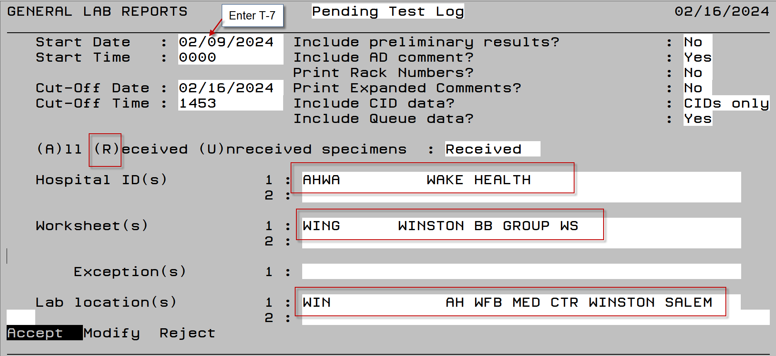
20. Follow the below rotation assignments when staffing levels are at their minimum

 | First Shift | Second Shift | Third Shift
 | - XM | XM | - FD (CP)
 | Vision 1 (V1) | Vision 1 (V1) | - Vision 1(CP)
 | - Vision 2 (V2) | - Vision 2 (V2) | - Vision 2 (CP)
 | - FD | - FD
 | - CP | - CP
 | FD/CP | CNP
Minimum Staffing Level | 6 | 5 | 3

- Front Desk, FD/CP, CNP Responsibilities
- General FD, FD/CP. CNP Responsibilities, all shifts
  - Receive all specimens as detailed in Specimen Receipt in Epic
Refer to BB.SOP.0054
- For Delayed XM:
  - Change the expiration date of the specimen to the day of surgery in Sunquest
  - Place blue tape on the specimen to indicate that it is a Delayed XM specimen and will have to be stored in the Delayed XM rack
  - Issue and Return all blood and blood components as detailed in Blood and Blood Product Issue
Refer to BB.SOP.0056
  - Process any orders for components (platelets, plasma, cryo) as received, deliver to CP area to be filled.
- Document your initials / historical blood type / date of last blood type (must be within the last 12 months) on component requisition
Refer to BB.SOP.0053
- Designate any special requirements as per PCW
- For Transfuse Neonate orders:
- Find most recent TSX for BBID verification
- Add unit to TSX order if needed
  - Answer telephone
- Best practice is to answer within the first 3 rings.
- Request phone be answered by coworker if unable to answer due to workload
  - Prepare cooler inserts/lids/panels/bricks
  - Monitor BBFront emails for notifications of special order blood, merges, name changes/updates and cooler alerts.
  - Track Blood Coolers as needed.
  - Monitor door entrance.
- FD/CP, CNP specific responsibilities (1st, 2nd shifts)
  - Assist, perform all FD and CP tasks as needed
  - Process blood/blood products/reagents
  - Restock, maintain remote refrigerators
- 1st shift: print remote refrigerator inventories, assess restocking and returning needs
Refer to Attachment 1: Generating ED Emerge Reports
- 1st shift: Take clipboard and fill out all areas of Emergency Blood Fridges Daily Weekly Monthly Tasks checklist when restocking / maintaining remote refrigerators.

- Component Prep Responsibilities
- General Responsibilities, all shifts
  - Complete Daily/Weekly/Monthly Component Prep checklist tasks
    - Verify that checklist is complete and complete any tasks necessary from previous shift.
Refer to Attachment 3: Daily Component Preparation Checklist; Weekly/Monthly CP Checklist
  - Review platelet inventory and order extra platelets as needed.
Refer to Blood Product Order Protocol
  - Perform preparation and modification of any and all components as ordered
  - Help Front Desk

D. CP Shift SpecificTasks
Shift | Component Prep Shift Specific Tasks
1st | - Consult with Medical Director or pathologist resident for Special Order Platelets and order as needed.  - Weekly: Print Visual Inspection Failures and turn in to management  • Open SmarTerm  • Device Location: WIN  • Enter Access Code and Password  • Function: BBR  • Printer: 9324 (or 9330 (CP) 9331 (offices))  • Select Option: 21 (Visual Inspection Failures)  • Hospital: AHWA  • Follow prompts to accept the report  • Enter Start Date: T-7  - Enter End Date: Today  • “A” Accept
2nd | - Consult with Medical Director or pathologist resident for Special Order Platelets and order as needed.  - Check pediatric cardiothoracic surgery list of patients on OR schedule for following day and make sure platelets are set aside for each patient
3rd | - Check pediatric cardiothoracic surgery list of patients on OR schedule for following day and make sure platelets are set aside for each patient  - Print a list of pediatric cardiothoracic surgery patients and place in CP area. Pull the schedule  - Order blood if necessary.  - Assign fresh (<5 days old) RBCs for patients for 7am OR.  - If fresh blood is not available refer to BB.PROTOCOL.1006.3  - Check cardiothoracic surgery list for thoracoabdominal aneurysm repairs(TAAA).  Place patient on BB Calendar.  - Obtain Short dated report  - Perform blood inspection, place orange short  date sticker on all units expiring within 5 days  - Check the age of the Neonate, ECMO and Pediatric Cardiothoracic Surgery units.  - Move the pediatric cardiothoracic surgery units that are greater than 5 days old to the Neonate/ECMO side of the shelf  - Move the Neonate and ECMO units that are too old to regular inventory:  - CPDA-1 units greater than 7 days old  - AS-3 units greater than 10 days old  - Change Segment Bags  - Complete all blood processing for the day  - Remove segment bag from metal container in Processing area  - Place in refrigerator in numerical sequence.  - Segments are kept for 56 days,(2 weeks past the last possible date of transfusion)  - Remove the next bag in sequence.  - Empty the segments into a lined trashcan.  - Write the next day's date on bag tape label.  - Place the bag in the metal container in the Processing area  - Take temperatures of equipment  - Communicate with 1st shift if not completed by end of shift

- Vision (V1/V2) Responsibilities
  - Run Daily Quality Control and Daily/Weekly/Monthly Maintenance
1.1 Vision 1(1st shift)
1.2 Vision 2 (2nd shift)
  - As needed on any shift
- Perform testing on V1 and V2.
  - Run all samples in the STAT and ROUTINE racks on instrument including but not limited to
- Samples with no prior history
- Samples with a history of negative antibody screen
- Samples in Prev Antibody rack if, based on antibody history, if routine screen will result in at least 1 negative cell.
  - Crossmatch required, ag negative units when antibody(ies) is/are present
  - Keep open communication with XM tech about samples being placed on bridge that cannot be completed on the instrument
  - Document ABO/Rh interpretation and antibody screen interpretation on the BB requisition.
- This information is especially helpful when there is a computer downtime and blood needs to be issued..
e. Provide XM with screen / panel antigrams and Green Sheet with completed patient test documentation when new antibody samples are placed on bridge for further testing.
f. Perform and complete antibody identifications and work-up on any specimens with a positive antibody screen as per SOP.
  - Assist XM tech as needed.
- Select units for patients using electronic XM
  - Perform OB selected screens and subsequent titer testing on samples with known antibody
history on the instrument,
      - Places sample and workup on bridge for XM tech if multiple OB titrations are needed or if a titer needs be done with cells other than current lot of 0.8% Ortho screening cells.
      - Communicates to XM that sample needs further testing.
  - Store samples in appropriate racks in refrigerator
- Routine and disqualified delayed samples in current day’s rack
- Acceptable Delayed samples in DELAYED RACK in DOS row.
  - File completed requisitions alphabetically by last name in front box.
- File completed, acceptable delayed XM requisitions in Delayed Box by DOS
  - Triage Electronic XM’s, ABO Rechecks and Delayed XM’s needing PCW comment and calendar entry to the bridge for XM to complete during periods of heavy workload.
  - Replenish instrument liquids, reagents and cards, empty waste bottle and card waste as required
  - Troubleshoot Vision Max - call Ortho for service if necessary.
  - Assist with other tasks as necessary due to workload such as donor testing, STAT manual testing, etc.

- Crossmatch: All shifts—general guidelines
  - Perform testing on samples placed in Antibody/Manual rack on instrument or manually
  - Assess complexity of antibody work-up
- Run sample on instrument or communicate to V1/V2 techs that the sample is suitable for testing on the instrument
- Allocate appropriate units in Sunquest if XM to be run on instrument.
- Load, start and complete antibody specimens on instrument when V1/V2 techs cannot.
  - Document applicable ABO/Rh interpretation, antibody screen interpretation, units crossmatched with results, DAT results on the BB requisition.
- This information is especially helpful when there is a computer downtime and blood needs to be issued
  - Document test results on Green Sheet, screen / panel antigrams, and on any other forms used while performing testing on specimen.
  - Perform required manual testing when samples cannot be run/completed on instrument
  - Act as point person to clean up Traumas, Emergency Releases and MTP’s unless otherwise communicated with co-workers.
  - Perform OB selected screens and subsequent titer testing on samples with known antibody
history on the instrument, or manually.
  - Identify antibodies in patient specimens
  - Order special antigen negative units as needed
  - Complete any testing on the bridge. Non-stat samples may be left for next shift to complete if staffing and/or workload prohibit their completion.
  - Complete transfusion reaction work-ups. Copy/File and Send completed documents to Medical Records as described in Transfusion Reaction folder.
  - Complete documentation of, review of genotype results in Sunquest. Copy/File and Send completed documents to Medical Records as described in DNA Genotype folder.
  - Process blood as needed. Perform donor testing as needed.
  - Complete shift specific tasks on Daily Quality Control Checklist and initial completion. If tasks from previous shift are not completed, then complete on next shift.
- 1st shift XM
- 2nd shift XM
- 3rd shift V2
  - Complete tasks on Weekly Quality Control Checklist – any shift

G. Crossmatch Shift Specific Tasks
Shift | Crossmatch Shift Specific Tasks
1st | - Perform Blood Inventory before 8am and order blood products as needed based on optimal inventory levels.  - Red Cell Inventories only  - Work with students: Give assignments, administer tests, prepare samples, answer questions (1st shift)  - Consult with Specialist Tech as needed.  - Verify completion of the following tasks with 3rd shift, complete any outstanding tasks  - QC Reagents  - Temps and Alarms  - Blood Inspection  - Expired Products/Reagents/Supplies
2nd | - Perform Blood Inventory before 2:30pm (done by 1-9pm person if present) and order blood products as needed based on optimal inventory levels.  - Red Cell, Plasma and Cryo Inventories  - Run Report for patients for whom units allocated is greater than units ordered  - Open SmarTerm  - Device Location: WIN  - Enter Access Code and Password  - Function: BBR  - Printer: 9324 (or 9330 (CP) 9331 (offices))  - Select Option: 14 (Patient/Unit Pending Log)  - Hospital: AHWA  - Follow prompts to accept the report  - Worksheet: WING  - “A” Accept  - ?: 3  - “A” Accept  For each accession number listed, go in to BOP and update the UO to match the number under the UA column  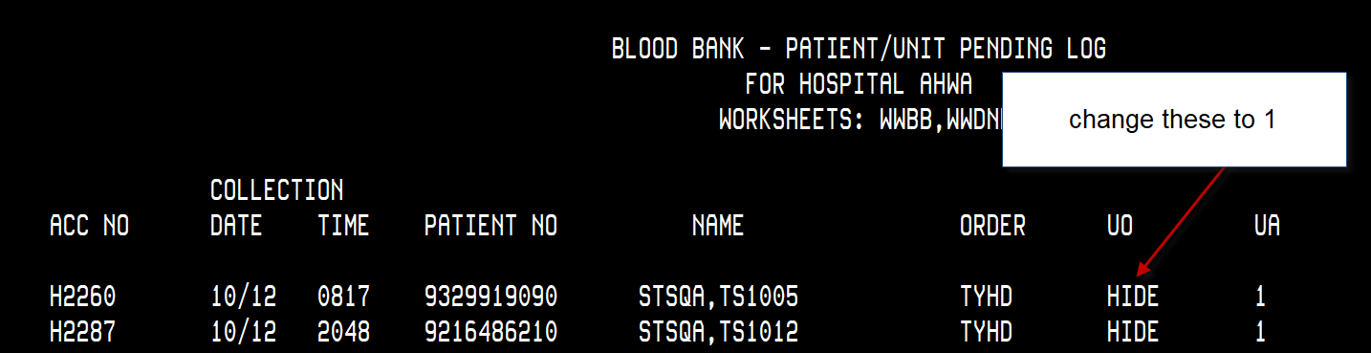  File the report with daily pending logs.
3rd | - Perform Blood Inventory before 10pm if possible and order blood products as needed based on optimal inventory levels.  - Check Special Order book and make sure all patient specific units are available and antigen negative units are correct on blood from 10pm delivery  - QC Reagents  - Temps and Alarms  - Blood Inspection  3. Reconcile Expired Products/Reagents/Supplies to Expired Products report and BB communication calendar.  - Confirm units have been properly dispositioned on Unacceptable Unit Disposition form.

- Reference Bench
- Work at designated Reference bench
- Perform Consultation work as requested by management.
- Complete complex work-ups as delegated to Reference by V1/V2, XM and or management including but not limited to:
- Elutions
- Adsorptions
- Chemical treatments
- Clearly communicate with Reference Tech on next shift tasks that need to be completed.
- Assist techs at XM as a second XM tech when no complex work-ups are pending.

- Other Third Shift Specific Tasks
- During 2nd / 3rd shift overlap
  - Check in with your assigned rotation 2nd shift counterpart to receive communication
  - Do blood inspection on Biofridges and check dates on plasma.
  - Pull expiring crossmatch slips, prenatal slips, etc. to be filed after MN
  - Check delayeds.
  - Check special order book to see what we are expecting on 10pm.
  - Check pediatric cardiothoracic surgery schedule.
  - Temps, balance QC, and begin irradiating/processing.
- After Midnight (Daily)
- Print the Expired Crossmatch List
- Open SmarTerm
- Device Location: WIN
- Enter Access Code and Password
- Function: BBR
- Printer: 9324 (or 9330 (CP) 9331 (offices))
- Select Option: 1 (Expired Crossmatch list)
- Hospital: AHWA
- Location: WIN
- Follow prompts to accept the report
- Always have the report IN HAND before proceeding to BEC
  - Release the Blood from the Expired Crossmatches physically
- Pull all the units listed as SELECTED on the Finished Product Report from the Crossmatched refrigerator shelves
- Remove the patient tags and BBID stickers and patient label sticker from back of units.
- Place the released units in the Uncrossmatched refrigerator in order of expiration.
- File the report in the Finished Product tray on the shelf over extra FD desk to left
- Check selected/issued product orders on expired TSX report and repeat steps above.
  - Release the blood from the Expired Crossmatches in the BB LIS
- Open SmarTerm
- Device Location: WIN
- Enter Access Code and Password
- Function: BEC
- Hospital: AHWA
- Location: WIN
- Follow prompts to release units
  - Print the Issued, Unreported, Product List (Presumed Transfused Report)
- Open SmarTerm
- Device Location: WIN
- Enter Access Code and Password
- Function: BBR
- Printer: 9324 (or 9330 (CP) 9331 (offices))
- Select Option: 5 (Issued, Unreported Product List)
- Hospital: AHWA
- Area: WIN
- Follow prompts to accept, modify or reject
- Component Type/Group: “Enter” for all
- Follow prompts to accept
- File report with presumed transfused reports.
e. Pull the ED Emerge Daily Report and verify units cleaned up.
Refer to Specials: SCC Reports and Labels
f. Print the Expired Products Report.
- Open SmarTerm
- Device Location: WIN
- Enter Access Code and Password
- Function: BBR
- Printer: 9324 (or 9330 (CP) 9331 (offices))
- Select Option: 4 (Expired Blood Product List)
- Hospital: AHWA
- Area: WIN
- Follow prompts to accept, modify or reject
- Component Type/Group: “Enter” for all
- Follow prompts to accept
- Pull the expired products from inventory and check off report.
- Check the QC shelf for any units that expired prior to midnight and check off report.
- Obtain any platelets that expired and check off report.
- Verify units are in a discard status in computer and physically discard.
- Request credit in BloodHub for any CDIEs. Note on form.
- Initial and date report and place in expired products notebook.
- Investigate any discrepancies and write QA if unable to resolve.
- File report in Expired Blood Products Binder (Do not discard this report. At the end of the month turn in to management)
  - Expire the units in BB LIS system
- Open SmarTerm
- Device Location: WIN
- Enter Access Code and Password
- Function: BEU (Outdate Expired Blood Product Unit Request)
- Hospital: AHWA
• Area: WIN
• Follo • Component Type/Group: “Enter” for all
• Follow prompts to accept
- Outdate Units Expired As of their Expiration Times Today: Y
  - After ALL coolers have been returned that are out to the floors from the previous day, Issue final all blood products.
- Open SmarTerm
- Device Location: WIN
- Enter Access Code and Password
- Function: BIF (Blood Issue Finalization)
- Hospital: AHWA
- Area: WIN
- Component Type/Group: “Enter” for all
- Follow prompts to accept
- Blood Product Unit Issues to the finalized. Confirm: Y
- If a unit comes back after BIF has been completed. Give to tech/management with admin privileges to have status updated in Blood Status Correction.
  - Check the BB Communication Calendar for expired reagents and supplies.
- Move or discard expired reagents/supplies
- Add follow-up comment to BB Communication Calendar. (example, “moved to student fridge,” “discarded,” “QC shelf for training,” etc.)
  - Back up patient data on two designated computers (daily)
Blood Bank Reports for Sunquest LIS Downtime
- BBR 6 Patient Problem Summary
Updated and saved daily on PCs in the blood bank. This is used in the event of a LIS downtime to perform history checks.

STEP | ACTION
1 | Login to SmartTerm
2 | Function: BBR
3 | Printer: 0 to pull the report to the computer instead of printing
4 | “6” then enter
5 | HID: AHWA
6 | “A” to accept
7 | Comment Code: enter to select all
8 | Select “Tools” on the toolbar menu
9 | Select “Start Capture”
10 | Locate from the desktop and select the folder “Patient Problem Summary”  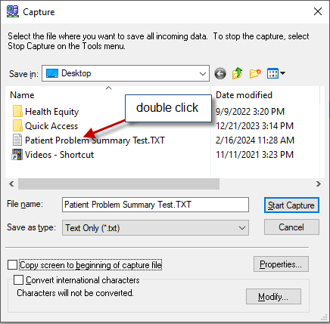
11 | Select “overwrite” when notified that this file already exists  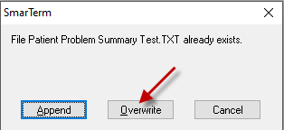
12 | Enter “A” to accept and the report will pull to the screen
13 | Select “Tools” on the toolbar menu once report is complete
14 | Select “Stop Capture”

- BBR 15 Patient Blood Type Listing
Updated and saved weekly on PCs in the blood bank. This is used in the event of a LIS downtime to perform history checks.
STEP | ACTION
1 | Login to SmartTerm
2 | Function: BBR
3 | Printer: 0 to pull the report to the computer instead of printing
4 | “15” then enter
5 | HID: AHWA
6 | Select “Tools” on the toolbar menu
7 | Select “Start Capture”
8 | Locate from the desktop and select the folder “Patient Blood Type Listing”  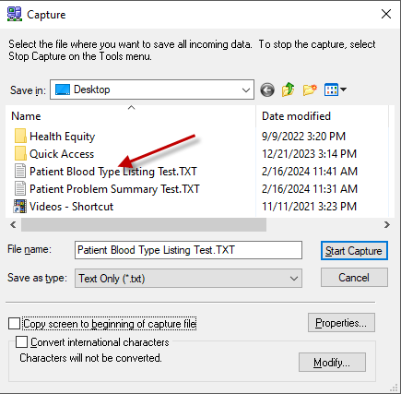
9 | Select “overwrite” when notified that this file already exists  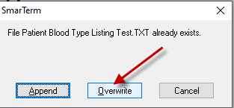
10 | Enter “A” to accept and the report will pull to the screen
11 | Select “Tools” on the toolbar menu
12 | Select “Stop Capture”

- Weekly:
      - perform Component Inventory Reconciliation as per SOP.

Attachment 1: Generating ED Emerge Reports

- Inventory Report
- Select REPORTS icon from Blood Track
- Click on Inventory
- Click on Generate at bottom of screen
- Select location using the drop down arrow at top
- ADULT ED FRIDGE > click Print at bottom of screen
- LND FRIDGE > click Print at bottom of screen
- PEDS-FRIDGE > click Print at bottom of screen

- Emergency Blood History Report

  - Select REPORTS icon from Blood Track.
  - Select Emergency Blood History.
  - Generate
  - Edit date range to dates needed
  - Click OK.
  - Report displays all units removed from the ED Fridge.
  - Print report which can be used to make sure units are issued in SCC.

- Storage History Report

- Select REPORTS icon from Blood Track (ED Emerge).
- Double Click on Storage History.
- Select from drop down box the location for storage history.
  - Adult FRIDGE
  - Peds FRIDGE
- Click on Date Range. The default is 7 days.
  - Enter yesterday’s date as the start date with the format DD-MMM-YYYY.
  - Enter today’s date as the end date with the format DD-MMM-YYYY.
  - NOTE: MMM is first three letters of the month.
  - Click OK.
- Click Print.
  - Select Printer.
  - Click OK.

Attachment 2: Monthly Logs/Worksheets and locations.
WORKSHEET | LOCATION | DISPOSITION
Rejection Log | Binder at FD | Give to management at end of month
Wastage Log | Binder at FD | Give to management at end of month
Antigen typing Worksheets (manual) | Binder over processing | Reviewed at end of month.  Kept 10 years
MTP log | Saved file on BB Monitor | NA
Rare Antisera QC | Clipboard on Sera 5 | Reviewed at end of month.  Kept 10 years
Sterile Docking log | Clipboard in CP | Reviewed at end of month.  Kept 10 years
Cobe CP log | Cobe/IBM work area | Reviewed at end of month.  Kept 10 years
QC checklist | Clipboard by XM1 | Give to management at end of month
Daily Temp recording logs | Clipboard in hang tray by XM1 | Reviewed at end of month.  Kept 10 years
Special Order forms | Special Order binder at processing | NA
Presumed Transfused Reports | Tray over FD left current month | File previous month(s) in current year – Box in irradiator room
Downtime issue sheets | Tray over secretary desk | Keep 2 months
Transfusion Rxn log | Binder in Processing area | Give to management at end of year.
Pending log | Binder at processing | Keep 1 month
Expired products report | Binder at processing | Give to BB management at the end of the month
Unacceptable Unit Disposition Log | Binder at processing | Keep 3 months
Plt Inventory | Binder in CP | Keep 1 month.
Component Products Received | Binder in CP | Keep 1 month. Discard previous month.

References

Literature References:

Related Policies/Procedures in Navex:
Customer Service Power Point

Attachments/Linked Documents in Title 21:

Attachment 1: Procedure for Generating ED Emerge Storage History Report
Attachment 2: Monthly Logs/Worksheets and locations
Attachment 3: Daily/Weekly/Monthly Component Preparation Checklist
Attachment 4: Daily/Weekly Quality Control Checklist
Attachment 5: Quarterly/Semi-annual/Annual Checklist
Attachment 6: How to Print the Inventory Disposition Report
Attachment 7: Unacceptable Unit Disposition Log

Revision Dates: Review Change Summary as Represented in Title 21.

