Applicable Laboratory(s)):

☒ North Carolina Baptist Hospital (NCBH)
☐ Lexington Medical Center (LMC)
☐ Davie Medical Center (DMC)
☐ Wilkes Medical Center (WMC)
☐ High Point Medical Center (HPMC)
☐ Westchester
☐ Clemmons

Procedure Statement

The purpose of this policy is list exceptions generated by SCC. Also when and which actions trigger each one.

Scope

Protocol owner/Implementer: Blood Bank Management
Protocol prepared by: Julie Jackson
Who performs protocol: Department staff/management

Definitions

- Policy: As defined in the Policy on Creating and Amending Policy, a statement of principle that is developed for the purpose of guiding decisions and activities related to governance, administration, or management of care, treatment, services or other activities of WFBH. A policy may help to ensure compliance with applicable laws and regulations, promote one or more of the missions of WFBH, contain guidelines for governance, and set parameters within which faculty, staff, students, visitors and others are expected to operate.
- WFBH Lab System: Wake Forest Baptist Lab System is a health system that includes Wake Forest Baptist Medical Center and all affiliated organizations including Wake Forest University Health Sciences (WFUHS), North Carolina Baptist Hospital (NCBH), Lexington Medical Center (LMC), Davie Medical Center (DMC), Wilkes Medical Center (WMC), High Point Medical Center (HPMC), Lab at Westchester and Lab at Clemmons.
- SCC: Soft Computer Consultants. The Blood Bank/Transfusion Services computer system for all sites of WFBH Lab System that have a Blood Bank/Transfusion Service.

Policy Guidelines

- QA Warnings are generated when an action performed in Sunquest is outside of the normal procedure or abnormal results and needs an explanation as to the circumstances of the action. This includes, but is not limited to, Issuing products, Emergency issuing products, Selecting products, Resulting patient testing, etc…
- Examples would include:
- When a Rh positive red cell unit is issued to a Rh negative patient
- Antigen positive or untested blood is selected to a patient with a clinically significant antibody.
- Emergency issue of red cells before XM testing is completed.
- QA warnings must be answered, they cannot be bypassed.
  - Reason Codes are available that may be used.
  - If tech cannot find the appropriate reason, use BBR (Blood Bank Reason) and free text in the explanation.
- When a warning is triggered, there is information in the box pertaining to the issue.
  - In the following example, a units of blood is emergency issued to a patient that that requires irradiated, HgbS negative units, but the unit is not registered as IRR or SDNEG.
  - The first warning is triggered at allocation. You must acknowledge the warning.
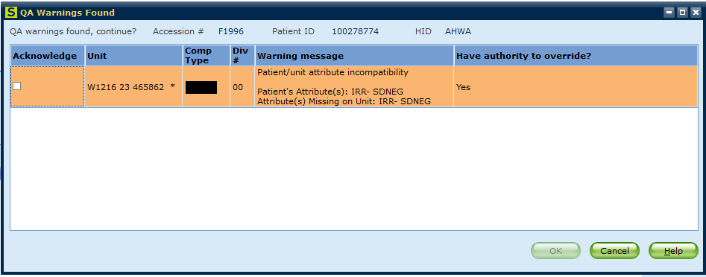
  - When you click save you will be prompted to override the QA warning.
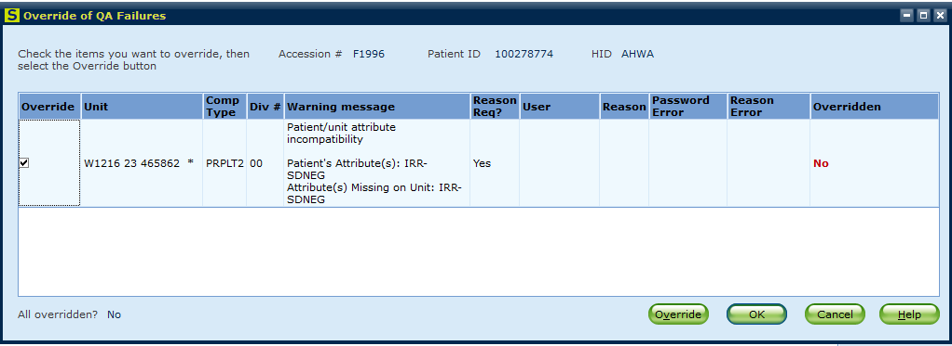
  - Ensure that you thoroughly read the Warning message. If you do not understand the meaning of the QA warning, consult management before proceeding.

- QA Warnings are reviewed by Blood Bank Management routinely.

  - Print the Quality Assurance Report
- Open and log in to SmarTerm
- Function: BBR
- ?: 7 (Quality Assurance Report)
- Hospital ID: AHWA
- Area: WIN
- Accept (A), Modify (M), or Reject (R): A
- Location: WIN
- Accept (A), Modify (M), or Reject (R): A
- ?: F (for full report)
- Start Date: T- # (Only 8 days are kept)
- End Date: Enter (Today)

  - This report should be printed daily M-F and ensure that ALL days have been printed and reviewed.

  - Staple report, review, initial, and file in Quality Assurance Report Binder.

  - Management will investigate any questionable QA Warnings.

  - Example: QA Warning for “Patient/unit attribute incompatiblilty”
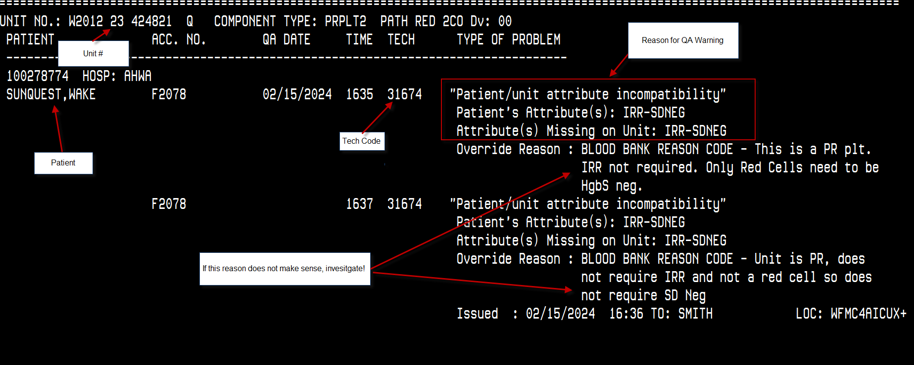

Related policies/procedures

Attachments/Linked documents (title 21)

Revision Dates: Review Change Summary as represented in Title 21.

