Applicable Laboratory(s):

☒ North Carolina Baptist Hospital (NCBH)
☐ Lexington Medical Center (LMC)
☐ Davie Medical Center (DMC)
☐ Wilkes Medical Center (WMC)
☐ High Point Medical Center (HPMC)
☐ Westchester
☐ Clemmons

Purpose

The purpose of this procedure is to describe the procedures for modifying components in Sunquest. Blood Component Preparation (BCP) allows documentation of the preparation of components and assignment of new unit/pool numbers when necessary. The component preparation should take place before entry into the system.

Scope

This procedure applies to Blood Bank Staff and Management.

Definitions

- Procedure: A process or method for accomplishing a specific task or objective.
- WFBH Lab System: Wake Forest Baptist Lab System is a health system that includes Wake Forest Baptist Medical Center and all affiliated organizations including Wake Forest University Health Sciences (WFUHS), North Carolina Baptist Hospital (NCBH), Lexington Medical Center (LMC), Davie Medical Center (DMC), Wilkes Medical Center (WMC), High Point Medical Center (HPMC), Lab at Westchester and Lab at Clemmons.
- Component Prep Functions:

Component Prep Function | Definition | Description
WPWB | Packing Whole Blood | Used when packing whole blood to make packed cell
WREWB | Combine Plasma with Red Cells | Used when combining plasma with red cells to make whole blood for exchange transfusions
WCCT | Change Component Type | Used when making corrections to a component type entry error
WDRC | Deglycerolize Frozen Red Cells | Used when thawing and deglycing frozen red cell units. Expiration 24 hours
WIRC | Irradiating Red Cells (Wake) | Used when irradiating packed red blood cells
WIPG | Irradiating Platelets (Wake) | Used when irradiating platelets, liquid plasma, or granulocytes
??? | Pool Cryo (single) | Used when pooling single units of cryo into on bag
WTHC | Thawing Cryo (single) | Used for thawing single units of cryo. 6 hour expiration.
WTHCP | Thawing Pre-Pooled Cryo | Used when thawing pre-pooled cryoprecipitate. 6 hour expiration.
WSATPC | Satellite bag packed cell | Used when dividing a pedi packed cell into satellite bags for pediatric transfusions. Expiration remains the same.
WSPLPT | Splitting Platelet Pheresis | Used when splitting apheresis platelets. Changes expiration to 4 hours.
WTH | Thaw Plasma | Used when thawing a unit of frozen plasma (FFP or FP24) 120 hour expiration. (IFC??)
CTHC | Thawing Cryopoor Plasma | Used when thawing a unit of cryopoor plasma. 120 hour expiration. (what about IgA def plasma?)
WRC | Wash Red Cell (Wake) | Used when washing a unit of red cells
WPLT | Wash Platelet (Wake) | Used when washing a unit of platelets

Supplies/Materials

Computer with Sunquest
Modified product
Label printer

Sections
- General
- Packing WB
- Pooling Plasma

Procedure Guidelines: General
STEP | ACTION
1 | In Sunquest > Blood Component Preparation (BCP)  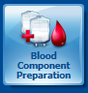
2 | Component Prep Function: Enter a valid Component Preparation Function code in the Value field. The ellipses button can be used to search for available functions; however, there are different functions for the Wake Market than the Charlotte Market. See Definitions for a brief description of each preparation function used in the Wake Market.  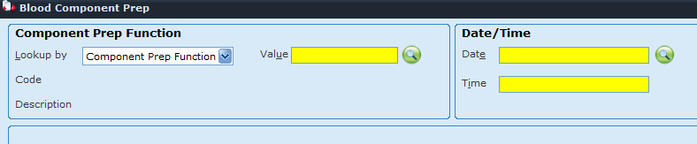
3 | Enter Date and Time.  Note: for thawed products, enter time that unit was removed from freezer.
4 | Press Continue.
5. | Enter unit number and Component Code by scanning the appropriate barcodes.  Note: Component type can be selected from the drop down menu; however, it is preferable to scan the component E-code to ensure the correct product is selected.
6. | Tab through or select the correct division number to populate unit data.
7. | Continue to Scan units until all units being modified are added.  Note: not all functions allow for multiple units to be modified at the same time (example: washing).
8. | Click on the yellow circle to select the unit being modified.  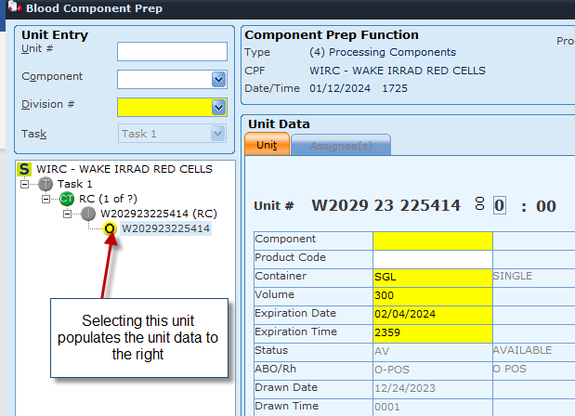
9. | Enter the Component Output code in the yellow box next to “Component” if it does not auto-populate. Once entered the yellow circle above will turn green.  Refer to Attachment 1: Component Prep Job Aid  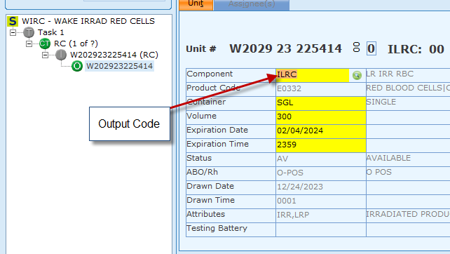
10. | Ensure the data in the bottom half of the screen is correct. You should see a new product code (Ecode) generated. If there is no Product Code (E Code) generated, contact management. (You may not have the correct Output code).  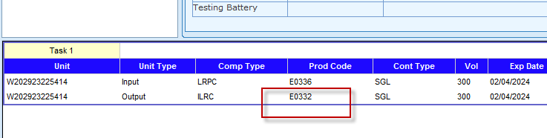
11. | Ensure the Expiration Date is correct.  Note: not all functions will automatically enter the correct expiration date. You MUST check to ensure it is correct. Example: when pooling: The system displays the expiration date for each unit being pooled; however, it does not compare the expiration dates of units to that of the pool. Therefore, it does not warn of any discrepancies. It is imperative for the tech to carefully review the dates and make sure that none of the individual component units will expire before the expiration of the pool.
12. | Press Save
13. | A preview box displays showing your new Output component type and Ecode. If everything is correct Press Finish. If anything is wrong, or no Ecode was generated, press Cancel and correct error.  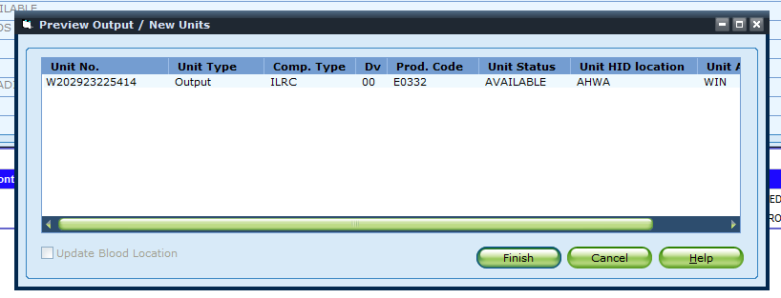
14. | A full face label will print, Label the blood product and proceed to Blood Label Check.  Refer to BB-SOP-0040: Label Verify (Check)

Procedure Guidelines: Packing WB

STEP | ACTION
1 | In Sunquest > Blood Component Preparation (BCP)
2 | Function: WPWB
3 | Scan the unit number to be packed.
4 | Enter number of new units: 1  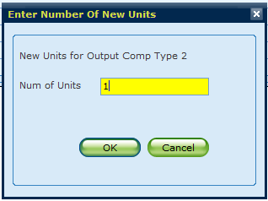
5. | Enter output component for the red cell.  Refer to Attachment 1: Component Prep Job Aid
6. | Click on the Salvaged plasma (SLV) and enter volume removed.  Note: average volume removed is 200. Use 200 mls, or exact volume if weighing salvaged plasma. The volume of the red cells will be calculated based off this value.  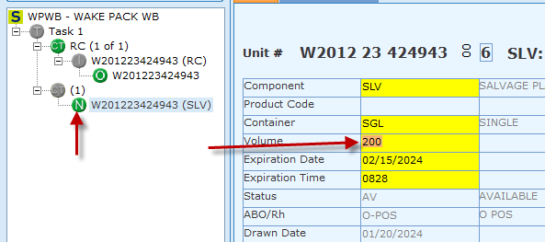
7. | Ensure All Ecodes are correct and click save.
8. | A warning box will appear alerting you that a label will not print for the salvaged plasma. Click Ok.  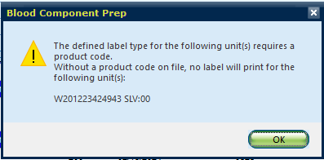
9. | The salvaged plasma is set to expire at the time of the component preparation. This plasma should be immediately discarded.
10. | The salvaged plasma will show up on the expired products report. This plasma will be discarded in Sunquest when third shift runs the BEU daily. Third shift does NOT have to physically locate the salvaged plasma since it is immediately discarded.  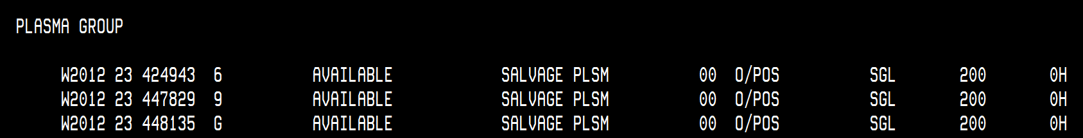
11. | A full face label will print for the red cell products. Label the product and proceed to Label check.  Refer to BB-SOP-0040: Label Verify (Check)

Procedure Guidelines: Pooling Plasma
STEP | ACTION
1 | In Sunquest > Blood Component Preparation (BCP)
2 | Function: WPPL
3 | Scan all units to be pooled.  Note: You can mix e-codes within component type groups, but you cannot mix e-codes from different component type groups.  Example: E2701, E2737, etc. from the FP24 component types can be pooled together; however, you cannot pool E2701 (FP24) and E7750 (FFP1)
4 | Enter output component type for new pool number.  Refer to Attachment 1: Component Prep Job Aid
5. | Expiration date will default to 24 hours OR the time of the shortest dated unit in the pool, whichever is sooner.
8. | Click Save.
9. | Review the pool. Ensure your new pool number is correct and click finish.  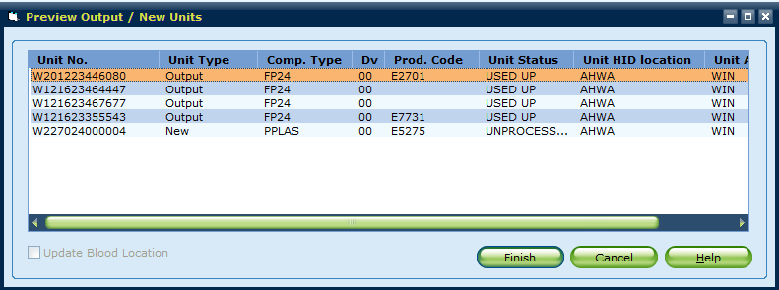
10. | A label will print. There will be NO ABO/Rh on the label.
11. | Open Blood Product Entry and click Modify.
12. | Scan the new pool number.
13. | Add the ABO.  Note: you cannot mix ABOs.
14. | Add the Rh.  Note: you can mix Rh. When Rh neg and Rh pos are in the same pool the Rh must be interpreted as “Pos” or an ABO/Rh will NOT print on your label.
15. | Open Blood Bank label print  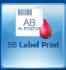
16. | Scan unit number of pooled plasma and click add.  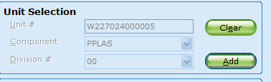
17. | Click Print.
18. | Obtain full face label and label pooled plasma product. Proceed to label check.  Note: Sunquest requires a label check for this new product but will only check the expiration, not the ABO. A manual label check is also required.  Refer to BB-SOP-0040: Label Verify (Check)

Literature References:

Related Procedures/Policies in Navex:

Attachments/Linked Documents in Title 21:

BB-FORMS-0216: Label Check Tag
BB-SOP-0040: Label Verify (Check)

Revision Dates: Review Change Summary as represented in Title 21.

Attachment 1: Component Prep Job Aid

Irradiation:

Component Prep Function | Input | E code | Output | Ecode
WIRC | LRPC | E0276 | ILRC | E0274
 |  | E0336 |  | E0332
 |  | E0226 |  | E0224
 |  | E0424 |  | E0420
 |  | E0678 |  | E0661
 | LRDAS1 | E0685 | ILRAS1 | E0668
 | LRDAS2 | E0686 | ILRAS2 | E0669
 | LRWB | E0033 | ILRWB | E0032
 | WB | E0112 | IRWB | E0120
 |  | E0068 |  | E0076
 | DPC | E4519 | IDPC | E4521
 |  | E4520 |  | E4522
 |  | E4587 |  | E4582
 | DPC1 | E4588 | IDPC1 | E4583
 | DPC2 | E4589 | IDPC2 | E4584
WIPG | LRPLT | EA007 | ILPLT | EA015
 |  | EA136 |  | EA152
 | LRPLT1 | EA008 | ILPLT1 | EA016
 |  | EA137 |  | EA153
 |  | EA141 |  | EA157
 | LRPLT2 | EA009 | ILPLT2 | EA017
 |  | EA138 |  | EA154
 | LRPLT3 | EA010 | ILPLT3 | EA018
 |  | EA139 |  | EA155
 |  | EA143 |  | EA159
 | GR | E3673 | IRGR | E3678
 | LQP | E2457 | ILQP | E2462

Deglyce:

Component Prep Function | Input | E code | Output | Ecode
WDRC | FLRC | E5085 | DPC | E4519
 |  | E5105 |  | E4587
 | FLRC1 | E5106 | DPC1 | E4588
 | FLRC2 | E5107 | DPC2 | E4589
 | AFRC | E5079100 | ADPC | E4520

Wash:

Component Prep Function | Input | E code | Output | Ecode
WRC | LRPC | E0276 | WLRC | E5169
 |  | E0336 |  | E5638
 |  | E0226 |  | E5169
 |  | E0424 |  | E5169
 |  | E0678 |  | E4144
 | LRDAS1 | E0685 | LRW1 | E4564
 | LRDAS2 | E0686 | LRW2 | E4565
 | ILRC | E0274 | ILRW | E5170
 |  | E0332 |  | E5170
 |  | E0224 |  | E5170
 |  | E0420 |  | E0484
 |  | E0661 |  | E4145
 | ILRAS1 | E0668 | ILRW1 | E4560
 | ILRAS2 | E0669 | ILRW2 | E4561
WPLT | PRPLT | E8340 | WPRPLT | E8695
 | PRPLT1 | E8341 | WPRPT1 | E8696
 | PRPLT2 | E8342 | WPRPT2 | E8697
 |  | E9139 |  | E8727
 | PRPLT3 | E8343 | WPRPT3 | E8698
 | LRPLT | EA007 | WLRPLT | E3556
 |  | EA136 |  | E9954
 | LRPLT1 | EA008 | WLRPT1 | E3558
 |  | EA137 |  | E9955
 | LRPLT2 | EA009 | WLRPT2 | E3559
 |  | EA138 |  | E9956
 | LRPLT3 | EA010 | WLRPT3 | E3560
 |  | EA139 |  | E9957
 | ILPLT | EA152 | WIPLT | E9938
 | ILPLT | EA015 | WIPLT | E3541
 | ILPLT1 | EA016 | WIPLT1 | E3543
 | ILPLT1 | EA153 | WIPLT1 | E9939
 | ILPLT2 | EA017 | WIPLT2 | E3544
 | ILPLT2 | EA154 | WIPLT2 | E9940
 | ILPLT3 | EA018 | WIPLT3 | E3545
 | ILPLT3 | EA155 | WIPLT3 | E9941

Thaw:

Component Prep Function | Input | E code | Output | Ecode
WTH | FFP | E0701 | FP | E2684
 |  | E0707 |  | E2702
 |  | E0713 |  | E2720
 |  | E0869 |  | E2121
 |  | E0900 |  | E2121
 |  | E4689 |  | E5548
 |  | E4693 |  | E5549
 |  | E1624 |  | E2284
 | FP?? | E2528 |  | E2684
 | FFP24 | E2555 | FP24 | E2701
 |  | E2619 |  | E2737
 |  | E2587 |  | E2719
 |  | E7644 |  | E7731
 | FFPP1 | E7646 | FFP1 | E7750
 | FFPP2 | E7648 | FFP2 | E7751
 | FFPP3 | E7650 | FFP3 | E7752
 | FFPP4 | E7607 | FFP4 | E7753
 | CPP | E2617 | TCPP | E2736
 |  | E2553 |  | E2700
 |  | E2585 |  | E2718
 | ACNVPL | E9736 | TACNVP | E9781
 |  | E9747 |  | E9752
 |  | E9754 |  | E9762
 |  | E9756 |  | E9752
 |  | E9757 |  | E9752
 | ACNPL2 | E9755 | TCNPL2 | E9763
 | CNVPLA | E9735 | TCNVP | E9780
 |  | E9804 |  | E9811
WTHC | CRY | E5165 | TCRYO | E3581
WTHCP | PCRYO | E3587 | TPCRYO | E3591
 |  | E5621 |  | E6552

Pool:
Component Prep Function | Input | E code | Output | Ecode
WPPL | FP | E2684
 |  | E2702
 |  | E2720
 |  | E2121
 |  | E2121
 |  | E5548
 |  | E5549
 |  | E2284
 |  | E2684
 | FP24 | E2701 | PPLAS | E5275
 |  | E2737
 |  | E2719
 |  | E7731
 | FFP1 | E7750
 | FFP2 | E7751
 | FFP3 | E7752
 | FFP4 | E7753
 | TCRYO | E3581

Pack:
Component Prep Function | Input | E code | Output | Ecode
WPWB | LRWB | E0033 | LRPC | E0181
 | WB | E0023 | PC | E0167
 |  | E0068 | PC | E0212
 |  | E0112 | PC | E0262
 | AWB | E0033 | AUPC | E0181
 | DDWB | E0033 | DDPC | E0181

