Applicable Laboratory(s):

☒ North Carolina Baptist Hospital (NCBH)
☐ Lexington Medical Center (LMC)
☐ Davie Medical Center (DMC)
☐ Wilkes Medical Center (WMC)
☐ High Point Medical Center (HPMC)
☐ Westchester
☐ Clemmons

Purpose

The purpose of this procedure is to meet AABB standard for general labeling requirements. AABB 5.1.6.3.1 5) If a component is modified and new labels are applied, the labeling process shall include a method to ensure the accuracy of all labels, including the donation identification number, ABO/Rh, expiration date (as appropriate), and product name and code. 6) The labeling process shall include a second check to ensure the accuracy of affixed labels, including the correct donation identification number, ABO/Rh, expiration date, and product name and code.

Scope

This procedure applies to blood bank staff and management.

Definitions

- Procedure: A process or method for accomplishing a specific task or objective.
- WFBH Lab System: Wake Forest Baptist Lab System is a health system that includes Wake Forest Baptist Medical Center and all affiliated organizations including Wake Forest University Health Sciences (WFUHS), North Carolina Baptist Hospital (NCBH), Lexington Medical Center (LMC), Davie Medical Center (DMC), Wilkes Medical Center (WMC), High Point Medical Center (HPMC), Lab at Westchester and Lab at Clemmons.
- AABB: Association for the Advancement of Blood and Biotherapies

Supplies/Materials

Blood component
Sunquest Computer system
Component label tag

Limitations
  - Label check is defined in Sunquest as a “Test”.
  - Sunquest will only “require” a label check on the first tested or changed product.
  - Since red cells all require ABO Recheck upon receipt, Sunquest will not “require” a label check to any modified red cell unit.
  - Sunquest will only retain a correct label check on the most recently modified product. All previously modified products will no longer have a label check attached. (An irradiated red cell that is subsequently washed will show a label check for the washed product but not the irradiated product.)
  - If the label check fails for units that do not “require” a label check, no action will be taken in Sunquest to prevent the issuing of the unit.

Protocol Guidelines

- Each time a component is modified and new labels are applied, the labeling process shall include a method to ensure the accuracy of all labels including the donor identification number, ABO/Rh, expiration date, product name, product code, and integrity of unit.
- The Label Check process is a second check to ensure the accuracy of affixed labels including the donor identification number, ABO/Rh, expiration date, product name, product code, and the observing the integrity of the unit.
- The Sunquest Computer System can solely be used routinely to label check the following functions:
  - Thaw Plasma
  - Thaw Cryo (single, AHF, and IFC)
  - Irradiate Liquid Plasma
- Manual Label Check must be performed for the following functions and for the above functions during computer downtime.
- All red cell modifications (Irradiation, Wash, Split, Degly, Pack WB, etc.)
- All platelet modifications (Irradiation, Wash, Split)
- All pooling (Plasma, Cryo, or reconstitution of WB)
- Irradiating granulocytes
- Any time this message is received when modifying a unit in BCP
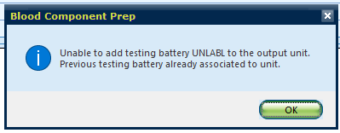
- A label check MUST be performed in the computer after EVERY component preparation to each unit/part
- Sunquest will retain a record of one correct label check only. While Sunquest computer system can be used to aid label checking, it does not provide an accurate record.
- Manual label checks will serve as a record of all label checks since Sunquest will not track them on every modified component.
- Manual label checks will provide the appropriate second verification record to ensure the labels are correct and take no action on units that are not in unprocessed status.
- The two part yellow Component Label Tag will be attached to all units requiring component preparation listed in section E and all units during downtime.
  - Refer to BB-FORMS-0216 Label Check Tag
  - Verify the white bottom copy stating “Label Check Complete” remains attached securely to the unit(s) as a physical verification of the Label check (as applicable).
    - The tag should remain attached to the unit until final disposition
    - If the unit is returned without the tag attached, Check Sunquest to determine if an acceptable label check was performed and re-verify the label check by tagging the unit.
  - DO NOT detach top yellow copy before the label check is complete
  - The technologist performing the final label check should be a different technologist than the one completing the component preparation.
- Upon completion of Label Check in computer (and manually if applicable), the unit is ready to be used. The top copy of the manual label check tag should be removed and filed.
- The same technologist can perform their own label checks in the computer system.
- Label verify audits may be performed.
- Verify that the unit number is not covered up with a full-face label when splitting into product bags that already have a unit number on them. The original DIN number cannot be obscured.

Procedure Guidelines

- Label Verify in Sunquest (Computer)

Chemical Risk Assessment: low
Biological Risk Assessment: low
Protective Equipment: Lab coat, gloves
Reagents: NA
Supplies: Component Label Tag (downtime)
Equipment: Computer
Specimen Requirements: NA

STEPS | INSTRUCTIONS
1.0 | Obtain unit(s) needing component preparation or modification.  - ALL units should be label checked in Sunquest even those that require manual label check tags!
2.0 | Perform component prep on unit(s) physically and then in computer.  - Refer to Component Preparation Manual for SOP.  - In Sunquest Go to Blood Label Check:  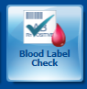  - Label verification will NOT be prompted automatically once ISBT label is printed; however, products that being “tested” for the first time will remain in Unprocessed status until label check is complete.
3.0 | In Sunquest, Scan the Unit number and product code. Select the correct division if applicable and click Search.  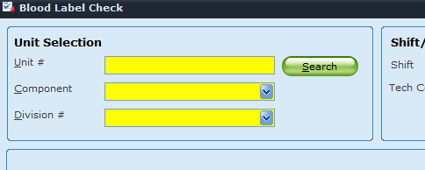
4.0 | Ensure the desired unit is displayed:  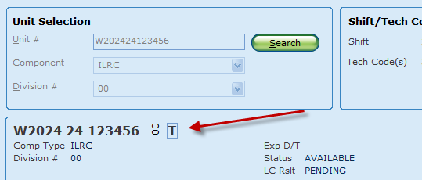
5.0 | Tab or select the yellow fields, scanning the ABO/Rh, and Expiration date/time.  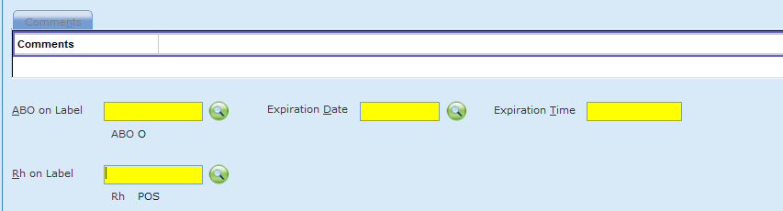
6.0 | Click Check Label  
7.0 | If the label does not match, an error message will display and tell you what field(s) do not match the file:  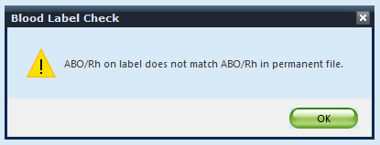  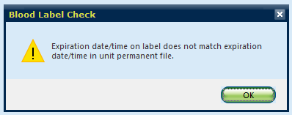  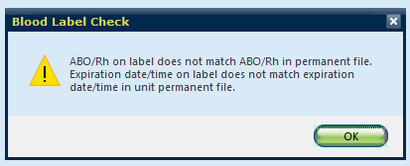  7.1. Sunquest gives two chances to pass the label check process before brining you  back to the start screen.  7.2. Correct scanning error and re-peat label check.
8.0 | If label check passes, NO box displays. You are taken back to the start screen.
9.0 | A history of passed label check will be visible under Blood Bank Inquiry > Product Testing along with other testing results.  9.1. Failed label checks are not recorded or visible.  9.2. Date/time of testing will reflect the date/time of the first resulted test (ABO  recheck results for red cells)  9.3. Subsequent label checks are not recorded or visible.

- Label Check Manually

Chemical Risk Assessment: low
Biological Risk Assessment: low
Protective Equipment: Lab coat, gloves
Reagents: NA
Supplies: Component Label Tag (downtime)
Equipment: Computer
Specimen Requirements: NA

STEPS | INSTRUCTIONS
1.0 | Obtain unit(s) needing component preparation or modification.
2.0 | Obtain Component Prep Label Check Clipboard  Refer to BB-FORMS-0264 Label Check Form
3.0 | Document Date/time, tech modifying component, type of modification, unit DIN, product E code, Expiration date/time on form.
4.0 | Complete computer label check (See section 1)
5.0 | Take Clipbard and component to another technologist.  - Second technologists shall check DIN, product code, expiration date/time to verify label.  - Product labels MUST match Sunquest unit information (Available in Blood Bank Inquiry)  - Second technologist will initial on the form for the label verification.
6.0 | After label check is complete, the technologist modifying the component will place a label checked sticker on the unit label in the bottom right hand corner.  Refer to BB-LABEL-0069: Label Check Performed (sticker)  6.1 This sticker will reflect that a label check has been completed.  6.2 If additional product modification is needed. The sticker will get covered by the  new product label and a new label check will be needed with new label check  sticker.  6.3 A label check MUST be done every time a unit label is modified.
7.0 | Retain Component Prep Label Check Form for 2 months.

Literature References:
AABB Standards for Blood Banks and Transfusion Services, revised periodically.

Related Procedures/Policies in Navex:

Attachments/Linked Documents in Title 21:
BB-FORMS-0264: Label Check Form
BB-LABEL-0069: Label Check Sticker

Revision Dates: Review Change Summary as represented in Title 21.

