# Applicable Laboratory(s):

North Carolina Baptist Hospital (NCBH)

Lexington Medical Center (LMC)

Davie Medical Center (DMC)

Wilkes Medical Center (WMC)

High Point Medical Center (HPMC)

Westchester

Clemmons

# Purpose

The purpose of this procedure is to describe the steps taken to enter blood products received into the computer and to perform ABO confirmation on red cell containing products and enter results into the computer to make the products available for use.

# Scope

This procedure applies to Blood Bank Staff and Management

# Definitions

1. Procedure: A process or method for accomplishing a specific task or objective.
2. WFBH Lab System: Wake Forest Baptist Lab System is a health system that includes Wake Forest Baptist Medical Center and all affiliated organizations including Wake Forest University Health Sciences (WFUHS), North Carolina Baptist Hospital (NCBH), Lexington Medical Center (LMC), Davie Medical Center (DMC), Wilkes Medical Center (WMC), High Point Medical Center (HPMC), Lab at Westchester and Lab at Clemmons.
3. SCC: Soft Computer System – Blood Bank Information System
4. Ag: antigen
5. Ab: antibody
6. Plt: platelet
7. Inventory>In/Out: blood product computer entry function
8. Delivery: single unit entry
9. Batch Delivery: batch unit entry
10. Results – Unit test worksheet computer entry of results for unit retypes
11. Results – Test Verify verification of interfaced unit retypes
12. Sterility Sterility of the component shall be maintained during the processing by use of aseptic methods and sterile pyrogen free equipment and solutions. Equipment that allows transfer of components without breakage of the seal is preferred.
13. Mannitol free units: AS3 and CPDA1 blood units
14. TFAIL Temperature failed
15. VFAIL Visual Inspection

# Sections

I. Entering Units into SCC

II. Printing Received Units Report

III. Unit ABO Confirmation Testing and Computer Entry

IV. Correcting or Adding Blood Product Information (Incorrect Source Code, Volume, Antigen,

Attribute)

V. Correction of Scanning Errors That Cannot be Edited

VI. Holding and Unholding Units

VII. Retype of Units on Ortho Vision Max Analyzers

# Supplies/Materials

See individual sections

# Downtime

If automated testing become inoperable, unit retypes should be performed manually.

Notify management if computer system or other manual processes become inoperable.

# Procedure Guidelines

**I. Entering Units into Inventory in Sunquest**

Chemical Risk Assessment: low

Biological Risk Assessment: low

Protective Equipment: Lab coat, gloves

Supplies: N/A

Reagents: N/A

Equipment: N/A

Specimen Requirements: **Units cannot be at room temperature for more than 20 minutes!**

| **STEPS** | **INSTRUCTIONS** |
| --- | --- |
| **1.0** | Enter Sunquest.  a. Log in under lab location “WIN”  b. Open Blood Product Entry (BPE) |
| **2.0** | Complete/stamp product invoice for date and time received and initials indicating acceptable appearance and shipping conditions or comments if unacceptable.  2.1 Obtain blood product units.  2.2 Verify blood product number and any special attributes, antigens or requests for unit. |
| **3.0** | Click on Blood Product and scan the following fields:   1. Supplier: Scan the DIN number (This will populate the Supplier and Supplier unit # field) 2. Component: Scan the component code (Ecode) (This will populate the component, division, container and volume fields).  * If division number does not populate, tab to the next field and it will auto-fill.  1. ABO: Scan the ABO/Rh. (This will populat ethe ABO and Rh fields) 2. Expiration Date: Scan the expiration. (This will populate the Expiration date, Expiration time, Draw date, draw time, receive date and receive time.)   *Refer to Attachment 1: ISBT Fields to Scan* |
| **4.0** | Modify unit Volume: Unit volume defaults to preset amounts. Change the Volume to match the unit label. |
| **5.0** | Modify the unit location:   1. If division number did not auto populate in step 3, the location of the unit needs to be entered. 2. Click on location on the top navigation bar      1. Select “WIN” under “AHWA” to specify that the unit is at the Winston Campus. If this is a special or frozen unit, the unit can be added to the specific shelf in the freezer where it will be stored. (WIN>RCF>SH001-SH014)        1. Note: Sunquest will “lose” the location of units when switching between component types. Example: When bringing in packed cells (E0336), most translate to “LRPC”, but if you scan in an “LRDAS1” (E0685), the location field will be lost and will need to be manually entered. It is easiest to bring in units by component type or Ecode, close BPE and re-enter to bring in other component types to avoid losing a unit’s location. |
| **6.0** | Add any Antigen, Antibody, or Attriubutes to the unit as applicable.  *Refer to Appendix A-C for Antigen, Antibody and Attribute Codes.*  a. Select Ag/Ab/Attributes:    b. Enter appropriate Codes and select “Add”    c. A complete list of available Sunquest codes is available using function MIQ #4 in roll and scroll. *Refer to Attachment 2: Antigen/Antibody codes* for more frequently used codes. |
| **7.0** | Add Comments to unit if applicable.  a. Select Comments:    b. Enter Comment Code or free text comments.   * Units cannot be “held” in Sunqest; however, a free text code should be entered when the unit is special ordered for a specific patient. Example: “Hold for Doe, John 45465874 Surgery 1/16/24” * Platelet Counts: Free text Plt count * HLA Plts: Use Comment Code HLAP and free text in HLA type     c. Select “Add” to add the comment to the unit |
| **8.0** | Add Assignees if applicable:  a. All Auto and Directed units must be assigned to a patient.  b. This field cannot be used to “hold” special order blood.  c. Select Assignees    d. Enter MRN. Ensure correct patient is populated and select “Add” |
| **9.0** | Once all the information on the unit has been entered correctly, Click “Add” to add this unit to the Unit Summary list. |
| **10.0** | Once all your units have been entered, they will all display on the unit summary list.  a. Ensure your location for all units shows as AHWA / WIN  b. Click Save in the bottom right corner. |
| **11.0** | A worklist number will be generated for liquid red cell units.    a. Write this WL# (WL, MMDD, #) on a piece of tape and place on the rack with the unit segments to be tested.  b. AHWA worklist numbers include those from all Wake locations and not just main campus. |

**II. Printing Received Units Report**

Chemical Risk Assessment: low

Biological Risk Assessment: low

Protective Equipment: Lab coat, gloves

Supplies: N/A

Reagents: N/A

Equipment: N/A

Specimen Requirements:NA

| **STEPS** | **INSTRUCTIONS** |
| --- | --- |
| **1.0** | **Log into Roll and Scroll .**   * 1. Select SmarTerm from the Sunqest Gui application   2. Select SmarTerm from the desktop   3. Log in to SmarTerm by entering your Access code and Password |
| **2.0** | **Function BBR.** |
| **3.0** | **Select printer #**  3.1 Printer WIN – front printer  3.2 Printer WIN2– back printer  3.3 Printer 0: Print to screen |
| **4.0** | **Select “11” Press “Enter”. Products Received Report**  **Hosptial ID:** “AHWA”  **Area:** “WIN”  **Area:** “Enter”  **Hospital ID:** “Enter”  **Accept (A), Modify (M), or Reject (R):** “A”  **Start Date <Yesterday>:** “T” (T=Today, “Enter”= Yesterday)  **End Date <Start Date>:** “T” (T=Today, “Enter” = Start Date)  **Start Time**: Enter time (HHMM)  **Component Type/Group**: Enter desired component type:   * RC = Red Cell * PLTG = Platelet Group   **Component Type/Group**: Enter second component type or “Enter” to continue  **Suppliers Requested**: “Enter” for ALL or enter supplier (example: ARC)  **Search on Active Units Only (<Y>/N):** “Enter” or “Y” for Yes. “N” for no  **Accept (A), Modify (M), or Reject (R):** “A” |
| **5.0** | **Check the information on the printed report against the shipping invoice**  Items to check include:   * Donor number * Unit ABO/Rh * Unit expiration   Place check mark next to unit number on shipping invoice as information is confirmed. |
| **6.0** | **File Received Reports (non-red cell products) in appropriate binder. Retain Red Cell Received Units report to be used to check ABO retypes and sticker units. See III.** |

**III. Unit ABO Confirmation Testing and Computer Entry (Manual Method: Hemagglutination by tube testing)**

Chemical Risk Assessment: low

Biological Risk Assessment: low

Protective Equipment: Lab coat, gloves, face shield (eye and mouth protection)

Supplies: N/A

Reagents: N/A

Equipment: N/A

Specimen Requirements: NA

| **STEPS** | **INSTRUCTIONS** |
| --- | --- |
| **1.0** | **Obtain segment(s) from unit(s) to be ABO Confirmed.**   * 1. Incoming Red Cell containing donor units (packed red cells, whole blood, granulocytes):  1. Place BARCODED donor number label vertically on a 10 or 12x75 tube 2. Remove one (1) to two (2) segments from unit and place in labeled tube. 3. Label two (2) segments with unit label to be retained segment. Segments are retained for 56 days and stored by day of receipt. 4. Complete computer entry of products (above) 5. Print Received Units Report    1. Washed Red Cells and Deglyced units 6. Label 12x75 tube with complete donor number 7. Remove segment from washed / deglyced unit, place in tube |
| **2.0** | **Open Blood Product Testing in Sunquest** |
| **3.0** | **Enter Worklist # and Click Add Worklist**  Alternatively, if only one unit was entered and no WL# is generated, Scan the unit number into the Unit # field, ensure proper component and division are selected and Press “Add”. |
| **4.0** | **Place labeled segment tubes in a testing rack, label(s) facing forward.**  4.1 This tube will be used as the segment suspension tube. (see Step 6.0)  4.2 Units will be listed on the WL in the order that they were scanned into SQ. It is helpful to ensure segments are pulled in the order that units are entered. |
| **5.0** | **Label 10x75 test tubes with a minimum of the LAST 6 number of the donor number and testing to be performed using a permanent marker. Place test tubes in rack in spaces adjacent to corresponding segment tube.**  5.1 Weak D testing is not required on RhD negative donor units  5.2 A saline control is not required for AB Positive units  5.3 Refer to the chart for required manual donor testing:   |  |  |  | | --- | --- | --- | | **Unit ABO/Rh** | **Required Testing** | **Label Test Tube with Antisera Used** | | **A POS**  **B POS**  **AB POS** | Anti-A  and    Anti-B | **A**  **B** | | **O POS** | Anti-A,B | **AB** | | **A NEG**  **B NEG**  **AB NEG** | Anti-A  and  Anti-B  and  Anti-D | **A**  **B**  **D** | | **O NEG** | Anti-A,B  and  Anti-D | **AB**  **D** | |
| **6.0** | **Prepare a 3-5% cell suspension of the donor red cells for manual testing.**  6.1 Add 1-2 drops of packed donor red cells from obtained segment into a properly  Labeled tube using a ***TypeSafe*** device.  *Refer to BB-SOP-0151: Typesafe Device*  6.3 Add 0.9% saline to produce a red cell suspension.  6.4 Mix red cell suspension.  6.5 Compare color of suspension with that of a commercial reagent red cell  suspension.   1. If suspension appears <3%, add sufficient patient red cells to achieve a 3-5% suspension. 2. If suspension appears >5%, add sufficient saline to suspension to achieve a 3-5% suspension. |
| **7.0** | **Add one drop of the appropriate antisera to each of the labeled 10x75 test tubes**  7.1 Read vial label carefully each time of use before dropping antisera to confirm  correct antisera.  7.2 Read test tube label with antisera before dropping.  7.3 Label tubes and drop antisera   |  |  |  | | --- | --- | --- | | **Tube label** | **Vial** | **# Drops** | | A | Anti A | 1 | | B | Anti B | 1 | | AB | Anti A,B | 1 | | D | Anti D | 1 | |
| **8.0** | **Add one drop of 3-5% donor red cell suspension to the tubes containing appropriate antisera.**  8.1 Reconfirm identifying information on donor suspension tube with test tube(s) |
| **9.0** | **Mix tube gently, centrifuge immediately at room temperature, 3400-3600 RPM for the immediate spin (IS) calibrated time as noted on centrifuge.**  *Refer to BB-SOP-0146: Centrifuge Operation* |
| **10.0** | **Carefully remove 2-3 tubes from centrifuge at a time** |
| **11.0** | **Dislodge / resuspend cell button from bottom of tubes gently over an approved agglutination lamp.**  11.1 Observe agglutination strength   |  |  |  | | --- | --- | --- | | **Reaction** | **Explanation** | **Interpretation** | | 3+ to 4+ agglutination | *Expected Reaction for presence of antigens* | **Positive** | | *No agglutination* | *Absence of an antigen/antibody reaction* | **Negative** | | ≥2+with or without mixed field agglutination | *Valid positive reaction indicating presence of antigens* | **Positive** | | Weak (<2+) reactions | *Weaker than expected reaction*.  *Examine for mixed field.*  *Reactions may be enhanced by RT incubation for up to 20 minutes* | Refer to Routine: *Refer to: BB-POL-0004: Grading of Positive and Negative Reactions* | |
| **12.0** | **Document reactions and make ABO (Rh) interpretation IN COMPUTER as they are performed.**   1. Once WL has been populated, click Continue to bring the first unit of the WL onto the unit testing screen.      1. Confirm donor number on test tube with donor number on computer screen      1. Observe agglutination strength in tube, key in reactivity strength into ***ABO/RH(D)*** grid for each antisera tested. Cursor will advance across grid as reactions are entered.      * N = not done * 1 = 1+ * 2 = 2+ * 3 = 3+ * 4 = 4+ * 0 = neg   12.3 Cursor will advance automatically to the ***Interpretation*** field upon completion of the ***ABO/RH(D)*** grid. Make interpretation of testing results.     |  |  |  |  | | --- | --- | --- | --- | | **Cells with**  **Anti-A** | **Cells with**  **Anti-B** | **Cells with Anti-A,B** | **ABO group**  **Interpretation** | | ND | ND | NEG | O | | NEG | NEG | ND | O | | 2-4+ | NEG | ND | A | | NEG | 2-4+ | ND | B | | 2-4+ | 2-4+ | ND | AB |  1. RH Positive Units  * Type interpretation of ABO and Rh even though Rh was not resulted. * Click Accept to accept results.  1. RH Negative Units  * Type interpretation of ABO and Rh. * Click Accept to accept results.   12.4 Click save to file the result for this unit. A message will appear indicating that the unit test has been completed.      12.5 Click OK.  12.6 Click Continue and repeat the above steps until all units on the worklist have been filed.  12.7 Obtain ABO Group Confirmed label that prints automatically for each unit  typed.  12.8 ABO (Rh) confirmation of WASHED units is documented on the COBE/IBM Preparation Worksheet. Reactions and interpretation must be documented BEFORE tubes are discarded.  12.9 ABO (Rh) confirmation of deglyced units is documented immediately in the  computer.  a. During downtime document on the Cobe/IBM Component Preparation  Worksheet.  b. Reactions and interpretation must be documented BEFORE tubes are  discarded.  12.10 Discrepant results or units with reaction results <2+ must be investigated   * Quarantine unit * Notify management / write QA * Return unit(s) to supplier |
| **13.0** | **Sticker units with ABO Confirmation Sticker.**  13.1 Take Report corresponding to units tested to refrigerator  13.2 Compare unit Donor number(s) with printed *Received Units Report****.*** Place a check mark next to the unit on the report, indicating that it has been received and tested.  13.3 **If Identical, apply a *ABO Group Confirmed* sticker next to the blood group**  **on the blood bag label.**   1. If there is a discrepancy. Investigate to determine if unit was not properly brought into inventory.   13.4 Move units to appropriate storage location. |
| **14.0** | **Initial completed report and file with Red Cell Products Received Reports.** |

**IV: Retype of units on Ortho Vision Max Analyzers**

Chemical Risk Assessment: low

Biological Risk Assessment: low

Protective Equipment: Lab coat, gloves, face shield (eye and mouth protection)

Supplies: N/A

Reagents: N/A

Equipment: N/A

Specimen Requirements:NA

| **STEPS** | **INSTRUCTIONS** |
| --- | --- |
| **1.0** | **Obtain segment(s) from unit(s) to be ABO Confirmed.**   * 1. Incoming Red Cell containing donor units (packed red cells, whole blood, granuloctyes):  1. Place BARCODED donor number label vertically on a 10x75 or 12x75 tube 2. Remove segment(s) from unit and place in labeled tube.  * One segment needed for 10 x 75 tube * Two segments needed for 12 x 75 tube  1. Label two (2) segments with unit label to be retained. Segments are kept for 56 days and stored by day of receipt into SCC. 2. Complete computer entry of products 3. Print Received Units Report |
| **2.0** | **Manually ordering Retypes for all units.**  2.1 Refer to: BB-SOP-0105 for creating single or batch order testing.  2.2 The test for Retypes is %ARC  2.3 Results will automatically cross into Sunquest  2.4 Promptly remove sample from analyzer to prevent the instrument from querying |
| **3.0** | **After testing is completed Enter BB Instruments in Sunquest**    *Refer to Attachment 3: Setting up SunQuest for Resulting Unit Testing from Max’s* |
| **4.0** | **Select the instrument from the menu list to view results.**  4.1 View reaction results by clicking on each unit  4.2 Ensure result interpretations match expected result   * For RH positive units that type RH negative, the result of the RH testing needs to be changed to “ND” not done and the interpretation changed to positive |
| **5.0** | **Release the units by clicking the empty box under the “Rel” field** |
| **6.0** | **Click Release Batch to confirm unit rechecks.**  6.1 A confirmation box will display confirming unit results are filed. |
| **7.0** | **Sticker units with ABO Confirmation Sticker.**  7.1 Take Report corresponding to units tested to refrigerator  7.2 Compare unit Donor number(s) with printed *Received Units Report****.*** Place a check mark next to the unit on the report, indicating that it has been received and tested.  7.3 **If Identical, apply a *ABO Group Confirmed* sticker next to the blood group**  **on the blood bag label.**   1. If there is a discrepancy. Investigate to determine if unit was not properly brought into inventory.   7.4 Move units to appropriate storage location. |

**IV. Correcting or Adding Blood Product Information (Incorrect Source Code, Volume, Antigen, Attribute. Etc.)**

Chemical Risk Assessment: low

Biological Risk Assessment: low

Protective Equipment: Lab coat, gloves

Supplies: N/A

Reagents: N/A

Equipment: N/A

Specimen Requirements:NA

| **STEPS** | **INSTRUCTIONS** |
| --- | --- |
| **1.0** | **Enter Sunquest Blood Product Entry.**   * 1. Select Modify Unit at the bottom left of the screen   2. Enter unit # to be corrected. Ensure correct component and division are selected.   3. Fields that can be edited in BPE:   + ABO   + RH   + Expiration date   + Expiration time   + Volume   + Receive date   + Receive time   + Antigens   + Attributes   + Comments   + Assignees (for directed/auto units)   + Location   1. Enter/change the product information and press “save” |
| **2.0** | **Some things cannot be change in BPE and must be re-entered. Example: unit number and product code.** |
| **3.0** | **Open Blood Status Update**  3.1. Scan or enter unit number to be corrected.  3.2. Ensure correct component and division are selected  3.3. Enter the date and time of the correction  3.4. Change the unit status to “WN” for Wrong Number   * This is a final status   3.5. Enter a reason Code (example: “LIE” = Log In Error) and select add  3.6. Click Save |

# Literature References:

Technical Manual, American Association of Blood Banks (AABB). Revised periodically

Standards for Blood Banks and Transfusion Services. Revised periodically

# Related Procedures/Policies in Navex: NA

# Attachments/Linked Documents in Title 21:

Attachment 1: ISBT and Codabar Bar Code Fields to Scan

Attachment 2: Attribute and Antigen Entry

BB-POL-0048 Receiving Blood Products into Inventory

BB-SOP-0146: Centrifuge Operation

BB-SOP-0151: Typesafe Device

BB-POL-0004: Grading of Positive and Negative Reactions

# Revision Dates: Review Change Summary as represented in Title 21.

**Attachment 1: ISBT Bar Code Fields to Scan**

|  |  |  |  |
| --- | --- | --- | --- |
| **ISBT** | **FOR** | **SCAN**  **BARCODE #** | **C:\Documents and Settings\bturner\My Documents\My Pictures\ISBT LABEL.jpg**  4  3 |
| **Supplier**  **Supplier unit #** | 1  **1** |
| **Component, Division #**  **Container, Volume**   * **For platelets, plasma, and apheresis rbcs key in volume from label** | 21  **2** |
| **ABO/RH** | **3** |
| **Expiration Date, Time**  **Draw Date, Time**  **Received Date, Time** | **4** |
|  | | | |
| **Codabar** | **Supplier** | **1**  3  2 | 5  4  **C:\Documents and Settings\bturner\My Documents\My Pictures\codabar label\codabar label 002.jpg**  1 |

**Attachment 2: Attribute and Antigen Entry**

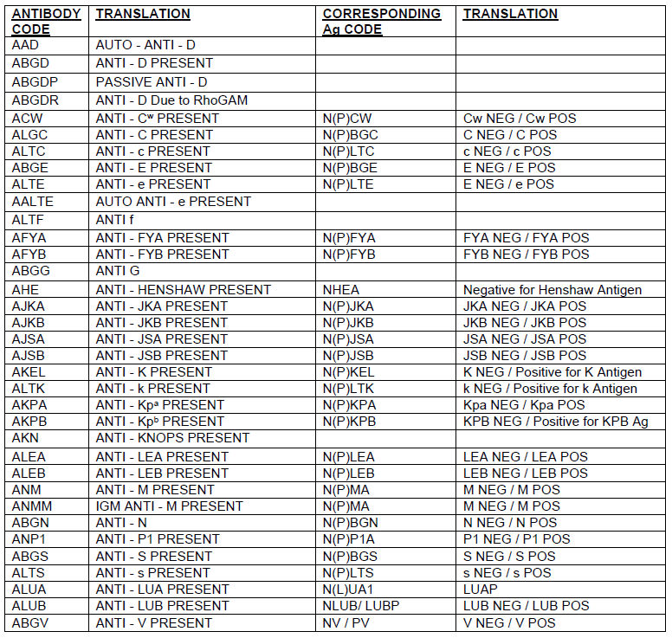

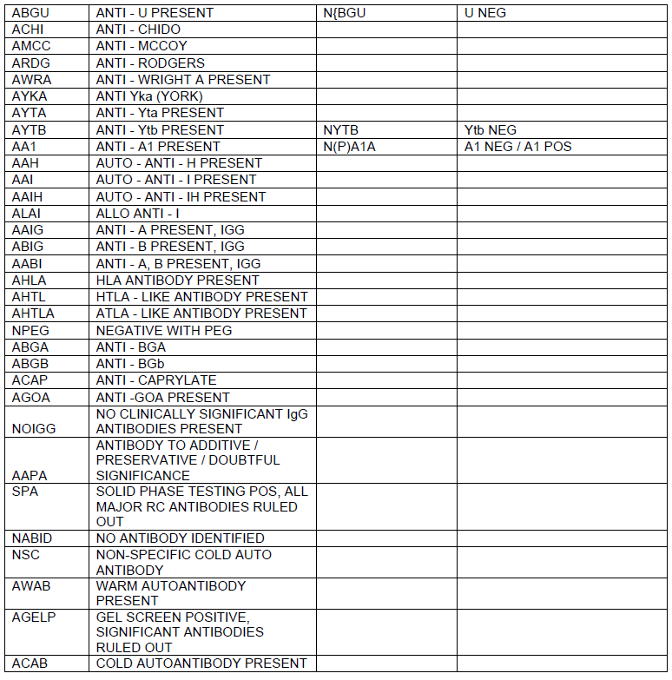

**Attachment 3: SETTING UP SUNQUEST FOR RESULTING UNIT TESTING FROM THE MAXs**

*This needs to be done once for each tech at go live*

Open the BB Method Config icon:

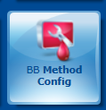

1. Enter a name, whatever you want to call it, it is individual to each person.
2. Select Product for Patient/Product
3. Move both instruments (Methods) from Available to Selected (highlight on the left and click Add to move to right)
4. For each instrument you will need to move all 5 tests from Available to Selected by clicking on Add All.
   1. Click on WVMAX1 and move all Tests
   2. Click on WVMAX2 and move all Tests
5. Checkmark the Default Configuration box in the bottom left corner.
6. Click Save.



3



3



4

2



1

To SAVE ANY changes, including moving icon from Right to Left on Main screen ALWAYS **LOGOUT** instead of Exiting:

This is on the top right of your screen:

