Applicable Laboratory(s):

☒ North Carolina Baptist Hospital (NCBH)
☐ Lexington Medical Center (LMC)
☐ Davie Medical Center (DMC)
☐ Wilkes Medical Center (WMC)
☐ High Point Medical Center (HPMC)
☐ Westchester
☐ Clemmons

Purpose

The purpose of this procedure is to ensure that routine reagents are in-date, show no visible evidence of contamination or deterioration and react as expected with a positive and negative control.

Scope

This procedure applies to Blood Bank Staff and Management

Definitions

- Procedure: A process or method for accomplishing a specific task or objective.
- WFBH Lab System: Wake Forest Baptist Lab System is a health system that includes Wake Forest Baptist Medical Center and all affiliated organizations including Wake Forest University Health Sciences (WFUHS), North Carolina Baptist Hospital (NCBH), Lexington Medical Center (LMC), Davie Medical Center (DMC), Wilkes Medical Center (WMC), High Point Medical Center (HPMC), Lab at Westchester and Lab at Clemmons.
- QC: Quality Control

Policy Guidelines

1.0 Management review of QC is documented electronically in Excel worksheet at least monthly.

2.0 Excel file can be generated as needed during inspections to demonstrate review of QC.

3.0 Review is performed by management or designee.

4.0 QC is performed daily.

5.0 Rare antisera (i.e. anti-E, -C, 3% A2 cells etc.) is performed on day of use.

6.0 Each daily rack is tested with the reagents within the specific daily rack. (i.e. Daily Rack 1 is
tested with only the reagents within Daily Rack 1). Daily rack reagents should not be mixed
when performing daily QC to assure all reagents within each rack are satisfactory.

7.0 Ph Paper QC is performed weekly (typically Monday).

8.0 Any reagent that fails to pass QC testing should be removed from use! Investigate if any
patient testing was affected. Notify management ASAP.

SECTIONS
I. Routine Rack for Daily QC
II. Special Rack for Daily QC
III. Preparation of Diluted Antisera for Quality Control
IV. Resulting QC on Excel QC worksheet
V. Review of QC by Management or Designee

I. Routine Rack for Daily QC
Chemical Risk Assessment: low
Biological Risk Assessment: low
Protective Equipment: Lab coat, gloves
Supplies: Gel cards, 10x75 tubes, pipets
Reagents: Anti-A, Anti-B, A1 cells, B cells, Anti-D, Screening Cells
Equipment: 37 C incubator, centrifuge
Specimen Requirements: NA

STEPS | INSTRUCTIONS
1.0 | Obtain from Refrigerator, each routine rack to be tested.  1.1 Racks 1-6 are tested Monday-Friday.  1.2 Racks 1-4, are tested on weekends and holidays.
2.0 | Go to Reagent QC Worksheet. Compare all reagents in Rack 1 to information in worksheet: Lot #, expiration date for Rack 1.  2.2 Check all lot numbers, expiration dates, vial opened dates, initials, volume and integrity. Lot numbers and expiration dates should correspond to Excel worksheet records.  2.3 Remove any expired reagent from rack physically.  2.4 Add any new reagent needed to the rack physically and in Excel Worksheet.  - Type lot number and expiration date using format mm/dd/yyyy  - Reagents that are expired will turn red  - Reagents that are expiring within the next 6 days will turn yellow.  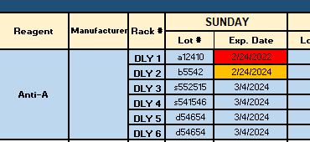  - DO NOT click and drag OR copy and paste any information into any field, this will mess up the formatting of the worksheet!  2.5 For all information that does not match investigate problem, write a QA, and  submit to management.
3.0 | Repeat step 2.0 for all other routine racks to be tested for daily QC.
4.0 | Label 10x75 tubes in the following manner for each routine rack.  Reagent to be tested Rack # Label tubes  Anti-A 1 1A+  1A-  Anti-B 1 1B+  1B-  Anti-D 1 1D+  1D-
5.0 | Testing Protocol: Add reagents from the specified rack number on test tubes.  Tube Labeled Add one drop of:  A+ Anti-A  A- Anti-A  B+ Anti-B  B- Anti-B  D+ Anti-D  D- Anti-D  5.1 Example: Anti-A from Rack 1 to test tube 1.
6.0 | Add one drop of 3% red cells to each tube being tested. Test in the following manner for each routine rack.  Tube Labeled Add one drop of:  A+ A1 cells  A- B cells  B+ B cells  B- A1 cells  D+ Screening cell 1  D- B cell  6.1 If tube labeled Rack 1, then use cells from Rack 1.  6.2 Use 3% screening cell from the specials rack for positive control for  testing of Anti-D.
7.0 | Centrifuge all test tubes at the calibrated time and speed for immediate spin room temperature testing.  7.1 Centrifuge all Anti-A, Anti-B, and Anti-D positive and negative controls for each  rack at the same time in the same centrifuge head.
8.0 | Read tubes immediately macroscopically with agglutination viewer.  8.1 Enter results in Worksheet.  8.2 Expected reaction results are listed in the worksheet. If reactions do not meet expected results the data box will turn red. This indicates failed QC and must be investigated.  Example of failed QC:  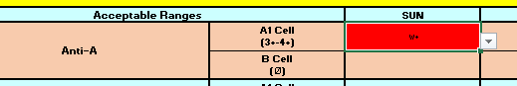  Example of acceptable QC:  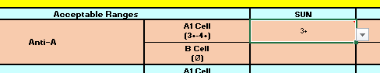  8.3 QC spreadsheet has been locked so that only certain columns allow for resulting or changes.
9.0 | Label IgG gel cards as follows to designate appropriate Rack, Cell being tested and expected positive or negative reaction.  Rack Cell 1 + Cell 1- Cell 2+ Cell 2- Cell 3+ Cell 3-  1 1 1+ 1 1- 1 2+ 1 2- 1 3+ 1 3-  2 2 1+ 2 1- 2 2+ 2 2- 2 3+ 2 3-  Only 2 racks have screening cells for supply purposes. Proceed with testing for Gel Method  Refer to: BB-SOP-0006 ANTIBODY SCREEN – TUBE and GEL METHOD Indirect Antiglobulin Test
10.0 | Add 50µL of each screening cell to the appropriately labeled well.  10.1 If cards labeled Rack 1, then use screening cells from Rack 1. If cards labeled for Rack 2, then use screening cells from Rack 2.
11.0 | Add 25 µL of diluted antisera to the wells appropriately labeled 1+, 1-, 2+, 2-, 3+, 3- in the following manner:  Screening Cell Dilute Antisera  Screening cell 1+ Anti-D  Screening cell 1- Anti-c  Screening cell 2+ Anti-D  Screening cell 2- Anti-C*  Screening cell 3+ Anti-c  Screening cell 3- Anti-D  *Anti-C will be undiluted and available in the special rack.  12.1 Dilute antisera is prepared by assigned tech as needed.  Refer to BB-SOP-0166: Preparation of QC Material
12.0 | Incubate all IgG gel cards for a minimum of 15±1 minute at 37°C ± 2°C (35-39°C).  13.1 Maximum incubation time for gel testing is 40’.
13.0 | Spin gel cards in centrifuge at calibrated time and speed.
14.0 | Read the front/back of each microtube macroscopically.  Refer to BB-POL-0004: Grading of Positive and Negative Reactions.
15.0 | Enter results in Excel QC Worksheet.  15.1 Expected reaction results are listed in the worksheet. If reactions do not meet expected results the data box will turn red. This indicates failed QC and must be investigated.  Example of failed QC:  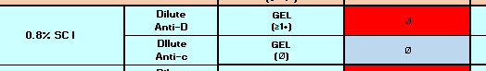  Example of acceptable QC:  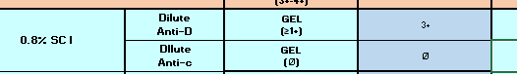
16.0 | Place Tech initials of tech performing testing in the appropriate box. (Ensure Week of: information is also completed).  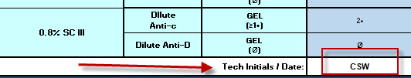

II. Special Rack for Daily QC

Chemical Risk Assessment: low
Biological Risk Assessment: low
Protective Equipment: Lab coat, gloves
Supplies: 10x75 tubes, pipets
Reagents: Anti-A,B Anti-AHG, Anti-C3d, CCC, A1 cells, A2 cells, B cells, Anti-D, Gel Screening Cells, Ortho gel card, Buffered (Neutral) Gel card
Equipment: 37 C incubator, centrifuge, Ortho centrifuge

STEPS | INSTRUCTIONS
1.0 | Obtain the Special rack from Refrigerator.
2.0 | Go to Reagent QC Worksheet. Compare all reagents in Specials and Misc lots to information in worksheet: Lot #, expiration date.  2.2 Check all lot numbers, expiration dates, vial opened dates, initials, volume and integrity. Lot numbers and expiration dates should correspond to Excel worksheet records.  2.3 Remove any expired reagent from rack physically.  2.4 Add any new reagent needed to the rack physically and in Excel Worksheet.  - Type lot number and expiration date using format mm/dd/yyyy  - Reagents that are expired will turn red  - Reagents that are expiring within the next 6 days will turn yellow.  2.5 Indicate whether the reagent is visually satisfactory or unsatisfactory by answering  “S” or “U” in the correct column.  - Note: on the first reagent on Sundays you have to Enter S and backspace and then enter S again. This prevents Excel from auto populating “Sunday” in this field.  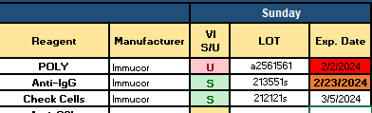
3.0 | Label 7 10x75 tubes in the following manner for testing reagents in the Special rack.  Reagent to be tested Label tubes  Anti-A,B A,B + A,B-  Anti-AHG AHG+; AHGC+ AHG-  Anti-C3d C3d+ C3d-  Note: 3% A2 cells are QC’d day of use in Buffer card with Anti-A and A1 lectin. Results are documented on the Rare Antisera QC Clipboard.
4.0 | Add one drop of Anti-A,B to the tubes labeled A,B+, A,B-.
5.0 | Add two drops of Polyspecific Anti-AHG to the tubes labeled AHG+, AHGC+, and AHG-.
6.0 | Add two drops of Anti-C3d to the tubes labeled C3d+, C3d-.
7.0 | Add the cells to labeled antisera tubes in the following manner.  Tube Labeled Cells added  A,B + B cell*  A,B1 Screening Cell 2  AHG+ Check Cells  AHGC+ EC3b cells  AHG- Screening Cell 1  C3d+ EC3b cells  C3d- Check cells  *From Rack 1
8.0 | Centrifuge all test tubes from above step at the calibrated time and speed for immediate spin room temperature testing.
9.0 | Read tubes macroscopically with agglutination viewer.  9.1 Read all negative results with Polyspecific Anti-AHG, and Anti-C3d  microscopically.
10.0 | Enter results in QC Worksheet  10.1 Expected Reaction Results are listed on the QC worksheet. Reactions that fail expected results will turn red.  Example of Failed QC:  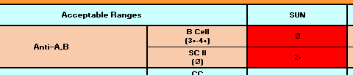  Example of acceptable QC:  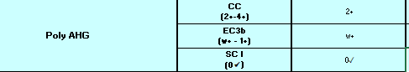
11.0 | Incubate all NEGATIVE reactions with Polyspecific Anti-AHG and Anti-C3d for 5 minutes at room temperature  11.1 After 5 minute incubation at room temperature, spin tubes for calibrated  time and speed for AHG reactions,  11.2 Record results on the Daily Reagent Quality Control Worksheet with tubes  in hand according to workload organization policy.  11.3 To all NEGATIVE tubes with Anti-AHG add one drop of CC.  11.4 To all NEGATIVE tubes with Anti-C3d add one drop of Ec3b cells.  11.5 Spin tubes for calibrated time and speed for AHG reactions.  Note: Test is invalid if check cells fail to result in positive reactions. Entering QC in Excel as Satisfactory confirms the proper reactivity with check cells.  Note: Use the 0 with a check to indicate reactions that were negative that required check cells to be added. This symbol indicates the reaction negative but when check cells were added the reaction was positive.  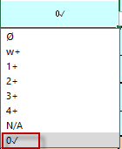
12.0 | Label 6 10x75 tubes for as follows to designate appropriate Rack, Cell being tested and expected positive or negative reaction.  Rack Cell 1 + Cell 1- Cell 2+ Cell 2- Cell 3+ Cell 3-  SP 1+ 1- 2+ 2- 3+ 3-  12.1 Proceed with testing as for Tube Method, Indirect Antiglobulin Testing.  Refer to: BB-SOP-0006 ANTIBODY SCREEN – TUBE and GEL METHOD Indirect Antiglobulin Test
13.0 | Add two drops of the following diluted antisera to the tubes appropriately labeled in the following manner:  Tube: Dilute Antisera  1+ Anti-D  1- Anti-c  2+ Anti-D  2- Anti-C*  3+ Anti-c  3- Anti-D  *Anti-C will be undiluted and available in the special rack.  13.1 Dilute antisera is prepared by assigned tech as needed.
14.0 | Add 1 drop of each screening cell to the appropriately labeled tube.  Tube: Screening Cells  1+ SC 1  1- SC 1  2+ SC 2  2- SC 2  3+ SC 3  3- SC 3
15.0 | Add 2 drops of PeG to each tube for screening cells 1 and 2. Add 2 drops of LISS to two tubes for screening cell 3.  Tube: Screening Cells  1+ PEG  1- PEG  2+ PEG  2- PEG  3+ LISS  3- LISS
16.0 | Incubate all tubes for a minimum of 15±1 minute at 37°C ± 2°C (35-39°C).  16.1 Maximum incubation time for PeG/LISS tube testing is 30 minutes.
17.0 | Remove tubes from the incubator and observe PEG tubes for hemolysis. Place LISS tubes in the centrifuge, spin for calibrated time for 37°C testing and read for agglutination.
18.0 | Wash tubes in cell washer or by hand 3-4 times.
19.0 | Add 2 drops Anti-IgG to each tube, mix.
20.0 | Centrifuge all test tubes at the calibrated time and speed for Antiglobulin testing.
21.0 | Read tubes immediately macroscopically with agglutination viewer.  22.1 Questionable reactions may be observed microscopically.
22.0 | Enter results in Excel QC Worksheet.  22.1 Expected Reactions are indicated in the worksheet. Unacceptable reactions will turn red.  Example of failed QC:  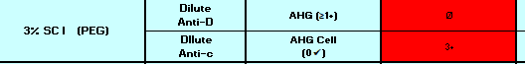  Example of acceptable QC:
23.0 | Place tech initials and date in appropriate column  
24.0 | Label 1 Buffered (Neutral) gel card as follows to designate Special Rack QC, Cell being tested and expected positive or negative reaction.  Special Rack QC  A2 Cell + Screening Cell 1-
25.0 | Add 50µL of each cell to the appropriate labeled well.  25.1 A2 cell – use 0.8% cells  25.2 Screening cell from rack 1
26.0 | Add 25µL of Anti-A,B to both wells
27.0 | Spin gel cards in centrifuge at calibrated time and speed for immediate spin XM testing.
28.0 | Read the front of each microtube macroscopically.  Refer to BB-POL-0004: Grading of Positive and Negative Reactions.
29.0 | Enter results in QC Worksheet.  29.1 Expected Reactions are indicated in the worksheet. Unacceptable reactions will turn red.  Example of failed QC:    Example of acceptable QC:  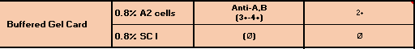
30.0 | Place tech initials and date in appropriate column
31.0 | Compare results with expected results.  31.1 Select S (Satisfactory) or U (Unsatisfactory) under the A/P column.  31.2 Interpret the QC in column QCInt as PASS, FAIL or INVALID.  Refer to Attachment: Interpretation of Results

- Review of QC by Management or Designee

STEPS | INSTRUCTIONS
1.0 | Go to QC Reagent QC Worksheet.
2.0 | Review testing for acceptability and expired reagents.  2.1 Initial management review initials and date.  2.2 Print report after week has been completed and reviewed.
3.0 | Make any notes for any unacceptable reactions on the printed report. Complete QA as needed.
4.0 | File in QC notebook.

Literature References:
Code of Federal Regulations, 606.65(b)(c), 606.160 (b)(5)(i) and (ii), revised periodically
Standards for Blood Banks and Transfusion Services, American Association of Blood Banks, revised periodically.

Related Procedures/Policies in Navex: NA

Attachments/Linked Documents in Title 21:
Attachment: Interpretation of Results
BB-FORMS-0046: Preparation of Diluted Antisera for Daily QC
BB-POL-0004 Grading of pos and neg Reactions.
BB-SOP-0006: Antibody Screen
BB-SOP-0166: Preparation of QC Material

Revision Dates: Review Change Summary as represented in Title 21.

