Applicable Laboratory(s):

☒ North Carolina Baptist Hospital (NCBH)
☐ Lexington Medical Center (LMC)
☐ Davie Medical Center (DMC)
☐ Wilkes Medical Center (WMC)
☐ High Point Medical Center (HPMC)
☐ Westchester
☐ Clemmons

Purpose

The purpose of this procedure is to assign the appropriate computer disposition or status and properly dispose of or return to the supplier units that are unacceptable for transfusion.

Scope

This procedure applies to Blood Bank Staff and Management

Definitions

- Procedure: A process or method for accomplishing a specific task or objective.
- WFBH Lab System: Wake Forest Baptist Lab System is a health system that includes Wake Forest Baptist Medical Center and all affiliated organizations including Wake Forest University Health Sciences (WFUHS), North Carolina Baptist Hospital (NCBH), Lexington Medical Center (LMC), Davie Medical Center (DMC), Wilkes Medical Center (WMC), High Point Medical Center (HPMC), Lab at Westchester and Lab at Clemmons.
- ARC: American Red Cross
- BC/TBC: The Blood Connection
- BCW: Blood Center of Wisconsin
- MISC: Miscellaneous
- CP: Component Prep
- Status Codes:
- DS Discarded
- OD Out Dated (Expired)
- WN Wrong Number
- IS Issued
- IF Issued Final
- INV Inventory
  - AV Available
  - AL Allocated
  - UP Unprocessed
- QU Quarantined
- SO Shipped Out

Supplies/Materials

See individual sections

Procedure Guidelines

I: General Blood status Update

Chemical Risk Assessment: none
Biological Risk Assessment: none
Protective Equipment: Lab coat, gloves
Supplies: N/A
Reagents: N/A
Equipment: Computer with Sunquest access

STEPS | INSTRUCTIONS
1.0 | BSU > Unit Update should be used when changing the status of a unit not in a finalized status.  - Non Final status: Unprocessed, Available, Allocated, Issued, Quarantine  - Finalized status include: Issued Final, Transfused, Wrong number, Discarded, Outdated
2.0 | 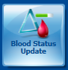  Update the unit in Sunquest.  2.1 Open Blood Status Update  2.2 Ensure the update option is “Unit Update”    2.3 Scan unit number and product code, ensure correct division is selected. (note:  only one unit can be updated at a time.)  - Populate date/time  - Select new status: (examples below)  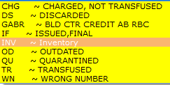  - Temperature: This field is optional but should be used if units were not stored/shipped at appropriate temperatures.  - Perform Visual Inspction and indicate pass or fail:    - Enter reason/comment if applicable: Refer to Attachment 1: Reason/Comment Codes  Note: ROK (returned in regulated cooler) and MTPOK are comment codes, not Reason Codes  - Update Unit location to WIN, or other location if applicable.    - If returning unit after issue: Select desired status of unit un Reallocation of Unit.  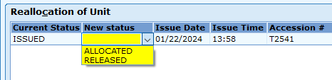  Note: it is standard practice to release units when they are returned unless they are serologically crossmatched or it is strongly believed they will be needed in the future.
3.0 | Physically take care of unit once computer is complete.  - If unit is released, place it on the available shelves after removing tags.  - If unit is allocated, place on allocated shelves.  - If unit is quarantined, place unit on quarantined shelf  - If unit is discarded, document on unacceptable units disposition log and/or complete RL6 and wastage log BEOFRE physically discarding the product. Product can be retained on appropriate shelf for QC or training if needed.  - If unit is expired, document on expired products log BEFORE physically discarding the product. Product can be retained on appropriate shelf for QC or training if needed.
4.0 | Units that are returned from the floor and are unacceptable for reissue during the day should have the status changed and the unit disposed of by the tech who returns the unit.  IF ACTION  Patient received any of the unit Status must remain Transfused for Lookback tracking. - In function BPE - Add comment specifying the volume given. - Dispose of the unit, if returned, in the large regulated biohazard waste box. - Record the wastage in the Wastage Log, if applicable. - Complete an RL6 report, if applicable.  No part was transfused In function Blood Status Update: - Ensure the update option is “unit update” - Scan unit number and product code, ensure correct division is selected. - Change the status of the unit to DS = Discarded and enter valid reason code. Refer to Attachment 1: Reason Codes - Write the Unit Number, ABO/Rh, and product along with status and reason codes on the daily expired products sheet. - Dispose of the unit in the large regulated biohazard waste box. - Record the wastage on the Wastage Log. - Complete an RL6 report.

II. Expired Products

Chemical Risk Assessment: none
Biological Risk Assessment: none
Protective Equipment: Lab coat, gloves
Supplies: N/A
Reagents: N/A
Equipment: Computer with Sunquest access

STEPS | INSTRUCTIONS
1.0 | Print Expired Products Report after midnight (Third shift task).  Open Sunquest SmarTerm (Roll and Scroll)  - Log in  - Function: BBR  - Printer: WIN (or WIN2)  - ?: 4 (Expired Blood Product List)  - Hosptial ID: AHWA  - Area: WIN  - Area: Enter  - Hosptial ID: Enter  - Accept (A), Modify (M), or Reject (R): A  - Component Type/Group: Enter (ALL)  If specific component type desired:  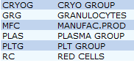  - Accept (A), Modify (M), or Reject (R): A
2.0 | Pull the expired products that have printed on the list.  2.1 Check the QC shelf for any products that may have expired prior to midnight.  - Units that expire prior to midnight should be removed to the QC shelf.  (plasma, cryo, etc.)
3.0 | Match the expired units to the units on the Expiration Report and place a check by each unit.  3.1 Initial and date the Expiration Report when all units have been pulled  and accounted for.  3.2 Request credit in Blood Hub if unit qualifies (CDIE).
4.0 | Discard all expired units in the large regulated waste biohazard bin.  4.1 Enter unit comment if released to research.  Refer to BB-POL-0018 (R): Platelets Protocols

III. Unacceptable Units Due for Credit

Chemical Risk Assessment: none
Biological Risk Assessment: none
Protective Equipment: Lab coat, gloves
Supplies: N/A
Reagents: N/A
Equipment: Computer with Sunquest access

STEPS | INSTRUCTIONS
1.0 | Unacceptable units due to a supplier issue should have a credit request placed in Blood Hub for ARC units. Non ARC units, contact the blood supplier.  - Request credit in Blood Hub for ARC products.  Refer to BB-SOP-0015: American Red Cross Connect Online Blood Ordering System  - Call the main ARC number 800-532-0025, option 3, Monday –Friday, during business hours for any product quality issues such as labeling problems or ABO discrepancies.  - During downtime fill out a Credit Request for Products-Non-Physical Return form.  - The ARC will fax a Return Authorization Form back to us.  - When the fax copy is received fill out Section 2: Customer Product Quality Certification.  - Fill in the Customer Number (2420) and Customer Name (WFUBMC)  - The tech filling out the form should Print their name and the date.  - Write the ENTIRE unit number, including the 00 and check digit (ex. W20121482589500V), on a separate line for each unit.  - Fill in the ABO/Rh and Product Code from the unit bag.  Broken Plasma Clotted, Hemolyzed, etc.  Check the box for Broken. Note: The sheet may be held until Friday and additional units added during the week as needed. Fax on Friday if held. Mark Return for Quality Issue and write ‘issue’ in the comment space. Note: If a frozen red cell is broken, make a note of any antigens charged in order to get credit.  Fill out the date and time of return.  - Fill out the date and time of return, SIGN THE FORM.  This must be done to obtain credit.  - Fax the Credit Request sheet to the ARC number printed on the form.  - The ARC will fax the completed request authorization back.  - File the completed form in the Blood Invoice tray.  - NOTE: Contact other suppliers to determine the documentation needed and to request credit.
2.0 | Update the unit in Sunquest.  2.1 Open Blood Status Update  2.2 Ensure the update option is “Unit Update”  2.3 Scan unit number and product code, ensure correct division is selected.  - Populate date/time  - Select new status: DS = Discarded  - Enter reason: Refer to Attachment 1: Reason Codes  - BWBR = Bag Broke in Waterbath  - CLOTS = Apparent Clots in Bag, Fails Vis Inspection  - DISCO = Discolored, Fails Visual Inspection  - HOTB = Exceeds Proper Temp, Do not Issue  - FAIL = Fails Visual Inspection  - HEMOL = Hemolyzed, Fials Visual Inspection  - ODDR = Outdated  - SDATE = Short Date  - VNDR = Ventor Request
3.0 | Physically take care of unit once paperwork is complete.  Discarding unit Returning unit  Place in large regulated waste biohazard bin. - Pack the returned product appropriately. - Make a copy of the return authorization form and write which product (ex. Plasma) was returned on the copy and place in the Blood Invoice tray. - Place the original inside the shipping box on top of the Styrofoam inner container before sealing the box. - Place a green Return Label on the outside of the box. - Write on the label which blood center the box is going to: Charlotte or Durham. - Refer to Attachment 4:Return To: American Red Cross - Give the box to the ARC delivery person to return to ARC.
4.0 | Place printout from BloodHub in Blood Invoice tray.
IV: Transfer

Chemical Risk Assessment: none
Biological Risk Assessment: none
Protective Equipment: Lab coat, gloves
Supplies: N/A
Reagents: N/A
Equipment: Computer with Sunquest access

STEPS | INSTRUCTIONS
1.0 | Units that are transferred to another hospital or sent to an offsite facility, Davie for stock, are Transferred in Sunquest.  - In function Blood Status Update, select update option “Ship Out”  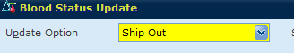  1.2 Scan the unit number and product code at the prompts. Note: More than 1  unit can be transferred at a time.  - When all the units being transferred are selected, click Submit to accept unit list.  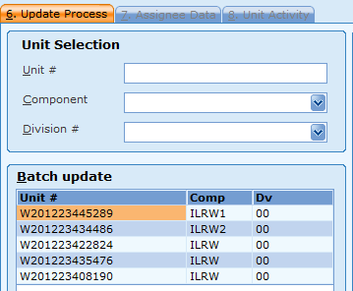  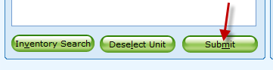  - Enter date/time and destination.  Note: look up box available to search for destinations.  Refer to Attachment 2: Outside Hospital Locations  - Indicate visual inspection pass    - Enter reason code.  Refer to Attachment 1: Reason Codes  - Press, Continue and Save.  - Change Location of Unit if applicable when prompted (only applicable if transferring inside AHWA HID).  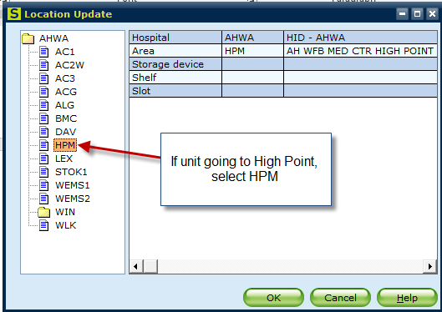
2.0 | Pack the product appropriately.  2.1 Units sent to outside hospitals are packed in ARC shipping boxes if cooler  cannot be returned or no cooler available.
3.0 | Ensure a courier is coming to pick up product.

V: Units Returned from “Transfer”

Chemical Risk Assessment: none
Biological Risk Assessment: none
Protective Equipment: Lab coat, gloves
Supplies: N/A
Reagents: N/A
Equipment: Computer with Sunquest access

STEPS | INSTRUCTIONS
1.0 | Units returned from Outside Hospitals  - Units that are in date and within temperature range can be returned to inventory.  - Units that are expired or out of acceptable temperature range must be discarded.
2.0 | - In function Blood Status Update, select update option “Ship Out to Inventory”  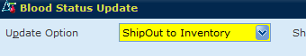  - Scan the unit number and product code at the prompts. When all the units being transferred are selected, click Submit to accept unit list.  Note: units must be returned one at a time.  - Enter date/time and “INV” for inventory.  - Enter temperature if unit is too hot/cold. This is not routinely documented but available if unit shipping status was questionable.  - Indicate visual inspection pass or fail  - Enter reason code if applicable. This field is optional.  Refer to Attachment 1: Reason Codes  - Press, Continue and Save.  - Update location to WIN  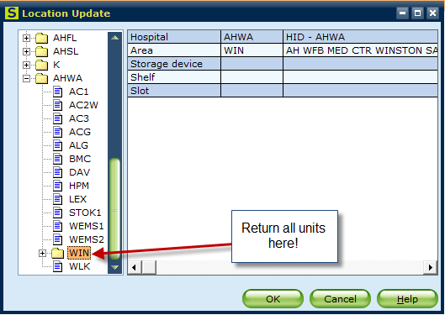

VI: Return for Freezing

Chemical Risk Assessment: none
Biological Risk Assessment: none
Protective Equipment: Lab coat, gloves
Supplies: N/A
Reagents: N/A
Equipment: Computer with Sunquest access

STEPS | INSTRUCTIONS
1.0 | Autologous units or liquid units with rare antigens may be returned to the ARC to be frozen for later use.  NOTE: Other suppliers – check with supplier to see if they will accept return and freeze.  - Return on line with ARC Blood Hub.  Refer to BB-SOP-0015: American Red Cross Connect Online Blood Ordering System  - During downtimes, call the main ARC number 800-532-0025, option 3, Monday –Friday during business hours, to obtain authorization for the return.  a. The ARC will fax a Return Authorization Form back to us.  b. When the fax copy is received fill out Section 2: Customer Product Quality  Certification.  c. Mark Return for Reissue.  d. Fill out the date and time of return.  e. SIGN THE FORM.  f. Note which ARC facility the unit needs to be sent to.
2.0 | Return the unit in SunQuest.  - Blood Status Update  - Follow steps in section IV: Transfer, ensure location is ARC.  - Free text that unit is being returned to be frozen.
3.0 | Pack the returned product appropriately.  3.1 Make a copy of the return authorization form and place in the Blood Invoice  tray.  3.2 Place the original inside the shipping box on top of the Styrofoam inner  container before sealing the box.  3.3 Place a green Return Label on the outside of the box. Write on the label which  blood center the box is going to: Charlotte or Durham.  3.4 Give the box to the ARC delivery person to return to ARC.

VI: Blood Status Correction

Chemical Risk Assessment: none
Biological Risk Assessment: none
Protective Equipment: Lab coat, gloves
Supplies: N/A
Reagents: N/A
Equipment: Computer with Sunquest access

STEPS | INSTRUCTIONS
1.0 | Units that need to be updated that have a finalized status cannot be updated in Blood Status Update, but must be done by a supervisor with access in Blood Status Correction  - Example: Blood in Issued Final status that was returned after BIF was performed.
2.0 | 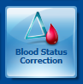  Open Blood Status Correction
3.0 | Scan or Enter unit number and product code/division.  3.1 Click Remove Status, to delete the finalized status.  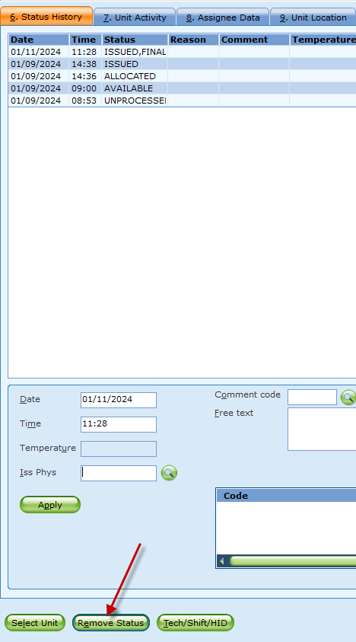
4.0 | Click Review. A new window opens to allow the unit to remain Allocated or Released.  Note: units that expired cannot remain allocated.
5.0 | Press Save.  Open Blood Bank Inquiry to ensure unit is desired status. If not, continue to Blood Status Update to further move unit into desired status.

VII. Blood Location Update

Chemical Risk Assessment: none
Biological Risk Assessment: none
Protective Equipment: Lab coat, gloves
Supplies: N/A
Reagents: N/A
Equipment: Computer with Sunquest access

STEPS | INSTRUCTIONS
1.0 | Units in AirCare/EMS locations should have their location updated using the Blood Location Function.  - These units remain under the control of the blood bank and these external locations allow for easy tracking of the units.  - Do NOT “ship out” the units to these locations.
2.0 |   Open Blood Location
3.0 | Select Single Unit (Multiple Units allows for an inventory search but the preference is to scan individual units.)  3.1 Scan unit number and component type  3.2 Enter date and time  3.3 Select the new location  3.4 Click Add to list
4.0 | Once all units have been added to the list, click Save

Literature References: NA

Related Procedures/Policies in Navex: NA

Attachments/Linked Documents in Title 21:

Attachment 1: Reason Codes
Attachment 2: Unit Recall Flow Chart
Attachment 3: Canned Messages for Status Changes
Attachment 4: Expired Products
Attachment 5: Unacceptable Unit Disposition
Attachment 6: Unacceptable Unit Disposition Log
BB-SOP-0015: American Red Cross Connect Online Blood Ordering System
BB-POL-0018 (R): Platelets Protocols

Revision Dates: Review Change Summary as represented in Title 21.

