Applicable Laboratory(s):

☒ North Carolina Baptist Hospital (NCBH)
☐ Lexington Medical Center (LMC)
☐ Davie Medical Center (DMC)
☐ Wilkes Medical Center (WMC)
☐ High Point Medical Center (HPMC)
☐ Westchester
☐ Clemmons

Purpose

The purpose of this procedure is to detail how to order, result, and credit patient and unit testing in the Sunquest Blood Bank and Epic LIS system.

Scope

This procedure applies to Blood Bank Management

Definitions

- Procedure: A process or method for accomplishing a specific task or objective.
- WFBH Lab System: Wake Forest Baptist Lab System is a health system that includes Wake Forest Baptist Medical Center and all affiliated organizations including Wake Forest University Health Sciences (WFUHS), North Carolina Baptist Hospital (NCBH), Lexington Medical Center (LMC), Davie Medical Center (DMC), Wilkes Medical Center (WMC), High Point Medical Center (HPMC), Lab at Westchester and Lab at Clemmons.

Supplies/Materials

Patient or Unit testing results
Computer with Access to Epic and Sunquest

Sections
- Ordering Tests in EPIC
- Resulting Tests in EPIC Beaker
- Ordering Tests in Sunquest
- Resulting Tests in Sunquest
- Charging tests in Sunquest
- Crediting tests in Sunquest

Procedure Guidelines
- Ordering Tests in EPIC

Chemical Risk Assessment: low
Biological Risk Assessment: low
Protective Equipment: Lab coat, gloves
Reagents: NA
Supplies: Patient information
Equipment: Computer
Specimen Requirements: NA
STEPS | INSTRUCTIONS
1.0 | Enter Patient Chart and open “Order Sets”
2.0 | Type in name of desire test or LAB code. All Tests start with “AH”  LAB Code Name Sunquest Code Testing  LAB2609 ABO/Rh type < 4 months NEABRH ABO/Rh (forward)  LAB895 ABO/Rh type ABRH ABO/Rh  LAB278 Antibody Screen ABSCR Antibody Screen  LAB274 Direct Antiglobulin Poly DAT Broad Spectrum (Poly)  LAB5518 DAT < 4 months NEODAT DAT IgG  LAB5540 Supplier Lookback Notification BBLKBK none  LAB647 Transfusion Reaction Workup TRXI ABO/Rh, DAT Post Transfusion Reaction  LAB276 Type and Screen TYHD ABO/Rh, Antibody Screen  LAB5519 Molecular RBC Genotyping RBCGEN Genotype (send out)  LAB892 Cord Blood Workup CDBLD ABO/Rh, DAT IgG  LAB5047 Prenatal Testing PREN ABO/Rh, Antibody Screen  LAB5161 Crossmatch Neonatal Red Cells TNRCC ABO/Rh  LAB5045 RhoGam Antenatal Evaluation RAE Rh(D) Factor  LAB5044 Isohemagulutinin ISOHEME Isoheme titer result  LAB6626 Patient ABO/Rh Recheck PRCXM ABO/Rh  LAB7537 PUBS Type and Screen PUBS ABO/Rh, DAT IgG  LAB7409 Type and Screen BMT donor BMTD ABO/Rh, Antibody Screen  LAB6749 Pathology Review Transfusion Reaction none  Pathology Review Blood Bank Testing none  LAB5046 Cord Blood for Hold NA None, hold for future add-on BB tests.  LAB7956 Plasma Free Hemoglobin (ECMO) NA Plasma Free Hgb  LAB762 Rhogam Workup TRHIG ABO/Rh, Fetal Screen  LAB286 LAB6898 Blood Bank Hold Tube NA None, hold for future add-on BB tests.
3.0 | Press Sign and Complete ordering information: Ordering Provider, etc.  3.1 If order needs to be collected and received, Refer to BB-SOP-0054 Specimen Receipt  in Epic

- Resulting Test in Epic Beaker

Chemical Risk Assessment: low
Biological Risk Assessment: low
Protective Equipment: Lab coat, gloves
Reagents: NA
Supplies: Patient information
Equipment: Computer
Specimen Requirements: NA

- Plasma Free Hemoglobin
STEPS | INSTRUCTIONS
1.0 | In Epic, Open the Outstanding List  - To find this list, open the search bar and type “outstanding” into the search field.  - Chick Outstanding list from the drop down menu.  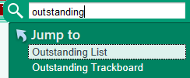  - Ensure the Outstanding list selected is .CP Blood Bank  - Pin this list to your task bar for easy access in the future.  
2.0 | Select the test that needs to be resulted from the outstanding list.  - Currently the only test resulted directly in Beaker is plasma free hemoglobin (ECMO) patients only.  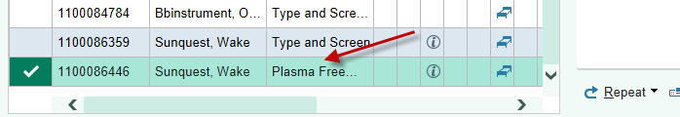
3.0 | The Patient test will be displayed in the center of the screen. Click the pencil for Edit Results.  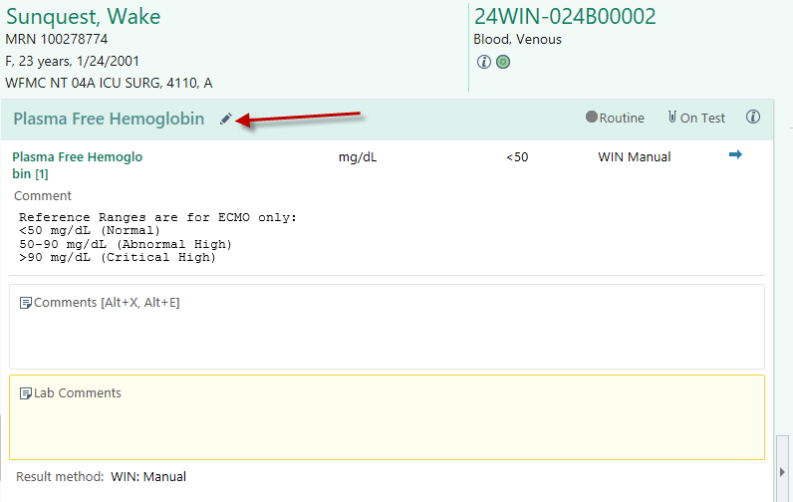
4.0 | Enter the result in the resulting grid that displays. Click the hourglass to search.  4.1. Note: Title = results. Values are sorted by Number which is an Epic build. Choose the  Title that matches your patient testing results.  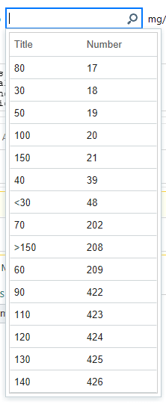
5.0 | Results will Display as follows.  Normal: check mark.  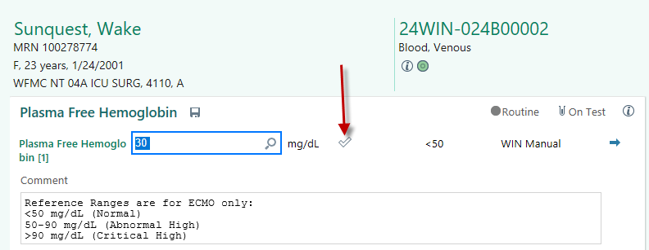  Abnormal: will have a red exclamation  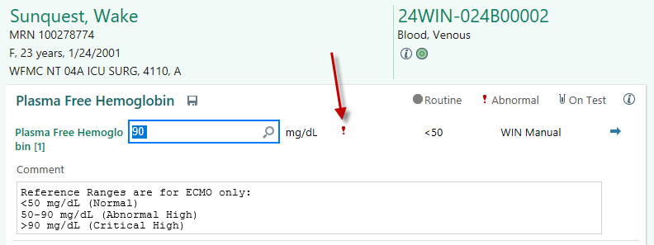  Critical: will have two red exclamations. These require the care team to be notified about critical value result.  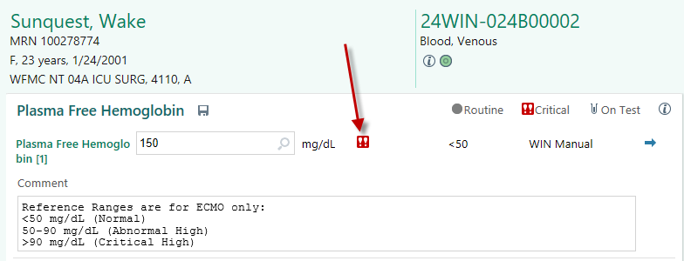  Note: Critical Values must be called and documented.  Refer to Section B: Critical Value Documentation in Epic
6.0 | Finalize Result by Clicking Verify at the bottom right of the screen.  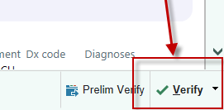
7.0 | Review Results for Accuracy and either go back to change/edit or Confirm Final the test results.  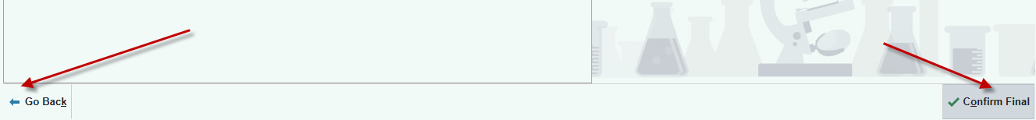  7.1. Once result has been verified, the test will fall off the outstanding list and be visible in  the patient chart.

- Critical Value Documentation in Epic

STEPS | INSTRUCTIONS
1.0 | For Epic only tests (plasma free hemoglobin) follow the steps below. Sunquest can be used to document critical values for Sunquest tests.  Refer to Section IV. T: Documenting Critical Value Calls in Sunquest
1.0 | Select Test from Outstanding List
2.0 | Click the pencil icon to edit the test result
3.0 | Click in the Comments box to add the following message:  “Critical Value Called to and Read back by Provider Last Name, First Name Credentials. Tech full name and credentials. Date and time.”  Note: the code .ctrb can be used to populate the correct phrasing. Techs will need to complete the blank fields indicated with ***.  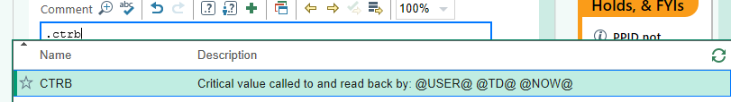  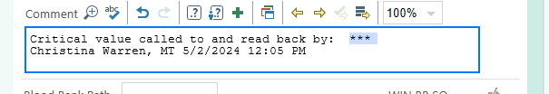  Examples:  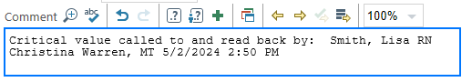
4.0 | If the comment box is not visible, you can click the page icon next to the blue arrow.  
5.0 | Ensure critical value call documentation is under the test associated with the critical value. Example: if using Epic to document critical value of an antibody screen result, ensure the comment is being added under the antibody screen and not under ABO, etc.  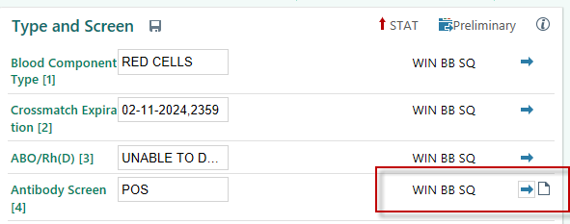
6.0 | Routinely Sunquest can be used to document critical values for Sunquest tests. For Epic only tests (plasma free hemoglobin) follow the steps below.
7.0

- Ordering Tests in Sunquest

Chemical Risk Assessment: low
Biological Risk Assessment: low
Protective Equipment: Lab coat, gloves
Reagents: NA
Supplies: Patient information
Equipment: Computer
Specimen Requirements: NA
STEPS | INSTRUCTIONS
1.0 | Initial Test must be ordered in EPIC. Additional testing can be added on in Blood Order Processing. Open BOP.
2.0 | Patient can be accessed multiple ways (see below); however, the preferred way is to scan the Container ID.  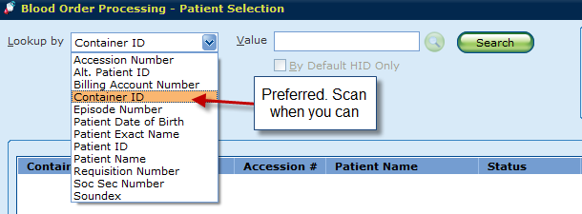
3.0 | Check patient Blood Administrative Data file for any important information before entering accession.
4.0 | Under order Selection, select accession to result current testing.
5.0 | First click inside the Add Spec. Test box to activate the keyboard, then click the keyboard button.  5.1. If the test is not on the keyboard, you can add a test by typing in the test code. After  clicking in the Add Spec. Test box, press the TAB key. You can now enter a test code,  example “ABI” for Antibody Identified. If you do not know the test code, you can click  the magnifying glass to look up tests to add.  Note: Testing on patients is added in the middle of the screen, under all patient testing. Testing on units (AGTB, etc) is added at the bottom of the screen under unit crossmatch testing.
6.0 | Add the tests desired to the order.  6.1. Note: Once the tests are ordered, they can be deleted ONLY if done so before  saving.  6.2. To delete a test. Click on the test under the result column and hit “SHIFT + Delete”.  The following box will appear. Click OK to delete test.  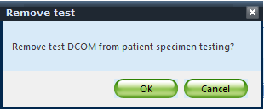  6.3 Do not add tests until you are ready to result them. Once the test is added and saved,  it will generate a charge. Refer to section V. for crediting tests.  6.4 Refer to Attachment 1: Sunquest Testing Key Board Job Aid for a list of test to add.  Common tests added under patient include:  Definition Test KEYBOARD KEY  Antibody eluted %ELU S  Antibody Identification %ABI M  Antibody Screen %AS V  Antigen Information (Patient) %AGI <  Blood Bank Comment to Pt. Chart BBC  Blood Bank Only BBO  Broad Spectrum Coombs %DBS R  Complement DAT %DCOM ^  DAT IgG Coombs %DIG E  Du Testing %DU D  Patient Problem Info %PB , (“comma”)  Common tests added under units include:  Definition Test KEYBOARD KEY  Coombs Crossmatch CXM $  Unit Tag Comment %CM C  Unit Tag Reprint %UR 1  Sickle Cell Testing SDX  Antigen Typing on Unit AGTB
7.0 | Click Save to keep ordered tests and close, or cancel to start over.

- Resulting Tests in Sunquest.

Chemical Risk Assessment: low
Biological Risk Assessment: low
Protective Equipment: Lab coat, gloves
Reagents: NA
Supplies: Patient information
Equipment: Computer
Specimen Requirements: NA

STEPS | INSTRUCTIONS
1.0 | Initial Test must be ordered in EPIC. Additional testing can be added on in Blood Order Processing. Open BOP.  NOTE: All testing should be complete and final before ordering in BOP. Tests ordered and left pending will generate charges and charges once generated cannot be changed!
2.0 | Patient can be accessed multiple ways (see below); however, the preferred way is to scan the Container ID.
3.0 | Check patient Blood Administrative Data file for any important information before entering accession.
4.0 | Under order Selection, select accession to result current testing. Continue to section below as applicable.

- Patient testing: ABO/Rh (Manual Entry)

STEPS | INSTRUCTIONS
1.0 | Enter Reactions in ABO/Rh(D) grid.  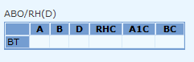  Note: If ABO Reaction grid does not display, click on the ABO/Rh test line in the result column. Also, The box titled “Use reaction result grids” should Always be checked unless instructed otherwise by management
2.0 | Enter interpretation.  Refer to BB-SOP-0003: ABO Testing Manual Method  Refer to BB-SOP-0004: Rh Testing and Weak D Typing  - The orange outline means you are typing using the keyboard. Most ABOs will be easy to result.  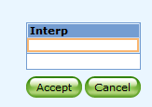  - If you are having difficulty remembering the keyboard code for a result, enter the semicolon key and click the hourglass to search for available interpretations.  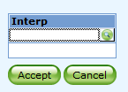  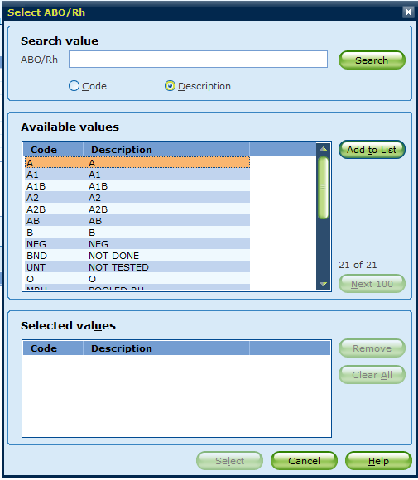

- Weak D Testing (Manual Entry)

STEPS | INSTRUCTIONS
1.0 | Click on DU test
2.0 | Enter reactions into the DU Antigen reaction grid  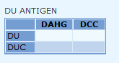  DU = Patient weak D  DUC = Control  DAHG = AHG result  DCC = Check Cell Result
3.0 | Enter Interpretation

- Antibody Screen (Manual Entry)

STEPS | INSTRUCTIONS
1.0 | Select Antibody Screen Under Result Column to display the Antibody Screen Reaction Grid.
2.0 | For Routine Screens (Manual) Enter the Antibody Screen Reactions in the Grid  - Note: The grid is built for a 4-cell screen. The 4th cell is not tested.  - The results will accept gel or tube testing results.  Note: If screen reaction grid does not display, click on the screen test line in the result column. Also, The box titled “Use reaction result grids” should Always be checked unless instructed otherwise by management
3.0 | Enter Interpretation and click accept.

- Selected Screens (Manual Entry)

STEPS | INSTRUCTIONS
1.0 | Deselect the box for “Use reaction results grids”  Note: This should be the ONLY time this box is deselected and reaction grids not used without management approval.
2.0 | In the Antibody Screen row under Results enter Interpretation only. (Example: Pos)
3.0 | Order a Blood Bank Only Comment  - In the Add Spec. Test box type semicolon BBO “;BBO”  - In the blood bank only comment result box type 2 semicolons”;;” to be able to free text and enter “Selected Screen”.  NOTE: DO NOT ORDER A BBC. This Comment goes to the Chart!  - All selected screens MUST go to management for review and be scanned into the patient files since reactions are not recorded in the BB LIS system.

- Antibody Identification

STEPS | INSTRUCTIONS
1.0 | Click on the ABI test result line and enter result.  - Result should be the specificity of antibody identified.  - Type a semicolon and then correct English text code to add antibody.  - If more than one antibody identified, hit tab and then semicolon to add additional antibodies.  - Refer to Attachment 2: Antigen and Antibody Codes  - Antibodies identified will be added to the BAD file.

- Direct Antiglobulin Testing (Manual)

STEPS | INSTRUCTIONS
1.0 | Click on DATBS (for Poly) and result the reactions in the grid.  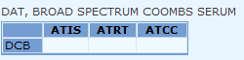  ATIS = Immediate Spin testing  ATRT=5 min incubation testing  ATCC= check cell reaction  Note: Per policy, anytime a DATBS is ordered, a full DAT profile is required  This grid is built for tube testing results. If resulting gel testing manually, enter ND for ATRT and ATCC. A QA failure will be generated.
2.0 | Enter Interpretation
3.0 | Click on DIG (for IgG) and result the reaction in the grid  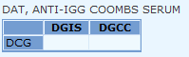  DGIS = Immediate Spin testing  DGCC = check cell reaction
4.0 | Enter interpretation
5.0 | Click on DCOM (for complement) and result the reactions in the grid.  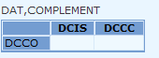  DCIS = Result of RT testing, includes 5 min incubation phase  DCCC = complement check cell reaction
6.0 | Enter interpretation

- Elution Testing (Acid Elution) or Lui Freeze Elution

STEPS | INSTRUCTIONS
1.0 | Click on the ELU or LUI test result line and enter result.  - Result should be the specificity of antibody eluted as free text entry.  - This information goes into the BAD file. Results should be documented as below:  - Press the semicolon key two times to free text entry  - “;Eluate negative mm/dd/yy”  - “;Anti-D in Eluate mm/dd/yy”  - Charge for panels as needed.  Refer to Section V. Charging in Sunquest

- Patient Antigen Typing

STEPS | INSTRUCTIONS
1.0 | Click on AGI test result line and enter result.  - Result should be the phenotype of the antigen tested.  - Type a semicolon and then correct English test code to add antigen.  - If more than one antigen tested, hit tab and then semicolon to add additional antigens.  - Refer to Attachment 2: Antigen and Antibody Codes.  - The antigen testing result will be added to the patient BAD file.

- Crossmatch (Electronic, Immediate Spin and AHG) and tag reprint.

STEPS | INSTRUCTIONS
1.0 | In BOP, click on Patient Specimen and update the UO (units ordered) to match how many units are crossmatched.  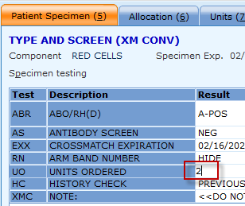
2.0 | In BOP, click on Allocation  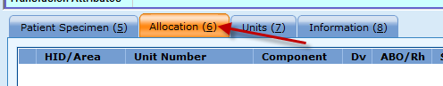
3.0 | Scan Unit and Product Code and hit select.  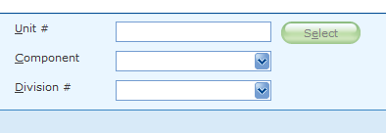
4.0 | Electronic Crossmatch: Press Save once all units have been allocated to the order.  - If the patient qualifies for an electronic crossmatch, the following box will display.  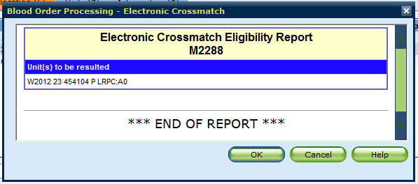  - Press Ok to complete EXM of unit.
5.0 | Immediate Spin Crossmatch: Enter ISXM result in the Crossmatch reaction grid.  - If the reaction grid is not displayed, click inside the XM column next to the unit selected.  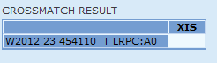  - Enter Interpretation as either compatible or incompatible using the keyboard, then Accept.  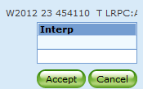  - Enter “OK” or “Not OK” under the TS column. This column is asking if the unit is ok to transfuse. Use the keyboard to result. If you result NOK, a unit tag will not print.  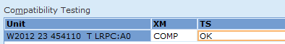  - When the ISXM cannot be done (example: trauma and no sample arrives on the patient) the Crossmatch result should be resulted as ND (not done) and the interpretation as NRQ (not required)  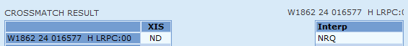
6.0 | Full AHG Crossmatch: Order the full crossmatch by adding the test “CXM”.
7.0 | Result the Crossmatch in the Coombs Crossmatch reaction grid.  - The grid will accept tube or gel testing reactions.  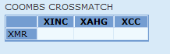  NOTE: if your patient requires a FULL AHG Crossmatch, and you fail to order one, Sunquest will not flag you if you only complete the ISXM and say the unit is ok to transfuse! You MUST follow policy and complete all Crossmatches needed PER POLICY!  - Result the interpretation of the AHG Crossmatch as either compatible or incompatible using the keyboard, then press accept.  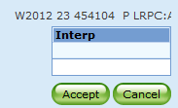  - Note: if the AHG XM is incompatible and the ISXM is compatible, you cannot result the XM as compatible. The XM test is what prints on the tags and what is transmitted so the following result in an incompatible unit being mistakenly called compatible.  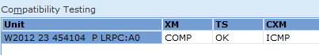  To avoid this, change the XM test to incompatible as the overall crossmatch interpretation.  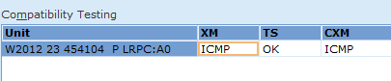  Override associated QA failure.  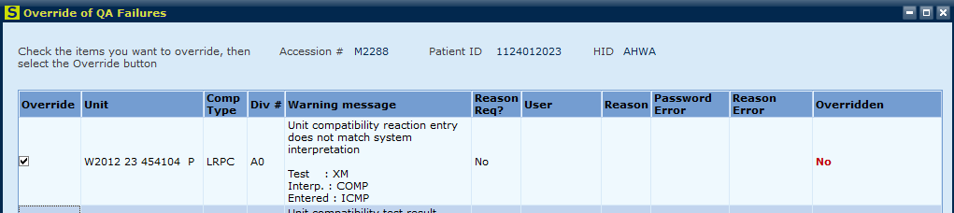  - Enter “OK” or “Not OK” under the TS column. This column is asking if the unit is ok to transfuse. Use the keyboard to result. If you result NOK, a unit tag will not print.
8.0 | Unit tags will print based on sign in location (WIN will print up front and WINCP will print in CP area).  - A screen will display allowing you to proceed to Issue, Emergency Issue, or Return to BOP.

- Titrations (Prenatal)

STEPS | INSTRUCTIONS
1.0 | Ensure “TITER” has been ordered under Add Spec. Test.
2.0 | Click on result field for TITER test and type in 2 semicolons to free text in result.
3.0 | Free text result should be standardized and entered as:  - Positive titers: “;IgG Anti (X) Titer is (#)”  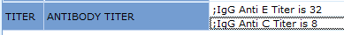  - Negative titer should be resulted with the verbiage “negative” and not “0” zero.

- Isohemagulutinin (Titers)

STEPS | INSTRUCTIONS
1.0 | Ensure accession for ISOH has been selected.
2.0 | Free text result should be standardized and entered as:  - Positive titers:  - “IgG Anti (X) Titer is (#)”  - “IgM Anti (X) Titer is (#)”  - “DTT IgG Anti (x) Titer is (#)”  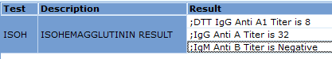  - Negative titers should be resulted with the verbiage “negative” and not “0” zero.
3.0 | Use the TAB key to add additional titration results, then click Save

- Crossmatch Neonatal Red Cells (TNRCC) (Type and Screen Neonate)

STEPS | INSTRUCTIONS
1.0 | Result ABO/Rh as per section A above.  - Follow current SOPs and add on DU test if Rh negative infant and result per section B above.
2.0 | Update units ordered if applicable.  - Note: All subsequent TNCC orders need to be allocated under the TNRCC order. Change the units ordered as applicable under the TNRCC while changing the total ordered under the TNCC order to zero.
3.0 | Under MHN, enter Mothers MRN  - Free text: Use BB Relationships to link Mom to baby if not already done by FD tech.
4.0 | Under Maternal Screen Comment enter “HIDE”, this will translate to Do not Report.  - This is the result of the mother’s antibody screen and is used in the Charlotte region instead of testing the baby’s sample if mother has a current TSX on file.  - Policy will remain to do antibody screen testing on the neonate sample here at NCBH.
5.0 | Order and result “AS” Antibody Screen (or selected screen) per section C and D above.
6.0 | Order “EXX” Expiration of Crossmatch. Enter date that neonate turns 4 months.
7.0 | Order and result “DIG” DAT IgG per section F above, if applicable.

- RHOGAM Workup (TRHIG)

STEPS | INSTRUCTIONS
1.0 | Result ABO/Rh per section A above.  - Only Rh negative Mothers will have this test ordered so they should ALWAYS have a DU (weak D) test added.
2.0 | Result DU test per section B above.
3.0 | Under Units Ordered, result “HIDE” if not defaulted. This will translate to “do not report”
4.0 | Enter Baby Blood Type.  - Free text in the baby’s ABO/Rh and MRN  - If more than one baby, ensure all results are free texted in on the same line.  Note if you tab and use two lines, the results will not cross correctly to Epic.
5.0 | Result Fetal Screen in reaction grid.  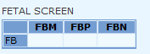  FBM = Fetal Screen Maternal Result  FBP = Positive Control  FMN = Negative Control  *Positive results should be entered as w+, negative results should be entered as 0.
6.0 | Result Fetal Screen Interpretation as positive or negative  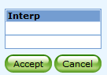
7.0 | Free text in Fetal Blood Screen Kit lot number and expiration date
8.0 | Press Save
- Transfusion Reaction

STEPS | INSTRUCTIONS
1.0 | Result ABO/Rh as per section A above on Post transfusion specimen.
2.0 | Result “YES” or “NOO” (NO) under BPCN for Blood Product Culture Needed  - If this field is answered “yes” then a blood culture is automatically ordered in Encompass. Print label and take product to Micro.
3.0 | Enter Blood Product. Free Text in the Component Type  - Example “Platelet”
4.0 | Enter Clerical Check Result  - CLCN = Clerical Check OK  - CLERR = Clerical Check Error
5.0 | Enter Pre and Post Transfusion Appearance in appropriate row.  - HZD = Hemolyzed  - LIP = Lipemic Specimen  - ICT = Icteric  - NORM = Normal
6.0 | Enter results for Post Transfusion DAT according to section F above.  - Note: Only a Poly DAT is ordered on the Post Sample.  - Order and Result IgG DAT and C3d DAT result on Post sample
7.0 | Enter the unit number and Ecode of the unit suspected to be involved in the reaction as a free text entry.
8.0 | Add on testing for Urine ONLY if received!  - 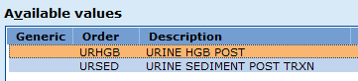  - Result using the following codes:  - Code for UHGB - Translation  - NA - Not Done – Do NOT Use. Cancel/credit test.  - NEG - Negative  - TR - Trace  - MD - Moderate  - ;free text - Hemolyzed Trace  - ;free text - Hemolyzed Small  - MODH - Hemolyzed Moderate  - ;free text - Hemolyzed Large  - Code URSED - Translation  - NA - Not applicable – do NOT use – cancel/credit test.  - NONE - None  WHIT White  BRWN Brown  LTAN Tan  PINK Pink  RED Red
9.0 | Order and result the Pre DATBS on the pre-sample accession number.  - Note: if pre Poly DAT is positive, result monospecific (IgG and C3d) results.
10.0 | Add on additional testing as required or requested by management/medical director.  - Example: Elution
11.0 | Press Save
12.0 | Blood Bank Pathology Review Transfusion Reaction is ordered automatically and will be on the pathologists outstanding list for resulting.  Management only:  - After completion; add history of transfusion reaction using the PB key and code “HRXN”  - Tab and free text product, type of reaction date and pathologist.

- Blood Bank Lookback Notification (Management only)

STEPS | INSTRUCTIONS
1.0 | Enter Blood Supplier Name as free text
2.0 | Enter classification as free text  - HIV, HCV, HBV
3.0 | Enter Blood Bank Lookback Comment if applicable as free text
4.0 | Enter Component type as free text
5.0 | Enter Date Notice was Returned to the Blood Supplier as free text
6.0 | Enter Date the Recipient was notified.
7.0 | Enter Notification Method as free text.
8.0 | Enter Date notification was received.
9.0 | Enter Unit number and product code as free text.
10.0 | Press Save
- Unit Testing

STEPS | INSTRUCTIONS
1.0 | Enter Blood Product Testing
2.0 | Scan/Enter unit number and product code and press “add”, then continue once all units are added.  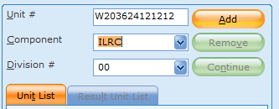
3.0 | First unit will display for unit testing. Ensure unit number matches unit being tested and order the required test.  - Commonly added on test is Unit antigen typing “AO”, DAT tests, or Hemoglobin S testing “SDX”.  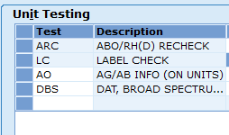
4.0 | Enter results under “Results” column.  - For antigen typing you are entering interpretations only using the keyboard. Example NBGE for Negative Big E Antigen.  - Since Sunquest does not document reaction strength on these tests, ensure your reaction results are correctly documented on the Antigen Typing Worksheet  Refer to BB-FORMS-0015: Antigen Typing Worksheet.  - For testing with reaction grid results (DAT) enter reactions and interpretation, then press “accept”  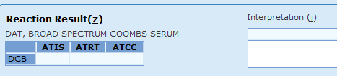
5.0 | Once Results have been saved, the unit Product Testing in Blood Bank Inquiry will show the result and <WIN> if the testing was done here. Testing results are added to the correct antigen/antibody or attribute line under the unit.  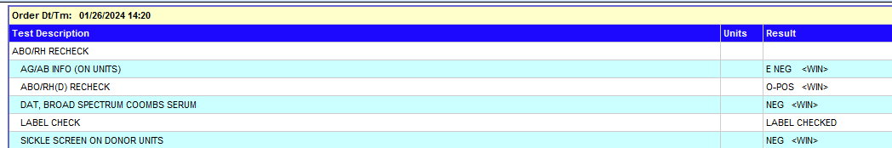

R. Automated Patient Testing

STEPS | INSTRUCTIONS
1.0 | In BOP select Patient Specimen
2.0 | Results from automation will populate. Click Load.  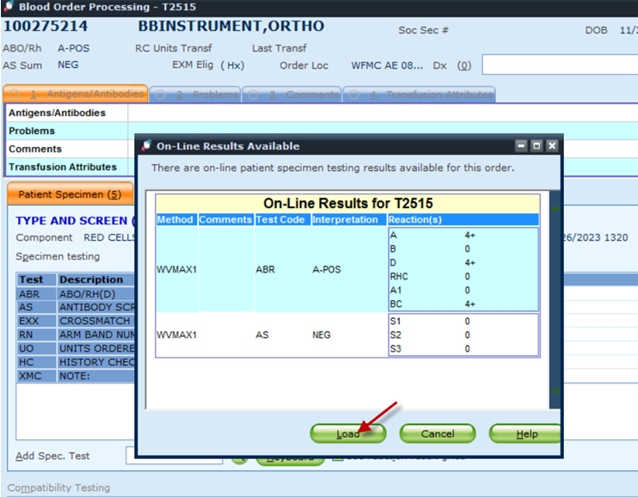  Note: Ensure all parts of the testing battery tested on the Vision have been ordered in Sunquest so that the results have a place to populate.  Example: TNRCC order in Sunquest does not include an antibody screen on the neonate but the vision test battery should run one. This result will be uploaded to Sunquest only if an antibody screen test is added to the TNRCC order.
3.0 | Results can then be accepted or rejected.  - If results are correct click “accept”  - If results are incorrect click “reject VMAX#”  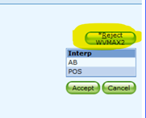
4.0 | Press Save.

S. Adding Blood Bank Path Review (Management)

STEPS | INSTRUCTIONS
1.0 | In BOP select Patient Specimen
2.0 | Add Spec. Test: BB Testing Path Review (BBPREV)
3.0 | Result this test as “yes”. This will order the Path Review in Encompass and place the test on the Pathologists outstanding list for completion.
4.0 | Click Save.

T. Documenting Critical Value Calls in Sunquest.

STEPS | INSTRUCTIONS
1.0 | Open Blood Order Processing (BOP)
2.0 | Add Test “BCALL”
3.0 | Free text in the following information:  - Name of test  - “Critical Value Called to and Read back by”  - Provider first and last name  - Provider credentials  - Date and Time of communication  - Full name and credentials of tech  Refer to BB-POL-0034 Critical Value Notification for full list of tests requiring critical value notification documentation.  Note: Do not use initials and ensure full test name is included in communication.  Example:
4.0 | Click Save

- Charging in Sunquest

Chemical Risk Assessment: low
Biological Risk Assessment: low
Protective Equipment: Lab coat, gloves
Reagents: NA
Supplies: Patient information
Equipment: Computer
Specimen Requirements: NA

STEPS | INSTRUCTIONS
1.0 | Certain tests are resulted in Sunquest as bill only charges. Examples include: adsorptions and chemical treatments.  - In BOP click on Add Special Test and enter charge as appropriate.  - Enter the semicolon key and then %TEST  Refer to Attachment 3: Codes to be used in Sunquest function BOP  - If more than one test is performed for a bill only test, hit the TAB key then the semicolon key and enter the number of tests performed, this will add a dash and a number and will charge that many times.  - Example: Charge for 3 cold antibody adsorptions:  NOTE: when entering multiple Bill only charges, ensure the result does not look like this:  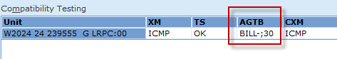  The extra semicolon will mess up billing and this cannot be fixed!  - Common Bill only charges include:  SQ Code SQ Description  ABID Bill only test – charges for a panel (Result with BILL- #performed –if more panels were run than accounted for in %ABI charge).  %PRCHM Bill only test. Chemical pretreatment of cells. This includes enzyme treatment. Charge for each cell tested.  %WMABA Bill only test. Warm adsorption charges. Result with BILL- #performed.  %CLDAA Bill only test. Cold antibody adsorption. Result with BILL - # performed  CAGSN Bill only test. Cold Panel
2.0 | Charging for Panels:  - The test “ABI” charges for one panel (up to 12 cells). This is used to identify antibodies. If two antibodies are identified and resulted per section E above, a charge for 2 panels is generated.  - Additional panels (12 cells) can be charged using the Bill only charge “ABID”. Only charge ABID if you need to charge for extra panels.  - Elution: The ELU test charges for making of the eluate, not the panels. You will need to add an ABID to charge for panels.  - Multiple panels: You can charge for Multiple ABIDs by hitting tab, semicolon, # of panels tested. Each panel equals 12 cells.  Examples:  - You identify 2 antibodies (anti-E and anti-K) and ran a total of 17 cells (not including screen). Since you resulted Anti-E and Anti-K under ABI, no additional charges are needed since 2 panels have been charged.  - You identify a little c and ran a total of 17 cells (not including screen). The ABI charges for 1 panel so you need to add the bill only ABID to bill for one more panel.  - Screen negative but DAT positive and you ran an Elution/Last Wash with a total of 18 cells. Do not order ABI—this result crosses to Epic. Instead order ABID (bill only), press TAB, semicolon, 2, TAB. This will generate a charge for 2 panels.  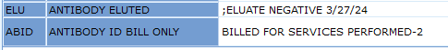  NOTE: Billing is one ONCE a day by Sunquest. Wait until all testing is complete to enter charges. Once charges have dropped, you cannot edit these charges easily. The person completing the workup is responsible for charging for all testing performed.
3.0 | Units are charged by keeping the “UO” units ordered row up to date in BOP under patient specimen.  - As units are requested and crossmatched to patients, update this value to match the total number of units requested.  - Example: 3 units were ordered and 3 were charged.  - If 2 more units are requested on this patient the UO value should be changed to 5.
4.0 | Charging for screening units  - Under the Compatibility Testing section in BOP: order the test “AGTB”  - If more than one unit is screened, hit the TAB key then the semicolon key and enter the number of units tested. This will add a dash and a number and will charge for that many antigen typings.  - Example: A unit was needed that was negative for e (little) and Fya. In order to find one unit negative for BOTH e and Fya the tech had to screen 45 units.  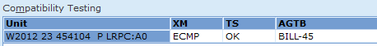
5.0 | Charging for units that are prescreened.  - Under the compatibility Testing section in BOP: order the test “AGTB”  - If the unit is screened for more than one antigen that the patient REQUIRES, hit the TAB key then the semicolon key and enter the number of antigens required.  - Example: C, E, K, Fya HgbS negative unit to go to a patient that requires C, E, K, HgbS negative products, we would only charge for the C, E, K required.  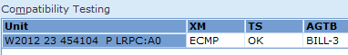
- Crediting Tests in Sunquest and Epic

- Cancelling in Epic for non-received or reflexed orders…not YET received into Encompass

- Orders that have a status of “In process” or “Needs to be Collected” can be canceled.
- In Order Inquiry select the test to cancel.
- Click on Cancel.
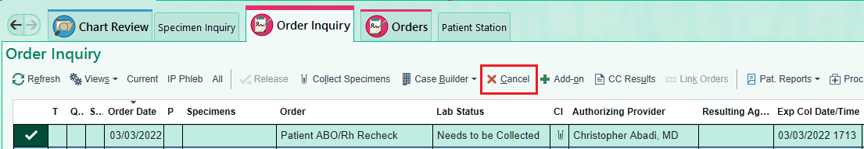

- Click on Search to choose from the list of cancel Reasons.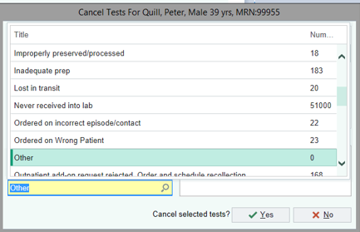

- If choose “Other” as a Reason then enter a Comment.
- Select Yes to Cancel.
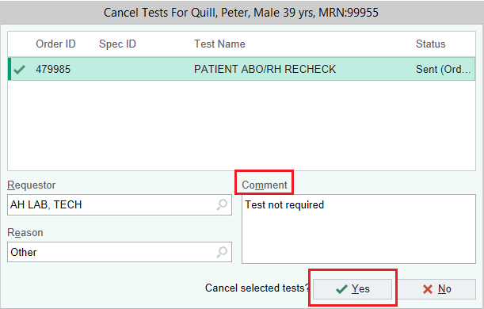

- Order is no longer visible in the current view.
- Change Views to AH Lab Order Inquiry Cancelled. Review the canceled order.

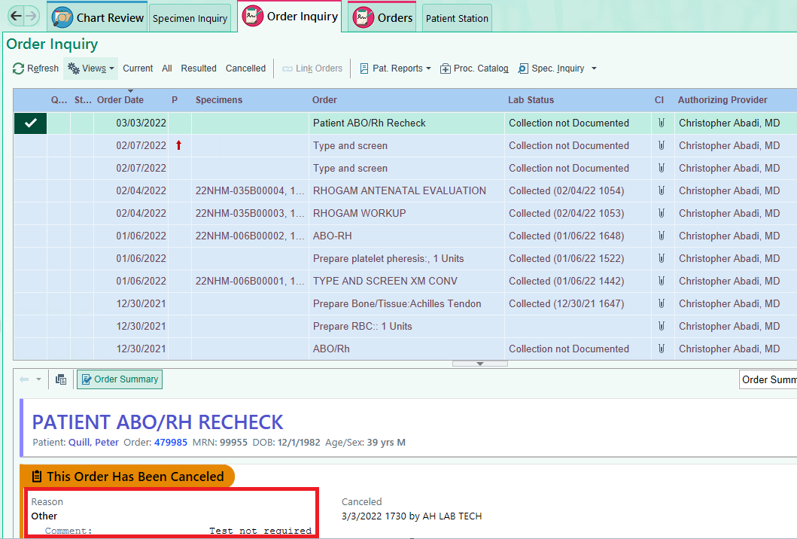

- Non-resulted tests credited in Sunquest General Laboratory

- These are tests that have been received in Encompass but not yet resulted in Sunquest.
- Go to General Laboratory
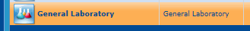

- Orders (upper left corner of screen). Select Order Receipt/Modify
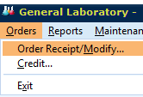
- Select Patient ID for Access Option. Enter the patient MRN. Click on Display Orders

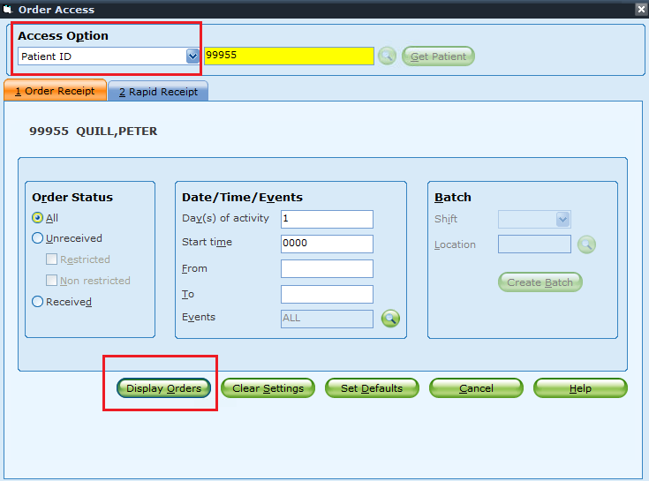

- Highlight the test to cancel.

- Click on Credit.
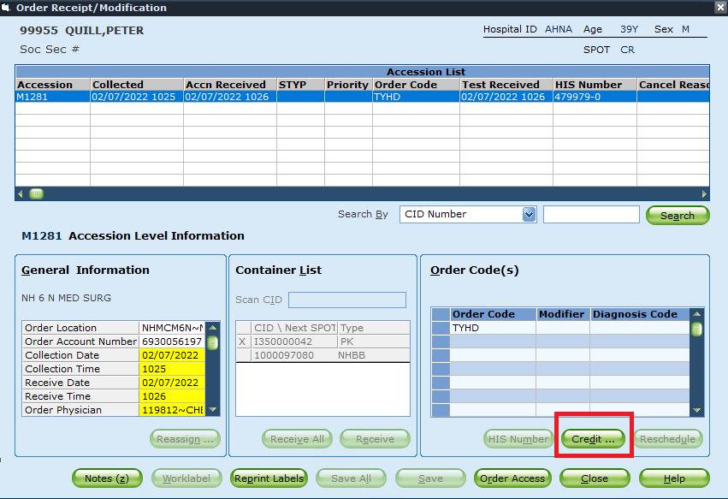

- Credit screen pops up. Do not make any changes to the Credit Mode. It should remain as “Remove Results.”

- Click on Select >>. The highlighted test on the left will move to the pane on the right.

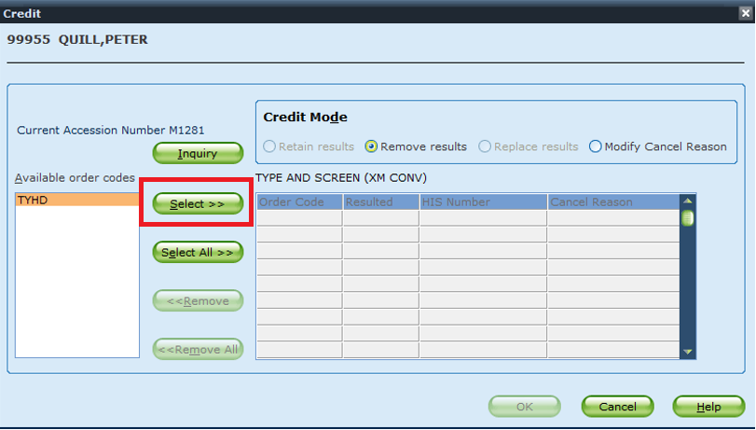

- Enter a Cancel Reason code. Do not free-text the reason!
*List of cancel reason codes are listed at end of document.
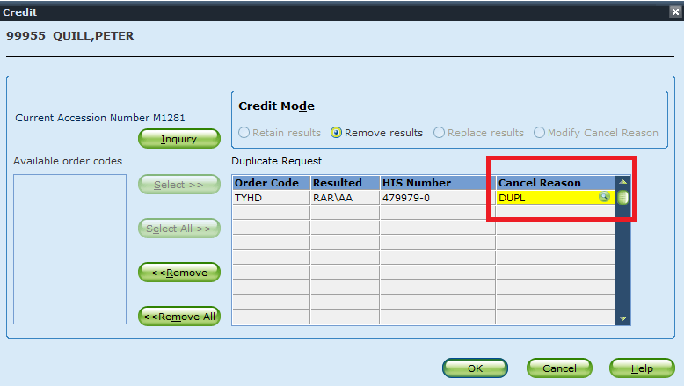

- Option to search for Cancel Reason by clicking on the search icon . Highlight a cancel reason code and Click on Add to List.

- Then click on Select.

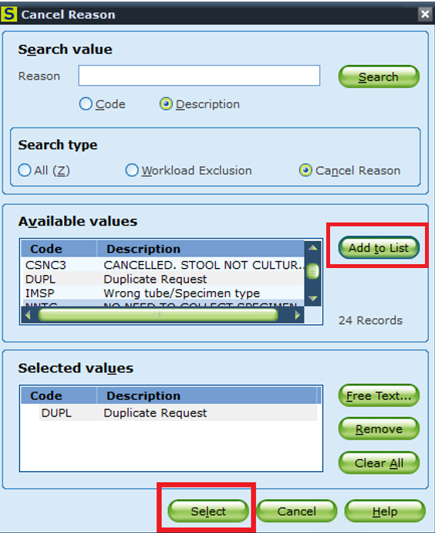

- Click OK.

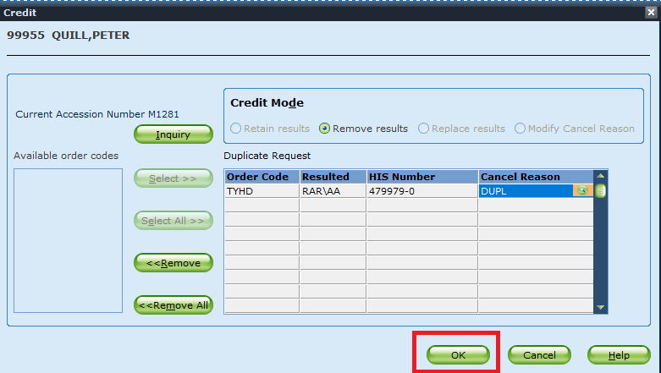

- Pop up message will appear. Click OK.

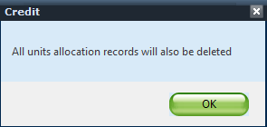

- Click on Save

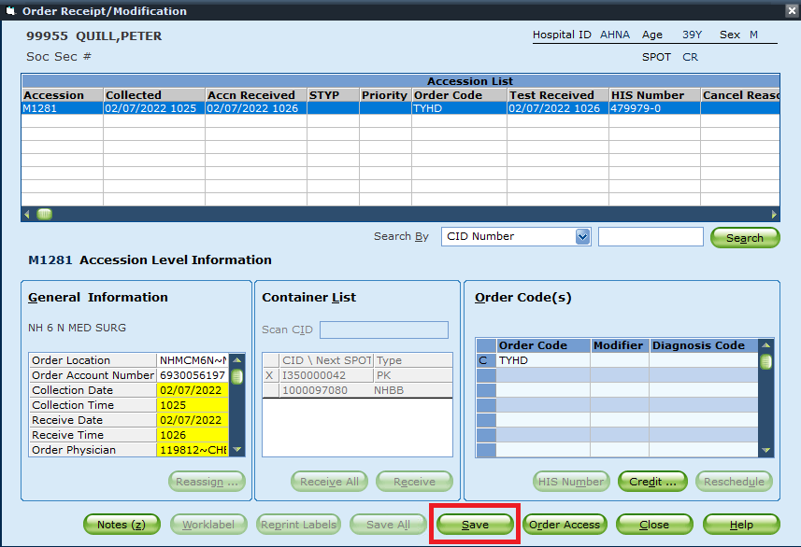

- In Blood Order Processing the order will show as credited. The order can no longer be accessed.
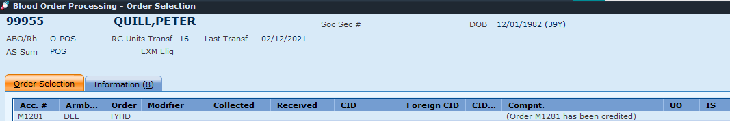

- The test will then Cancel in Epic!

- Resulted tests credited in Blood Order Processing

- Any test that has been partially resulted, including history checks must be credited using this method.
- Go to Blood Order Processing under the test accession number.
- Result all testing as Not Done.
- Add the Sunquest credit code in the Add Spec. Test field.
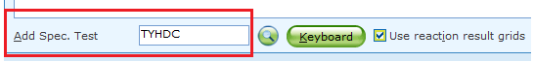

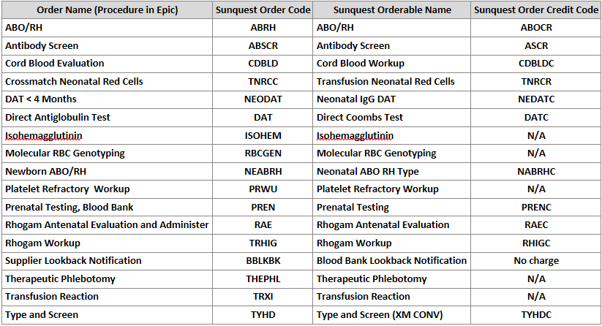

Points to remember:
- If mistakenly use a free-text cancel reason or a cancel reason code not on the list then cancel the order in Epic.
- Cancels done in Epic will not cross over to Sunquest.
- Don’t forget about the reflex tests in Epic. Cancel in Epic if applicable.
  - Patient ABO/Rh Recheck.
  - If Transfusion Reaction is cancelled in SQ then cancel Path Review Transfusion Reaction.
  - If answered “YES” in SQ in error to Blood Product Culture then cancel Blood Product Culture order.
  - If Fetal Screen resulted POS in error then cancel Kleihauer-Betke.
- If test is already resulted, then add the Bill Only credit code in SQ BOP.
- If test is not resulted then use SQ Gen Lab.
- Do not free-text the cancel reason. Epic will reject the SQ cancellation.
- Always use a cancel reason credit code.
- Test is first canceled in Epic then canceled in Sunquest. Epic will reject the SQ cancellation.
- Test is Preliminary or Final result status in Epic. Epic will reject the SQ cancellation.
  - Saving a result in SQ will always send out results to Epic. This updates the test to Prelim or Final status in Epic.
- If Prepare product order is canceled in Epic by a provider
  - Use Gen Lab to match the Order ID to the SQ accession number. Make sure not to result the prepare order in SQ or else results will fail.
  - Cancel the product order in Gen lab.
- LRRBCO – Prepare RBC order will not send a cancellation from Sunquest to Epic. Results are suppressed.
- If see a pop-up like this while crediting in Gen Lab then click No and credit in BOP.
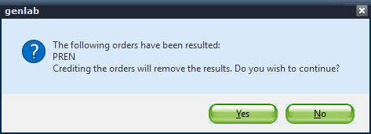

*List of Sunquest cancel reason codes
SQ Code | SQ Description | Epic Description
DUPL | Duplicate Request | Duplicate
AA | ORDER ENTRY ERROR | Entered in Error
EE | PATIENT DISCHARGED OR EXPIRED | Patient Discharge
YY | PATIENT DISCHARGED | Patient Discharge
LT | LOST IN TRANSIT | Lost in transit
RP | WRONG PATIENT | Ordered on Wrong Patient
QNS | QNS | Quantity Not Sufficient
CLTD | CLOTTED | Specimen Clotted
MLBL | SPECIMEN WAS RECEIVED MISLABELED OR UNLABELED. LABORATORY POLICY | Specimen mislabeled
IP | IMPROPER SPECIMEN HANDLING | Improper specimen handling
IC | INCORRECT SPECIMEN TYPE RECEIVED | Incorrect specimen type received
NI | NOT INDICATED | Not indicated
QR | QUESTIONABLE RESULTS | Questionable results
TTN | TEST TEMPORARILY NOT AVAILABLE | Test Temporarily Not Available

Add-on testing Credit codes for BOP
Order Name Description | Order Code | Credit Order Name Description | Credit Order Code
ADMINISTRATIVE FEE DIRECTED DONOR | DDFEE | ADMINISTRATIVE FEE DD CREDIT | DDFC
ANTIGEN INFO | %AGI | ANTIGEN CREDIT | AGCR
AG/AB INFO (ON UNITS) | AGTB | ANTIGEN CREDIT | AGCR
ANTIBODY IDENTIFICATION | %ABI | ANTIBODY ID CREDIT | ABIC
ANTIBODY ELUTED | %ELU | ELUTION CREDIT | ELUC
ANTIBODY TITER | TITER | TITER CREDIT | TITERC
ANTIBODY SCREEN | %AS | ANTIBODY SCREEN CREDIT | ASCR
COLD AUTOABSORBED AS | CAAABS | ANTIBODY SCREEN CREDIT | ASCR
PREWARMED AB SCREEN | PWAS | ANTIBODY SCREEN CREDIT | ASCR
REST ABS AS | RESTAS | ANTIBODY SCREEN CREDIT | ASCR
WARM AUTOABSORBED AS | WAAABS | ANTIBODY SCREEN CREDIT | ASCR
ARC PLT CROSSMATCH | PLTXM | ARC PLT CROSSMATCH CREDIT | PLTXMC
CROSSMATCH RESULT | %XM | CROSSMATCH UNIT CREDIT | XMUC
COLD AUTOABSORBED XM | CAAXM | CROSSMATCH UNIT CREDIT | XMUC
DAT, BROAD SPECTRUM COOMBS SERUM | %DBS | DIRECT COOMBS CREDIT | DATC
DAT, ANTI-IGG COOMBS SERUM | %DIG | DIRECT COOMBS CREDIT | DATC
DAT,COMPLEMENT | DCOM | DIRECT COOMBS CREDIT | DATC
FETAL SCREEN | FESCR | FETAL SCREEN CREDIT | FESCRC
LUI ELUTION | LUI | LUI ELUTION CREDIT | LUIC
REST ABS BILL ONLY | REST | REST ABS CREDIT | RESTC
SICKLE SCREEN ON DONOR UNITS | SDX | SICKLEDEX CREDIT | SDXC

Literature References:

Related Procedures/Policies in Navex:

Attachments/Linked Documents in Title 21:

Revision Dates: Review Change Summary as represented in Title 21.
Attachment 1: Sunquest Testing Key Board Job Aid

- Definition | Test | KEY
ABO/Rh Recheck | %ARC | X
ABO/Rh |  | T
Antibody eluted | %ELU | S
Antibody Identification | %ABI | M
Antibody Screen | %AS | V
Antigen Information | %AGI | <
Antigen & Antibody Info for Units | %AG | Z
Blood Bank Comment to Pt. Chart | BBC
Blood Bank Only | BBO
Blood Bank Result Correction to Chart | BBRC
Broad Spectrum Coombs | %DBS | R
Compatible |  | Y
Complement DAT | %DCOM | ^
Coombs Crossmatch | CXM | $
Crossmatch Expiration | %EXX | I
Crossmatch Result Incomplete at Issue | %XM/ICI | : (“colon”)
Crossmatch Result Not Required | %XM | K
DAT IgG Coombs | %DIG | E
Du Testing | %DU | D
History Check | HC | )
Incompatible | ICMP | {
Least Incompatible | LCMP | Little “L” Key
Mixed Field |  | F
Negative | %NEG | N
Patient Problem Info | %PB | , (“comma”)
Positive | %POS | P
Prewarmed Antibody Screen | PWAS | &
Type A |  | A
Type A2 |  | H
Type AB |  | L
Type A2B |  | G
Type B |  | B
Type O |  | O
Units Ordered | %UO | U
Unit Tag Comment | %CM | C
Unit Tag Reprint | %UR | 1
RPAS – Repeat Antibody Screen |  | r
RL Invalid Due to Positive DAT | INVD
LUI | Lui

Attachment 2: Antigen/Antibody Codes

ANTIBODY CODE | TRANSLATION | CORRESPONDING Ag CODE | TRANSLATION
AAD | AUTO - ANTI - D
ABGD | ANTI - D PRESENT
ABGDP | PASSIVE ANTI - D
ABGDR | ANTI - D Due to RhoGAM
ADW | Anti-D Due to Winrho
ACW | ANTI - C^{w} PRESENT | N(P)CW | Cw NEG / Cw POS
ALGC | ANTI - C PRESENT | N(P)BGC | C NEG / C POS
AUGBC | AUTO-C
ALTC | ANTI - c PRESENT | N(P)LTC | c NEG / c POS
AULTC | AUTO-c
ABGE | ANTI - E PRESENT | N(P)BGE | E NEG / E POS
AUTE | AUTO-E
ALTE | ANTI - e PRESENT | N(P)LTE | E NEG / e POS
AALTE | AUTO ANTI - e PRESENT
ALTF | ANTI f
AUF | AUTO-f
AFYA | ANTI - FYA PRESENT | N(P)FYA | FYA NEG / FYA POS
AFYB | ANTI - FYB PRESENT | N(P)FYB | FYB NEG / FYB POS
ABGG | ANTI G
AHE | ANTI - HENSHAW PRESENT | NHEA | Negative for Henshaw Antigen
AJKA | ANTI - JKA PRESENT | N(P)JKA | JKA NEG / JKA POS
AJKB | ANTI - JKB PRESENT | N(P)JKB | JKB NEG / JKB POS
AJSA | ANTI - JSA PRESENT | N(P)JSA | JSA NEG / JSA POS
AJSB | ANTI - JSB PRESENT | N(P)JSB | JSB NEG / JSB POS
AKEL | ANTI - K PRESENT | N(P)KEL | K NEG / Positive for K Antigen
ALTK | ANTI - k PRESENT | N(P)LTK | k NEG / Positive for k Antigen
AKPA | ANTI - Kpª PRESENT | N(P)KPA | Kpa NEG / Kpa POS
AKPB | ANTI - Kp^{b} PRESENT | N(P)KPB | KPB NEG / Positive for KPB Ag
AKNA | ANTI KNOPS A
AKNB | ANTI KNOPS B
ALEA | ANTI - LEA PRESENT | N(P)LEA | LEA NEG / LEA POS
ALEB | ANTI - LEB PRESENT | N(P)LEB | LEB NEG / LEB POS
ANM | ANTI - M PRESENT | N(P)MA | M NEG / M POS
ABGN | ANTI - N | N(P)BGN | N NEG / N POS
ANP1 | ANTI - P1 PRESENT | N(P)P1A | P1 NEG / P1 POS
ABGS | ANTI - S PRESENT | N(P)BGS | S NEG / S POS
ALTS | ANTI - s PRESENT | N(P)LTS | s NEG / s POS
ALUA | ANTI - LUA PRESENT | N(L)UA1 | LUAP
ALUB | ANTI - LUB PRESENT | NLUB/ LUBP | LUB NEG / LUB POS
ABGV | ANTI - V PRESENT | NV / PV | V NEG / V POS
ABGU | ANTI - U PRESENT | NBGU | U NEG
ACHI | ANTI - CHIDO
AMCA | ANTI MCCOY A
ARDG | ANTI - RODGERS
AWRA | ANTI - WRIGHT A PRESENT | WRAN(P) | Wra NEGATIVE / Wra POSITIVE
AWRB | ANTI WRIGHT B
AYKA | ANTI Yka (YORK)
AYTA | ANTI - Yta PRESENT | YTAN(P) | Yta NEGATIVE / Yta POSITIVE
AYTB | ANTI - Ytb PRESENT |  | Ytb NEG
AA1 | ANTI - A1 PRESENT | N(P)A1A | A1 NEG / A1 POS
AAH | AUTO - ANTI - H PRESENT
AAI | AUTO - ANTI - I PRESENT
AAIH | AUTO - ANTI - IH PRESENT
ALAI | ALLO ANTI - I
ABGI | Anti-I Suspected
AAP | ANTI - A
ABP | ANTI - B
AHLA | HLA ANTIBODY PRESENT
AHTL | HTLA - LIKE ANTIBODY PRESENT
HTLAB | HTLA Antibody Suspected
ABGA | ANTI - BGA
ABGB | ANTI - BGb
ACAP | ANTI - CAPRYLATE
AGOA | ANTI -GOA PRESENT | GOAN(P) | Goa NEGATIVE / Goa POSITIVE
NOIGG | NO CLINICALLY SIGNIFICANT IgG ANTIBODIES PRESENT
AAPA | ANTIBODY TO ADDITIVE /  PRESERVATIVE / DOUBTFUL  SIGNIFICANCE
AWAB | WARM AUTOANTIBODY PRESENT
ACAB | COLD AUTOANTIBODY PRESENT
CKAB | Check unit AGORG against PCW
DARAB | DARATUMUMAB ANTIBODY
LOWF | Low Incidence Ab
HINC | High Incidence Ab
NOID | Antibody ID Unknown
RH46 | Anti-Rh46

Attachment 3: Codes to be used in Sunquest BOP

SQ Code | SQ Description
%ABI | Antibody Identification – charges a panel for each antibody ID’d
ABID | Bill only test – charges for a panel (Result with BILL- #performed –if more panels were run than accounted for in %ABI charge).
%AGI | Antigen Info (Patient) – charges for each antigen entered
%ELU | Antibody Eluted – free text comment with results, charges for Elution Process
%DIG | DAT-IgG
%DCOM | DAT-C3
AGTB | Antigen Typing on Units. Result with BILL-# performed
%PRCHM | Bill only test. Chemical pretreatment of cells. This includes enzyme treatment. Charge for each cell tested.
%WMABA | Bill only test. Warm adsorption charges. Result with BILL- #performed.
%WAAABS | Warm auto adsorbed antibody screen
%WAAXM | Warm auto adsorbed crossmatch
%RETSEP | Bill only test. Reticulocyte separation or autologous cell separation.
%TITER | Prenatal titer
%PWAS | Prewarm antibody screen
%PWXM | Prewarm crossmatch
%CLDAA | Bill only test. Cold antibody adsorption. Result with BILL - # performed
%CAAABS | Cold auto adsorbed screen
%CAAXM | Cold auto adsorbed crossmatch
CAGSN | Bill only test. Cold Panel

Attachment 4: SCC to Sunquest Problem Codes

