# Applicable Laboratory(s):

North Carolina Baptist Hospital (NCBH)

Lexington Medical Center (LMC)

Davie Medical Center (DMC)

Wilkes Medical Center (WMC)

High Point Medical Center (HPMC)

Westchester

Clemmons

# Purpose

The purpose of this procedure is to provide Blood Bank technologists with the correct process to register outside Dialysis Center patients so that the Dialysis Center is billed correctly, and the patient is not billed.

# Scope

This procedure applies to Blood Bank staff and management

# Definitions

1. Procedure: A process or method for accomplishing a specific task or objective.
2. WFBH Lab System: Wake Forest Baptist Lab System is a health system that includes Wake Forest Baptist Medical Center and all affiliated organizations including Wake Forest University Health Sciences (WFUHS), North Carolina Baptist Hospital (NCBH), Lexington Medical Center (LMC), Davie Medical Center (DMC), Wilkes Medical Center (WMC), High Point Medical Center (HPMC), Lab at Westchester and Lab at Clemmons.

# Supplies/Materials

Use appropriate personal protective equipment (PPE) when handling biohazardous specimens.

# Procedure Guidelines

1. **Receiving Samples for Testing**
   1. Samples will be handed directly to a Blood Bank staff member at the window or tubed to Blood Bank from Central Processing.
   2. Customer Service in Central Processing will no longer be registering patients for lab testing.
   3. Verify all samples are properly labeled per Blood Bank protocols.
2. **Ordering Testing**
3. Orders will be placed into Beaker using Requisition Entry.
   * 1. Open **Requisition Entry.**

* If you do not already have the quick link at the top of your Epic screen, go to *Attachment A: How to access Requisition Entry*
  + 1. Enter **Submitter name** from paper requisition into the Submitter field (for example: Piedmont Dialysis).
    2. Enter the **Patient Name** in the Patient field.
    3. For a new patient enter: Sex, DOB, and SSN.
       1. If SSN is not available, enter all zeros (000-00-0000) or click on question mark and select “Standard Unknown SSN.”
       2. Click Create New (bottom left of this box)

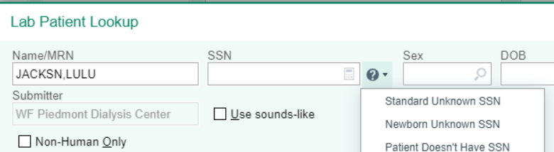



* + 1. Enter the **Authorizing & Ordering Provider** as indicated on the paper requisition.
       1. If the Authorizing and Ordering provider are two separate physicians, click on **Split** to enter the required information.
    2. Make sure **Client Bill** is selected, ***always*** use Client Bill for Dialysis centers.

* + 1. Enter the **Diagnosis Code(s)** listed on the paper requisition.
       1. Select the best option you can find. If only Anemia is written you can use **Anemia, unspecified**. The clinic will be billing the insurance.A screenshot of a phone

          Description automatically generated
    2. Enter **Type and screen (LAB276)** in the Procedure box, as requested on the requisition.
       1. *Do Not order the crossmatch in Epic*, only the Type and Screen.
          1. You can order the PRCXM in Epic as needed along with the T&S, there is no charge associated with that test. Just enter it as a second procedure when ordering the T&S.
    3. Click “Create Specimens.”

* + 1. Enter **Collection Date** and **Time** in appropriate fields.
       1. Make sure to check the requisition, it could have been collected the day before. This is important for billing.

* + 1. Enter the **Collector** with the free text option, they will not be in the system.

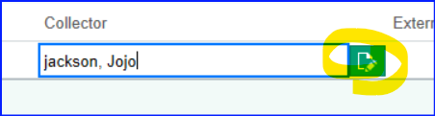

* + 1. Make sure to *leave the Draw Type blank* so we will not drop a venipuncture charge.





* + 1. Click **Receive, Accept, & New** at the bottom right of your screen.
    2. File requisition in folder on the bridge to be scanned to the patient’s chart.
  1. Perform the Type and screen testing per Blood Bank protocols and result in SunQuest.
  2. In SunQuest, you will add the units onto the TYHD in BOP under Allocation and change the UO (Units Ordered) to match the number of units.

# Literature References:

# Related Procedures/Policies in Navex:

# Attachments/Linked Documents in Title 21:

# Revision Dates: Review Change Summary as represented in Title 21.

**HOW TO ACCESS REQUISITION ENTRY**

**ATTACHMENT A**

* 1. Click on the Red Epic at the top left of the screen
  2. Type in **Requisition Entry** in the search box
  3. You can pin it to your Pinned list or Tool bar by going to **Lab > Requisition Entry** and click on the **pin**

click on the **pin** to save to your pinned area

or add to your

tool bar at the top.

**Or** click on **Lab >** go down to **Registration Entry**

Tool bar

Type **Requisition Entry** here