Applicable Laboratory(s):

☒ North Carolina Baptist Hospital (NCBH)
☒ Lexington Medical Center (LMC)
☒ Davie Medical Center (DMC)
☒ Wilkes Medical Center (WMC)
☒ High Point Medical Center (HPMC)
☐ Westchester
☐ Clemmons

Purpose

The purpose of this procedure is to transfer patient specimens between laboratories. Specialized Blood Bank testing that cannot be done at smaller facilities are to be sent to Winston Campus Blood Bank for further testing. The WC Blood Bank is setup to perform IRL (Immunohematology Reference Lab) level antibody identification.
This protocol is to standardize the process of sending samples from the various sites.

Scope

This procedure applies to Atrium Health Wake Forest Baptist Wake Market Blood Banks

Definitions

- Procedure: A process or method for accomplishing a specific task or objective.
- WFBH Lab System: Wake Forest Baptist Lab System is a health system that includes Wake Forest Baptist Medical Center and all affiliated organizations including Wake Forest University Health Sciences (WFUHS), North Carolina Baptist Hospital (NCBH), Lexington Medical Center (LMC), Davie Medical Center (DMC), Wilkes Medical Center (WMC), High Point Medical Center (HPMC), Lab at Westchester and Lab at Clemmons.
- WC: Winston Campus
- WIN: Winston Campus

Sections

- Sending Facility
- WFBMC Blood Bank

Procedure Guidelines

- Sending Facility
STEPS | INSTRUCTIONS
1.0 | Collect and receive the sample at the original facility in Epic. .
2.0 | If this is an unknown, new antibody on the patient that needs further testing:  - Perform routine testing at your facility per your facility’s protocols  - Result all reactions for testing in Sunquest but leave interpretations PENDING  - Photocopy any antigrams or other testing not in Sunquest to send with the sample. Write on the paperwork if units are needed and how many.  - When possible have 2 more properly labeled pink top tubes collected to send to WC.  - Keep the original sample at your facility, unless it is the only sample that is available.  - The tubes must have been collected with PPID or 2 verifiers of collections if transfusion is requested.  - If it is not possible to collect more sample send the original sample to WC along with any purple tops or other pink top samples collected (i.e. CBC sample)  - Proceed to step 4.0
3.0 | If this is a patient with a known complex antibody (i.e. WARM auto, DARA patient, multiple antibodies)  - You do not need to perform testing at your facility  - If you do please enter reaction results in Sunquest but leave the interpretations pending and photocopy any antigrams.  - When possible have 1-2 more properly labeled pink top tubes collected or locate any recent purple or pink tops from hematology/chemistry (i.e. CBC sample)  - Send the original sample to WC along with any other tubes from step 3.2
4.0 | Pack up the sample to send out  - Place the samples (ensure that the lid is secure if it has been opened) in a biohazard bag. Place any paperwork in the side pocket of the bag.  - Label the bag clearly to go to the Blood Bank at WFBMC, preferably use bright colored paper or tape if available.
5.0 | Ensure there is a pending test and make an Encompass Packing List.
6.0 | Open the Packing List Editor.  - This may be on your tool bar or you may need to search under the Epic tab    6.3 Select an acceptable packing list or create new  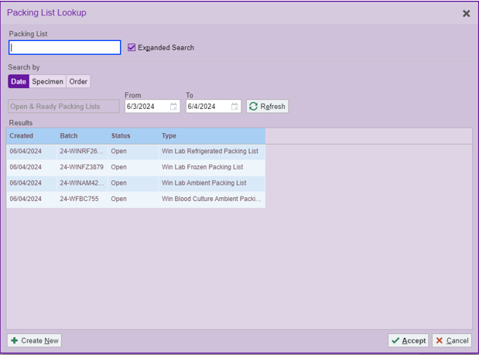  6.4 Check your beaker label for storage temps. Most BB tubes are sent refrigerated, create new  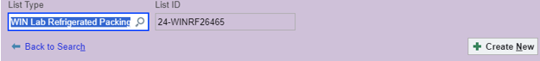  6.5 Scan the LIS label of any test needing to the transferred out  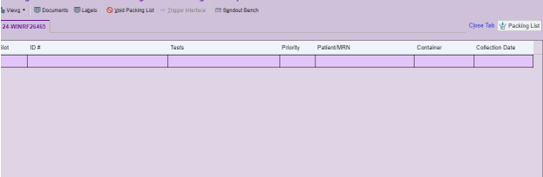  6.6 If this is a test such as a type and screen that accsssions to an outside facility (example: Davie) you will have to click the box to move it on to the packing list  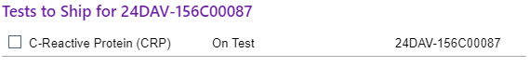  6.7 Once you have scanned and selected all test to the packing list you will click Ready then Pick up.  
7.0 | Call the WC Blood Bank that a sample is coming  - WCBB phone # 336-716-2618  - Give a brief description of the situation  - Whether it is STAT or Routine  - How many units of blood are needed and when  - Example:  “We are sending patient Mouse, Mickey, MRN 123456 for an antibody workup. This patient has a history of a WARM auto and we need 2 units of blood for surgery tomorrow”
8.0 | Add a flag to the specimen package that alerts Main Campus Blood Bank that this is reflex reference testing and from which affiliated lab.
8.0 | Once the testing is completed units (if needed) will be sent  - Units will be Transferred in Sunquest to your facility  - WCBB will call the courier to send to your facility  - WCBB will call your Blood Bank to let you know they are coming and that the workup is complete.  - If the units qualify for Emergency Release per WCBB protocol an Emergency Release form will be sent with the units.  - Use this form at your facility’s discretion  - The form does not need to be returned to WCBB.
9.0 | Call the WCBB to request more units if needed  - Call with patient name, MRN and # of units needed and when (if STAT or Routine)

- WFBMC Blood Bank

STEPS | INSTRUCTIONS
1.0 | Receive the sample in Epic  - This should be done at in the Blood Bank at WFBMC.  - If the sample has not been sent on a packing list, call the facility and have them send the sample via packing list.
2.0 | If this is an unknown, new antibody on the patient that needs further testing:  - Initial testing will be done at the sending facility  - All of their results and charges should be in Sunquest  - They should send a photocopy of any antigrams or other testing not in Sunquest with the sample. And should write on the paperwork if units are needed and how many.  - They should be sending 2 properly labeled pink top tubes and keep the original sample at their facility, unless it is the only sample that is available.  - They will send the original tube only if new samples cannot be collected. And send any other lavender or pink tops from their hematology/chemistry lab.
3.0 | They should call the WC Blood Bank that a sample is coming  - Give a brief description of the situation  - Whether it is STAT or Routine  - How many units of blood are needed and when  - Example:  “We are sending patient Mouse, Mickey, MRN 123456 for an antibody workup. This patient has a history of a WARM auto and we need 2 units of blood for surgery tomorrow”  3.5 The sample will arrive with a flag alerting main campus techs that this is sample  from an affiliated institution for reference/extended testing.
4.0 | Once the testing is completed units (if needed) will be sent  - Transfer the units in Sunquest to their facility using Blood Status Update: Ship Out  - Transfer the units in ARC’s Connect/Blood Hub system  - If the units are not from ARC, let management know  - Call the courier to send the units  - Call the Blood Bank to let them know the units are coming and that the workup is complete.  - If the units qualify for Emergency Release per WCBB protocol send an Emergency Release form with the units.  - This form does not need to be returned to WCBB.
5.0 | The other facility will call the WCBB to request more units if needed  - They should call with patient name, MRN and # of units needed and when (if STAT or Routine)

Literature References:

Related Procedures/Policies in Navex:

Attachments/Linked Documents in Title 21:

Revision Dates: Review Change Summary as represented in Title 21.

