Print the attached documents for reference throughout the test:

Patient DF, a 56 y.o. male is admitted to the ED with extensive GI Bleeding. This is an ongoing issue for which he was also admitted for 2 months prior. During his previous stay, the patient’s ABO/Rh were determined to be Aneg and his antibody screen was negative. The patient was transfused 8 units of RBC’s during his last admission.

The patient’s hemoglobin upon admission is 7.2 and he continues to bleed. The ED sends a sample for Type and Screen. Results are as follows:

|  |  |  |  |  |
| --- | --- | --- | --- | --- |
| Anti-A | Anti-B | Anti-D | A1 cell | B cell |
| 3+mf | 0 | 3+mf | 0 | 4+ |

|  |  |
| --- | --- |
| Scr cell | Result |
| Scr 1 | 3+ |
| Scr 2 | 3+ |
| Scr 3 | 1+ |

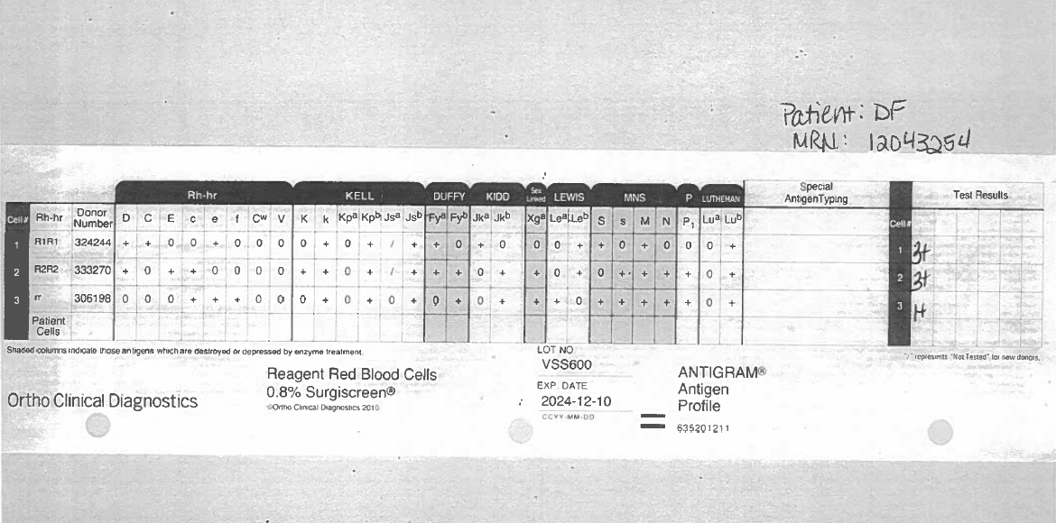

Refer to PANEL A (1)

While Panel A was running on the instrument, a DAT profile was performed. The results were as follows:

|  |  |  |  |
| --- | --- | --- | --- |
|  | **IS** | **5’RT** | **CC / CCC** |
| **Poly gel** | 2+ |  |  |
| **IgG gel** | 2+ |  |  |
| **Anti-C3d** | 0 | 0 | WK+ |
| **Saline Control** | 0 | 0 |  |

Given that Panel A did not rule out very much, the tech decided to run another panel on the patient’s plasma. Review the results of PANEL C (2) (Untreated)

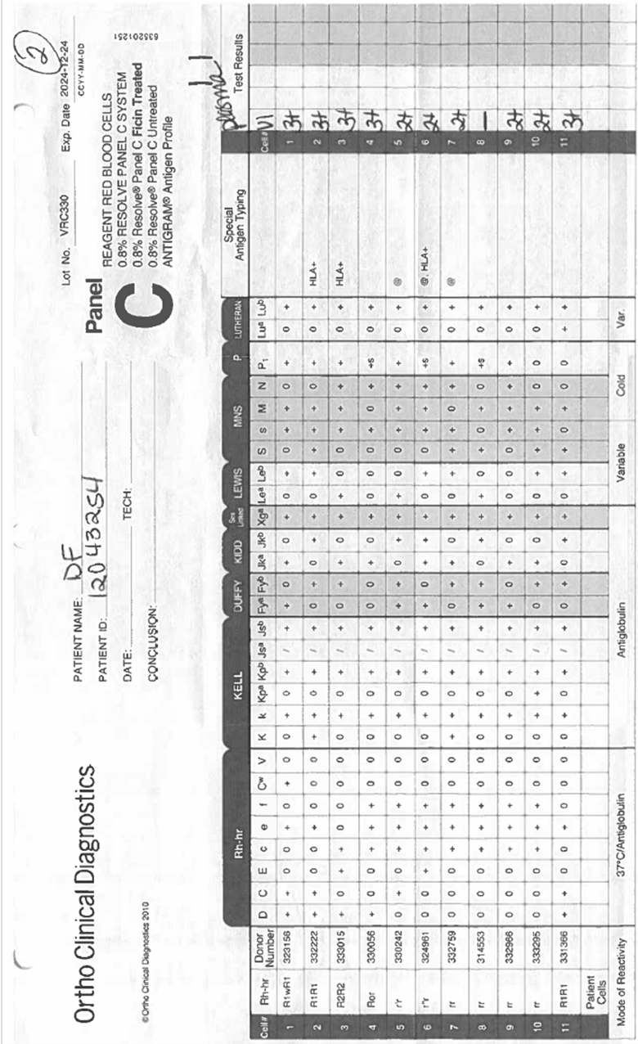

QUESTION 9 – SELECTED CELLS

* 1. 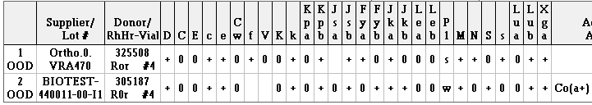
  2. 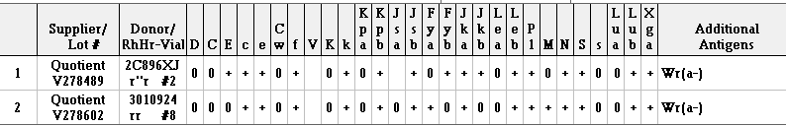
  3. A group of black letters

     Description automatically generated
  4. A screenshot of a computer screen

     Description automatically generated

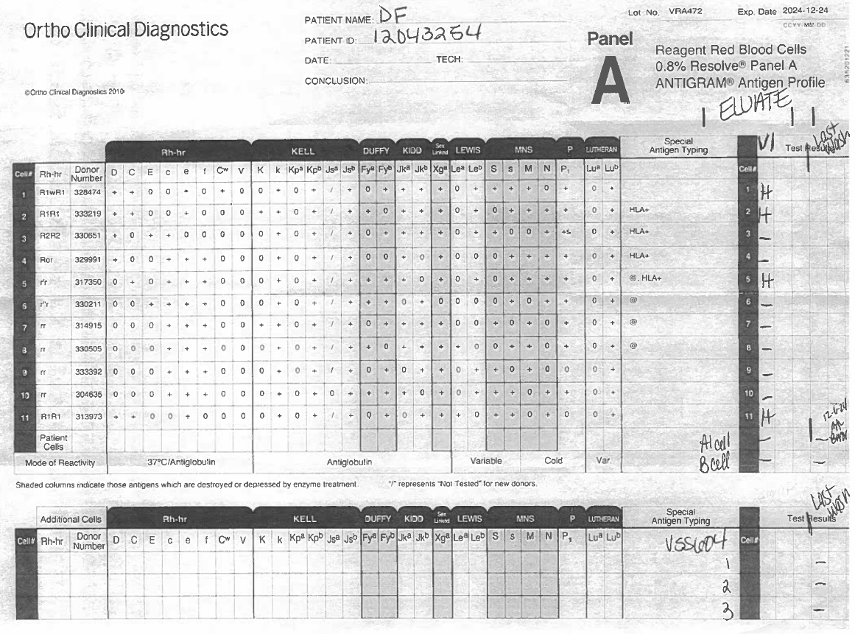Refer to ELUATE Panel A