Situation:
CAP citation for TRM.43650 Component Handling
The laboratory maintains sterility of each component during component handling,
including pooling and the use of sterile connecting devices.
Several instances in March of 2025 techs failed to circle Y or N indicating that the weld was completed. Should a weld NOT be complete AND the unit itself compromised, the unit must be considered an open system and expiration date/time likely changed. Management missed these errors upon review.
Corrective Action:
- Sterile docking log policy and procedure assigned to all staff to read in Policy Tech.
Preventative Action:
- Missed documentation and review by management likely since the column already had written in it (Y/N). Moving forward techs will have to write “Y” or “N” and any applicable corrective action for “N” in the blank columns. Using blank columns will make errors more visible to staff and management upon review.
Previous:
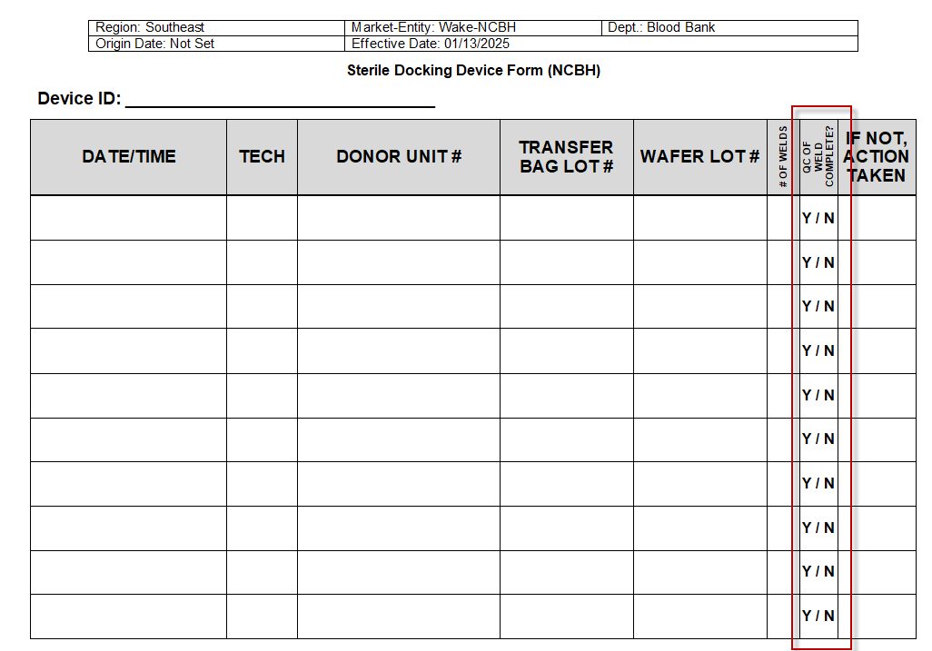
New:
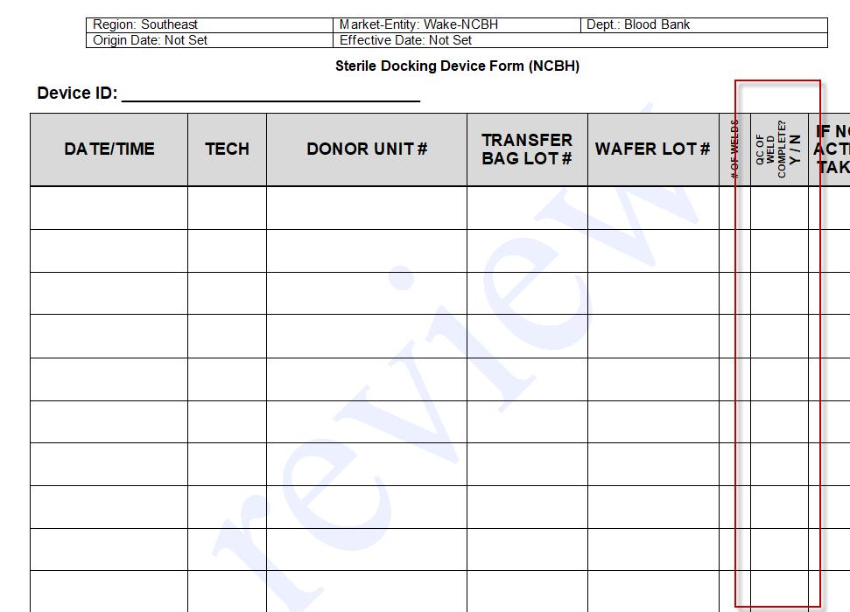

- Form: Sterile Docking Device Form (NCBH) updated to new format in Policy Tech and this training document will be assigned to staff to read and sign in Medtraining.

