SBAR: Situation, Background, Assessment, Recommendation
Topic | Emergency Blood Products were delayed |  | Date: | 9/27/2025 @1800
Submitted To: | Blood Bank |  | Submitted By: | CRNA
Situation | From RL6: “Patient was coding and experiencing a pulmonary hemorrhage. Emergency blood products were ordered. Blood bank was called. CAN ran to blood bank and stated they did not have the FFP thawed.”
Background | Baby had current Type and Screen neonate from 2 days prior. Routine blood orders (12ml plasma, 8ml platelets, 12ml rbcs) were placed on 2-day old Male in NICU at around 1835.
Assessment | No emergency orders or communication about the situation escalating from routine to emergent could be located in paper files or in Encompass.
Recommendation | Blood Bank staff must consider all inquiries about the status of a sample or product as an emergent situation. Per The Emergency Blood Policy:  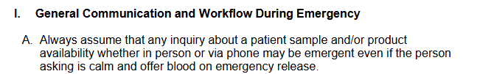  Blood Bank staff must note any communication with care teams onto order forms or workups and clearly state if Emergency Release was offered, accepted or rejected.
Status | SBAR loaded into MedTraining for staff review and signature.

