- True/False:
When receiving supplies and reagents, the following is the direction circular/IFU?
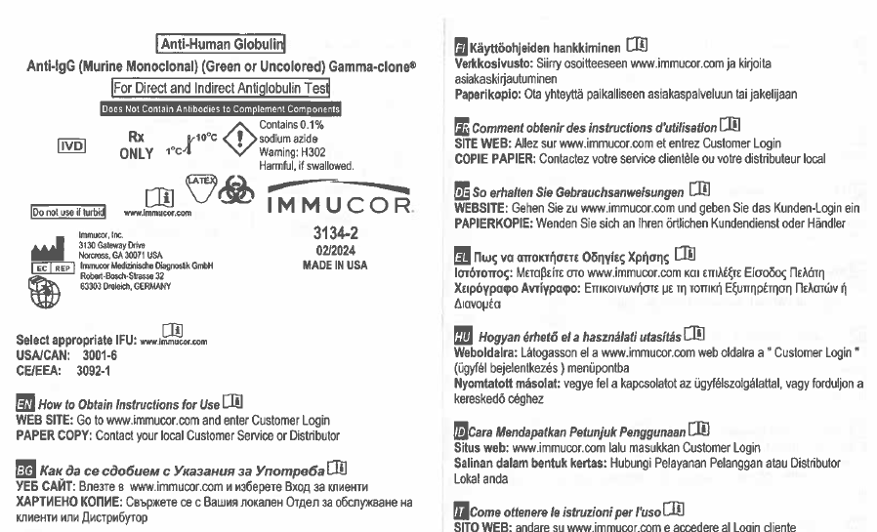
- The IFU number of the above package insert is:
- 3092-1
- 3001-6
- 3134-2
- None of the above
- True/False:
Once the IFU number is identified, the IFU number is compared to the Insert Code / Version # on the Direction Circular Document Change Control Form (NCBH) in the Direction Circular binders?
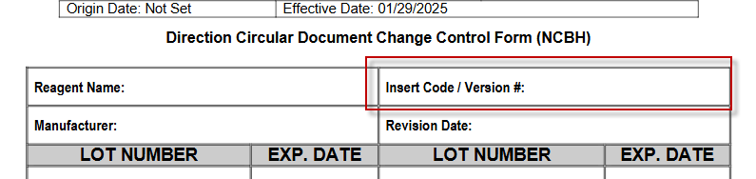
- If this number is the same, the next step is to:
- Write the lot number and expiration date on the current Direction Circular Document Change Control Form.
- Make a new Direction Circular Document Change Control Form.
- Don’t write the information down, it’s the same so it’s not needed.

- If the numbers do not match, and the IFU is a new version:
- Send management this form:
- Look up the new IFU on the manufacturer’s website and send management the new form.
- Make a copy of the current form from the Direction Circular Book and submit to management making sure to keep the original in the binder.
- Make a new Direction Circular Document Change Control Form filling out the below information and submit to management:
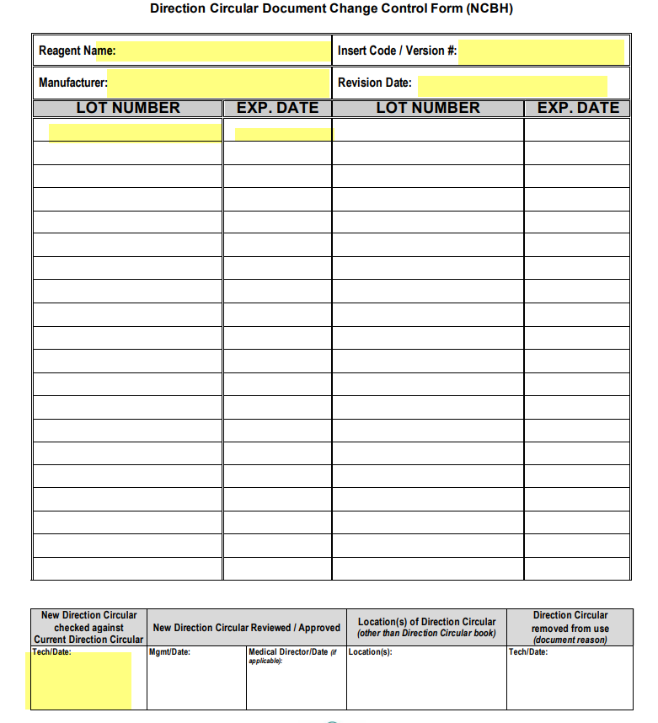
- B, C, D.
- Tracking which direction circular or IFU a reagent lot number corresponds to is important because:
- It is mandated by all regulatory agencies (AABB, CAP, FDA) that reagents and supplies be used as per manufacturer instructions.
- Management is crazy OCD.
- Because that’s the way we’ve always done it and we don’t like change.

- True/False:
It is easy to find the correct direction circular version for a specific lot number months after the lot has been put into use.

- True/False:
If I have any questions about this process I should ask my charge tech or management.

