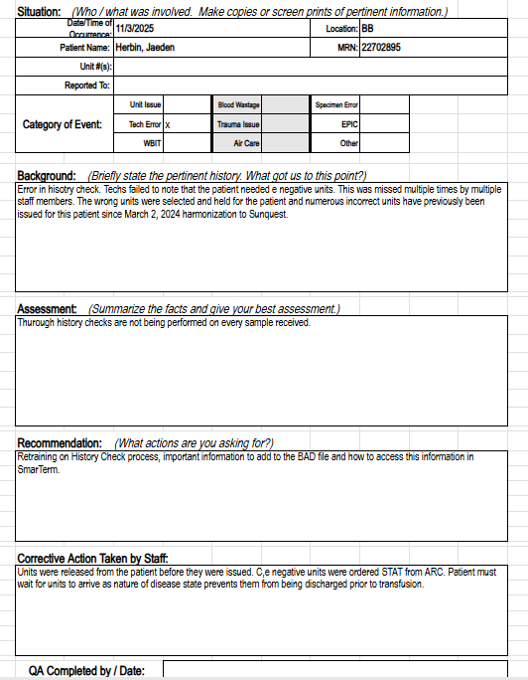
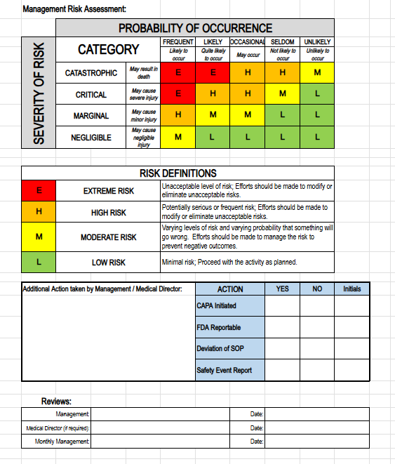

Retraining:
When performing history checks every sample must be checked every single time. There is NEVER a time when it is ok to forgo history checks. This patient had been seen multiple times since March 2, 2024 and every single history check missed the need for e negative units!
History checks should now be performed using Sunquest SmarTerm function “BUA”. Type in the MRN and hit enter. ANY information in legacy SCC will be visible here.
This patient’s history is below:
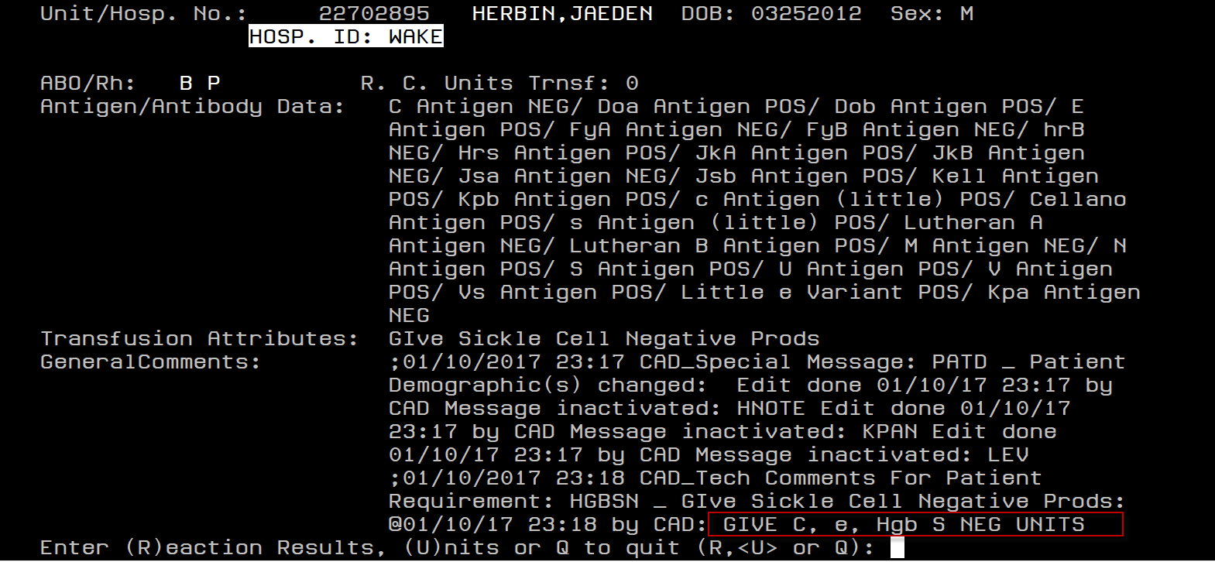
Under General comments you can see that the patient requires C, e, HgbS negative units.
In SCC the history looks like this:
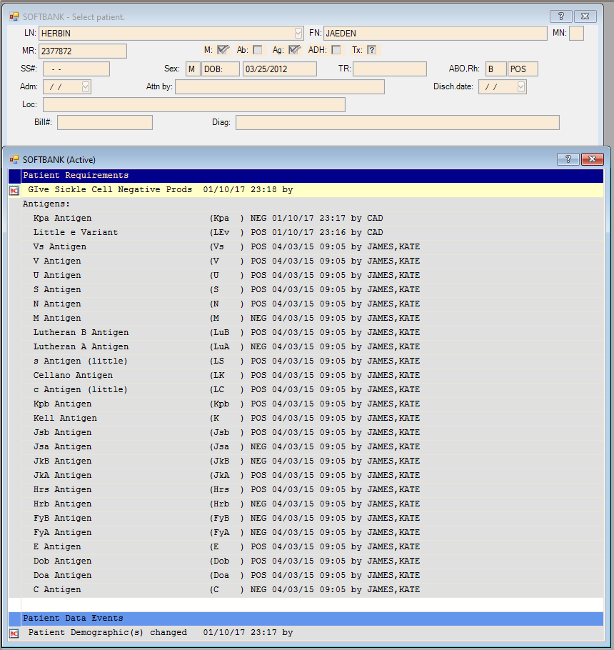
Anytime there is a symbol, you MUST double click this symbol to reveal extra information about these patients. Double clicking this symbol next to the yellow line “Give Sickle Cell Negative Products” reveals the following message:
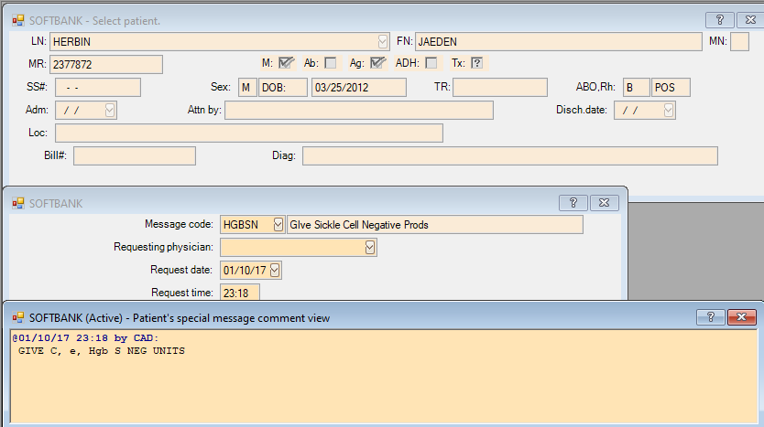
This information MUST be put into Sunquest as soon as it is discovered.
Due to the complexities of SCC and not all staff being trained on the nuances of SCC and how to access this hidden information, it is imperative that history checks are performed using SunQuest SmarTerm function “BUA”.
Patient review reveals that this patient has been seen numerous times since March 2, 2024 and the requirement to receive e negative units was repeatedly missed. As consequence the patient has received multiple e positive units:
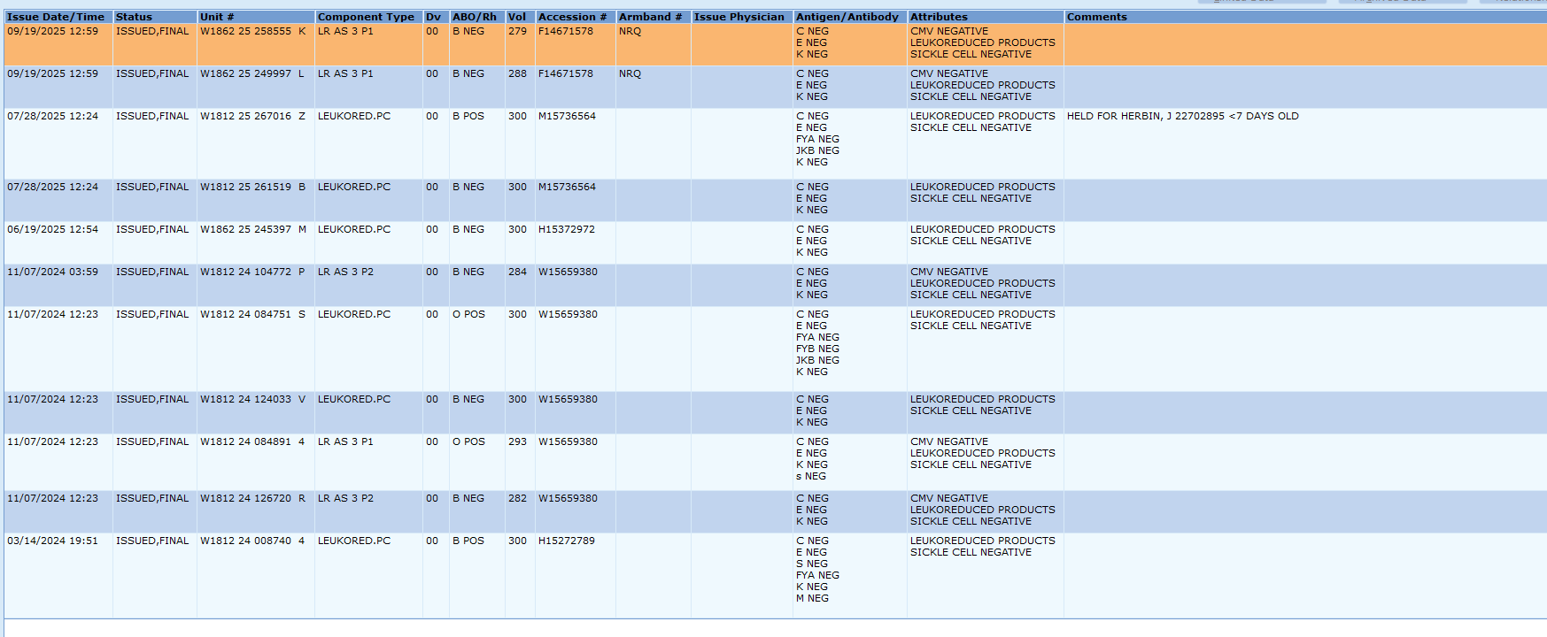
Pathology will review the patient’s chart and determine harm score.
Staff must review the policy: Refer to Receiving Specimens for Blood Bank Testing Policy (WAKE):
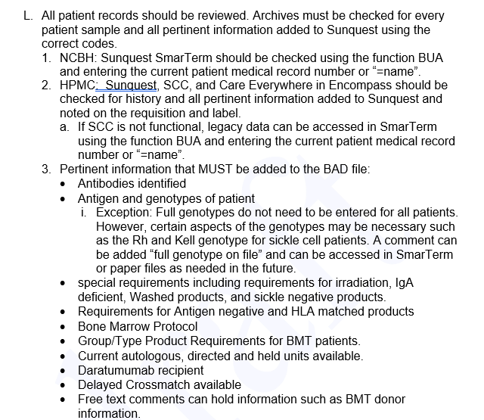
Finally, before ordering or holding units for a patient, it would be wise to re-perform the history check and ensure the correct units are being ordered/held for the patient.

