- PURPOSE

Atrium Health Wake Forest Baptist NCBH Blood Bank supports the use of blood in the prehospital setting. This document is a guide to ensure blood issued, stored and transfused in the prehospital setting has met all regulatory and accreditation requirements.

- SCOPE

NCBH Blood Bank staff and management.

- DEFINITIONS/ABBREVIATIONS

- AC1: Air Care 1 Lexington
- AC2W: Air Care 2 Wilkesboro
- AC3: Air Care 3 Martinsville
- ACG: Air Care Ground Transport
- FEMS1: Forsyth County EMS 1
- FEMS2: Forsyth County EMS2
- STOK1: Stokes County EMS 1
- SEMS1: Surry County EMS 1
- AEMS1: Alexander County EMS
- YEMS1: Yadkin County EMS

- POLICY

- Blood will be dispensed in a manner that has been validated to maintain the proper storage and/or transport of blood.
  - Some blood will be dispensed in coolers while other sites may use refrigerators or a combination of both.
  - Refer to individual service agreements.
- Coolers will be maintained, stocked with blood product (see 10.0), dispensed to Air Care/EMS employees or designated courier to support the Medical Centers mission of providing emergent care for blood transfusion when necessary to the communities it serves.
- Air Care or Local County EMS will notify Blood Bank when there is a need for additional blood/or an exchange of coolers/blood.
- The conditioning of the cooler liners will only be prepared by the Blood Bank at the time of notification.
  - Do not use the preconditioned liners in an effort to maximize the time for use.
  - Condition liners when Air Care/County EMS notifies the Blood Bank.
Condition the interior of the cooler if applicable by adding refrigerated gel packs when phone call is received in order to maximize the cooler time.
    - Coolers are not routinely used by all EMS crews but are available if remote refrigerators are out of service.
- The cooler will have conditioned liners inserted along with a global sensor data logger. The data logger should be programmed for 30 minute intervals (maximum).
- The cooler lids, inserts, bricks, and panels will have quality control performed every other year by the Blood Bank once they have been validated upon receipt (new).
Refer to EQ New Cooler Validation and QC Procedure (NCBH)
- Blood units will be maintained in the cooler and routinely returned to the BB prior to the expiration date.
  - During the months of June through September the coolers will be evaluated to determine if return time will be shorter.
- Local EMS crews that have a remote refrigerator on their supervisor vehicles must be validated by NCBH blood bank.
  - Remote refrigerator temperatures will be audited continually for compliance.
  - Records and temperature logs will be reviewed by management and stored by NCBH.
  - EMS agencies that use NCBH owned refrigeration devices will comply with NCBH clinical engineering in maintaining PM and temperature checks. EMS agencies that use self-owned devices are responsible for ensuring PMs are performed as required by the manufacturer.
- All units will have Safe-T-Vue indicators attached to the back of the unit to monitor the temperature during storage outside the Blood Bank environment.

Acceptable criteria: white, white speckled with red (1- 10C)
Unacceptable criteria: completely red (greater than 10C or less than 1C)
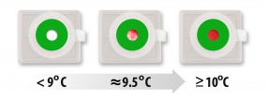

- Blood Bank will provide the following for each cooler/remote refrigerator:

Air Care | Stokes County EMS | Wilkes County EMS | Alexander County EMS | Yadkin County EMS
2 units: Group O low titer Whole Blood  1 unit: Group O neg red cell  1 unit: Group A plasma | 2 units: Group O low titer Whole Blood  OR  2 units each of Group O red cells and  Group A plasma  (If WB not available) | 2 units: Group O low titer Whole Blood  OR  2 units each of Group O red cells and  Group A plasma  (If WB not available) | 2 units: Group O low titer Whole Blood  OR  2 units each of Group O red cells and  Group A plasma  (If WB not available) | 2 units: Group O low titer Whole Blood  OR  2 units each of Group O red cells and  Group A plasma  (If WB not available)
* Forsyth County EMS has suspended their program.
* Surry County EMS is supplied by Northern Hospital. Request to supply Surry should be forwarded to management.

  - In times of blood shortages, Group O negative red cell units may not be available and Group O positive red cell units may be substituted.

- Do not attach any transfusion product tags to units.

- All units transfused must have a Blood Bank Emergency Release Form completed for the patient and signed by the ordering physician and returned to the Blood Bank.
  - These completed forms can be stored in the returned cooler, scanned and emailed or faxed by Air Care or County EMS within 24 hours of transfusion.

- Coolers for blood units will be refreshed or restocked by Blood Bank routinely prior to cooler expiration whether or not the blood units issued to Air Care/ County EMS have been transfused.

- Coolers hold temperature at 1-6°C for longer periods of time as predetermined by validation testing but Air Care will return the coolers for reconditioning on the 4th day or sooner if units of blood are needed or as cooler temps warrant.

- Air Care or County EMS will obtain blood units only from the Blood Bank at ATRIUM HEALTH WAKE FOREST BAPTIST.

- Air Care or County EMS will not store any other blood units or medication in the coolers except the blood issued by Blood Bank at ATRIUM HEALTH WAKE FOREST BAPTIST.

- Blood units will not be removed from the cooler/remote refrigerator to be stored in another location.

- Coolers will not be stored in refrigerators or freezers outside the Blood Bank.
    - Exception: Refrigerators used by EMS that have been validated by Blood Bank.

- Utilization review of the blood units issued to Air Care/ County EMS will be reported: units issued, transfused, wasted.

- Patients transfused with any blood units MUST be identified on the Emergency Release form.

- Any blood product transfused, presumed transfused, or not returned when expected must have a form filled out for tracking purposes. This form should be turned in to management.
Refer to AirCare and EMS Transfused Units Form (NCBH)
        - Units must be reconciled in the blood bank LIS as soon as possible.
        - Refer to Emergency Blood Policy (NCBH). All units transfused in the prehospital setting require crossmatching whenever possible.
        - NCBH medical director will take responsibility of lookbacks for units given to patients in the prehospital setting that were admitted to other hospitals. The medical director will work in conjunction with the transfusing agency (county EMS medical director) to complete this process.

- Coolers will have RFID tags on the outside and be tracked by the SPOT program on screen as coolers.

- Each unit transfusion will be audited by Blood Bank.

- When a transfusion reaction is reported, the policies and procedures for nursing will be followed.
    - A blood specimen and the unit will be returned to the Blood Bank for investigation.
Refer to FD Blood Cooler Policy (NCBH) for cooler descriptions.

- PROCEDURE / GUIDELINE

- Packing Air Care Canvas blood coolers
Chemical Risk Assessment: None
Biological Risk Assessment: None
Protective Equipment: Gloves
Supplies: Cooler Prep Flag
Reagents: N/A
Equipment: Cooler Inserts and Panels
Specimen Requirements: N/A

STEPS | INSTRUCTIONS
1.0 | Condition panels per procedure and condition cooler interior by filling it with refrigerated gel packs until the panels are ready.  - Go to Section I: Conditioning of Cooler inserts/panels for use- Golden Hour, Credo and Canvas blood coolers  - Condition 5 of the 6 panels to a temperature of 2-5°C  - The 6th panel must remain frozen until ready to place in cooler  - Document on cooler prep flag as stated in the procedure in section I.  - Time removed from freezer  - Temperature readings when conditioning
  Air Care
  4 – Day panels | 6x6
2.0 | Immediately prepare the following units:  - Make certain the units will not outdate during the time they are at Air Care.  - Apply a Safe-T-Vue to each unit.  - Attach label to each red cell containing unit, “Uncrossmatched Blood”.
  Air Care
  2 units: Group O low titer Whole Blood
  1 unit: Group O neg red cell
  1 unit: Group A plasma

3.0 | 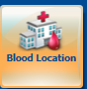  Change the Location for each unit in Sunquest  - In Blood Location  - Scan unit (also scan product code)  - Select New Location from list:  NOTE: location WIN is for use when units are returned
  AC1 | AirCare 1
  AC2W | AirCare 2
  AC3 | AirCare 3
  ACG | AirCare Ground
  ALG | Aleganey
  BMC | Do Not Use
  DAV | Davie Medical Center
  HPM | High Point Medical Center
  LEX | Lexington Medical Center
  STOK1 | Stokes EMS
  WEMS1 | Wilkes EMS1 (APRU)
  WEMS2 | Wilkes EMS 2 (cooler)
  WIN | Winston Main Campus
  RCF | Red Cell Freezer shelves
  WLK | Wilkes Medical Center
  AEMS1 | Alexander County EMS
  YEMS1 | Yadkin County EMS
4.0 | Fill out a Blood Bank Issue form.  4.1 On the Issue form  - Record all of the unit #s and product codes (E code) in the cooler. (Use barcode labels on both top and bottom copy when available.)  - Record the date to be returned (5 days before the oldest unit will expire)  4.2 Air Care must sign the Blood Bank Issue slip before removal from the  Blood Bank.  - The pink copy of the issue form goes with AirCare.  - Record the temperature of cooler at time of issuing from the Data logger  - Attach the top copy of the Issue form to the cooler prep flag and store in the clip for Air Care at front desk.  - Any copies of ISBT labels of the units (photocopy or reprinted ISBT label) should be stapled to the form.

5.0 | Pack the cooler.  - Remove the gel packs from the cooler interior and return to refrigerator.  - Place the thawed panels into the cooler, leaving the top frozen off. Place  the units into the cooler.  5.3The data logger probe must be placed either:  - Between the units and secured to one of the units with rubber band so that the probe remains in contact with the unit.  - Between the single unit and the gel pack and secured with rubber band to the unit.  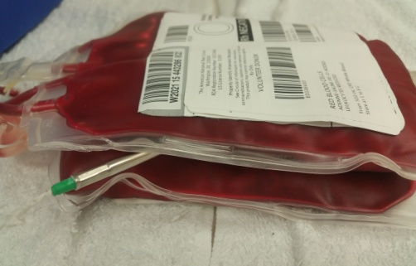  - Add one of the smaller polar packs with temperature range of 2-5°C on top of the two units or single unit/gel pack.  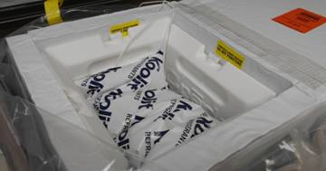  - Obtain the frozen panel from the freezer and place on the top. This must be placed on the top and should not come into direct contact with the units (thus the polar pack)  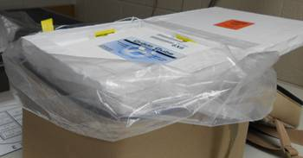  - Securely close the inner liner lid. Close the Velcro straps.  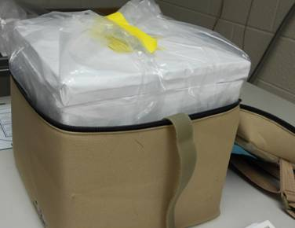  - Zip up the cooler and secure the cooler with a red fastener.
6.0 | Insert Emergency Release forms, one for each unit in cooler.  - Fold forms and insert into the top cooler pocket.
7.0 | Calculate the “Return by” date/time and attach to cooler.  - In the clear plastic tag attached to the cooler place the “Return by” card with the date and time that the cooler must be returned to the Blood Bank.
  Air Care
  4 – day return
  Decrease to 3 days during summer
  (OR maximum time indicated on inserts)

- Preparing and Issuing Blood to Stokes County EMS and Yadkin County EMS

STEPS | INSTRUCTIONS
1.0 | Immediately prepare the following units:  - Issue freshest units. Units will be stored in validated refrigerators on supervisor vehicles until they become short dated (5 days before they expire).
  Stokes EMS | Yadkin EMS
  2 units: Group O low titer Whole Blood  OR  Group O red cells  Group A plasma  (If WB not available) | 2 units: Group O low titer Whole Blood  OR  Group O red cells  Group A plasma  (If WB not available)
2.0 | Apply a Safe-T-Vue to each unit
3.0 | Attach “uncrossmatched blood” label to each unit bag.
4.0 | Fill out a Blood Bank Issue form.  - On the Issue form  - Record all of the unit #s and product codes (E code) to be sent. (Use barcode stickers from units on top and bottom copy when available).  - Record the date to be returned (5 days before the oldest unit will expire)  - Stokes/Yadkin County EMS must sign the Blood Bank Issue slip before removal from the Blood Bank.  - The pink copy of the issue form goes with County EMS.  - Store the top copy of the issue form in the clip for Air Care or County EMS at front desk.  - Any copies of ISBT labels of the units (photocopy or reprinted ISBT label) should be stapled to the form.

5.0 | Change the Location for each unit in Sunquest  - In Blood Location  - Scan unit (also scan product code)  - Select New Location from list:  NOTE: location WIN is for use when units are returned
  AC1 | AirCare 1
  AC2W | AirCare 2
  AC3 | AirCare 3
  ACG | AirCare Ground
  ALG | Aleganey
  BMC | Do not use
  DAV | Davie Medical Center
  HPM | High Point Medical Center
  LEX | Lexington Medical Center
  STOK1 | Stokes EMS
  WEMS1 | Wilkes EMS1 (APRU)
  WEMS2 | Wilkes EMS 2 (cooler)
  WIN | Winston Main Campus
  RCF | Red Cell Freezer shelves
  WLK | Wilkes Medical Center
  AEMS1 | Alexander County EMS
  YEMS1 | Yadkin County EMS
6.0 | Pack each unit in plastic bag between two small gel packs.  Front: Back:  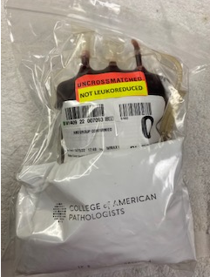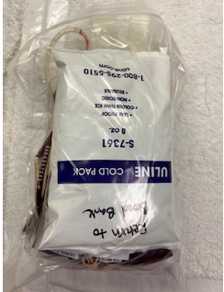
7.0 | Give units to EMS Personnel in transport cooler for storage in validated refrigerator.

8.0 | Contact information for Stokes / Yadkin County EMS  8.1 Primary contact is EMS Supervisor. Management can contact project manager or Wilkes Medical Director if needed.  Stokes EMS duty shift supervisor: available 24/7: 336-403-3810  Operations Manager Stokes County EMS: 336-593-5409  Darrell Nelson, MD Associate Professor Department of Emergency Medicine/EMS and Disaster Fellowship Director/Forsyth County EMS and Stokes County EMS Medical Director: 336-716-6912  Yadkin EMS  Operations Manager Yadkin County EMS: Dan Tucker: 336-849-7621  Assistant Director Yadkin County EMS: Christopher Bolden: 336-849-7620

- Preparing and Issuing Blood to Alexander County EMS and Wilkes EMS APRU

STEPS | INSTRUCTIONS
1.0 | Immediately prepare the following units:  - Issue freshest units. Units will be stored in validated refrigerators on supervisor vehicles until they become short dated (5 days before they expire).
  Alexander EMS | Wilkes EMS APRU
  2 Units: Group O low titer Whole Blood  OR  Group O red cells  Group A plasma  (If WB not available) | 2 Units: Group O low titer Whole Blood  OR  Group O red cells  Group A plasma  (If WB not available)
2.0 | Apply a Safe-T-Vue to each unit
3.0 | Attach “uncrossmatched blood” label to each unit bag.
4.0 | Fill out a Blood Bank Issue form.  - On the Issue form  - Record all of the unit #s and product codes (E code) to be sent. (use barcode stickers from units on top and bottom copy when available).  - Record the date to be returned (5 days before the oldest unit will expire)  - Alexander EMS must sign the Blood Bank Issue slip before removal from the Blood Bank at Wilkes BB.  - The pink copy of the issue form goes with EMS.  - Store the top copy of the issue form in the clip for AirCare cooler tracking at front desk upon its return to BB by Wilkes BB staff.
5.0 | Fill out a return by date card and place inside each unit.  5.1 Return date should be 5 days before unit expiration.  5.2 The day before this date (noted on card), place reminder on BB Calendar to send fresh units to Wilkes Blood Bank for exchange.
6.0 | Change the Location for each unit in Sunquest  6.1 In Blood Location  6.2 Scan unit (also scan product code)  6.3 Select New Location from list:  NOTE: location WIN is for use when units are returned
  AC1 | AirCare 1
  AC2W | AirCare 2
  AC3 | AirCare 3
  ACG | AirCare Ground
  ALG | Aleganey
  BMC | Do Not Use
  DAV | Davie Medical Center
  HPM | High Point Medical Center
  LEX | Lexington Medical Center
  STOK1 | Stokes EMS
  WEMS1 | Wilkes EMS1 (APRU)
  WEMS2 | Wilkes EMS 2 (cooler)
  WIN | Winston Main Campus
  RCF | Red Cell Freezer shelves
  WLK | Wilkes Medical Center
  AEMS1 | Alexander County EMS
  YEMS1 | Yadkin County EMS
7.0 | Pack each unit in plastic bag between two small gel packs.  Front: Back:

8.0 | Make copy of unsigned issue slip and retain in designated acetate. Pack units in ARC box and send via courier to Wilkes Blood Bank the day before change out is needed by EMS.  8.1 Send issue slip with units. Wilkes BB will have the EMS crew sign the issue slip.  8.2. Pink copy of signed issue slip will go with EMS crew  8.3. White copy of signed issue slip will come back to Main Campus with any units being sent back after exchange.  Refer to Receiving and Issuing WB to EMS Agencies Policy (NCBH, WMC)
9.0 | Contact information for Alexander County EMS  9.1 Primary contact is EMS Supervisor. Management can contact project manager or Medical Director if needed.  Ashlee Patterson, Support Specialist: 828-632-4166  Kevin Richards, Alexander County EMS Training Officer: (cell) 828-312-4314  Contact information for Wilkes EMS  11.1 Primary contact is EMS Supervisor. Management can contact project manager or Wilkes Medical Director if needed.  EMS supervisor: available 24/7: 336-927-1043  Jason Reavis, EMS project manager: 336-957-1067  Jeff Hinshaw Chief Physician Assistant, Emergency Medicine/Assistant Medical Director of Wilkes County EMS: 336-414-2485

- Preparing and Issuing Blood to Wilkes County EMS (Canvas Cooler)
STEPS | INSTRUCTIONS
1.0 | Immediately prepare the following units:  - Issue freshest units. Units will be stored in validated AirCare Canvas Coolers.
  Wilkes EMS
  2 units: Group O low titer Whole Blood
  OR
  2 Group O red cells
  2 Group A plasma
  (If WB not available)
2.0 | Apply a Safe-T-Vue to each unit
3.0 | Attach “uncrossmatched blood” label to each unit bag.
4.0 | Fill out a Blood Bank Issue form.  - On the Issue form  - Record all of the unit #s and product codes (E code) to be sent. (use barcode stickers from units on top and bottom copy when available).  - Record the date to be returned (5 days in winter/4 in summer)  - Wilkes County EMS must sign the Blood Bank Issue slip before removal from the Blood Bank. Alternatively, Courier will sign at pickup.  - The pink copy of the issue form goes with Cooler.  - Store the top copy of the issue form in the clip for Air Care or Local County EMS at front desk.  - Any copies of ISBT labels of the units (photocopy or reprinted ISBT label) should be stapled to the form.
5.0 | Change the Location for each unit in Sunquest  5.1 In Blood Location  5.2 Scan unit (also scan product code)  5.3 Select New Location from list:  NOTE: location WIN is for use when units are returned
  AC1 | AirCare 1
  AC2W | AirCare 2
  AC3 | AirCare 3
  ACG | AirCare Ground
  ALG | Aleganey
  BMC | Do Not Use
  DAV | Davie Medical Center
  HPM | High Point Medical Center
  LEX | Lexington Medical Center
  STOK1 | Stokes EMS
  WEMS1 | Wilkes EMS1 (APRU)
  WEMS2 | Wilkes EMS 2 (cooler)
  WIN | Winston Main Campus
  RCF | Red Cell Freezer shelves
  WLK | Wilkes Medical Center
  AEMS1 | Alexander County EMS
  YEMS1 | Yadkin County EMS
6.0 | Prepare a 5 day cooler.  Refer to Blood Cooler Issue Procedure (NCBH)  - Condition 5 of the 6 panels to a temperature of 2-5°C  6.3 The 6th panel must remain frozen until ready to place in cooler  6.4 Document on cooler prep flag as stated in the procedure in section I.  - Time removed from freezer  - Temperature readings when conditioning  6.5 If using blood components, a 4 day inserts may be required to fit product.
7.0 | Pack the cooler.  7.1 Remove the gel packs from the cooler interior and return to refrigerator.  7.2 Place the thawed panels into the cooler, leaving the top frozen off. Place the units into the cooler.  7.3 The data logger probe must be placed between the units and secured to one of the units with rubber band so that the probe remains in contact with the unit.  (note: image shows PRBCs but WB will typically be packed for Wilkes EMS)  7.4 Add one of the smaller polar packs with temperature range of 2-5°C on top of the two units or single unit/gel pack.  (Note: 6x6 cooler inserts are shown below. Wilkes will require use of 5x5 inserts).  7.5 Obtain the frozen panel from the freezer and place on the top. This must be placed on the top and should not come into direct contact with the units (thus the polar pack)  7.6 Securely close the inner liner lid. Close the Velcro straps.  7.7 Zip up the cooler and secure the cooler with a red fastener.
8.0 | Insert Emergency Release Forms into Plastic sleeve
9.0 | Calculate Return time.  9.1 5 days during the winter, 4 days during summer (OR maximum time indicated on inserts)  9.2 Not to exceed the expiration date of any units packed  9.3 In the clear plastic tag attached to the cooler place the “Return by” card with the date and time that the cooler must be returned to the Blood Bank
10.0 | Issue Cooler to EMS staff or Blood Courier  10.1 Double check the temperature of the cooler before issue  10.2 Personnel picking up cooler must sign the issue slip

11.0 | Contact information for Wilkes EMS  11.1 Primary contact is EMS Supervisor. Management can contact project manager or Wilkes Medical Director if needed.  EMS supervisor: available 24/7: 336-927-1043  Jason Reavis, EMS project manager: 336-957-1067  Jeff Hinshaw Chief Physician Assistant, Emergency Medicine/Assistant Medical Director of Wilkes County EMS: 336-414-2485

- Returning Air Care and EMS blood
Chemical Risk Assessment: None
Biological Risk Assessment: None
Protective Equipment: Gloves
Supplies: Cooler Prep Flag
Reagents: N/A
Equipment: Cooler Inserts and Panels
Specimen Requirements: N/A
STEPS | INSTRUCTIONS
1.0 | Check the temperature of the returned cooler if applicable using the attached data logger.  - If the temperature is 2-6°C the units may be placed back into inventory.  - If the temperature is 6-10°C quarantine units and consult management.  - If the temperature is over 10°C discard unit (physically and in BB LIS) and write a QA for management.
2.0 | Change the Location for each unit in Sunquest  2.1 In Blood Location  2.2 Scan unit (also scan product code)  2.3 Select New Location from list:  NOTE: location WIN is for use when units are returned
  AC1 | AirCare 1
  AC2W | AirCare 2
  AC3 | AirCare 3
  ACG | AirCare Ground
  ALG | Aleganey
  BMC | Do Not Use
  DAV | Davie Medical Center
  HPM | High Point Medical Center
  LEX | Lexington Medical Center
  STOK1 | Stokes EMS
  WEMS1 | Wilkes EMS1
  WEMS2 | Wilkes EMS 2
  WIN | Winston Main Campus
  RCF | Red Cell Freezer shelves
  WLK | Wilkes Medical Center
  AEMS1 | Alexander County EMS
  YEMS1 | Yadkin County EMS
3.0 | Pull the returned Issue form from the bin and file with other issue slips.
4.0 | Place all 6 inserts back in freezer and place gel pack in refrigerator.
5.0 | Emergency issue in BB LIS any units transfused by Air Care or EMS if possible.  - Patient information should be on the Emergency Release form filled out by the Air Care or EMS team.  - If units were given to a patient that was taken to another facility:  - Air Care or EMS will provide the Blood Bank the identity of the other hospital and the patient on the Blood Bank Emergency Release form.  - Alert BB management to reconcile.  - Do not transfer units to any other facility.  - Do not transfer units in Blood Hub.  - Place comment under unit with as much information as possible as to who got the unit.  5.3 Complete AirCare EMS Transfused Units Checklist Form (NCBH) and turn in to management.
6.0 | Units returned from EMS refrigerators must have safe-t-vue checked upon return.  6.1 If safe-t-vue is sold red. Place unit in quarantine and complete QA to management  6.2 Units not returned should be presumed transfused and must have an AirCare EMS Transfused Units Checklist Form (NCBH) completed.

- CROSS REFERENCES

AirCare EMS Transfused Units Checklist Form (NCBH)

- RESOURCES AND REFERENCES

Not Applicable

- ATTACHMENTS
Attachment 1: Prehospital Blood Job-Aid
Attachment 2: Blood Product Issue Form

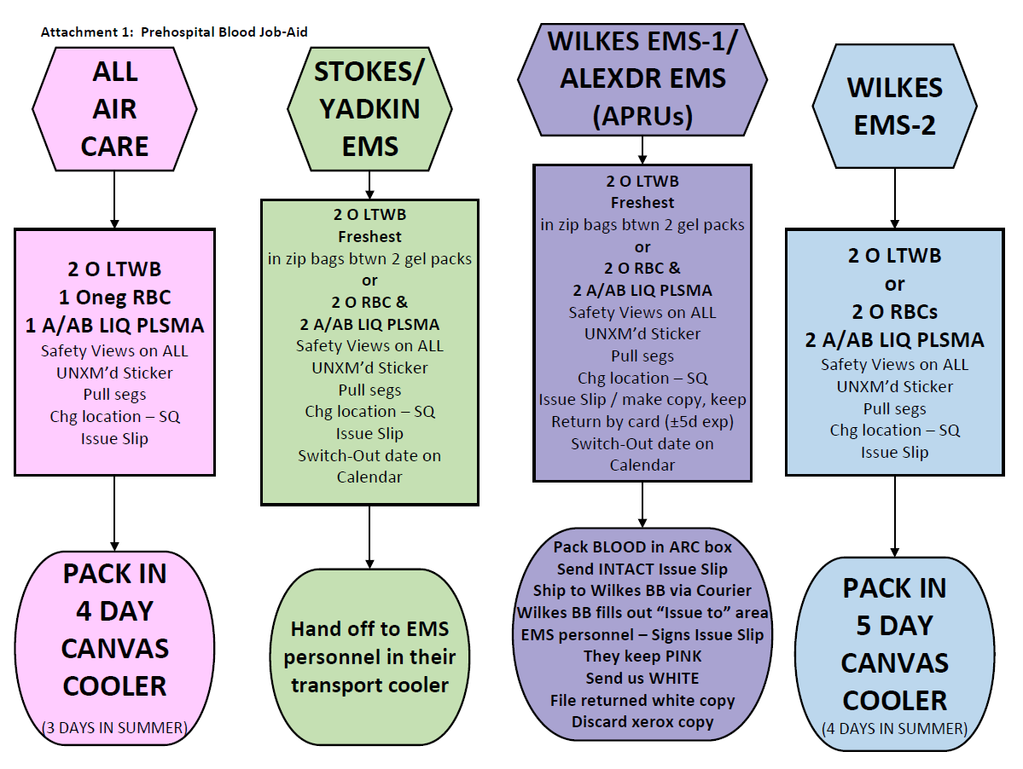
Attachment 2: Blood Product Issue Form

