|  |  |  |  |  |  |  |
| --- | --- | --- | --- | --- | --- | --- |
| **Application:** | | Epiccare Ambulatory | | | **Role:** | Provider |
| **Author:** | | Karyn Harris  Patricia Harman  Sheri Sanders | | | **eMail:** | [harrisk@wvumedicine.com](mailto:harrisk@wvumedicine.com)  [harmanpat@wvumedicine.com](mailto:harmanpat@wvumedicine.com)  [sanderssh@wvumedicine.com](mailto:sanderssh@wvumedicine.com) |
| **Date:** | 12/18/2015 | | **Topic:** | **Provider Preformed POCT (12-2015)** | | |

The following POCT being resulted by the provider (Ferning test, KOH Prep Test, Wet Mount Test UA Micro, Pinworms, and Nitrazine) will need to be documented by the **Provider** in the flowsheet section of chart.

1. Click on the “Flowsheet” activities tabs to the left of the visit navigator:

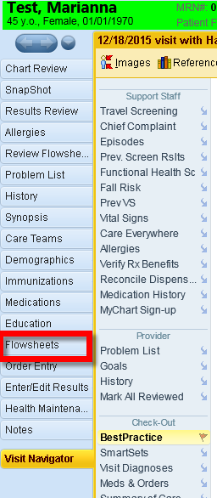

1. In the search bar (upper left corner of the Flowsheet screen) enter the word “Provider”

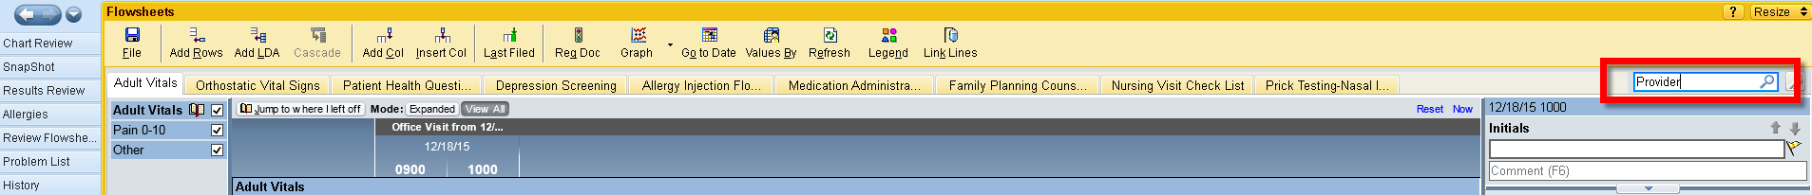

1. Hit “enter”
2. Make sure that “Provider Performed POCT” is highlighted and “Click” accept.

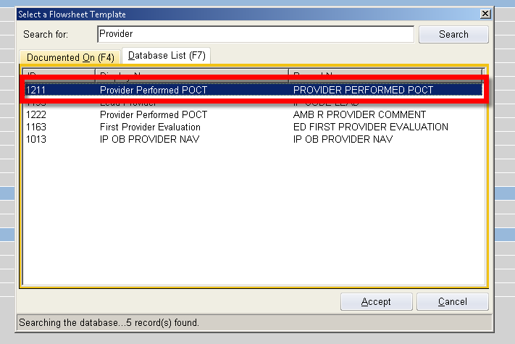

1. On the right hand of the screen, that you can point and click to fill in what you need to

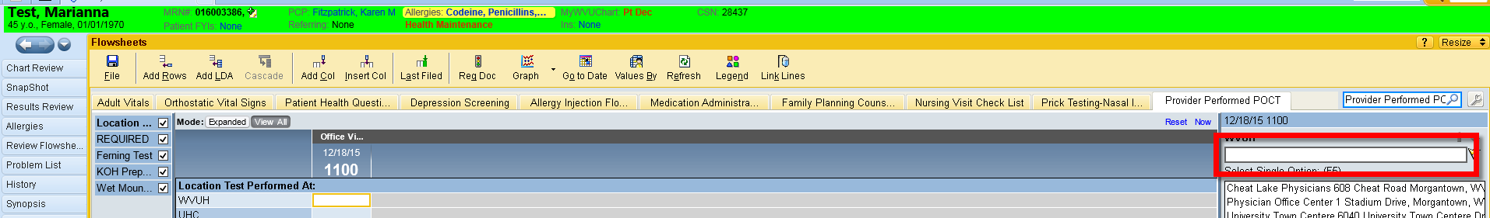

1. The “Location Test Performed at” and “Required” sections must be completed

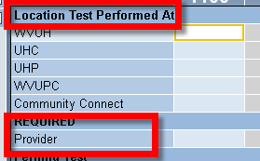

1. Choose the test that you need to document on

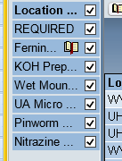

1. Move back to the right hand side of the form and answer the questions using you mouse and the drop down list

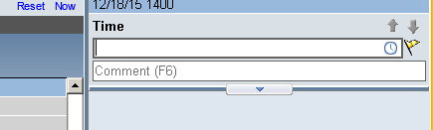t

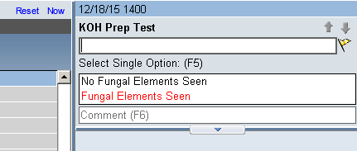

1. When you move back to the Visit Navigator/ another page, the information will save automatically.
2. To pull the flowsheet info to your note, use the following Smartphrase.

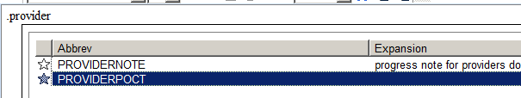

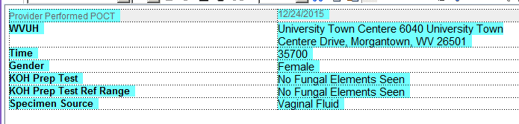

1. After the test is ordered and complete, the charge will need to added so that the billing can be completed. To do this, you will go to the Orders and Procedures section of the navigator to “Charge Capture”

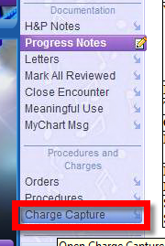

1. In the “Charge Capture” section, find the hyperlink that says “Poct (place A Check Mark In The Appropriate Check Box” line

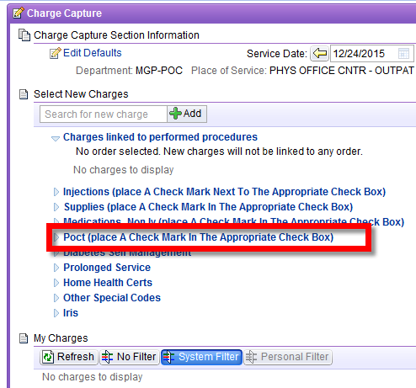

1. You will find the test to charge for in your charge capture as you are logged into your specific department. (The screen shot below is what the OB/GYN charge capture looks like with the Provider POCTs that they would do are shown)

