

This image was from the most recent Hematology (FH9-B) Survey. It was one of the ungraded portions of the survey. Our lab selected the identification as “Megakaryocyte.” 46.6% of labs and 42.0% of referees agreed with our assessment. The correct response as sought by CAP was “Blast Cell.” Only 33.2% of labs and 40.2% of referees agreed with this identification. This was an educational challenge, and as such, the following considered to be educational material (not a reprimand). The case and reasoning follow:

**Case History**

This peripheral blood smear is from a 15-year-old boy who presented with fevers, headaches, night sewats, and pancytopenia. He underwent a bone marrow biopsy and was subsequently diagnosed with acute megakaryoblastic leukemia. Laboratory data include: WBC = 0.5 x 10E9/L; RBC = 2.24 x 10E12/L; HGB = 6.3 g/dL; HCT = 18.1%; MCV = 81 fL; PLT = 7 x 10E9/L; and RDW = 18%.

**Explanation**

The arrowed cells are blasts, as correctly identified by 40.2% of the referees and 33.2% of participants. Blasts are large, round-to-oval cells, with high nuclear-to-cytoplasmic ratios, often with large nuclei demonstrating lacy or reticular (immature) chromatin.

The arrowed cells were incorrectly identified as a megakaryocyte (normal, abnormal or nuclear fragment) by 42.0% of the referees and 46.6% of the participants. While the arrowed cells do demonstrate features suggestive of megakaryocytic lineage, namely the cytoplasmic coloration and blebbing, the immaturity of the nuclear chromatin and prominence of the nucleoli suggest immaturity. As such, the classification as blast is more appropriate than megakaryocyte (normal, abnormal or nuclear fragment)[1].

**Further Notes**

Blebbing - The bulging out of a part of a cell below the plasma membrane[2], characterized by a spherical, bulky morphology.[3]

Below are some pictures of megakaryocytes. You will notice that some have the blebbing like the cells in the photos from the CAP survey image. All of the nuclei, though, are more mature looking. They are less fine and with no distinctly noticeable nucleoli.

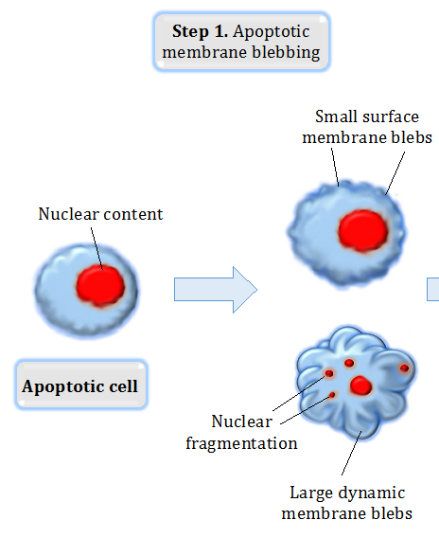

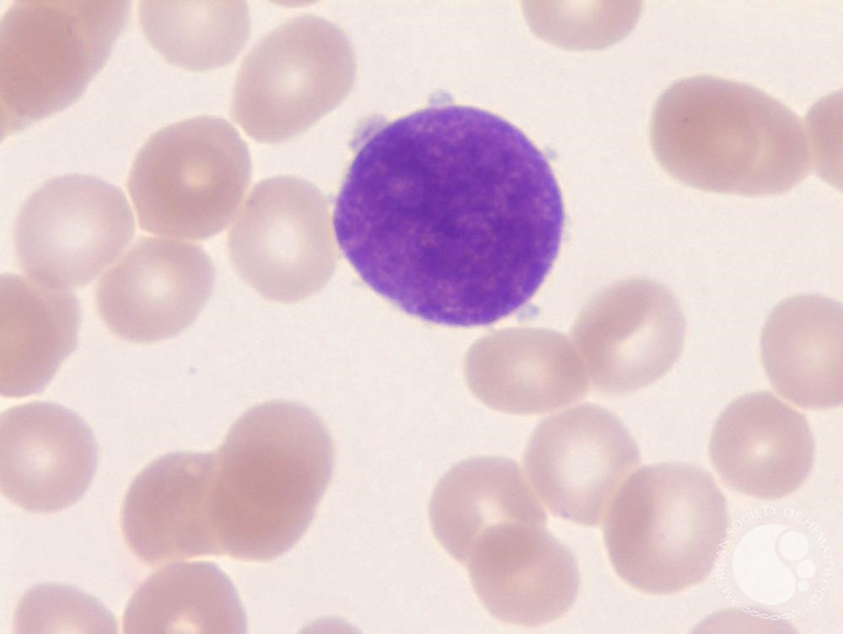 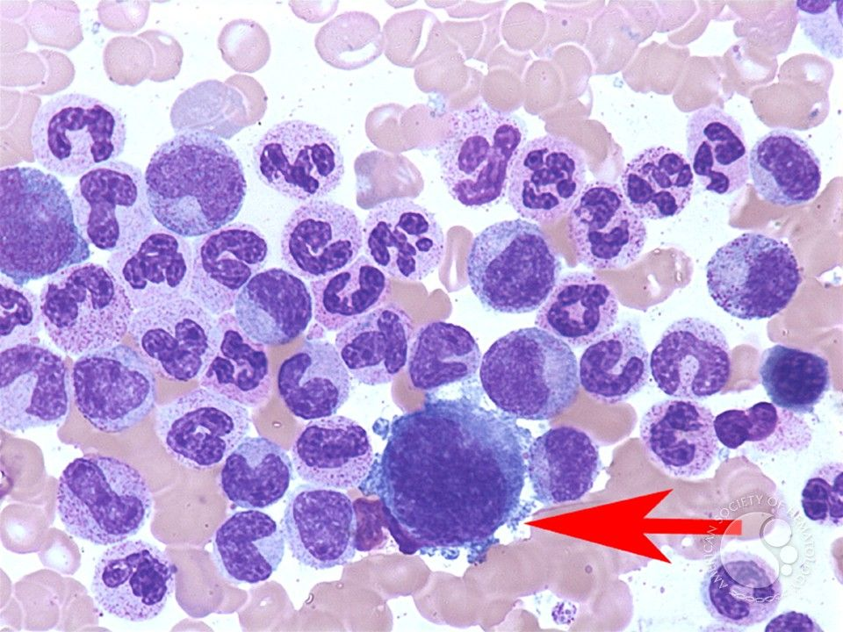

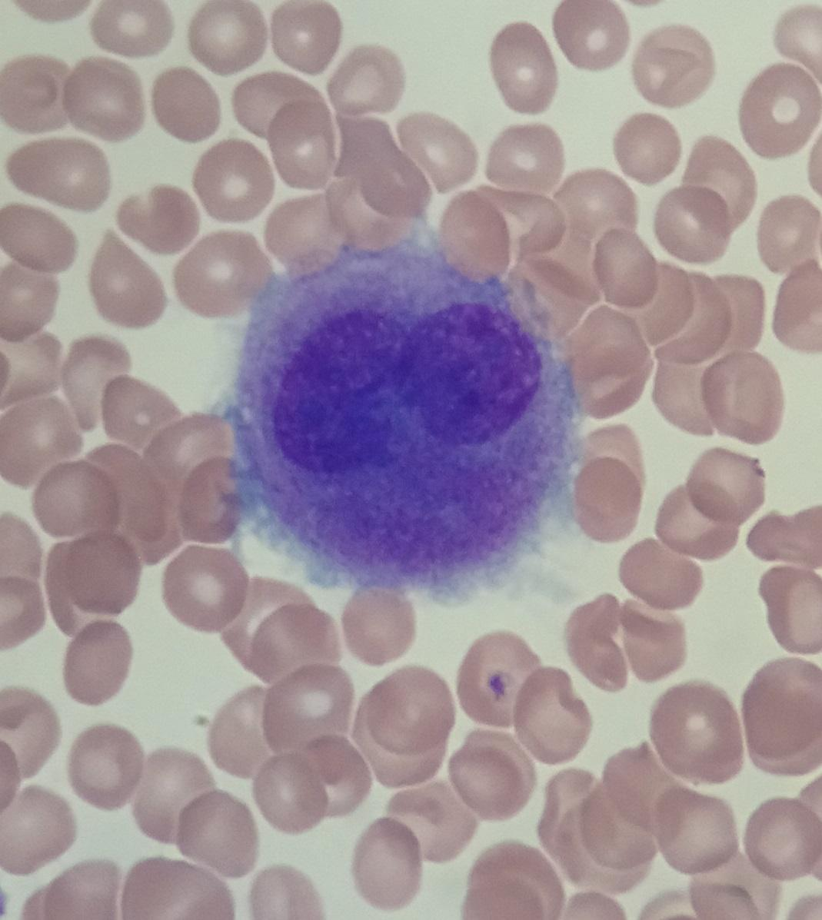

Here is one more picture of a BLAST with blebs. It is blurry, but notice the nucleus to cytoplasm ratio and the prominent nucleoli.

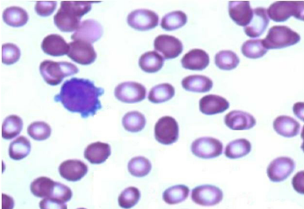

1. College of American Pathologists. "Comprehensive Hematology with Automated Differential FH9-B 2020 Participant Summary." *Surveys and Anatomic Pathology Education Program* (2020): 32. Document.
2. “blebbing." Segen's Medical Dictionary. 2011. Farlex, Inc. 7 Jul. 2020 <https://medical-dictionary.thefreedictionary.com/blebbing>
3. [***c***](https://en.wikipedia.org/wiki/Bleb_(cell_biology)#cite_ref-:0_2-2) *Fackler OT, Grosse R (Jun 2008).* [*"Cell motility through plasma membrane blebbing"*](https://www.ncbi.nlm.nih.gov/pmc/articles/PMC2426937)*. J. Cell Biol.* ***181*** *(6): 879–84.* [*doi*](https://en.wikipedia.org/wiki/Doi_(identifier))*:*[*10.1083/jcb.200802081*](https://doi.org/10.1083%2Fjcb.200802081)*.* [*PMC*](https://en.wikipedia.org/wiki/PMC_(identifier))[*2426937*](https://www.ncbi.nlm.nih.gov/pmc/articles/PMC2426937)*.* [*PMID*](https://en.wikipedia.org/wiki/PMID_(identifier))[*18541702*](https://pubmed.ncbi.nlm.nih.gov/18541702)*.*