Situation: We missed one of the samples on the most recent Urine Crystal survey. We certainly shouldn’t feel bad about this as 40% of participants also missed this sample. However, in order to avoid a similar situation in the future, I want to create an education document for now and a resource for future urine crystal surveys. Thank you for your time with this education document.

CRS-A 2021: URC-01

Our response: “Crystals Absent”

Intended response: “Crystals Present – Amorphous Urates”

Urine pH given: 5.2

**10x objective**

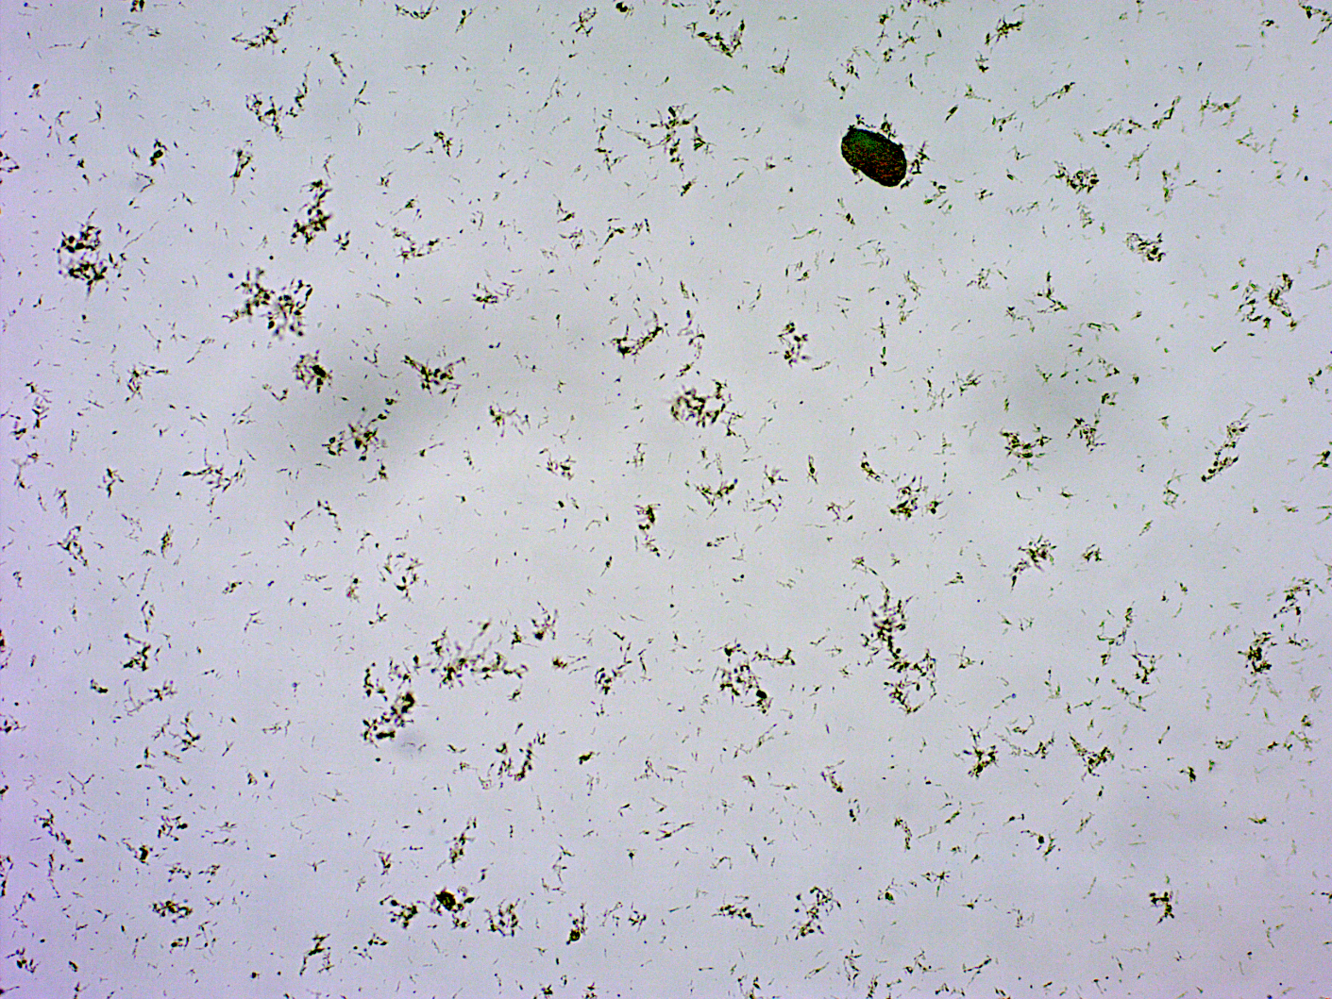

Background: What you cannot see in these still images is the motion of the particles, as some of them did seem to be moving some. This motion and the general appearance (stretched out like a bacterial rod would be) led the tech to think most of the artifacts in the image were bacteria and not crystals.

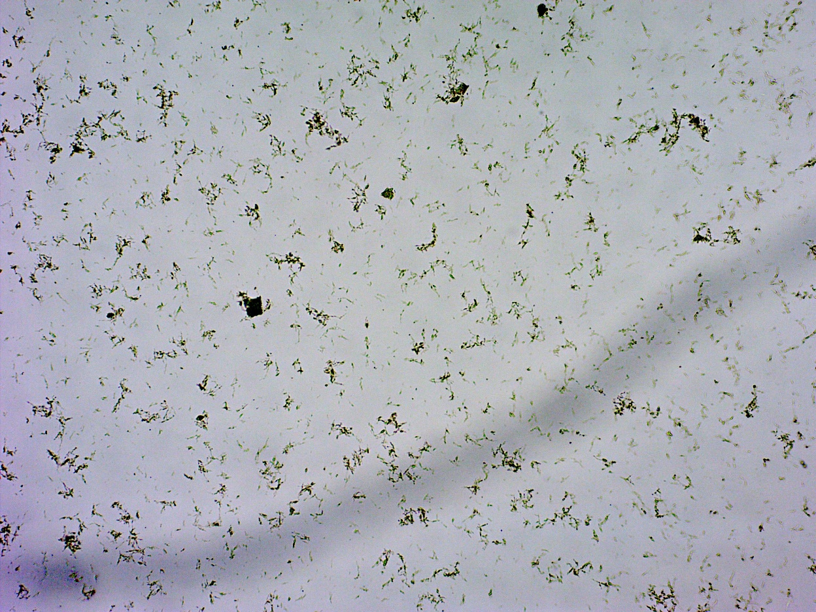 10x objective

**Now 40x objective**

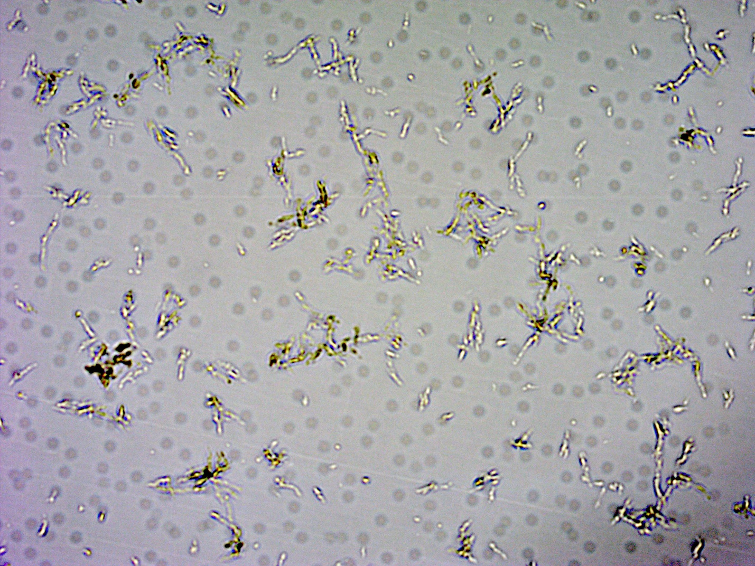

Assessment: Make sure you use all of the clues given to you when making decisions. The urine pH is 5.2 (acidic). Generally in a bacterial infection, the pH will be 7+ because bacteria make the environment more basic. Also, you would expect to see white blood cells with a bacterial infection. There are none in the sample. Most of the artifacts in the sample images are non-descript specs, and the motion they were showing is more akin to Brownian motion than a swimming bacteria (they are sort of “buzzing” in place). Those major clues, as well as the appearance of the urine microscopic (especially on the low power 10x objective), were trying to lead us to a result of amorphous urate crystals present. I agree this is not the perfect example of amorphous crystals as we would see them naturally, but the survey isn’t 100% natural.

Recommendation: Take all clues you are given into account for a specimen like this. In the future, these resources/clues will include images of past surveys available to you. There will be a spot on the G:Drive (FSED folder → ED at Proffit → Urinalysis → Crystal Survey folder) where these labeled images are kept. Note that this folder will appear AFTER everyone has completed the online education activity/quiz. For further education, though, I would also like to include in this document an image of a survey sample whose result actually was “Crystals Absent.” You will note the stark absence of almost any artifact in the sample with an “absent” result.

CRYSTALS ABSENT AMORPHOUS CRYSTALS PRESENT

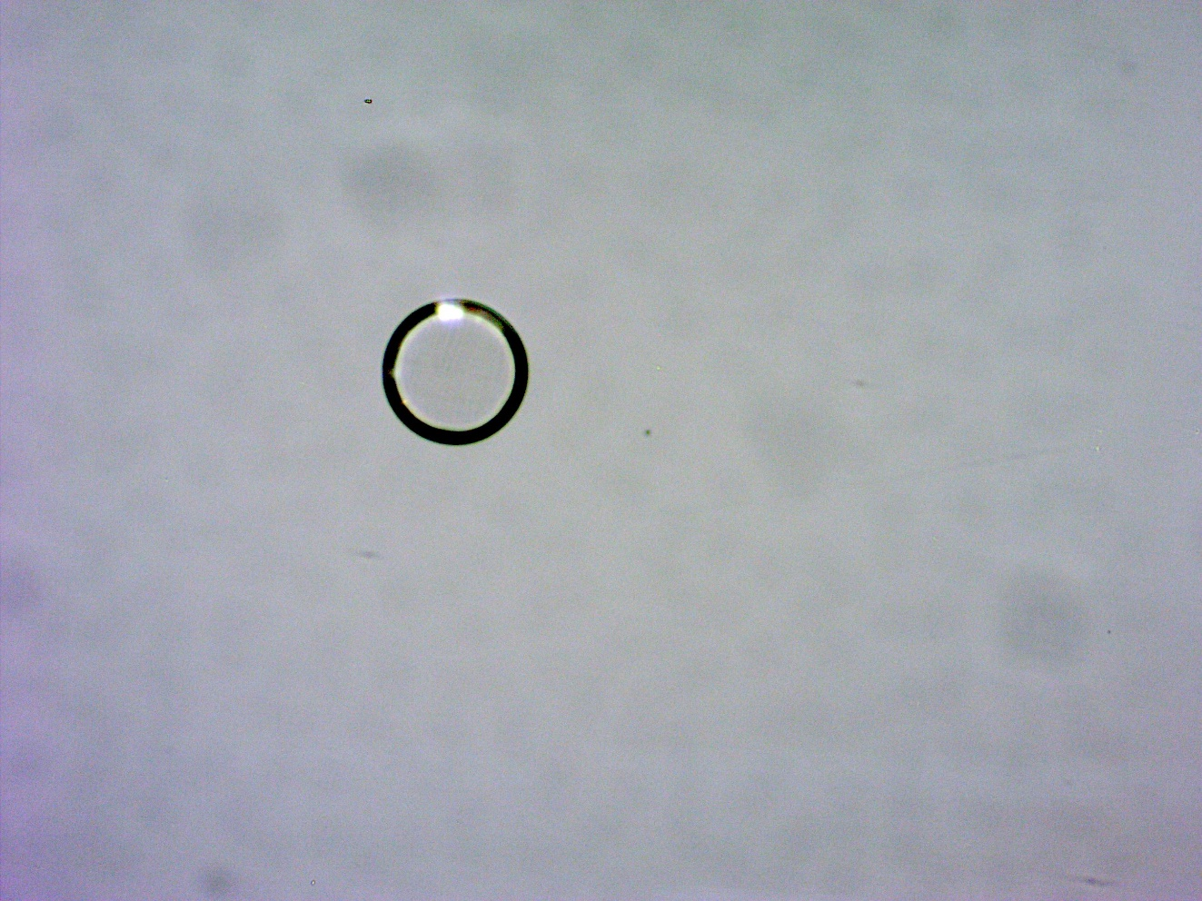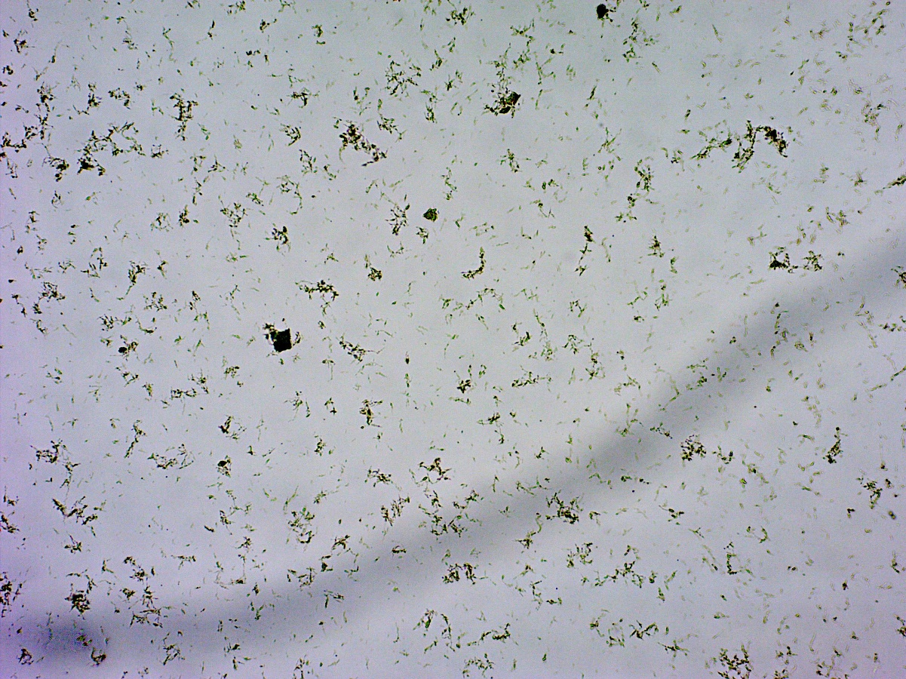

After you have read this document, please take the quiz attached within [www.medtraining.org](http://www.medtraining.org).