Our lab missed one image on the CM-A 2023 survey. Technically there was no consensus, but since we did not report the intended result, I want to make sure we are all educated on it.

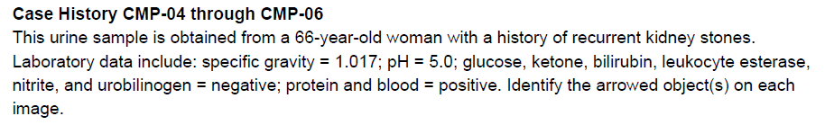
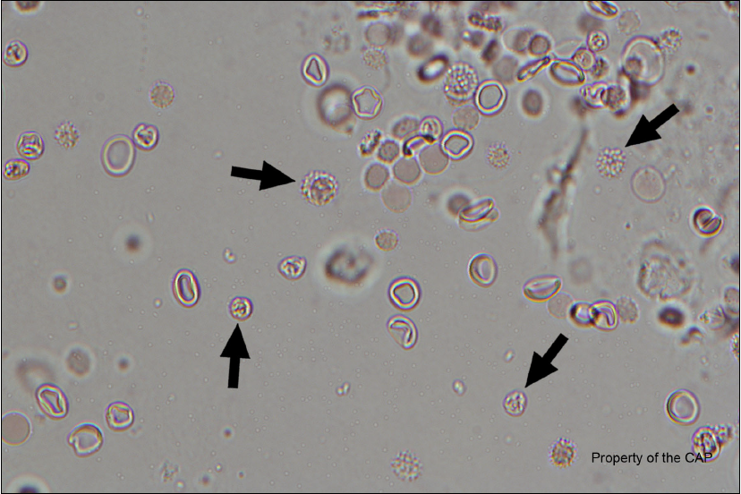
What would be your best guess?

Our lab reported these cells as Dysmorphic RBCs (crenated).
25% of referees and 41.5% of participants agreed with us.
The intended result was WBCs.
The reason they gave was that one of the four arrowed cells appears to have a clear nucleus and that these kind of “crenated WBCs” can be seen in a UTI.

My argument is that the case history does not read like a UTI, and the arrowed cells are even smaller than the normal RBCs. The elevated protein and high/normal pH point more to kidney injury or glomerulonephritis, which would point more towards dysmorphic RBC’s.

The takeaway I want all of us to get from this document, however, is that BOTH RBCs and WBCs can be crenated depending on the urine environment. We don’t often think of crenated WBCs when reviewing urines. This is why correlation with urine chemistry (dipstick) results AND clinical presentation can be important tools when performing urine microscopic examinations.

The CAP pages from the participant summary follow. Please review and then check the read receipt button.

