BMDIF Manual Differential (Bone Marrow) Keyboard

Purpose | Examination of the bone marrow aspirate and Trephine biopsy is essential for the diagnosis of bone marrow disorders. A bone marrow differential cell count should be performed to assess hematopoietic activity and to compare the proportions of the different cell lineages with known reference ranges, and also to quantify abnormal cells if present.
Policy Statements | The laboratory technologist can assess cellularity, presence of megakaryocytes, and possible presence of tumor cells on the bone marrow smears. Ultimately, the pathologist is responsible for interpreting the bone marrow differential results after meticulous review of all smears stained, as well as any biopsy sections available. It is also the pathologist's responsibility to identify tumor cells that may be present.
Selecting a slide or area of a slide for examination  Performing the Differential  Result Reporting  Reference Ranges  References | Verify the patient name, medical record number and accession number.  Once you select your smears, scan using 10X magnification on the microscope. Are some of the fragments (bone spicules)/smears so thick that you cannot see good morphology?  If so, reject these areas/slides.  Are some of the fragments/smears so thin that everything is smashed?  These areas/smears cannot be used either.  Are there areas in the vicinity of any of the fragments that have good staining characteristics as well as readable morphology?  This is where you should begin your differential.  Use low power (10x) to look at the distribution on the slide and the quality of the stain. Find areas where the spread/distribution of cells are thin enough (monolayer) to read easily and where the  color balance and intensity of the stain is good.  Use low power (10x) to scan the slide for the presence of Megakaryocytes (decreased, normal or increased ) and tumor cell aggregates ( present or not present ). Increased numbers of Macrophages should also be documented including the presence of hemophagocytosis if present.  Cell counts are performed on 50x magnification with oil moving up to 100x magnification with oil as needed for fine detail. Begin counting at the feathered edge, be sure that you are in  deep enough from the thin edge so that the numbers of damaged cells are kept to a minimum to  avoid skewing the count, as some cell types are more fragile than others.  The differential count should not include Megakaryocytes, Macrophages, Osteoblasts, Osteoclasts, Stromal Cells, Smudged Cells, or non-hematopoietic cells (i.e. tumor cells).  For a description of cells commonly found in bone marrow go to the following link;  Description of cells commonly found in Bone Marrow  Once you have decided where to count the marrow, you can perform the differential count using the BMA Keyboard in Sunquest.  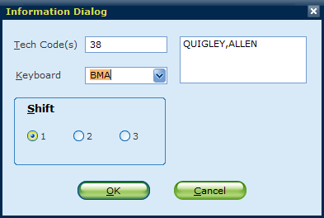  A 500 cell bone marrow differential is the minimum acceptable count. In rare cases when it is not possible to count 500 cells it is possible to terminate your count by selecting the TERM key and the percentages will be calculated from that number.  Remember, unlike peripheral differentials, all nucleated cells are included in the total count, including all maturation stages of the erythroid cell series (which are counted in one category as erythroid precursors) using the ERYM key.  Blast cells (MBLAM), Promyelocytes (PROMM), Myelocytes (MYELM), Metamyelocytes (METAM), Band forms (NEUTM), Segmented Neutrophils (NEUTM), Eosinophils (EOSBM), Basophils (BASOM), Promonocytes (PROMM) and Monocytes (MONOM), Lymphocytes (LYMPM), and Plasma Cells (PCBM) should be counted. Notice that Segmented Neutrophils and Bands are grouped together use the NEUTM key to count these.  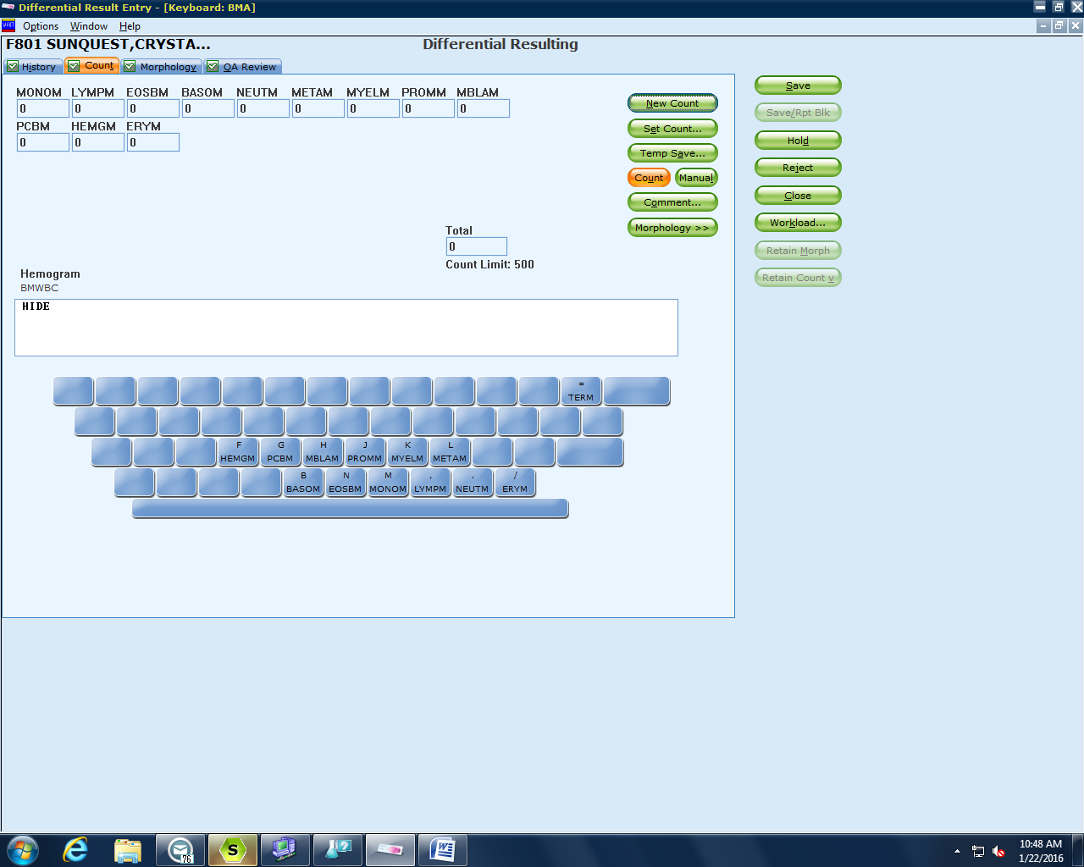  After the differential count has been completed enter results for an estimate of the number of Megakaryocytes as well as the presence or absence of tumor cell by using the following keys;  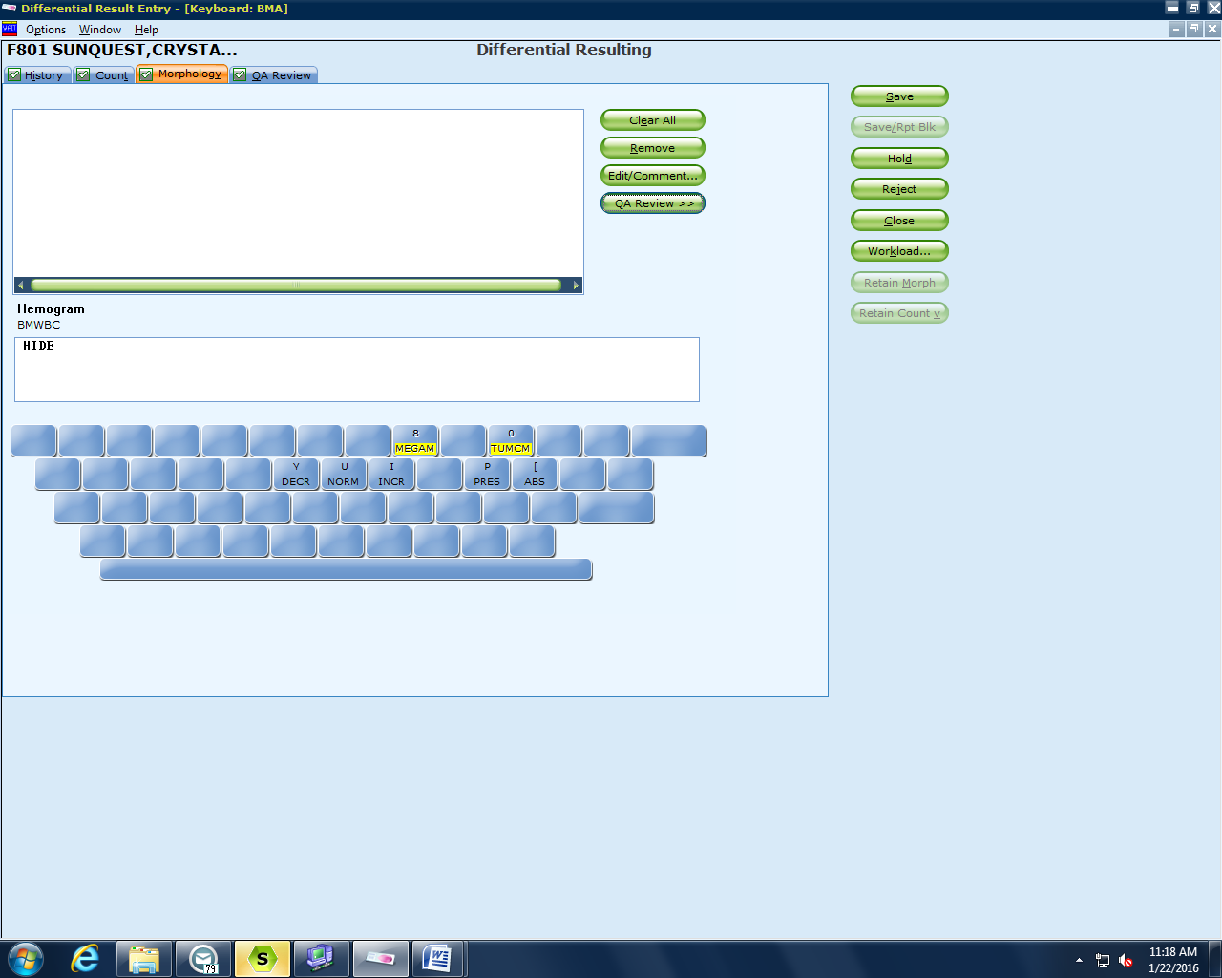  After the differential has been completed exit from the Differential result entry screen and select Laboratory Inquiry. Enter the accession number of the sample, then select Get Results, print the results and include them with the Bone Marrow Report Form that goes to the Pathologist for final review and interpretation. Bone Marrow Report form  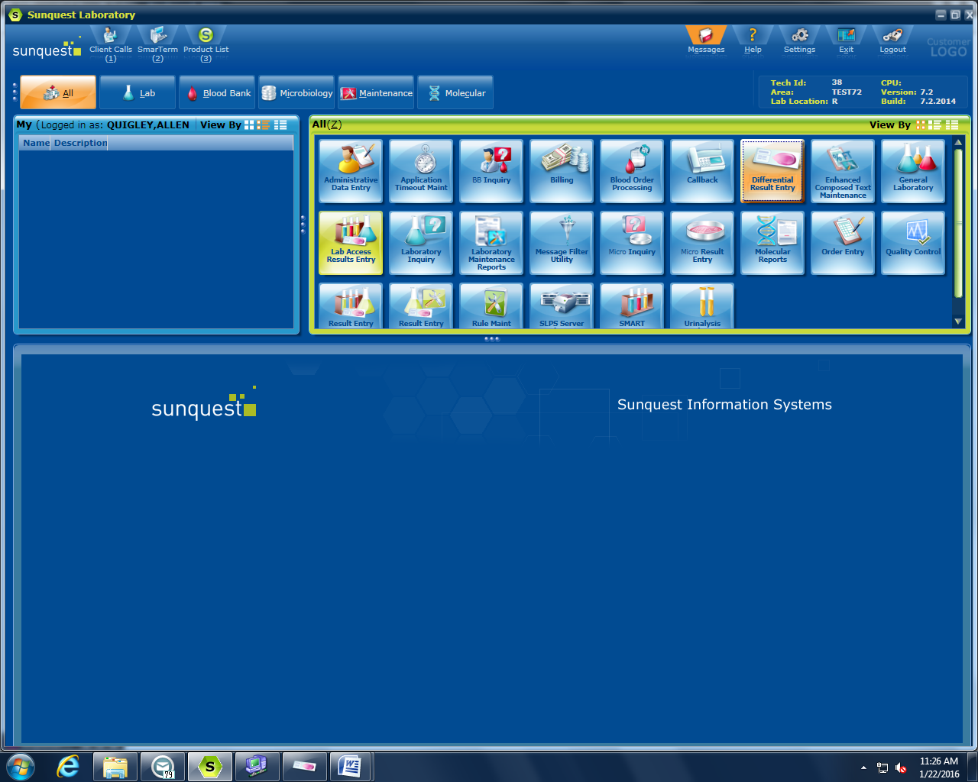  After the differential has been completed exit from the Differential result entry screen and select Laboratory Inquiry. Enter the accession number of the sample, then select Get Results, print the results and include them with the Bone Marrow Report Form that goes to the Pathologist for final review and interpretation. Bone Marrow Report form  Reference ranges for bone marrow differential counts; Bone Marrow Reference Ranges  Lab CE Bone Marrow Aspiration Part I: Normal Hematopoiesis and Basic Interpretation Procedures  College of American Pathologists. 2010 Hematology and Clinical Microscopy Glossary. Northfield, IL: College of American Pathologists; 2010.  Foucar K, Reichard K, Czuchlewski D. Bone Marrow Pathology 3rd ed. Chicago, IL: ASCP Press; 2010.  Glassy EF, ed. Color Atlas of Hematology. Northfield, IL: College of American Pathologists; 1998.  Hoffbrand AV, Pettit JE. Color Atlas of Clinical Hematology. St Louis, MO: Mosby; 2001.  ICSH Guidelines for the Standardization of Bone Marrow Specimens and Reports  S.-H. LEE, W.N. ERBER, A.PORWIT, M. TOMONAGA, L.C. PETERSON For The International  Council For Standardization In Hematology
 | Version | Written/Revised by: | Effective Date: | Summary of Revisions
 | 1 | Al Quigley | 02/01/16 | Initial Version
 | 2 | Al Quigley | 02/01/16 | Added details from new Keyboard.
 | Archived by: |  | Archived Date:

