ADIF Manual Differential Keyboard

Purpose | This procedure provides instructions for using the ADIF MANUAL DIFFERENTIAL KEYBOARD. This method is used for reporting a manual microscopic examination of a Wright-Giemsa stained peripheral blood smear.
Policy Statements | - This procedure applies to all laboratory technologists performing hematology testing, the section supervisor, and section pathologist.
Materials | Equipment |  |  | Reagents |  |  |  | Supplies
 | - Microscope with 10X, 50X and 100X objectives  - Personal computer with Sunquest DFR keyboard |  |  | Cargille Type B Immersion oil for microscopy, Fisher 12-369B:  - Formulated from synthetic hydrocarbons and natural petroleum derivatives  - Safe for lens/optics  - Store at 4 - 40°C |  |  |  | - 3 x 1 frosted-end slides  - Kim-Wipes® Lint-free wipes, available from storeroom.  - CDSapphire color printout or CD 3200 printout (when used)  - Differential QC logbook  - PC with Sunquest DFR keyboard
Sample | - Collect blood from a clean venipuncture; avoid foaming.  - Whole blood anticoagulated with K₃EDTA or K₂EDTA  - Minimum volume: 0.6 mL  - Maximum volume: 2.0 mL  - Invert and mix well (invert Microtainers 10 times, invert 2mL Lavender tubes 5 times). Transport at room temperature to Lab.  - Check sample for clots with applicator stick.  - Test within 4 hours for the most reliable data.  - Sample preparation:  - Make one thin smear with feathered edge that is ¾ the length of the slide.  - Prepare blood films on clean 23 x 75 mm, 0.9 to 1.2 mm thick, good quality microscope slides.  - Prepare films within 1 hour of the blood collection in K₂EDTA.  - Adequate mixing is necessary before film preparation.  - Prepare films using the wedge-pulled film technique.  - Place one drop (0.05 mL) of well-mixed blood near one end of a glass microscope slide.  - Hold a second spreader slide with polished hedges at about a 45° angle and immediately draw into the drop of blood.  - Allow the blood to spread almost to the width of the slide.  - Rapidly and smoothly push the spreader slide to the opposite end of the slide.  - Characteristics of a wedge blood film:  - Gradual transition in thickness from the thick to thin areas, ending in a curve  - Minimum 2.5 cm in length terminating at least 1 cm from the end of the slide.  - No artifact introduced by the technique.  - A far end that becomes gradually thinner, without grainy streaks, troughs, or ridges, all of which indicated an increased number of leukocytes carried into the area.  - With a pencil, label the frosted end with the patient's last name, accession number, and a D (diff) or P (platelet) or R (Retic).  - Allow to dry for at least one minute before staining in Wescor slide stainer.  - Stain peripheral blood smears with Wright’s Giesma stain using the Wescor slide stainer. See HEM 13.1 Wrights Staining of Peripheral Blood and Body Fluid Smears
Quality Control | - Performed by day shift.  - One diff per month.  - Compare verified automated differential to manual differential.  Results should agree within 95% limits established by Rumke. Refer to Table I – Manual Differential Confidence Table  - Document on Monthly Instrument Correlation worksheet.  - Another technologist, section supervisor, or pathologist should review questionable differentials before verifying.
Procedure | Follow the activities in the table below to perform ADIF MANUAL DIFFERENTIAL KEYBOARD.
 | Step | Action |  |  |  |  |  |  |  | Related Document
 | 1 | Place slide on microscope stage. Examine smear for the following:  - At 10x, examine slide for even distribution of cells and lack of platelet clumps:  - Even Cellular Distribution:  - WBCs pulled to the feather edge of the blood slide should not exceed 2-3 times the number of white cells present in the examination area of the smear.  - Remake slides that do not meet this standard as larger cells (blasts, granulocytes, and monocytes) are disproportionately pulled to the feather, and this action may affect differential accuracy.  - The examination area of the blood film is typically the area where approximately 50% are individually spaced.  - WBC Estimation:  - Perform WBC estimation in the examination area of the blood film. Average the number of WBCs in ten fields of 10x (low power) times 200.  - Using low power objectives (10x):  20-30 WBC/10x field = approximately 4,000-6,000 WBCs/mm³  40-60 WBC/10x field = approximately 8,000-12,000 WBCs/mm³  90-110 WBC/10x field = approximately 18,000-22,000 WBCs/mm³  - Compare WBC estimate to the value obtained by the Cell-Dyn. Investigate significant discrepancies.  - Accurate WBC estimates are dependent on well-made blood smears:  - Poor slide making technique can result in too many WBCs being deposited on the feather or lateral edges.  - Reject smears having more than three (3) times the number of leukocytes on the edges than in the examination area.  - Reject smears with holes or fingerprints, or that appear washed off after staining.  - Presence of Smudged Cells  - Albumin smears must always be made when WBC smudging exceeds 10% of cells present.  - Prepare slides using Albumin Blood Smears procedures.  - Rouleaux Formation and Either WBC or RBC Agglutination:  - RBC may be spuriously decreased because of cold agglutinins (MCHC >37%); warm the sample for 10 minutes at 37° C, and rerun immediately.  - Platelet Clumps, Parasites, or Abnormal Cells in the Feather Edge:  - The feather and lateral edges of the smear should be routinely examined in order to detect significant abnormalities not present in the smear area.  - The larger cellular elements tend to be pulled to the feather, leaving the smaller WBCs (lymphocytes) in the body of the smear.  - Examine the entire smear for platelet clumps or evidence of fibrin, especially when validating an abnormal low platelet count.  - Examine stained smear under high power (100x oil objective):  - Examine the platelets under 100x power (high oil), in an area of the smear where the RBCs are touching but not overlapping.  - Normal platelets average 1-2 microns in diameter, and show wide variation in shape, from round to elongated. They should stain pale blue with red or purple granules.  - Perform a PLT estimate in the examination area of the blood smear. Average the number of platelets seen in ten fields of 100x (high power) times 10,000.  Using the 100x (high power) objective:  15 platelets/field = approximately 150 x 10³/µL platelets  45 platelets/field = approximately 450 x 10³/µL platelets  - Compare the PLT estimate to the value obtained by the Cell-Dyn. Any significant discrepancies must be investigated.
 | 2 | Log in Sunquest Differential Result Entry:  - Double-click DFR icon or click Differential button at bottom of screen:  - Enter USER ID (initials).  - Tab to Password and enter it.  - Tab to Location: Enter R (Minneapolis) or L (St. Paul).  - Click OK or press Enter.
 | 3 | Verify that the data below in the Information Dialogue box is correct:  - Your tech code and name  - Correct keyboard (peripheral blood differential = DFW)  After verifying information, click OK or press Enter.  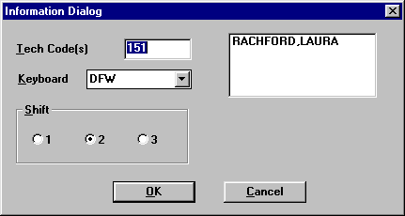  Illustration A – Information Dialogue Box
 | 4 | - In the yellow box (top left of History tab), enter the sample accession number, then press Enter.  - The patient demographics, current ABC results, and previous ABC and ADIF results will appear.  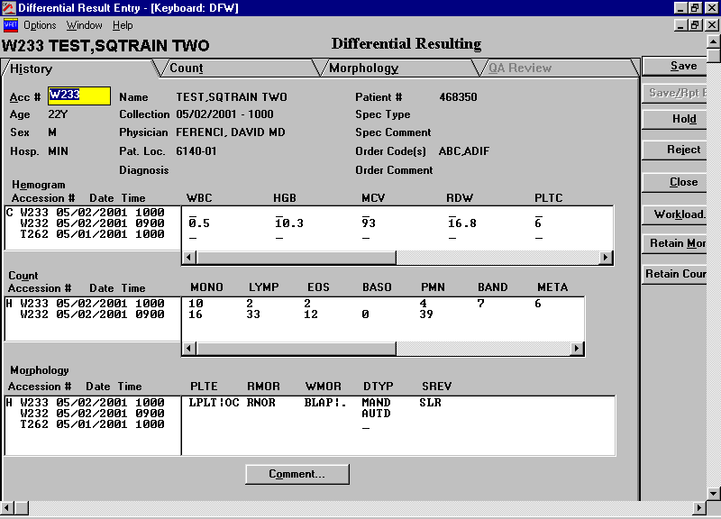  Illustration B – Differential Result Entry
 | 5 | Click the Count tab.  - The differential counting keyboard will appear.  - With the appropriate keys, count the leukocyte cell types.  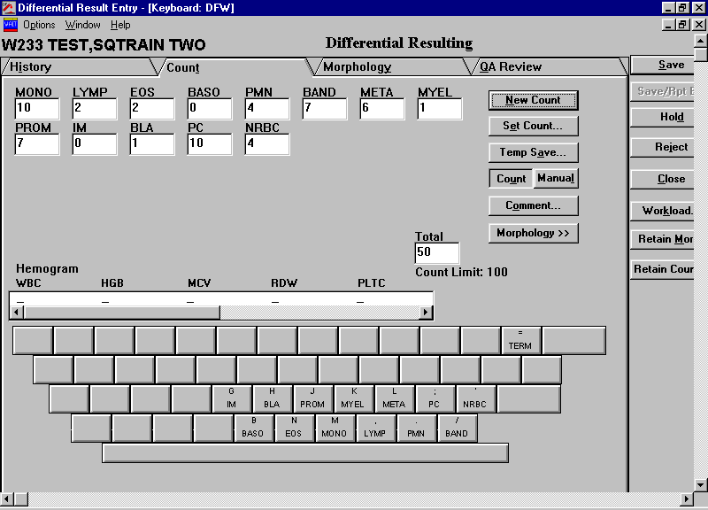  Illustration C – Differential Counting Keyboard  - Begin the microscopic examination of the blood film by determining the suitable examination area:  - Extend the examination from the area where approximately 50% of the erythrocytes show a strong tendency to linear orientation, which, in even thinner parts of the film, causes separation streaks known as the “feather edge.”  - Use the “battlement” track for this examination (see illustration below):  Illustration D – “Battlement” Track  - Each identified leukocyte must be placed into one of the following categories: neutrophil, segmented, neutrophil, band; neutrophil, metamyelocyte; neutrophil, myelocyte; neutrophil, promyelocyte; blast; monocyte; lymphocyte; plasma cell; eosinophil; or basophil.  - Include distorted cells that are clearly identifiable in the appropriate classification.  - Count any nucleated erythroid cells present and express the result as the number per 100 leukocytes counted.  - If the auto diff comes across, and a manual diff is needed, to start a new diff, click New Count.  - The computer will ask: “Clear all count boxes, Yes or No.” If the boxes are cleared, the auto diff will still be in Sunquest’s memory.  - The total number of cells counted can be set by pressing “Set Count.”  - Select the appropriate level (e.g., 50, 100, 200, or 400).  - If the WBC is between 0.5 and 0.9, ten percent of the total cells are counted. For example, 60 cells are counted for a WBC of 0.6. Count 60 cells on the differential keyboard and then press the “Term” key to recalculate the differential to 100 cells.  - If the WBC is > 50.0, count 200 cells.  - If necessary (for instance, if the computer is recovering from extended downtime), the differential can be entered manually. To enter the differential manually, press Manual.  - To add comments to a cell type, highlight the cell type box, and press Comment (you can then type free text in the box at the bottom of the Comment screen).
 | 6 | Click the Morphology tab.  - Highlight DTYP: AUTD, then click Remove (to correct the diff type carried across from the interface when a manual diff is performed).  - Point and click the keys for WBC/RBC morphology and platelet estimate; at a minimum, you must enter WNOR, RNOR, and PNOR.  - Point and click on Shift + the appropriate key to bill the differential:  - Shift + Z = CBCC (ABC + manual diff)  - Shift + X = CBCS (ABC + automated diff + slide review for morphology and platelet clumps)  - Shift + C = DIFM (WBC + manual diff)  - Shift + V = DIFS (WBC + automated diff + slide review for morphology and platelet clumps)  NOTE:  - CBCC, CBCS, DIFM, and DIFS automatically enter the SREV: SLR when QA Review tab is clicked.  - CBCC and DIFM automatically enter the DTYP: MAND when the QA Review tab is clicked.  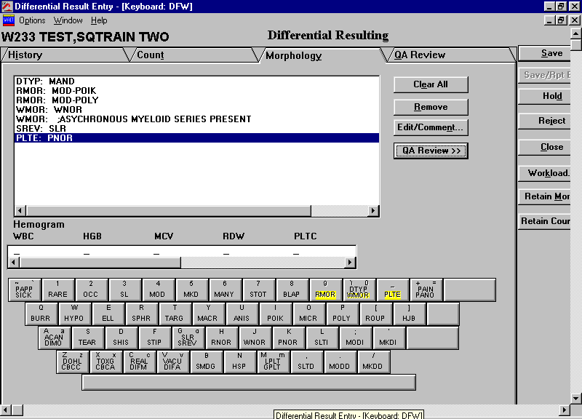  Illustration E – Differential Keyboard, Morphology Tab
 | 7 | Click the QA Review tab.  If an automated diff and a manual diff are both present, a box will appear for you to choose the diff for reporting.  - Check the results for accuracy.  - Check that the billing code and DTYP code are included.  - If a second diff is desired, click Hold.  - If necessary, reject the count.  - If the diff is acceptable, click Save.  A prompt to accept the HIS# for differential charge will appear. Click OK.  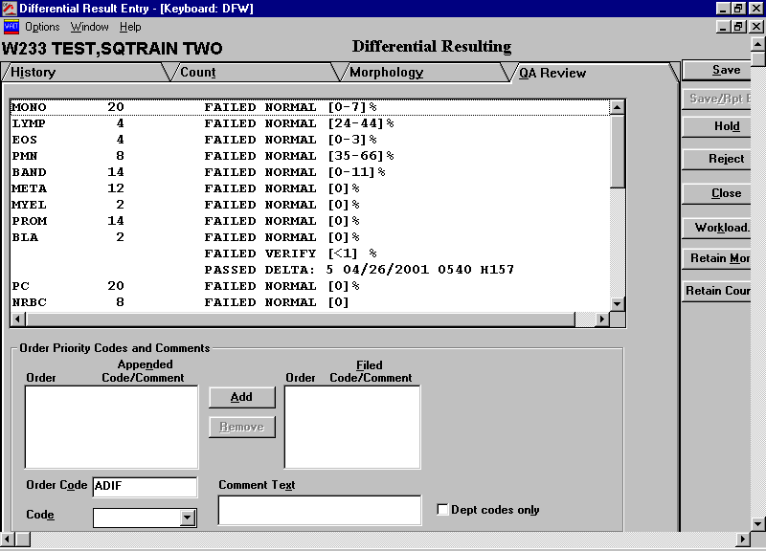  Illustration F – Differential Keyboard, QA Review Tab
 | 8 | Procedural Notes:  - The correct keyboard to perform a peripheral blood differential is DFW.  - Mandatory answers are required for WBC/RBC morphology:  - Normal RBC morphology use key H RNOR  - Normal WBC morphology use key J WNOR  - Free text key 9 RMOR (used when no key is defined, i.e., pseudo Pelger Huet)  - Free text key 0 WMOR (used when no key is defined, i.e., asynchronous myeloid maturation)  - Mandatory answer is required for Platelet estimate  - Platelet estimates Use the following keys:  - K = PNOR = normal platelet count (150-450)  - L = SLTI = slightly increased platelet count (450-750)  - ; = MODI = moderately increased platelet count (750-1000)  - ‘ = MKDI = markedly increased platelet count (>1000)  - , = SLTD = slightly decreased platelet count (100-150)  - . = MODD = moderately decreased platelet count (50-100)  - / = MKDD = markedly decreased platelet count (<50)  Platelet Morphology Use the following keys:  - M = LPLT = platelets which are larger than normal platelets and smaller than an RBC  - Shift + M = GPLT = giant platelets are ≥ in size to an RBC  - PLCL (enter in ABC platelet count field) = unable to result due to platelet clumping  - The following keys are used as WBC/RBC morphology modifiers:  - 1 = RARE  - 2 = OCC = occasional (few)  - 3 = SL = slight  - 4 = MOD = moderate  - 5 = MKD = marked  - 6 = MANY = many  Slight = up to 10% of the field  Moderate = 10-50% of the field  Marked = >50% of the field  Slight, moderate, marked are general descriptions for hypochromia anisocytosis, poikilocytosis, polychromasia, toxic granulation.
Rare = 1 per 5 fields to 1 per field
Occasional = 2 to 4 per field
Moderate = Up to 50% of the field
Many = > 50% of the field

Rare, occasional, moderate, many are used to describe individual cells: acanthocytes, basophilic stipping, burr cells, Doehle Bodies, elliptocytes, macrocytes, microcytes, sickle cells, spherocytes, target cells, reactive lymphs.

- In Pseudoleukocytosis, particles being counted are actually a combination of white blood cells and nucleated red blood cells, cryoglobulin crystals, fibrin, clumped platelets, giant platelets, platelet satellitosis, WBC fragments, RBCs resistant to lysing and/or agglutination.

- Some patients develop platelet agglutination in the present of EDTA. Accurate counts may be obtained by collecting the specimen in 3.2% buffered sodium citrate. (Multiply the CD Sapphire or CD 3200 platelet count by 1.1 to correct for dilution when using the buffered sodium citrate.)

- Platelet satellitism, in most cases, occurs only in EDTA anti-coagulated blood.

- Atypical platelets usually indicate a myeloproliferative disorder.

- Excessive RBC fragmentation may mask thrombocytopenia with automated methods. Check the slide for schistocytes and/or microcytes.

- Slides that meet the following criteria are reviewed by the Technical Specialist in Hematology. Slides will then be reviewed by a Pathologist if necessary:

  - First time any of the following is encountered:
- Markedly abnormal RBC morphology
- Blasts
- CSF/body fluids with yeast/bacteria
- Peripheral smear with yeast/bacteria/parasites
- PLT < 10,000
- Unusual leukocyte or PLT morphology, such as Pelger-Huet/May-Hegglin/gray PLT syndrome

  - Slides of interest when first encountered include:
- Coarse basophilic stippling
- MCV < 70 fl
- Abnormal change in any differential parameter greater than five times previous results in a long-term patient
- > 30% bands
- 5% basophils
- 15% eosinophils
- 20% monocytes
- 90% lymphocytes
- 15% combined promyelocytes, myelocytes, and metamyelocytes

For additional notes, see:

- Flow Chart A - RBC Sizing and Quantitative Abnormalities

- Document A - Cell Identification and Clinical Significance

Interpretation/  Results/Alert Values | See Table J – Interpretation/Reference Ranges.
Result Reporting | Results are reported when saved using the GUI-DFR keyboard.
References | 1. GUI Differential Result Entry. Sunquest Systems Functions Training Manual, 1998, pp. 92-97.
Historical Record | Version |  | Written/Revised by: |  |  | Effective Date: | Summary of Revisions
Historical Record | 1 |  |  |  |  | 1993 | Initial Version
Historical Record | 2 |  | Jim Berger |  |  | 03/2002 | Collated and reformatted
Historical Record | 3 |  | Al Quigley |  |  | 07/2009 | Added 95% confidence limits as QC criteria
Historical Record | 4 |  | Al Quigley |  |  | 06/01/11 | Revised, reformatted, renamed
Historical Record | 5 |  | Al Quigley |  |  | 03/07/16 | Technical Specialist Slide review

