Simplexa Group A Strep PCR Background and Principle

BACKGROUND

The most common illness caused by Streptococcus pyogenes (group A streptococcus [GAS]) is acute pharyngitis or tonsillitis in school-age children. The primary significance of GAS pharyngitis is identifying patients at risk of developing sequelae, i.e., acute rheumatic fever or acute glomerulonephritis. Scarlet fever occurs most often in association with pharyngitis. Scarlet fever has a characteristic erythematous sandpaper-like rash on the skin which is caused by one or more of the erythrogenic toxins produced by GAS strains¹. In temperate climates, GAS pharyngitis is a disease of the cold months occurring in the late autumn, winter and early spring and primarily affecting children between ages 3 and 18. GAS disease rarely occurs before age 2 due to the presence of maternal anti-exotoxin antibodies and lack of prior sensitization². Although GAS pharyngitis is usually self-limiting, rapid and accurate diagnosis is preferred by patients and physicians to provide antibiotic therapy that can relieve symptoms sooner, to prevent sequelae and to decrease transmission of the organism to close contacts. GAS is a costly disease due to medical costs and absenteeism from work, daycare or school. Costs range from $224 to $539 million per year, with almost half being attributed to nonmedical costs³

Over the past years, rapid antigen tests have been available for point-of-care testing in physician offices, emergency rooms and clinics. These assays lack sensitivity, usually between 60 – 80 %, and in some instances specificity. Primary prevention of rheumatic fever requires testing with a high level of sensitivity. Because of low sensitivity of rapid antigen tests, the Infectious Disease Society of America (IDSA) recommends that all negative results be cultured which takes an additional 24 to 48 hours to complete⁴. More recently, PCR testing has been shown to improve sensitivity/specificity and reduce turnaround times (TAT) since 80 - 85% of throat swabs must be cultured. The high sensitivity/specificity of PCR eliminates the need for culture back-up testing for GAS. Since respiratory viruses are the most common cause of pharyngitis, accurate diagnosis with improved TAT can also minimize the unnecessary use of antibiotics that are prescribed empirically⁵.

PRINCIPLE

The Simplexa ASR Group A Strep (GAS) assay is a real time PCR assay that utilizes a bi-functional fluorescent probe-primer (Scorpion primer) in which a primer is covalently linked to the probe. The Scorpion primer is located at the 3’ end which carries a Scorpion probe contained within the hairpin loop structure at 5’ end. The primer sequence contains a PCR blocker at the start of the hairpin loop to prevent the Taq DNA polymerase from reading through the Scorpion primer and copying the probe region. The probe is a self-complementary stem sequence with a fluorophore (FAM) at one end and a quencher (BHQ) at the other end. The loop of the probe includes a sequence that is complementary to an internal portion of the target sequence. The DNA is amplified using the bi-functional primer-probe together with a reverse primer targeting the Streptococcus pyrogenic exotoxin B gene (speB) of Streptococcus pyogenes. During the first PCR cycle, the Scorpion PCR primer is extended, and the sequence complementary to the loop sequence is generated on the same strand. After subsequent denaturation and annealing, the loop hybridizes to the internal target sequence, and the reporter is separated from the quencher. The resulting signal is proportional to the amount of amplified product in the sample (Fig. 2)⁶. An internal control (IC) is included in the assay that is amplified at the same time to detect PCR inhibition and to confirm that the reagents are working properly

Because the Scorpion probe and primer are incorporated into a single molecule, the reaction kinetics of this probe is extremely fast. The reaction leading to generation of a fluorescent signal is essentially instantaneous and occurs prior to any competing side reactions. This enables Scorpion probes to provide stronger signals, shorter reaction times and better discrimination than other conventional bi-molecular mechanisms. It also allows for more reliable probe design.

Figure 1: Gene target
Analyte | Gene Targeted | Probe Fluorophore | Excitation | Emission
Streptococcus pyogenes | speB | FAM | 495 nm | 520 nm
Internal control | NA | Q670 | 644 nm | 670 nm

Figure 2: Scorpion Primer Function
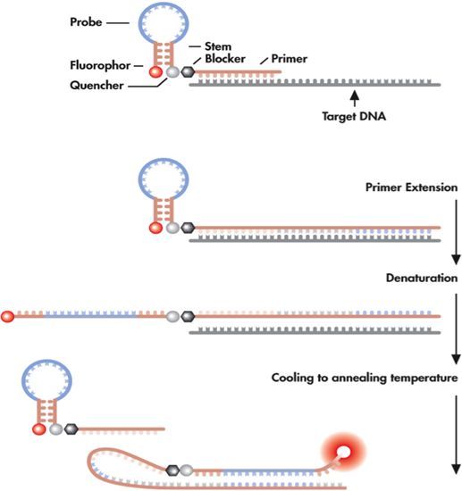 | - The Scorpion primer acts as a primer and a probe. The intact primer forms a hairpin so that the quenched reporter does not fluoresce.  - During the annealing, the hairpin primer binds to the template and is extended.  - After denaturation and annealing, the reporter separates from the quencher, and the loop sequence binds to the internal target sequence. The reporter on the extended Scorpion primer fluoresces.

REFERENCES

- Red Book 2012: 668-680: Group A Streptococcal Infections, American Academy of Pediatrics
- Michael A. Gerber and Stanford T. Shulman, Rapid Diagnosis of Pharyngitis Caused by Group A Streptococci, Clin. Microbiol. Rev 2004, 17(3):571.DOI:10.1128/CMR.17.3.571-580.2004
- Elizabeth Pfoh, Wessels ,DG and Lee, GM, Burden and Economic Cost of Group A Streptococci Pharyngitis, Pediatrics 2008; 121;229 DOI10.1542/peds.2007-0484
- Stanford T Schulman, Bisno, AL, Clegg, HW, Gerber, MA, Kaplan, EL, et al, Clinical Practice Guideline for the Diagnosis and Management of Group A Streptococcal Pharyngitis: 2012 Update by the Infectious Disease Society of America, CID 2012:12:55 (15 November)
- J.R. Uhl, Adamson, SC, Vetter, EA, Schleck, CD, Harmsen, LK, et al, Compasrison of LightCycler PCR, Rapid Antigen Immunoassay, and Culture for Detection of Group A Streptococci fro Throat Swabs, J. Clin. Microbiol, 2003, 41(1): 242
- PCR Primer and Probe Chemistries, www.bio-rad.com/en-us/applications-technologies

Approval
 | Approved by |  |  |  | Signature |  |  |  |  | Date
 | Timothy Casey, MD
 | Patricia Ackerman, Technical Specialist |  |  |  | P. Ackerman, TS |  |  |  |  | 8.30.14
Annual Review
 | Reviewed by |  | Signature |  |  | Date |  | Reviewed by | Signature |  |  | Date
 | P. Ackerman |  | PA |  |  | 8.30.14
Historical Record
 | Version | Written/Revised by: |  | Effective Date: |  |  | Summary of Revisions
 | 1 | P. Ackerman |  | 9.9.14 |  |  | Initial Version

Distribution
 | Location |  |  |  | #Copies |  | Location |  |  |  | #Copies
 | Molecular Diagnostics rm B422 |  |  |  | 1 |  | G drive: Molecular Biology/Molecular Manual/GASD |  |  |  | 1

