|  |
| --- |
| 1a **Strategy Acknowledgement** |

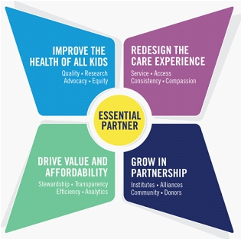

**I acknowledge that the following has been shared with me in an effort to ensure that Children's workforce has visibility to the strategic plan:**

* I have received the strategic plan and how the laboratory and I play a role in the overall strategy.
* I had the opportunity to discuss and ask questions about the strategic plan.
* The importance of the "Be remarkable" pledge was communicated to me.