Return from Issue

Purpose | This process provides instruction for the return of blood products from issue.
Policy Statements | - Attend to the returned product(s) as soon as possible.  - Blood products may be returned to Inventory if ALL of following criteria are meet. If any attribute is in question then Quarantine or Discard the product physically and in Sunquest-function BSU.
  Attribute | Acceptable criteria
  Container | Intact, the container has not been entered or damaged
  Volume | Volume issued matches the volume returned
  Label | Attached, intact and readable
  Expiration date/time | Usable in-date
  Temperature  - Temperature of syringe aliquoted products cannot be monitored and are not eligible for reissue. | RBCs  FFP | 1 - 10°C
   | Platelets | 20-24°C
   | Cooler Returns-LogTag datalogger | Confirm Alarm has not been activated.  Download record indicates temperature maintained at 1- 6°C.  Refer to TS 12.12 Using a LogTag Recorder
   | Hemotemp indicator | Refer to TS 12.15 Using Temperature Indicators
  Time from Issue to Return: | Syringe container:  Blood products issued in a syringe that are returned to the blood bank CAN NOT be reissued. Quarantine syringes and place product in quarantine bucket in the blood bank refrigerator.
  Time from Issue to Return: | Bag container issued to patient care areas without use of an approved storage device (not in a BB cooler or stored in surgery BB refrigerator):  a. RBCs or Platelets  - Temperature dependent. If < 4 hours and all other criteria are met including the product temperature, verify with the patient care unit that the product has been appropriately controlled by the nursing staff. If controlled then acceptable for return.  b. Thawed plasma or thawed Cryoprecipitate  - CAN NOT be reissued. Quarantine product and place product in quarantine bucket in the blood bank refrigerator
  Time from Issue to Return: | Bag container of RBC or thawed plasma issued in a cooler or to Surgery refrigerator:  - Coolers: < 12 hours if all other criteria met.  Note: If > 12 hours and a Hematemp indicator was used/OK on products and LogTag report indicates that cooler temperature was maintained at 1-6° for the duration of the issue, products may be returned to inventory with approval of the Technical Specialist. A free comment of approval must to added in BSU.  - Surgery Refrigerator: Time not a factor if all other criteria met
  Visual Inspection | No leaking, clumping, clots, discoloration
  RBC unit segment | At least one sealed segment is integrally attached to a primary red cell unit.
Process
 | Activity |  |  |  | Key Considerations |  |  | Related Document
 | 1 | Evaluate product |  |  | - Note time of return  - Assess product acceptability according to table above.  - Take product temperature-RBCs and PLTs if not issued in a cooler. |  |  | TS 7.6 Monitoring theTemperature of Blood Products
 | 2 | Determine time of issue |  |  | As document on unit tag or review unit history in function Blood Bank Inquiry. Lookup by: Unit Number, selecting Unit history |  |  | TS 9.8 Reviewing Unit History-Sunquest
 | 3 | Document return in Sunquest |  |  | See below.
 | 4 | Obtain middle copy of unit tag from issue box.
  If product status is | Then
  Allocated or Quarantine | Reattach middle copy to the unit tag
  Inventory or Discard | Remove and discard all copies of associated unit tag
 | 5 | Place unit in proper storage location
  If product status is | Then
  Quarantine Status | - RBCs or plasma-  place in quarantine container in BB refrigerator  - Platelets-  tag as quarantine and segregate on platelet rotator
  Discard Status | - Document product  on daily QC form  - Discard product in  biohazard container
 | 5 | Recondition cooler liner assembly |  |  |  |  |  | TS 12.11 Transport of Blood Products in Coolers
 | 6 | Upload LogTag as needed |  |  |  |  |  | TS 12.12 Use of LogTag in Coolers
 | Step |  | Action
Record Return in in Sunquest | 1 |  | Log into the Gateway choosing location: R for Mpls, L for STP and open the Blood Status Update folder from the All or Blood Bank tab.
 | 2 |  | Select Unit Update in the Update Option box.  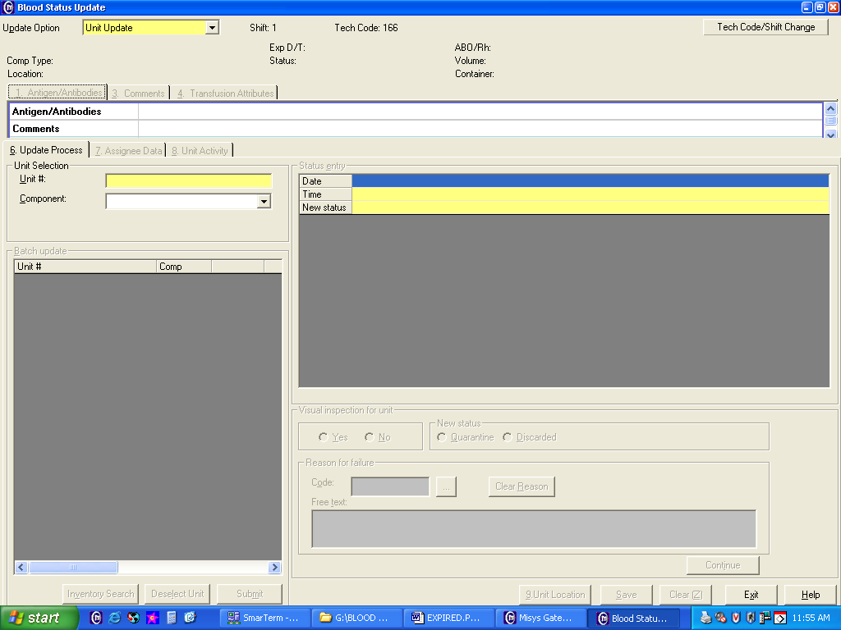
 | 3 |  | - Scan or enter the product unit number barcode.  - Scan or enter the Supplier ID if prompted. (Codabar units)  - Select the proper component and division if prompted. (Note: If multiple units with the  same unit number in inventory. E.g. Aphereis platelets part one and two.)  - Tab through date and time entry fields or enter a specific time and date.
 | 4 |  | Enter a new status of INV (Inventory) in the New status box and Tab X2.
 | 5 |  | Click in the appropriate box for Pass visual inspection.  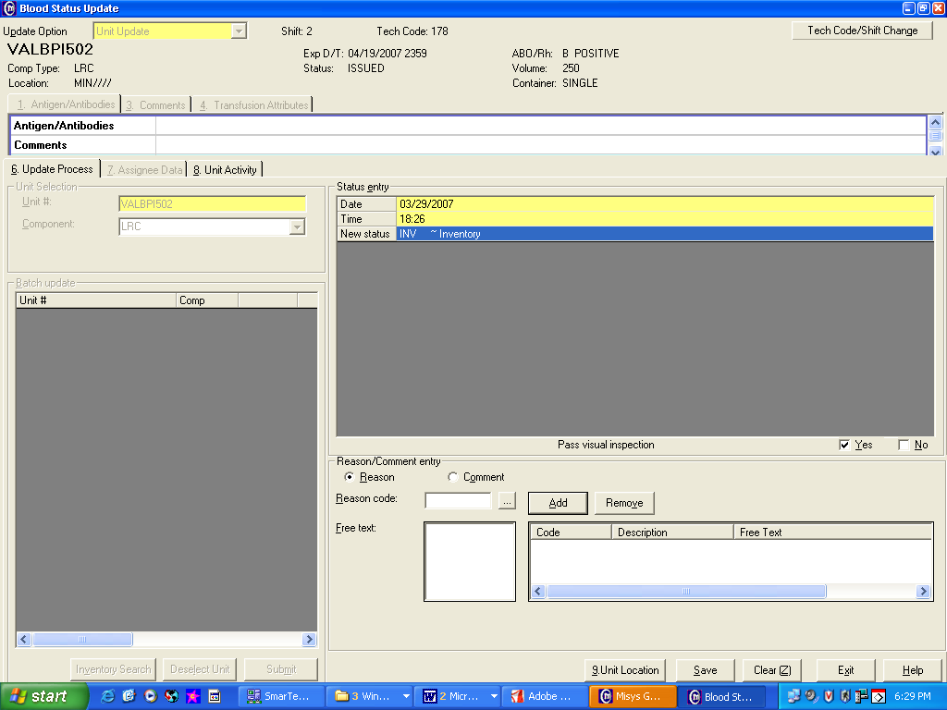  If the unit does not pass visual inspection or other return criteria select NO. The product must be placed in a Quarantine or Discarded status with a Reason code or free text comment must be entered.  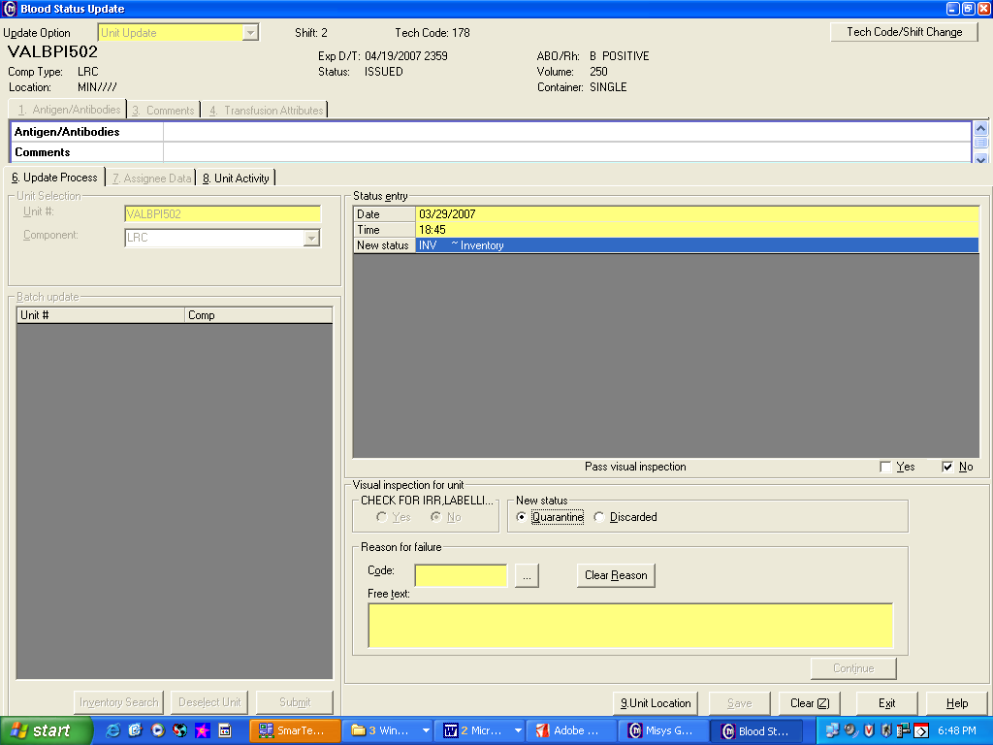
 | 6 |  | Select Reason/Comment entry and enter the appropriate comment(s).  - Enter appropriate Reason codes. To look up a code, use the search function.  HTOK-Hematemp OK  HTOR-Hematemp Out of Range  WARM-Returned warm  RCCL-Returned from CCL (Cardiac Cath Lab)  b. In the Comment Free Text box:  - Free Text in the product temperature for products returned from non-cooler issues. E.g. 6.4C.  - Add additional comments as appropriate.  c. Click Add. The code and description display or the free text comment displays in the list.
 | 7 |  | Click Save. The Unit Activity tab opens for a unit that passed visual inspection.  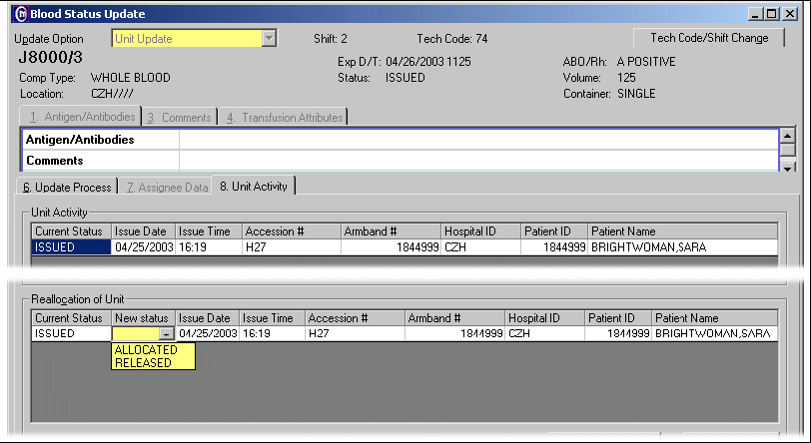
  If | Then
  the unit is to remain allocated to the patient | Select Allocated
  the unit may be returned to general inventory | Select Released.
Approval  Workflow | Transfusion Service/Medical Director
 | Version |  |  | Written/Revised by: |  | Effective Date: | Summary of Revisions
Historical Record | 1 |  |  | C Berglund |  | 5/1984 | Initial Version
Historical Record | 2 |  |  | J Wenzel |  | 10/1991
Historical Record | 3 |  |  | J Wenzel |  | 1/1992
Historical Record | 4 |  |  | J Wenzel |  | 9/1997 | Post merger
Historical Record | 5 |  |  | J Wenzel |  | 5/22/2001 | St Paul on Sunquest
Historical Record | 6 |  |  | J Wenzel |  | 3/10/2007 | Sunquest Gui
Historical Record | 7 |  |  | J Wenzel |  | 11/10/2009 | Online format
Historical Record | 8 |  |  | N Poupard |  | 02/26/2010 | Clarified return of plts and cryo
Historical Record | 9 |  |  | J Wenzel |  | 6/4/2012 | Previous numbered as TS 12.16. Added SQ steps from TS 12.17v7.Expanded policy Table: Added Volume, RBCs at 1-10°C, Returns > 30 minutes, Cooler returns using LogTag record. Added documentation of temp of returns in BSU.
 | 10 |  |  | S. Cassidy |  | 9/28/15 | Removed syringe criteria for return into inventory and added statement to quarantine all syringe blood products returned from issue.
 | 11 |  |  | S. Cassidy |  | 10/27/16 | Removed criteria for re-issue for FFP and Cryo if Bag container issued to patient care areas without use of an approved storage device (not in a BB cooler or stored in surgery BB refrigerator):

