Capillary Blood Gas Collection
Purpose | This procedure provides specific instructions for CAPILLARY BLOOD GAS COLLECTION.
Policy Statements | This procedure applies to all laboratory staff responsible for collecting capillary blood gas specimens and must be used in conjunction with SCM 3.20 Capillary Blood Collection.
Materials and Equipment | Balanced Heparin plastic capillary tube – Radiometer safeCLINITUBES (D957P-70-125x1) (Order code 942-893), CHC# 9006
Sample | Whole Blood:  - Two 125 uL heparinized safeCLINITUBE (preferred)  - One 125 uL heparinized safeCLINITUBES (absolute minimum)  - Collected without air bubbles, or air bubbles removed prior to transport  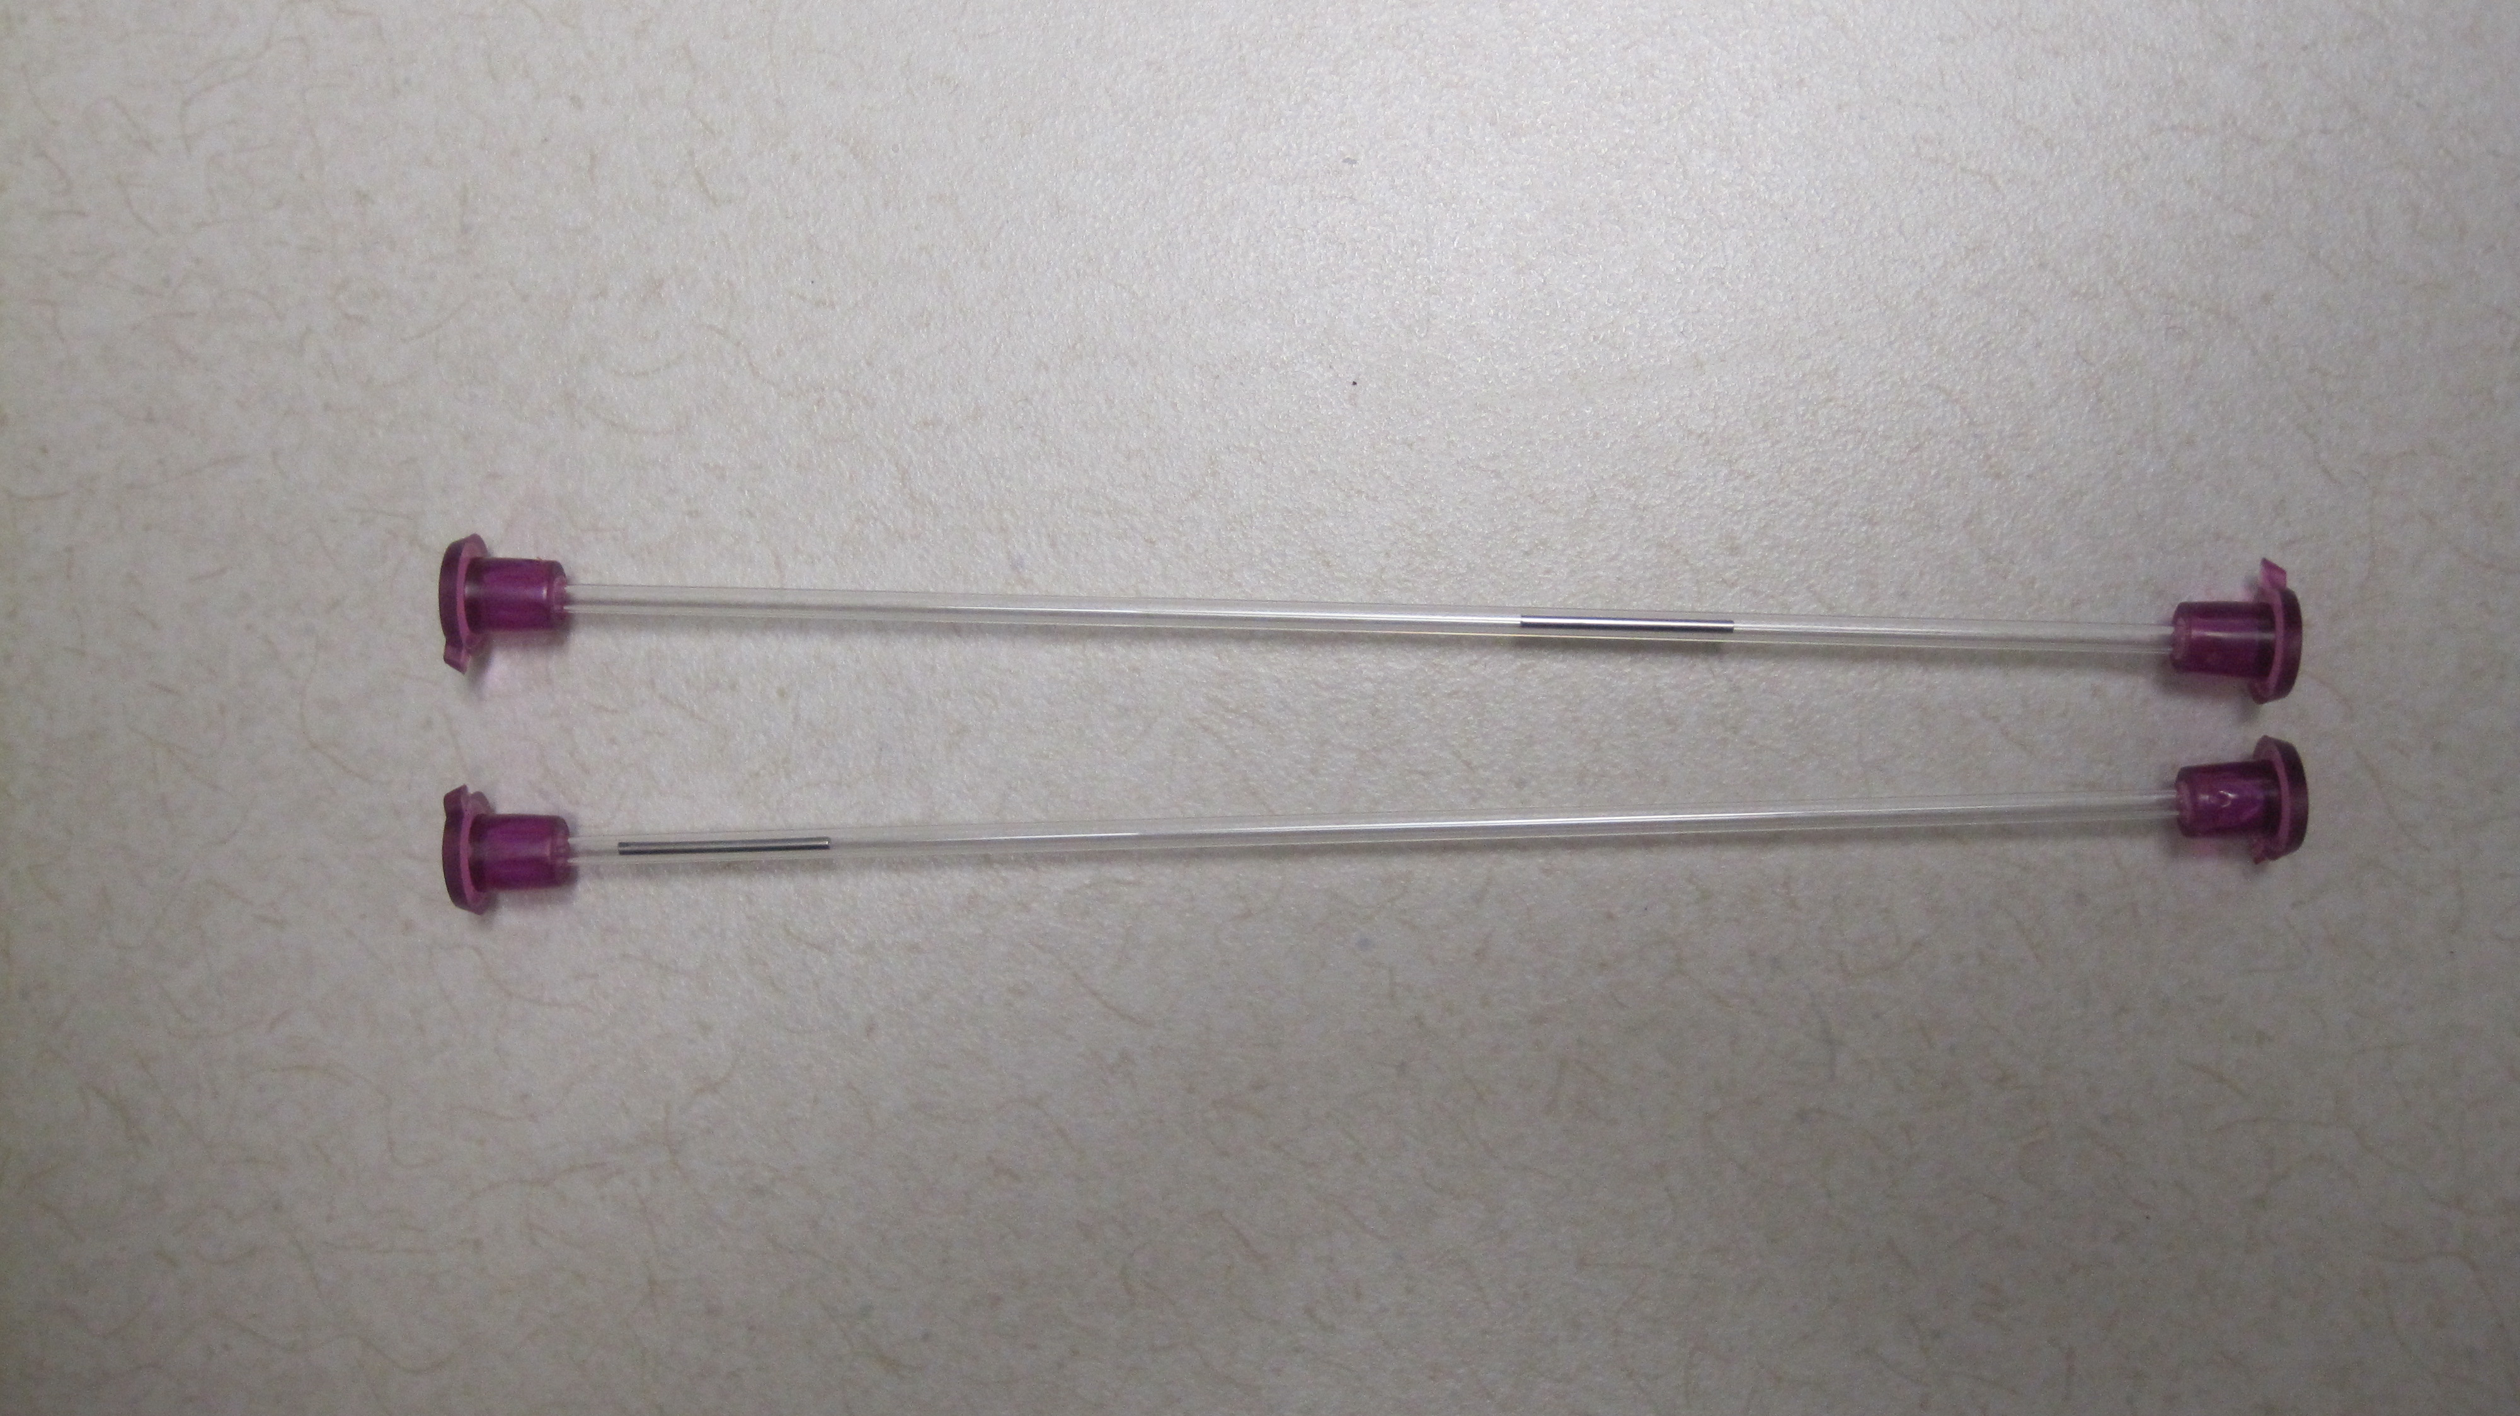  Patient Preparation: The patient should preferably be in a steady state of ventilation before and during the collection of blood sample  Minimum volume: 0.125 mL  Stability: Room Temperature; 10 minutes (preferred) or 30 minutes maximum  Rejection criteria:  - Unlabelled specimens  - Clotted specimens  - Air contaminated specimens
Special Safety Precautions | Authorized personnel should perform blood sampling.  Always handle blood samples and capillaries with care.  Avoid direct contact with the sample by using certified protective gloves.  Do not re-use sampling devices.
Procedure | Follow the activities in the table below for CAPILLARY BLOOD GAS COLLECTION.
  Step | Action
  1 | See SCM 3.20 Capillary Specimen Collection. Follow instructions until ready to collect the blood gas sample, go to Step 2.
  2 | Loosely mount a capillary cap on one end of the safeCLINITUBE.
  3 | Assure the safeCLINITUBE contains a mixing wire. Allow it to slide to the same end as the cap.
  4 | Fill the safeCLINITUBE with freely forming drops, holding the puncture site in a downward position and allowing capillary action to pull sample into the tube. Do not allow air to enter the capillary tube.
  5 | Tighten the capillary cap.
  6 | Tightly mount a cap on the other end of the safeCLINITUBE.
  7 | Move the mixing wire 20 times along the full length of the capillary using the magnet to mix the blood and anticoagulant together.
  8 | Place one capillary tube under each Sunquest barcode label, keeping the Sunquest cap gas labels attached to each other, and assuring each sample has its own label.
  9 | Transport sample tubes immediately to main lab either by walking, or placing the cap tubes in a biohazard sample bag and immediately transporting the sample via pneumatic tube.
  10 | Analyze the sample within 10 minutes. If storage is unavoidable, store the sample for a maximum of 30 minutes. Before the sample is analyzed, mix it again.
References | - Radiometer safeCLINITUBES® Product Insert, Radiometer Medical ApS, Denmark, 989-890.  - ABL 800 Flex Operator’s Guide, Radiometer Medical ApS, Denmark.  - CLSI. Procedures and Devices for the Collection of Diagnostic Capillary Blood Specimens; Approved Standard – Sixth Edition, H04-06. Clinical and Laboratory Standards Institute, Wayne, PA. 2008.

