Replacing Primary IPU Sysmex XN 3000

Purpose  Replacing the  Primary  Computer  Procedure Notes  References | The following procedure is intended to be performed in the event of a Motherboard or other non-hard drive hardware failure. This procedure assumes that the primary computer has failed and will not boot.  IPU  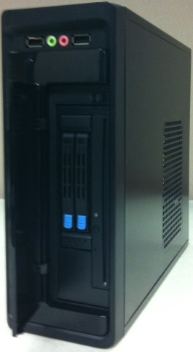  Hard Drive  USB Ports  1. The green button on the Sysmex XN3000 that powers on the full system, will not power on the IPU computer until the FSR is able to reconfigure this feature for the backup/secondary computer.  2. If you have trouble restarting the analyzer and get the following message “Missing Operating System” remove the flash drive from the IPU and reboot.  1. Sysmex Field Service Manual, Sysmex America Inc.
  Step | Action | Related Document
  1 | Call Sysmex Technical Assistance Center ( TAC ) to report and troubleshoot the issue 1-888-879-7639.
  2 | If it is determined that the primary computer is non-functional, proceed to step 3.
  3 | Call LIS and tell them you are going to the backup PC for Sysmex.  Mpls. - Method code XNM  a.) Primary ipaddress: 10.23.2.226  mac address: 68:05:CA:3D:ED:97  b.) Back-up ipaddress:10.23.2.227  mac address: 68:05:CA:3C:B2:A0  St. Paul – Method code XNS  a.) Primary ipaddress: 10.33.53.150  mac address: 68:05:CA:3A:E6:D1  b.) Back-up ipaddress:10.33.53.151  mac address: 68:05:CA:3A:E6:C9
  4 | Power – down the XN instruments by opening the front cover of each XN and turning the power switch to OFF.
  5 | Locate the XN IPU computer. | 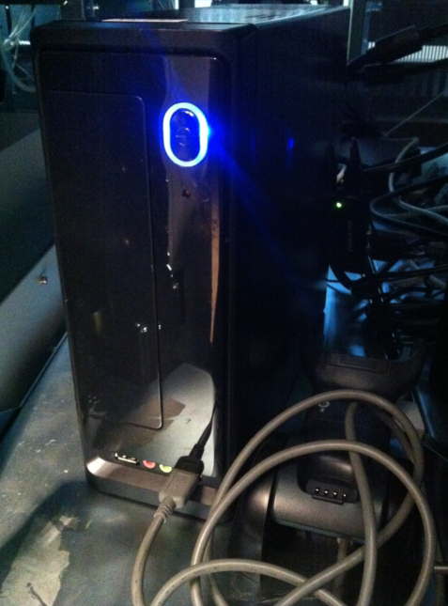
  6 | Power-down the XN-IPU computer, by holding the main power button until the light turns off. | Power Button
  7 | Retrieve the Backup Shell and place it next to the primary computer with the power button in the same orientation as the primary. Open the drive bay door on the front of both PC’s by pressing the textured corner. | 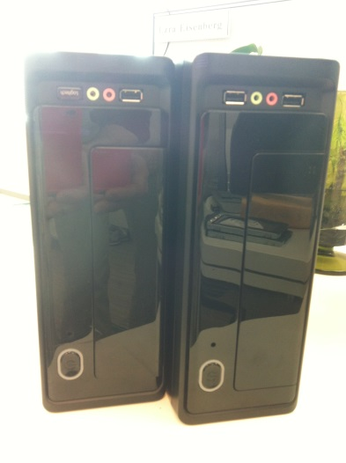  Textured Corner
  8 | On the primary PC depress the blue button to release the hard drive handles.  Gently pull the handle of each drive until the drive pulls out. | 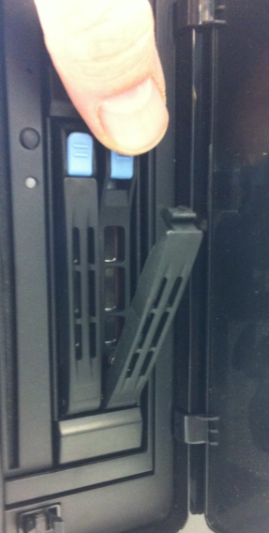
  9 | Place the drives in the corresponding slots in the shell and gently push the drive all the way into the slot.  Close the handle until it snaps beneath the blue button and the drive is secure. | 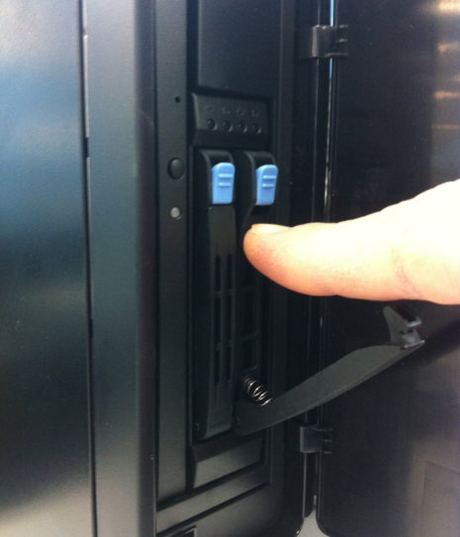
  10 | One at a time, move the cables from the back of the primary PC to the same position on the back of the backup shell.  Note: Move the power cable last to prevent booting before cables are in place. | 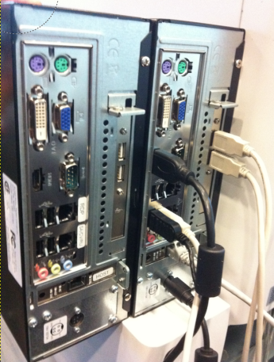  Power  Cable
  11 | Move the primary computer out of the way and put the backup computer in its place.
  12 | Press the power button on the front of the backup computer to power it on.
  13 | Power on the instruments. The instruments will come to ready.
  14 | Make sure the Sysmex TAC agent has the serial numbers from both computers, has dispatched a local FSR and has answered any questions you may have.
Historical Record | Version | Written/Revised by: | Effective Date: | Summary of Revisions
Historical Record | 1 | Al Quigley | 1/13/17 | Initial Version

