PARQ Blood Parasites, Quantitative

Purpose | This procedure provides instructions for PARQ BLOOD PARASITES, QUANTITATIVE.
Principle | Determining the percentage of malaria-infected red cells is a simple and direct way to measure the effectiveness of therapy.  It is important to report the level of parasitemia when blood films are examined and found to be positive for malaria. The level of parasitemia may determine whether a patient is managed with conventional medication or possibly an exchange transfusion if necessary. Because of the potential for drug resistance in some of the Plasmodium species, particularly P. falciparum, it is important that every positive smear be assessed – and the parasitemia reported – exactly the same way on follow-up specimens as on the initial specimen.
Policy Statements | - This procedure applies to all laboratory technologists performing hematology testing, the section supervisor, and section pathologist.
Materials | Equipment |  |  | Reagents |  |  | Supplies
 | - Manual cell counter  - Microscope |  |  | - N/A |  |  | - Glass microscope slides  - Worksheet H2  - Hematology Manual Results form
Sample | Stained thick or thin blood films that are positive for Plasmodium or Babesia species.
Quality Control | Prepare and stain films from “normal” blood and microscopically evaluate the staining reactions of the RBCs, platelets and WBCs.
Procedure | Follow the activities in the table below for PARQ BLOOD PARASITES, QUANTITATIVE.
 | Step | Action |  |  |  |  |  | Related Document
 | 1 | Place a drop of blood on each of 3 glass slides.
 | 2 | Spread the drop of blood the width of the slide. Push it out so that it covers 1/2 -3/4 of the length of the slide.
 | 3 | Dry rapidly in front of a fan.
 | 4 | Label with patient name and accession number.
 | 5 | Stain on Sysmex SP-10
 | 6 | On a well prepared slide find the feathered edge of the blood smear. Using the PARQ keyboard count a total of 3,000 RBCs using the 100 x oil immersion lens in the area of the smear where there is close proximity but little overlap of the red blood cells. For each field count the total number of cells followed by the number of infected cells.  A RBC containing multiple ring forms is counted as 1 infected cell (IRBC).  Make sure to look for appliqué ring forms, these are delicate rings that appear on the periphery of the RBC.  After the first IRBC count has been determined a second technologist performs another IRBC count on the same slide. If the two counts are not within 10% a count should be performed by a third technologist. The two IRBC counts that are within 10% should be reported in Sunquest as IRBC1 and IRBC2. These will be averaged by Sunquest and a percent parasitemia will be reported (see example below). |  |  |  |  |  | 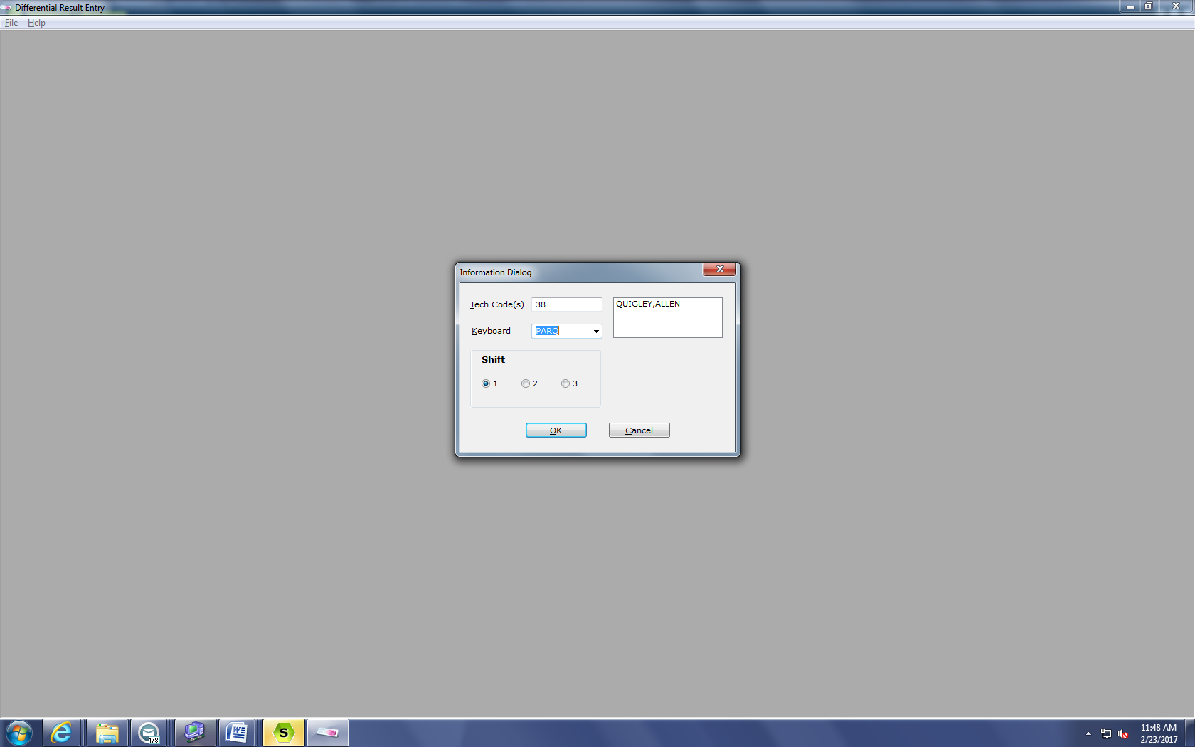  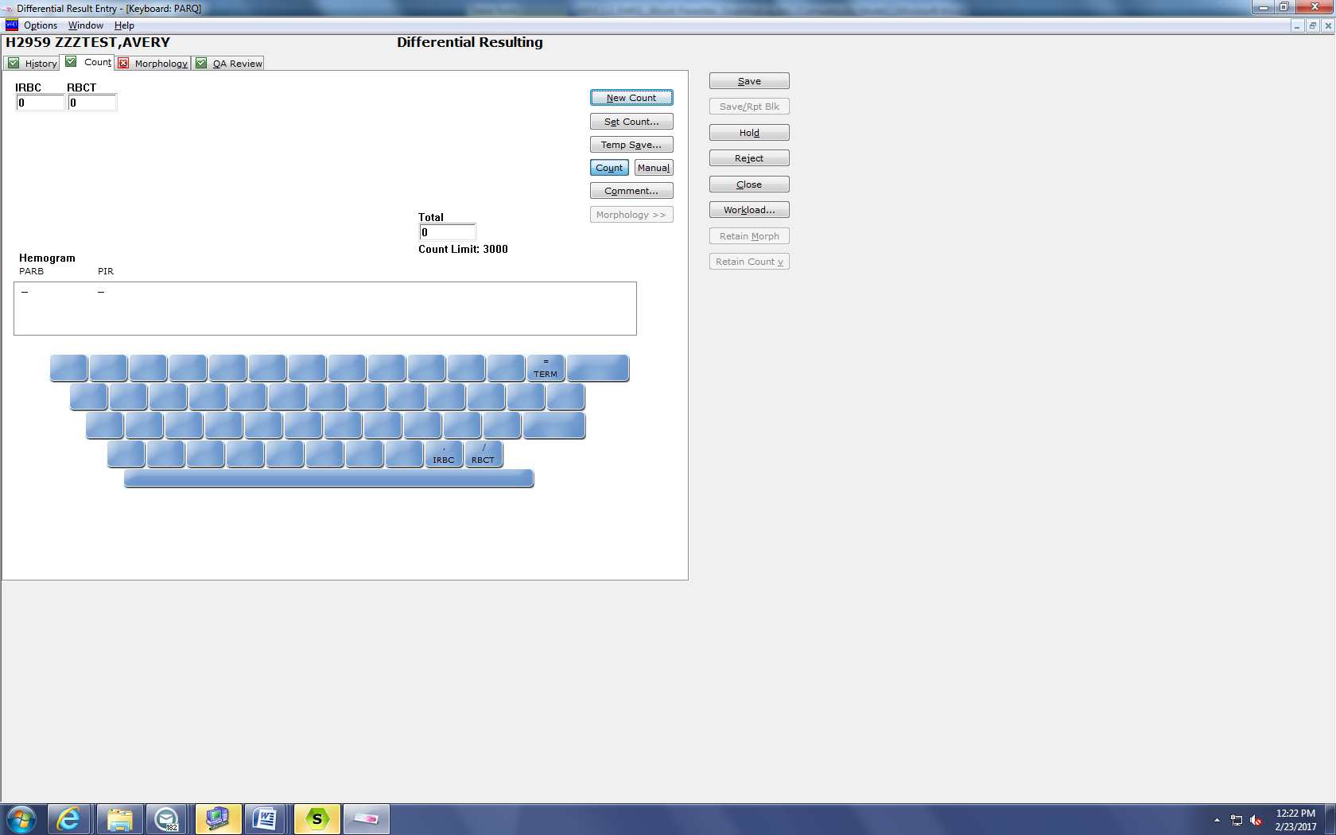  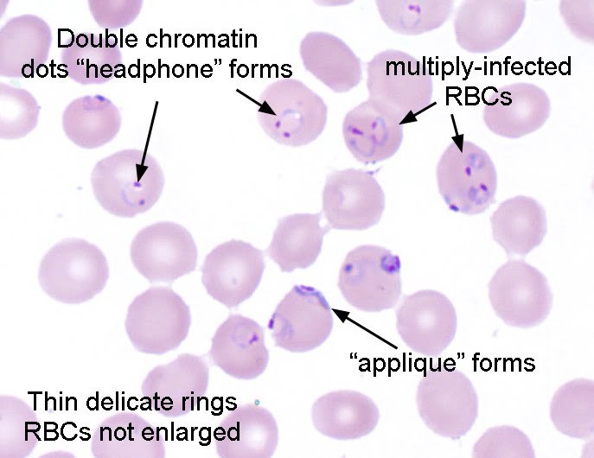
 | 7 | Record results on worksheet.
 | 8 | Enter raw data in Sunquest at appropriate prompt to determine % parasitemia.
Calculations  Result Entry in Sunquest | - Perform two counts (counting IRBC per 3000 RBC) using the PARQ keyboard.  - Perform the following calculation;  Example: Tech 1 = 100 infected cells  Tech 2 = 105 infected cells  Duplicate IRBC counts should agree within 10%. If they don't, count the third slide and take the two counts that are the closest.  The following calculation is performed in Sunquest;  102.5 Infected RBCs X 100 = 3.42%  3000 Total RBCs counted  Example;  MANUAL RESULT ENTRY  WORKSHEET: H2  DEVICE LAB LOCATION: R MIN MINNEAPOLIS  TEST-1: PARQ  PARASITE  INFECTED RBCS  TOTAL RBCS  % INFECTED RBCS  TEST-2:  CAP METHODS TO BE USED DURING THIS RESULT ENTRY SESSION  TEST - METH TEST - METH TEST - METH TEST - METH TEST - METH  PARB IRBC RBCT PIR  ACCEPT (A) OR MODIFY (M) ?  MANUAL RESULT ENTRY  DEVICE LOC: R MIN MINNEAPOLIS HOSP. ID: STP  ACC NO NAME PN: 4587006 AGE/SEX LOC PHYSICIAN  H2959 ZZZTEST,AVERY 17Y M 4108-O1 ZZZTEST,MD  DX: ASTHMA  DOB: 04/28/1999 COLL: 02/23/2017 09:44  PARB : PLAF PLASMODIUM FALCIPARUM (PARASITE CODES IN MIQ)  IRBC : Enter 1ST COUNT : 100  2ND COUNT : 105  102.5  RBCT : 3000  PIR : 3.42 FAILED NORMAL [0]%  (ORDER: PARQ)  ACCEPT (A), MODIFY (M), DISPLAY PRIOR (D), PRELIM (P), OR REJECT (R) ?  Enter raw data and Sunquest - calculated data on the Hematology Result form.
Procedure  Notes | - Drug resistance may not become evident for several days; the parasitemia may appear to be decrease before it begins to increase again.  - It is important that good quality blood films be examined and counted according to directions. Poorly prepared and/or stained smears lead to incorrect assessments of the parasitemia (both too low and too high).  - There may be instances when very few parasites are present, when they are seen on the peripheral smear but not included in the quantitative count (less than 1 infected RBC seen per 3000 RBCs). Please modify your answer in MEM to be reported as <0.03%.  - Follow-up counts are critical in following the patient, and it is critical to understand the types of malaria resistance (Table O, below).  - When low numbers of IRBC are seen (1-10 per 3000) or 0.03 – 0.33% agreement within 10% is not necessary.  - Table N - Clinical Correlation Parasitemia  - Table O - Malarial Resistance
Reference Intervals | - Reference Ranges: 0%  - WHO criteria for severe malaria are parasitemia >10.000/μL and severe anemia (hemoglobin <5g/L).  - Prognosis is poor if >20% of parasites are pigment containing trophozoites and schizonts and/or if >5% of neutrophils contain visible pigment.
References | - CAP Inspection Checklist, Hematology Section, # HEM.34687, revised 07/31/03.  - Garcia LS, Diagnostic Medical Parasitology, 4th edition, ASM Press, Washington D.C., 2001.  - NCCLS, Laboratory Diagnosis of Blood-Borne Parasitic Diseases, Approved Guideline M15-A. National Committee for Clinical Laboratory Standards, Villanova, PA, 2000.
Historical Record | Version |  | Written/Revised by: |  | Effective Date: | Summary of Revisions
Historical Record | 1 |  | Laura Rachford |  | 08/2004 | Initial Version
Historical Record | 2 |  | Al Quigley |  | 06/01/11 | Revised and reformatted (renamed from Heme.B.12)
Historical Record | 3 |  | Al Quigley |  | 03/20/17 | Replaced Miller Disc method of counting with method for counting total RBCs.

