Entering Cardiac Tissue into Inventory and Storage using TrackCore

Purpose | This procedure provides instructions for entering cardiac tissue into inventory and storage into the liquid nitrogen freezer in CVCC OR in Minneapolis using TrackCore.
Policy Statements | - At the time of receipt the package integrity and transport temperature range was controlled and acceptable for cardiac tissues are documented.
Materials | - Cryo laminating tape  - Jumpsuit  - Surgical Cap  - Cryogenic gloves
Before  You Begin | - Verify from the white board in Blood Bank or surgery that a cardiac tissue was ordered.
Procedure
 | Step |  | Action
Entering Tissue into TrackCore | 1 |  | Log onto Tissue Track Manager icon on the paperwork desk PC in Minneapolis.  
 | 2 |  | Sign-in using your Children’s credentials (CE # and password)  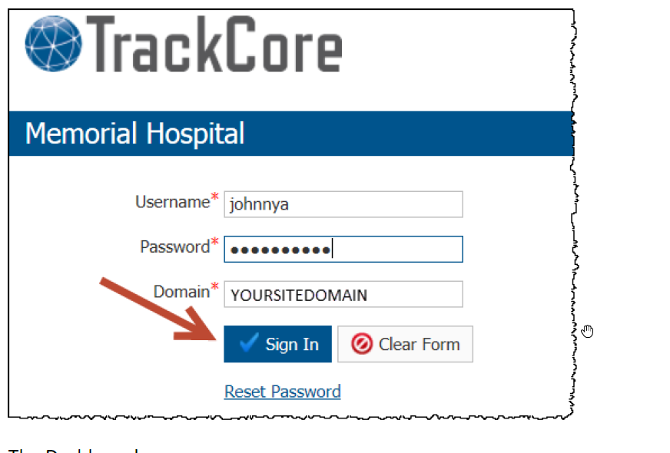
 | 3 |  | Dashboard screen appears.  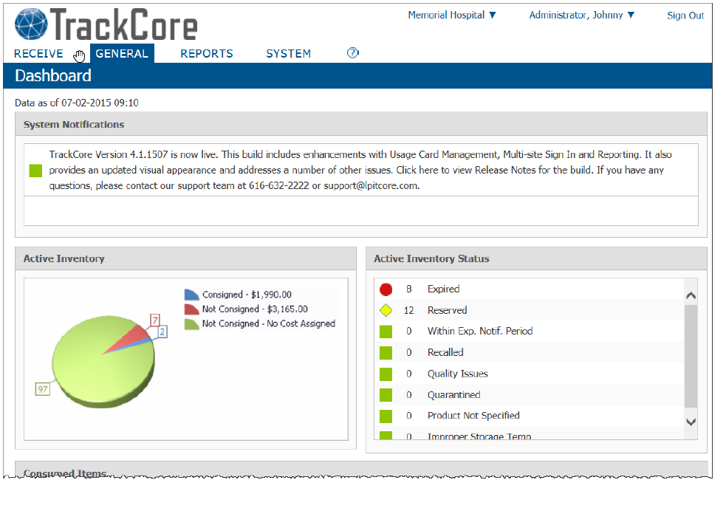
 | 4 |  | Click on Receive menu, select Vendor Items.  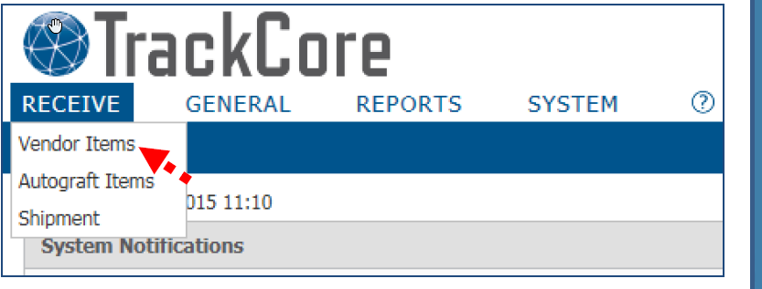
 | 5 |  | Select a Vendor for the drop-down.  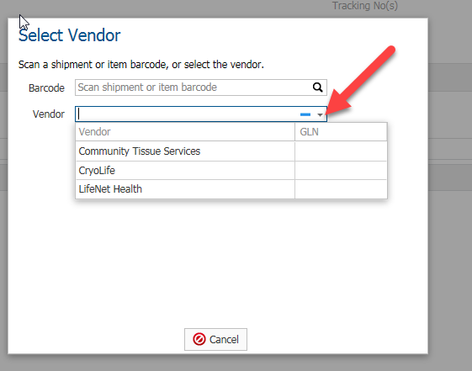
 | 6 |  | Input Item Details
  If | Then
  Manual Input | - Click Add Blank Row link.  - Enter Serial number of Tissue  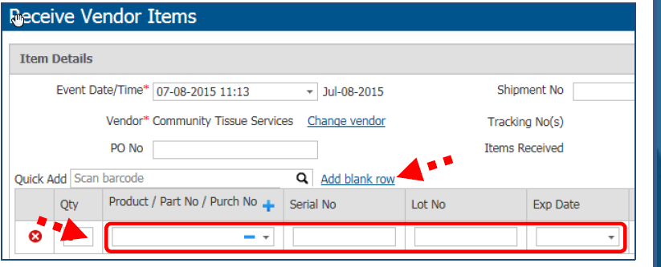
  Scan Vendor Barcode | - Move Cursor to Quick Add Field.  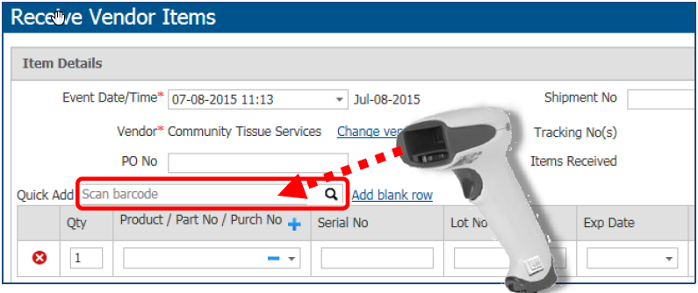
 | 7 |  | Click on the drop-down box to choose product type  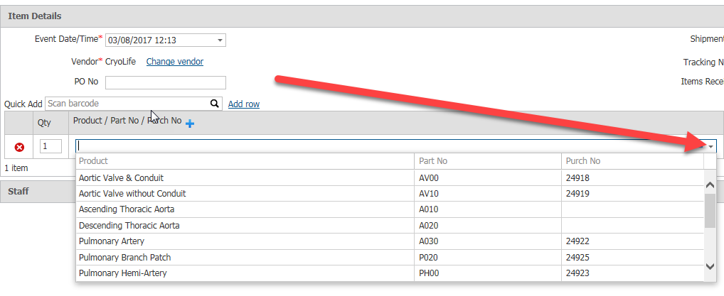
 | 8 |  | Type in the expiration date MMDDYYYY or click on the drop-down box to choose date from calendar.  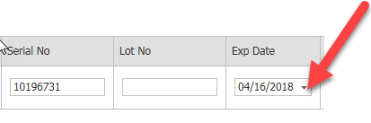
 | 9 |  | Click on “…” field to add more demographics.  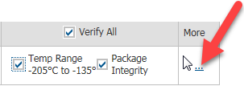
 | 10 |  | Type in diameter and length of cardiac tissue into the dimension field.  Note: Add a zero in front of any dimension that is a single digit. Example 09mm x 1.5cm  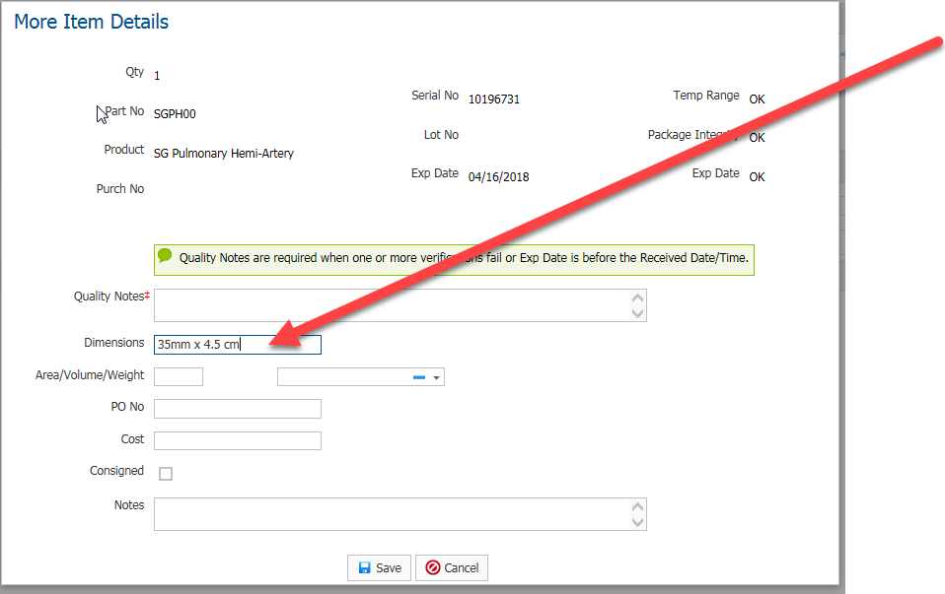
 | 11 |  | Click Save.  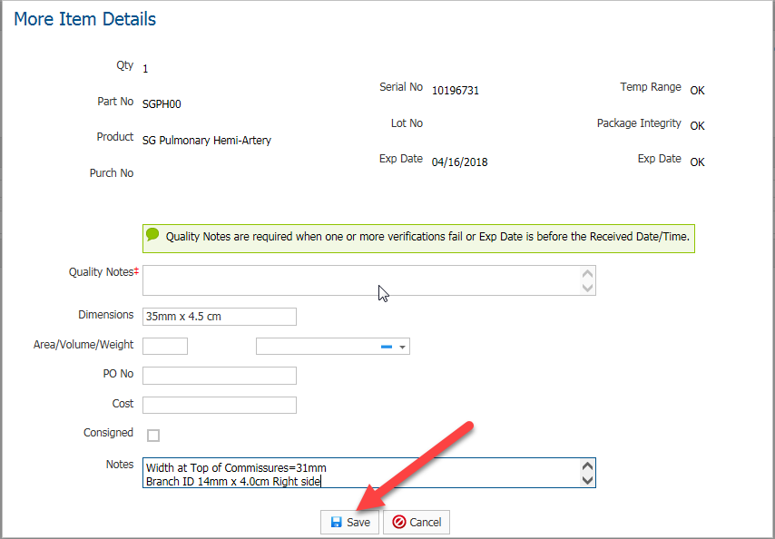
 | 12 |  | Click “Save and Print Labels”  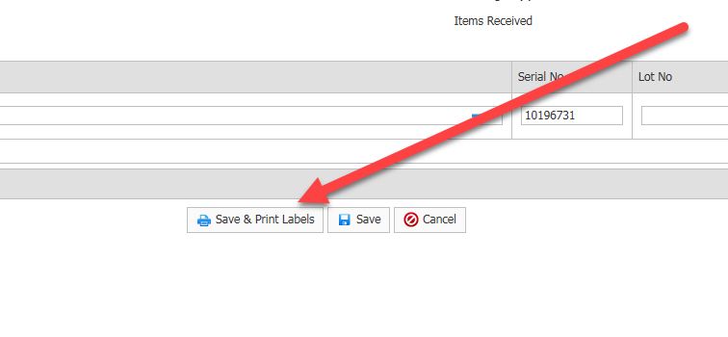
 | 13 |  | Select the barcode Printer ZD420-203dpi and print two labels.  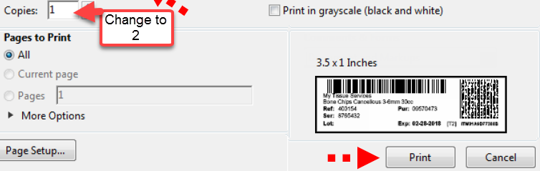
 | 14 |  | Place one label on tissue paperwork and save the other for the tissue box.  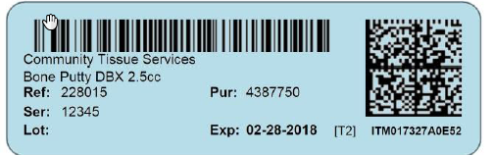
 | 15 |  | Print an Item Search Report to find a location to place the graft.  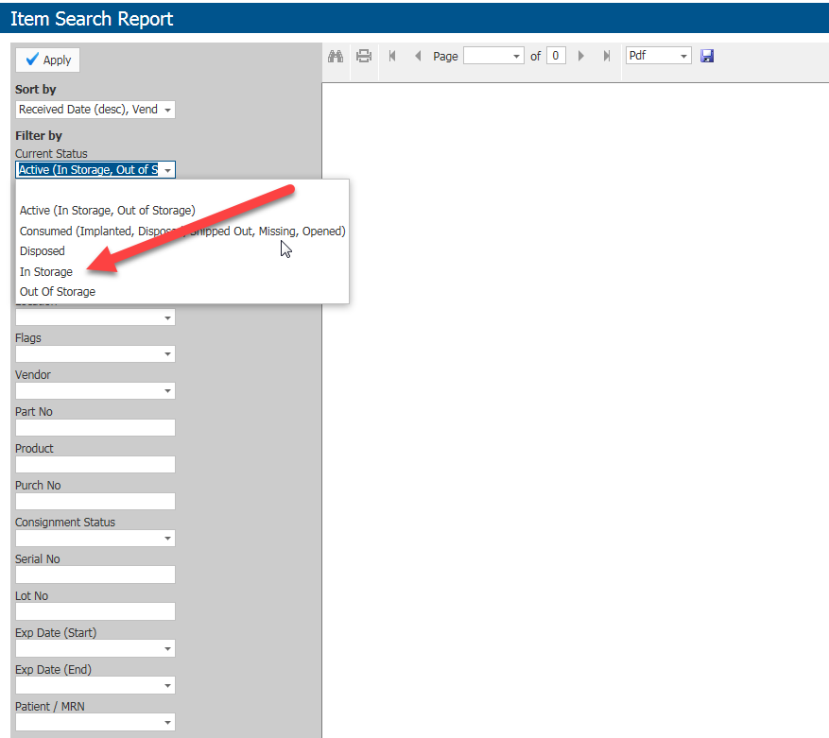
 | Step | Action
Placing Tissue into Liquid N2 Freezer using TrackCore  **Note this is a 2 person job | 1 | Take tissue in shipping container and paperwork to surgery.
 | 2 | Put on jumpsuit and surgical cap prior to entering CVCC OR.
 | 3 | Log onto Tissue Track Manager icon on the computer in the freezer room
 | 4 | Click on the general Tab and select Search Cart.  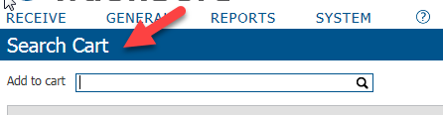
 | 5 | Scan the TrackCore barcode or check item if already in cart.  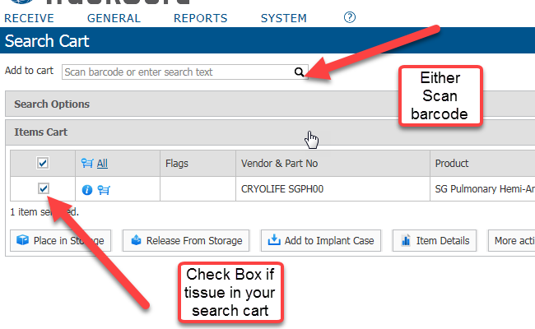
 | 6 | Click Place in Storage.  Warning: Only place one graft into storage at a time.  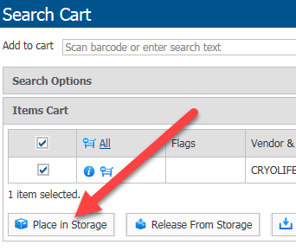
 | 7 | Click the drop-down box for storage location.  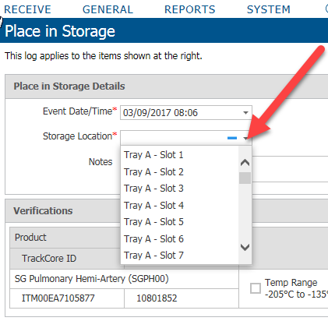
 | 8 | Check Verify All to document QA checks  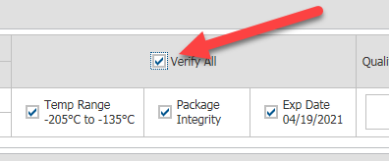
 | 9 | Click Save.  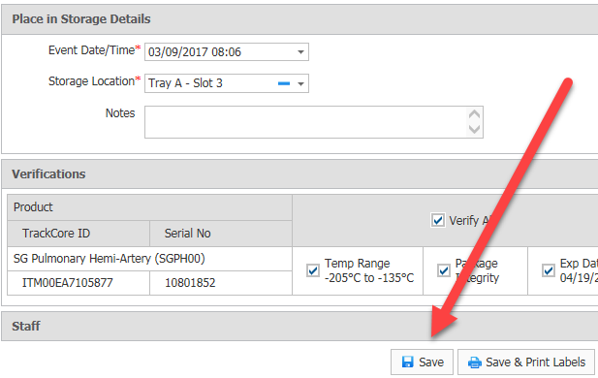
 | 10 | Attach Trackcore barcode with thermal tape to tissue box. (Place label flat on the front of the box, toward the bottom making sure not to cover any important information.)  Note: Tissue must be placed in freezer within 3 minutes after removal from shipper.
 | 11
  If | Then
  Cryolife tissue | Note: CryoLife tissues must be placed in the liquid in vapors for a minimum of 2 hours then moved to liquid storage.  - Place tissue in upper slots of sleeves (vapors).  - Record temporary slot locations on a post-it note.  - Wait at least two hours before moving tissue into permanent storage (liquid).
  Lifenet tissue | Note: Lifenet tissues must never be placed in the liquid nitrogen. Store in the vapors only.  - Place tissue in the slot selected.
 | 12 | Place Tissue paperwork in mailbox outside the freezer room..
 | Step | Action
Shipping back Cryoshippers containers | 1 | Empty shipping container.
Shipping back Cryoshippers containers | 2 | Replace all packing material inside the box.
Shipping back Cryoshippers containers | 3
  If | Then
  Lifenet | - Secure the lid of the cryoshipper with a plastic tie and fit the cryoshipper securely within the shipping container if it has been removed.  - Close the lid of the shipping container and tighten down the metal latches. Secure the latches with two plastic ties.  - Attach the LifeNet Health return address label to the top of the shipping container being careful not obscure or cover any other labels.  - Place cryoshipper in supermarket; place a label that says “empty, ready for return’.
 | 4
  If | Then
  Cryolife | - Tape box shut with packing tape.  - Place FedEx shipping label on the top right corner of the box.  - Place cryoshipper in supermarket; place a label that says “empty, ready for return”.
Approval  Workflow | Transfusion Service/Medical Director
Historical Record | Version |  |  | Written/Revised by: | Effective Date: | Summary of Revisions
Historical Record | 1 |  |  | S. Cassidy | 03/15/2017 | Initial Version

