TrackCore Daily Report

Purpose | This procedure provides instructions for running the daily report in the TrackCore System
Procedure
 | Step | Action
 | 1 | Log onto TrackCore  
 | 2 | Click the Reports button  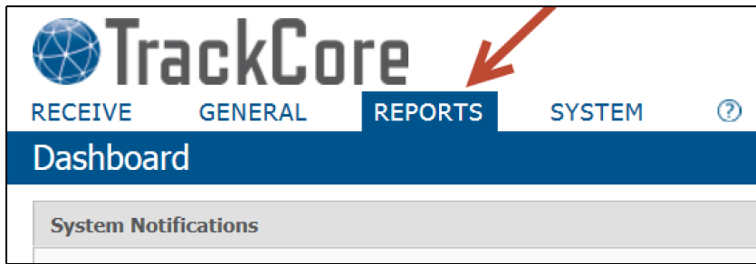
 | 3 | Locate Item Search Report  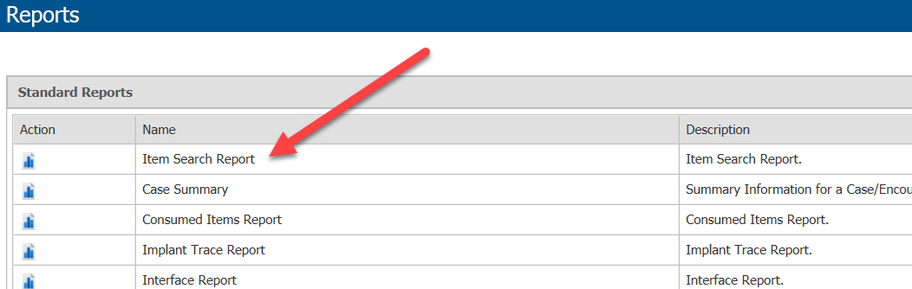
 | 4 | Change the Filter by status to “In Storage”.  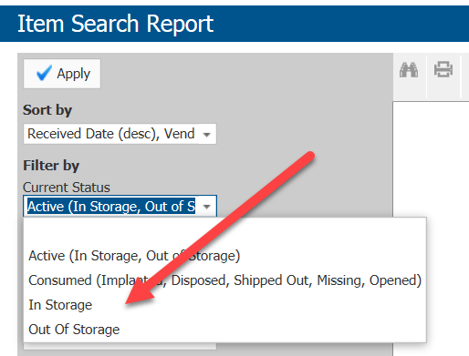
 | 5 | Click the Apply button.  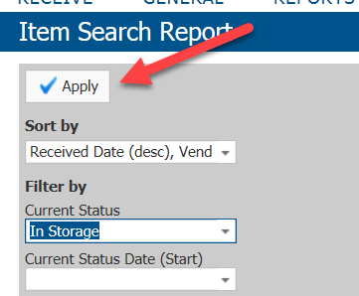
 | 6 | Minimize the TrackCore Screen and Open the TrackCore Inventory Excel spreadsheet.  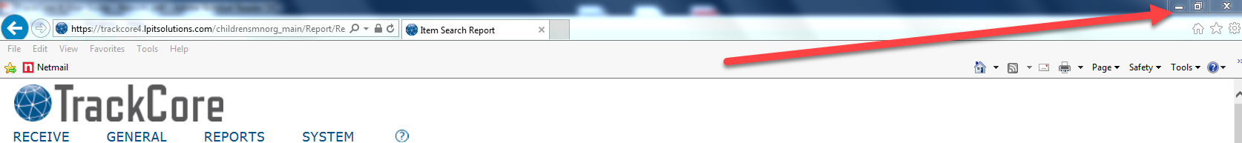  
 | 7 | Re-open Track Core.
 | 8 | Change the PDF to Xlsx.  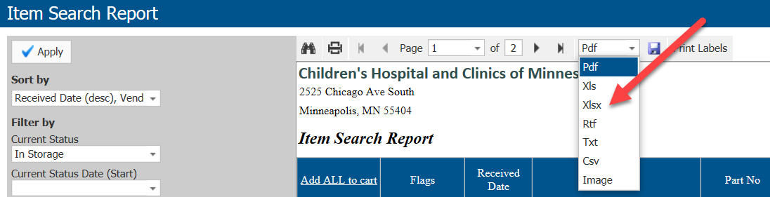
 | 9 | Click on the export button.  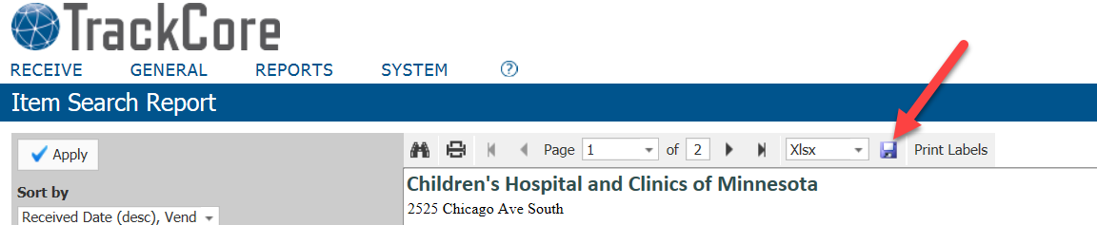
 | 10 | Click on the item search report to open file.  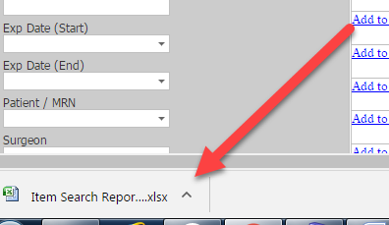
 | 11 | Excel file will open, click on the excel worksheet anywhere to activate screen.
 | 12 | Hit <ALT> F8
 | 13 | The Macro box will appear. Click Run.  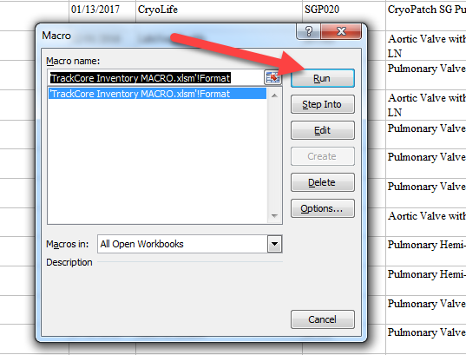
 | 14 | The macro report will generate the new formatted excel spreadsheet  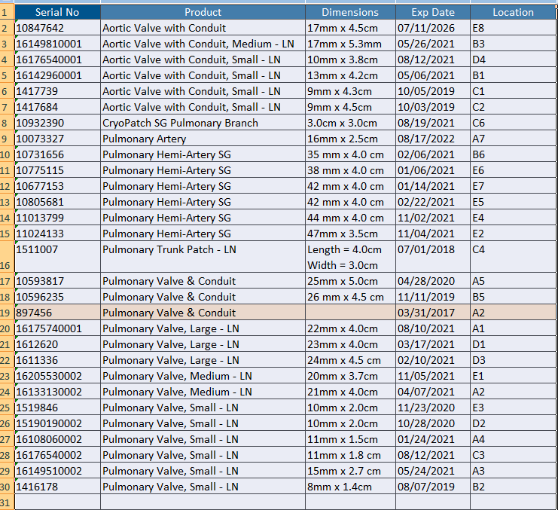
 | 15 | Print the report to printers MPS-4-PCVP-Q2 and MPS-4-CVP-Q7
Approval  Workflow | Transfusion Service/Medical Director
Historical Record | Version |  | Written/Revised by: | Effective Date: | Summary of Revisions
Historical Record | 1 |  | S. Cassidy | 03/15/2017 | Initial Version

