Disposition of Cardiac Tissues in TrackCore

Purpose | This procedure provides instructions for disposing of cardiac tissue in TrackCore system.
Procedure
 | Step | Action
 | 1 | Cardiac usage card sent down from CVOR.
 | 2 | Log into TrackCore using your Children’s credentials. (CE# and password)  
 | 3 | Sign-in using your Children’s credentials (CE # and password)  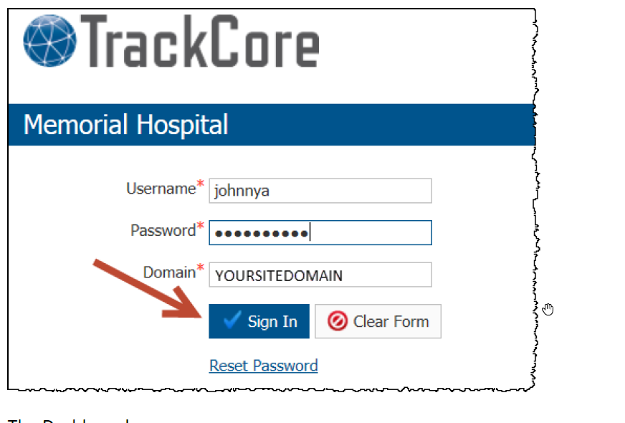
 | 4 | Dashboard screen appears.  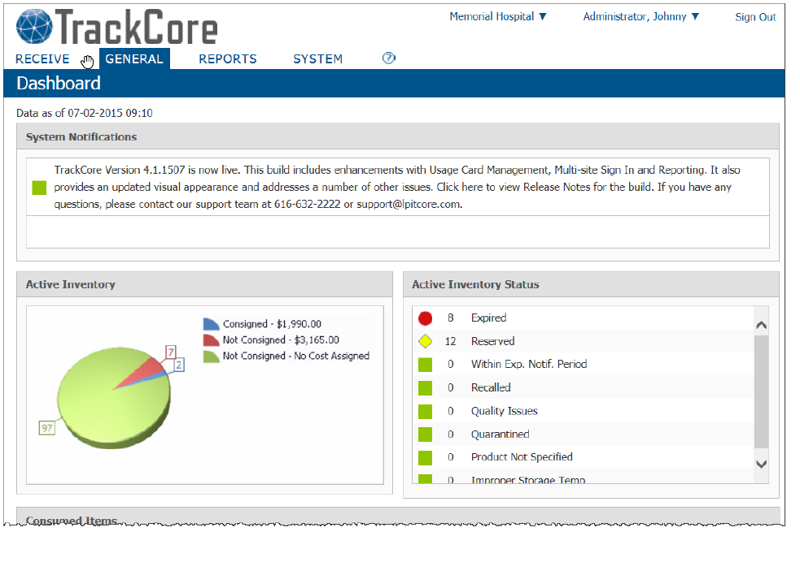
 | 5 | Scroll down to Items Out of Storage on the dashboard.  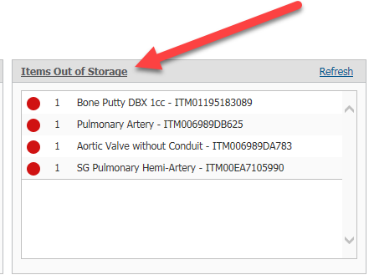
 | 6 | Either click on “Items Out of Storage” or the individual graft that the tissue card is for.  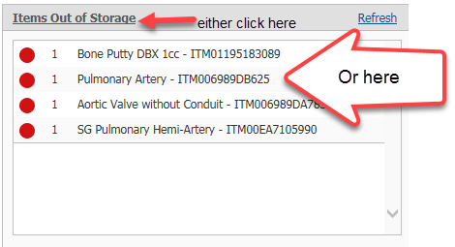
 | 7 | The Item Search Report will open.  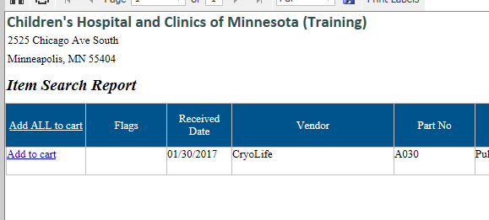
 | 8 | Click “Add to cart”  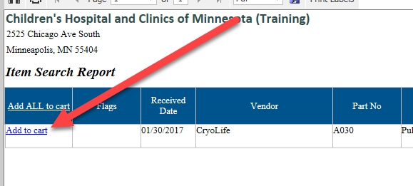
 | 9 | Item is added to the cart.  Click on “View Cart”  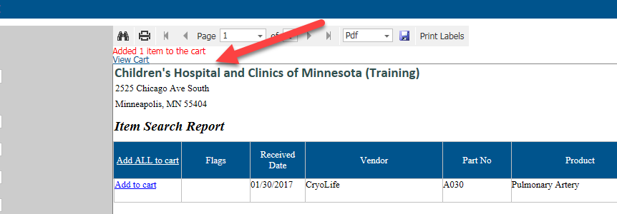
 | 10 | The Search Cart opens up.  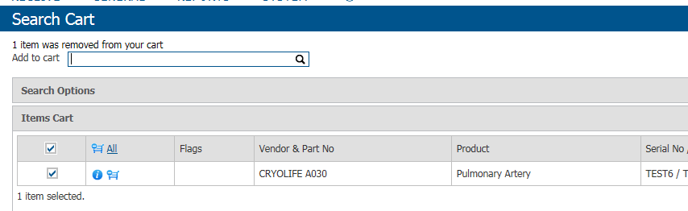
 | 11 | Click on more actions and then click on “Dispose”  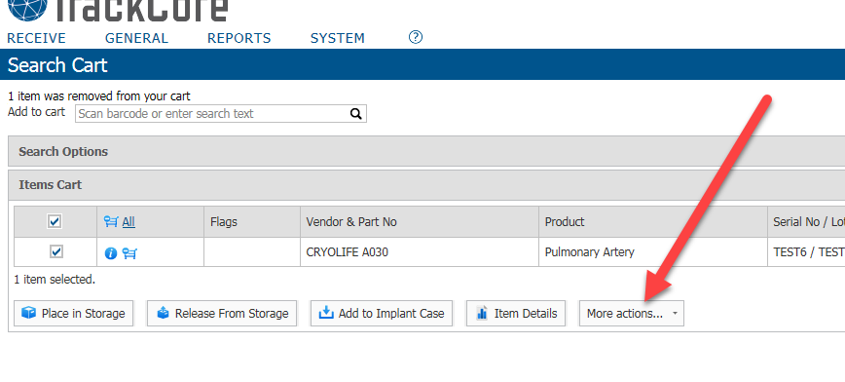
 | 12 | The Dispose record opens.  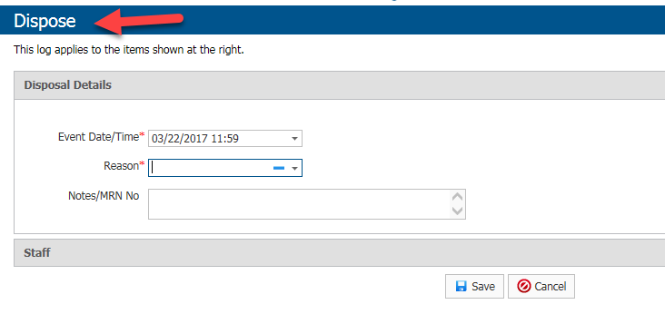
 | 13 | Log into Cerner.  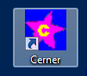
 | 14 | Log into PowerChart  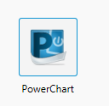
 | 15 | Type in the patient’s MRN that graft was implanted.  
 | 16 | Click on Clinical Documents.  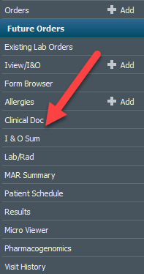
 | 17 | Locate the date of the surgery.  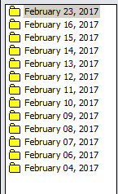
 | 18 | Find the Intraop document and open the document.  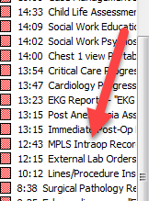
 | 19 | Scroll down until you find the Implants location.  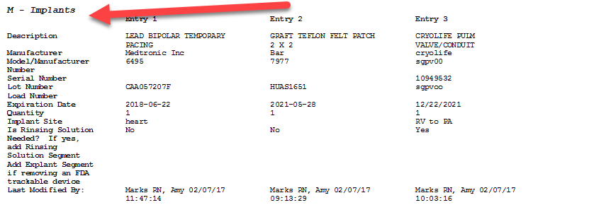
 | 20 | Locate the cardiac tissue that was implanted and find the date and time graft implanted.  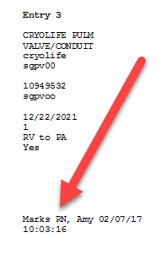
 | 21 | Enter the date and time of implantation in the Event Date/Time,  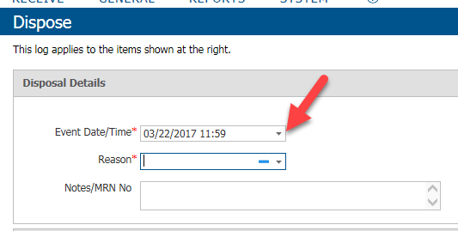
 | 22 | Click on the drop-down box in the “Reason” field and choose “Implanted Item-See EMR Record”.  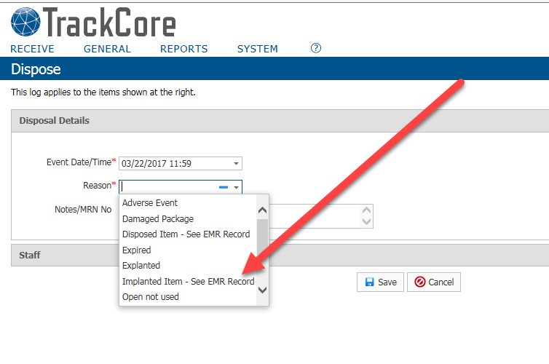
 | 23 | Type in the patient’s MRN in the “Notes/MRN No Field.  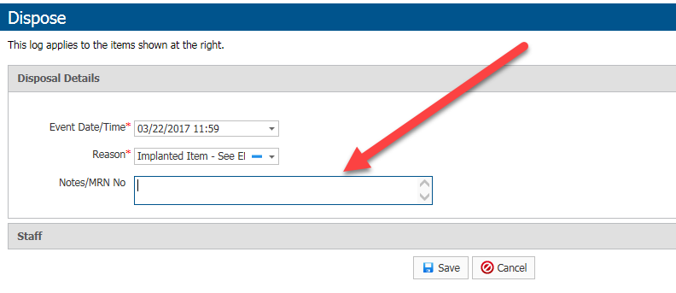
 | 24 | Click Save  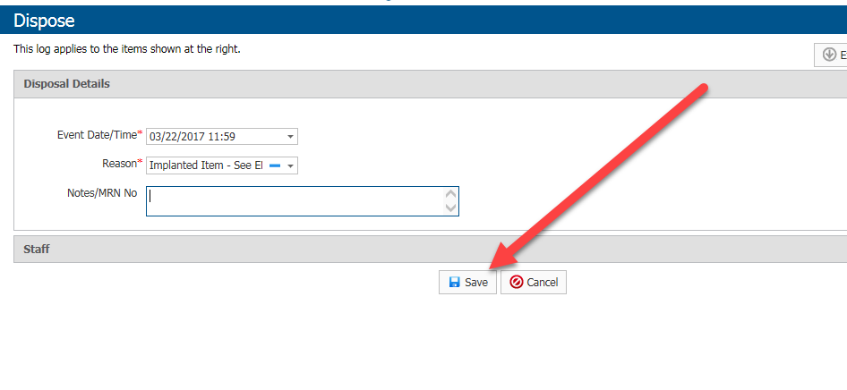
 | 25 | Make a copy of the implant card and place in the Cardiac Tissue Tracking binder and send the original to the vendor
References | - TrackCore
Approval  Workflow | Transfusion Service/Medical Director
Historical Record | Version |  | Written/Revised by: | Effective Date: | Summary of Revisions
Historical Record | 1 |  | S. Cassidy | 03/15/2017 | Initial Version

