Releasing Cardiac Tissues from Storage-TrackCore

Purpose | This procedure provides instructions for releasing cardiac tissue from storage using the TrackCore system,
Materials | Equipment
Materials | - Barcode Scanner
Procedure
 | Step | Action
Releasing Cardiac Tissue from Storage | 1 | Surgeon will choose the homograft that will be used for surgical case.
 | 2 | Choose the correct homograft Certificate of Assurance paperwork from the file folder located in CVOR 1.
 | 3 | Proceed to the Cryo freezer room with the Certificate of Assurance paperwork and patient label
 | 4 | Log into the computer using your Children’s credentials. (CE# and password)
  If | Then
  Log-in Successful | Proceed to step 5
  Log-in Failed | Proceed to downtime procedure
 | 5 | Log into TrackCore using your Children’s credentials. (CE# and password)  
  If | Then
  Log-in Successful | Proceed to step 6
  Log-in Failed | Proceed to downtime procedure
 | 6 | Search Cart Empty.
  If | Then
  Yes | Proceed to step 7
  No | Check the square upper left side corner of “Items Cart” and click shopping cart to clear the Search Cart.  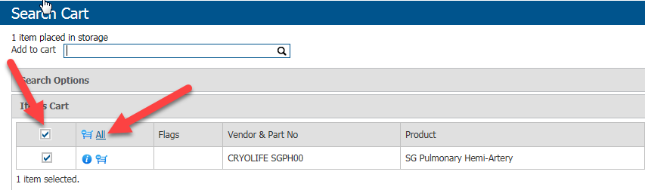
 | 7 | Scan barcode label on the Certificate of Assurance paperwork into the “add to Cart”.  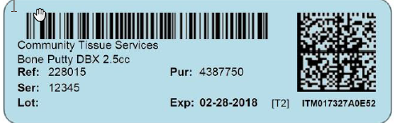  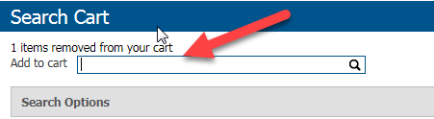
 | 8 | Locate the location of the homograft in the freezer and remove graft from freezer.  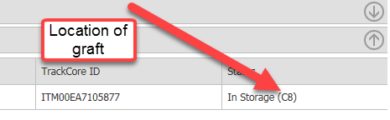
 | 9 | Click “Release from Storage” button.  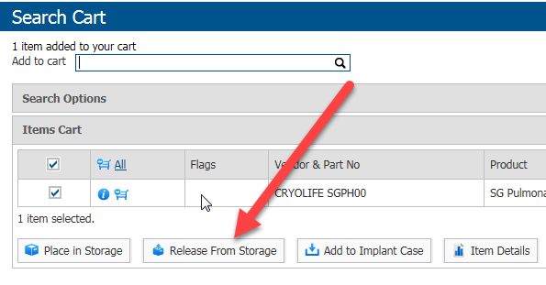
 | 10 | Either click the drop-down box or start typing name in the “Release to Staff” box.  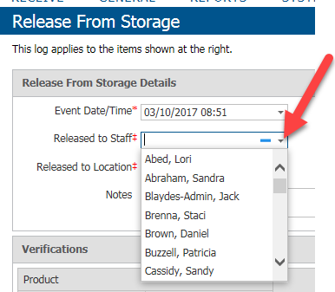
 | 11 | Click the drop-down box “Release to Location” to choose the location of where the graft will be implanted.  CVOR 1-Main room  CVOR 2-Hybrid room  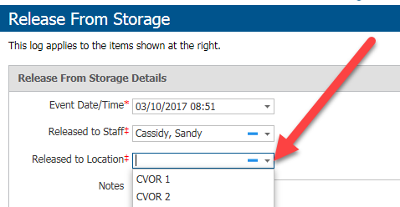
 | 12 | Scan patient’s MRN in the notes section.  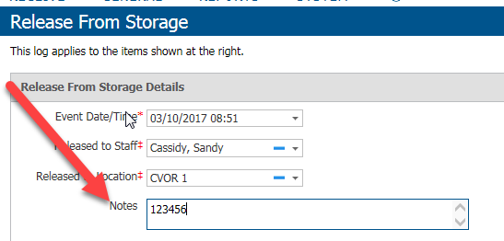
 | 13 | Check “Verify All” if homograft passes all quality measures.  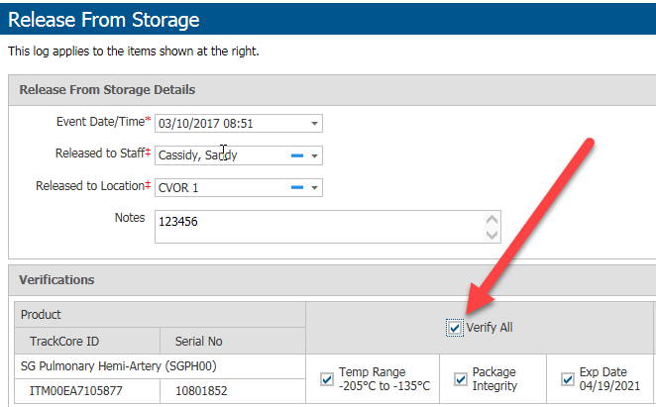
 | 14 | Click Save.  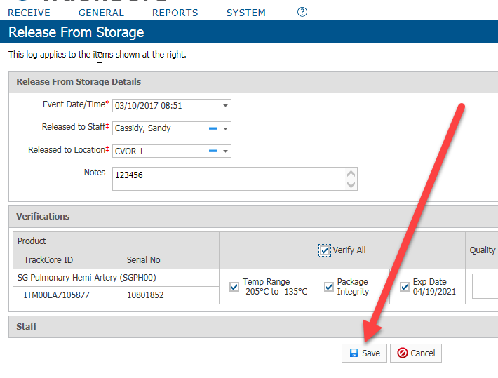
 | 15 | Log out of TrackCore and Computer station.
Alternate Procedure | TS 20.20 TrackCore Downtime
References | - TrackCore
Approval  Workflow | Transfusion Service/Medical Director
Historical Record | Version |  | Written/Revised by: | Effective Date: | Summary of Revisions
Historical Record | 1 |  | S. Cassidy | 03/15/2017 | Initial Version

