**<10 Kg MTP packs**

Initial Pack

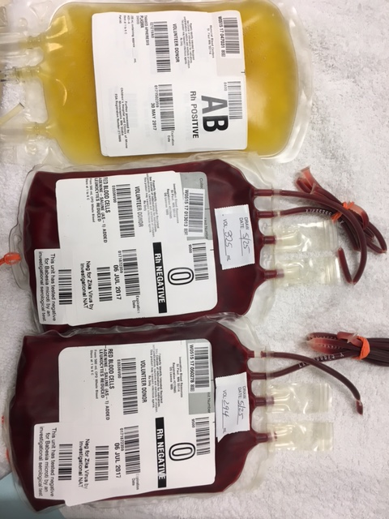

1 FFP and 2 RBCs

2nd Pack

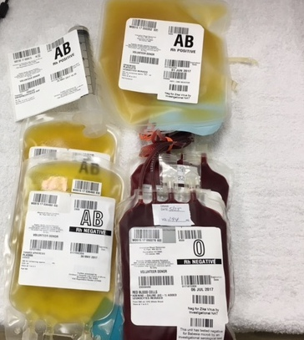

2 FFP, 2 RBCs, 1 platelet, and 1 unit Cryo (syringe)

3rd, 5th and 7th Packs

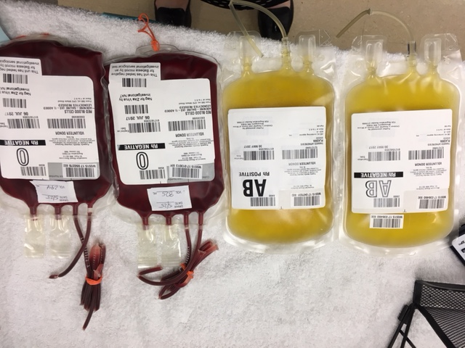

2 FFP and 2 RBCs

4th, 6th, and 8th packs

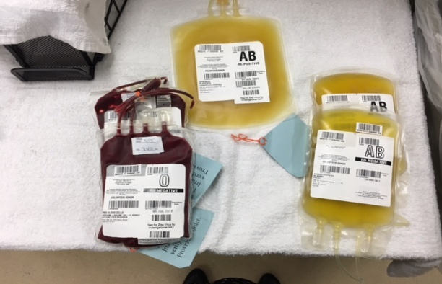

2 FFP, 2 RBCs and 1 platelet

**>10 Kg MTP Packs**

Initial Pack



1 FFP and 2 RBCs

2nd Pack

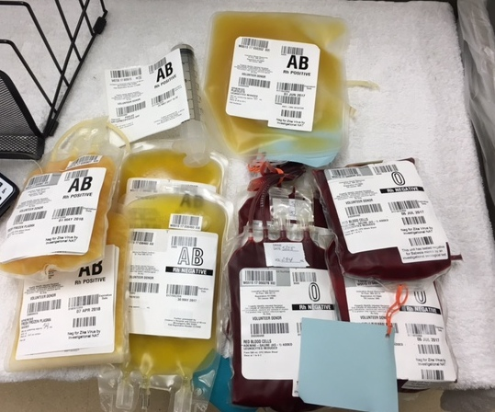

4 FFP, 4 RBCs, 1 platelet and 2 units of Cryo (syringe)

3rd, 5th, and 7th packs

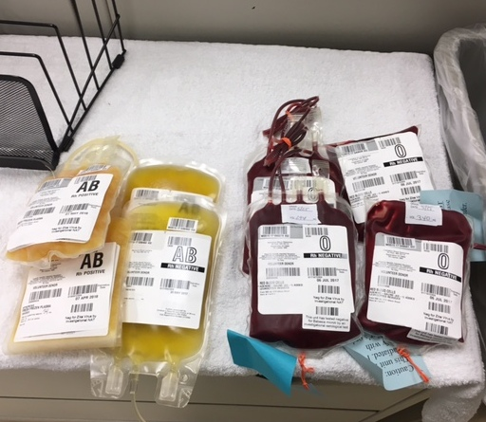

4 FFP and 2 RBCs

4th, 6th and 8th packs

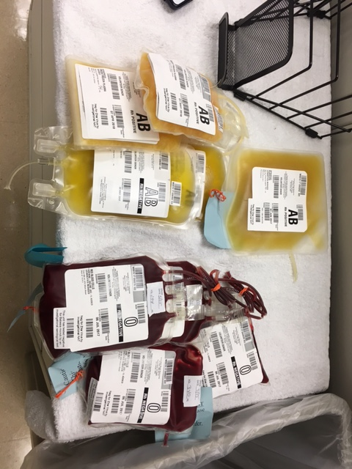

4 FFP, 4 RBCs and 1 platelet