Order Receipt/Modify (GUI ORM)

Purpose | This procedure provides instructions for using Order Receipt/Modify (GUI ORM) in Sunquest for receipt of specimens, modification, rescheduling and crediting of orders.
Policy Statements | - This procedure applies to all laboratory staff
 | Follow the activities in the table below to RECEIVE, MODIFY, RESCHEDULE OR CREDIT ORDERS IN GUI ORM.
Procedure | Step | Action |  |  |  | Related Document
 | 1 | Loggin into Order/Receipt Modify (GUI ORM)
A. Log into the Sunquest Gateway by clicking on the Sunquest GUI icon on your desktop indicated by the symbol below.


B. The Laboratory Logon Screen will open, Select work area:
Should reflect MIN. Click OK.

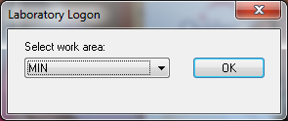

C. The SQ Main Logon page will open

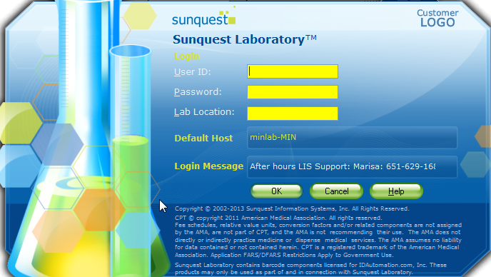

 |  | D. Enter your credentials (User ID: Password, Lab Location) and click the OK button.
E. The Main SQ GUI Menu Selection Screen will open, select General Laboratory.

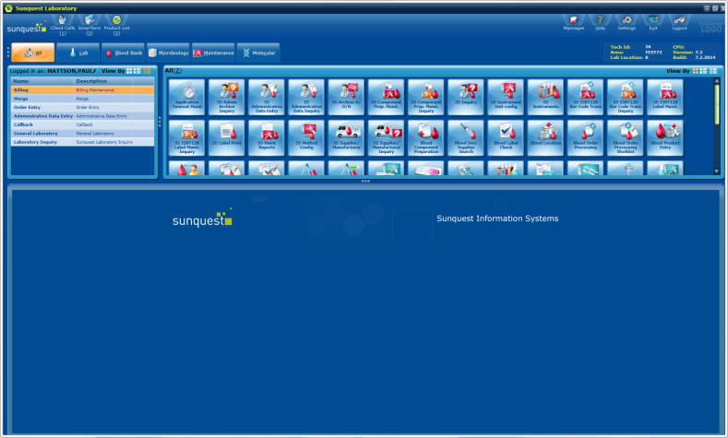
F. Select the Orders option that appears in the upper left hand corner of the screen.
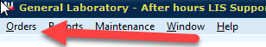

 |  | G. Then select Order Receipt/Modify (ORM) from the drop down list.
 | 2 | RECEIVING LAB SPECIMENS
A. Once you are in ORM to receive orders, the following window will open. The default for the search screen is Patient ID (Patient Medical Record Number, MRN):

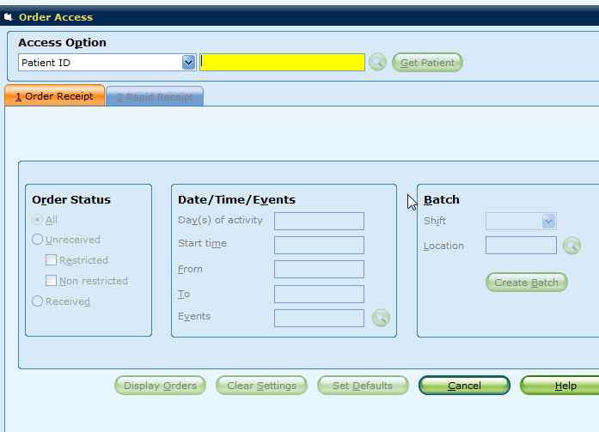
B. Look for all active orders for the Patient ID/MRN or Select Accession number from the drop down, if appropriate. The Collection Manager/Clinical Collect bar code represents the Accession number. The Cerner labels represent the Patient ID/MRN. You can scan these fields from bar codes attached to the specimen labels OR type directly into the field. Yellow fields in these screens are MANDATORY data fields. If you select Accession Number, Order Status Options will not display and will bring you directly to the Order Receipt/Modify window.

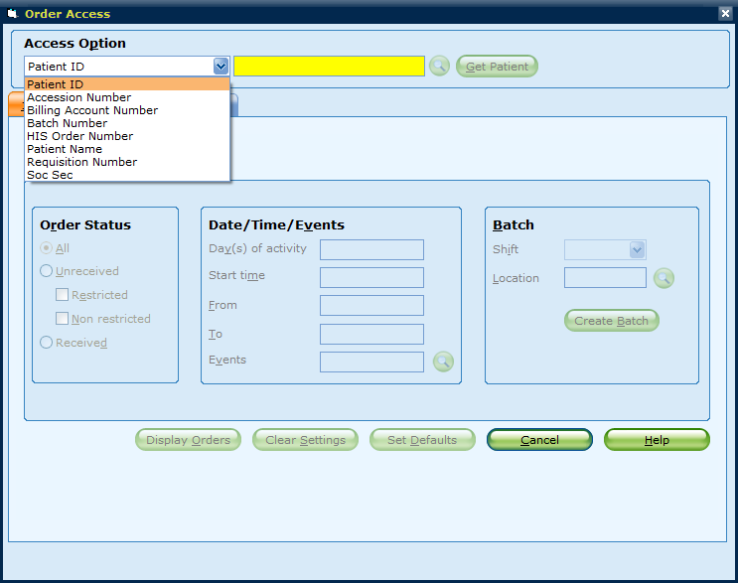
C. Once you click Get Patient (or ENTER), you will have an option to pick items under the Order Status selection box as seen above. Look for Unreceived Orders and both Restricted and Unrestricted orders. Then ENTER and Display Orders will activate and your unreceived orders will appear on the next screen. The line highlighted in ORANGE below is currently selected and information for H3546 appears in the General Information Window.

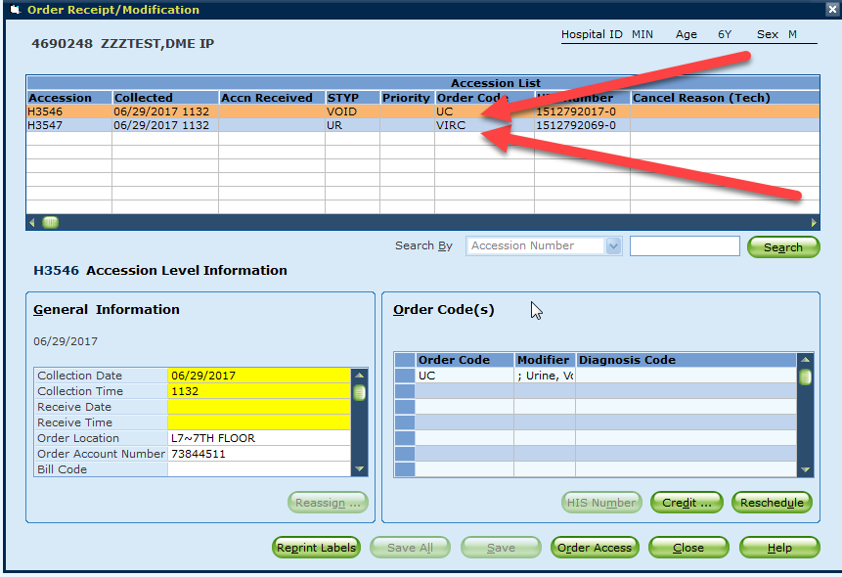
D. Click into the Collection Date cell and ENTER/TAB through each of the yellow fields. The correct Collect date/time (if collected in Collection Manager/Clinical Collect) will automatically drop into the fields. If the specimen was not collected in Clinical Collect, you will need to manually enter the information hand written on the label or form submitted with the sample. The Receipt Date/Time will drop in as you ENTER/TAB through the fields. NOTE: If there is a Modifier present under the Order code box, follow instructions in #13.
If the sample was collected in Clinical Collect or Collection Manager, the phlebotomist code and order workload code will be populated. These are mandatory fields, if it is a floor collected sample and they did not use clinical collect, enter your tech code as the phlebotomist and RN as the workload

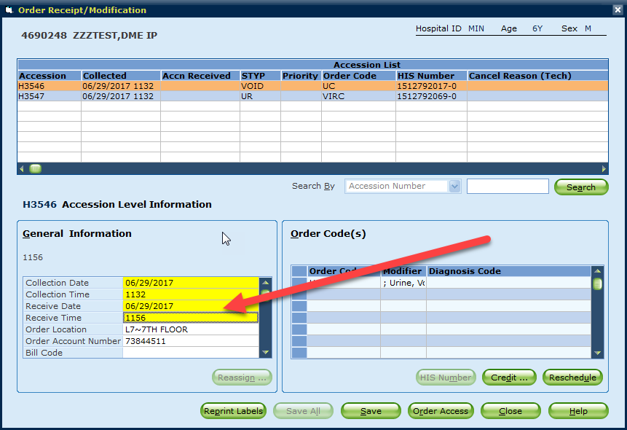
E. If you click on the Modifier field under the Order Code box, you will see the full description of the modifier listed above the box as indicated by the RED ARROW in the image below. If there is a modifier present, you must use the Modifier Info to add to SDES on the following screen (ie, port 1). The modifier info also displays on the Clinical Collect label and helps further identify the source of the specimen so culture results are accurately associated to the specimen submitted to the lab. Once done with this Screen, click SAVE and Enter.

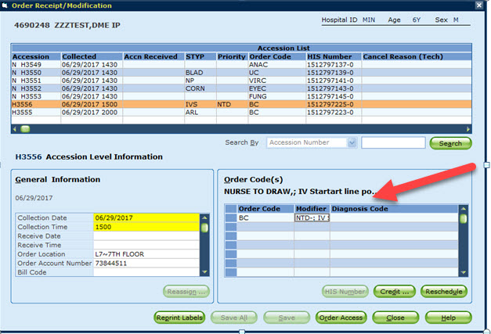
F. After the SAVE, the Micro RESULT ENTRY detail screen for Result at Requisition Tests will appear. Edit these as necessary to complete the Order Receipt Process. If Free Text appears in the SDES cell, replace it with the appropriate specimen type code(s) and remember to add any Modifer information from the Order (Detailed in #13 above).

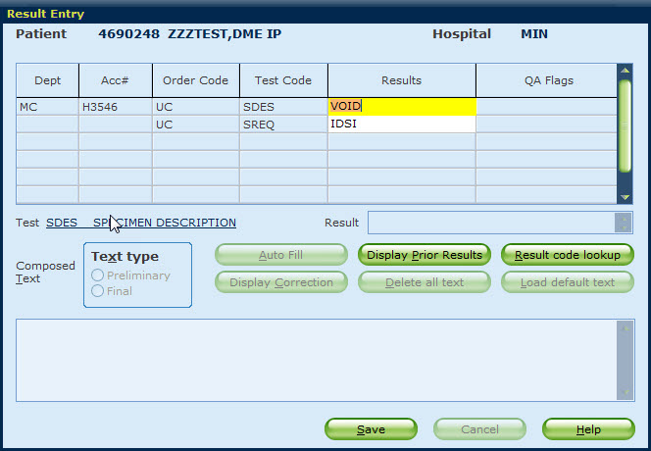
 |  | G. The Micro Workcard label will now print for this specimen and the ORM window will return to the next unreceived specimen(s) for processing. Or back to the main window display to select another MRN or accession number.
 | 3 | CREDIT/RESCHEDULE
A. Click on Credit or Reschedule below the Order Code(s) box.

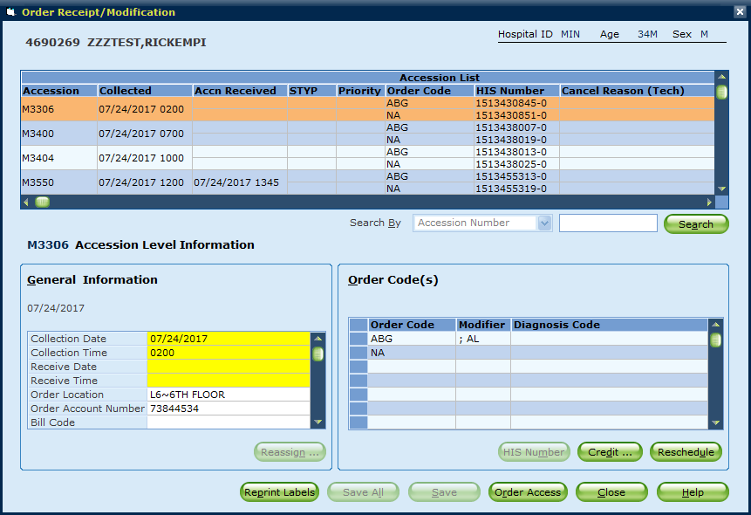

B. Credit
Select the test(s) that need to be credited. They will move to the box on the right.

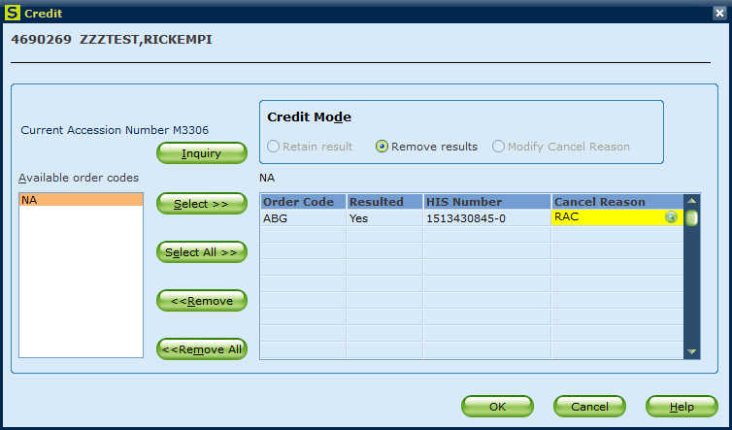
In the example above, the ABG has been selected and moved over to the Credit window. Crediting/Cancelling in this window will Remove Results. If it is desired to keep any results associated with the test being credited/cancelled, please see the Credit Without Moving Results procedure. The Cancel Reason is mandatory. Cancel reasons can be searched by using the magnifying glass icon to the right on the Cancel Reason box. Once fields are completed, Click OK to complete the cancel.
C. Reschedule
Select the tests that need to be rescheduled. They will move to the right side “To be Rescheduled” box. The Collect Date, Collect Time, New Accesson Number and Reschedule Reason are all mandatory fields depicted in yellow below.

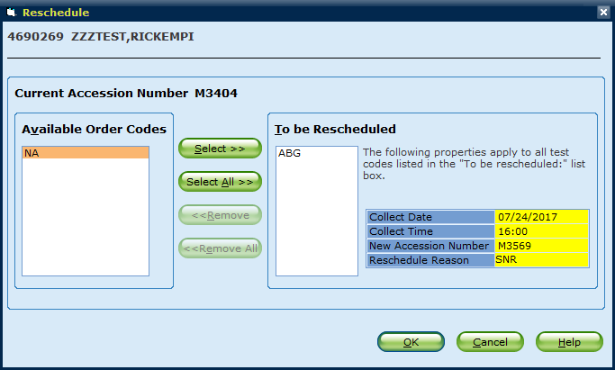
Click into the Date/Time fields and enter the desired future collection information. Click into the New Accession Number, but do not enter any information. Then click on the Reschedule reason and the New Accession Number will automatically populate. Then enter the Reschedule Reason and Click OK to save. The new accession number will qualify on Collection Manager/Clinical Collect for a future draw.

 | 4 | ADD ON TESTING
A. From the Main Order/Receipt/Modification Window, search by Patient MRN or Accession. Select the Accession you wish to Modify. Type the new Test Order into the first open cell under the Order Code column. (To search for a test code, click the open cell and press F3).

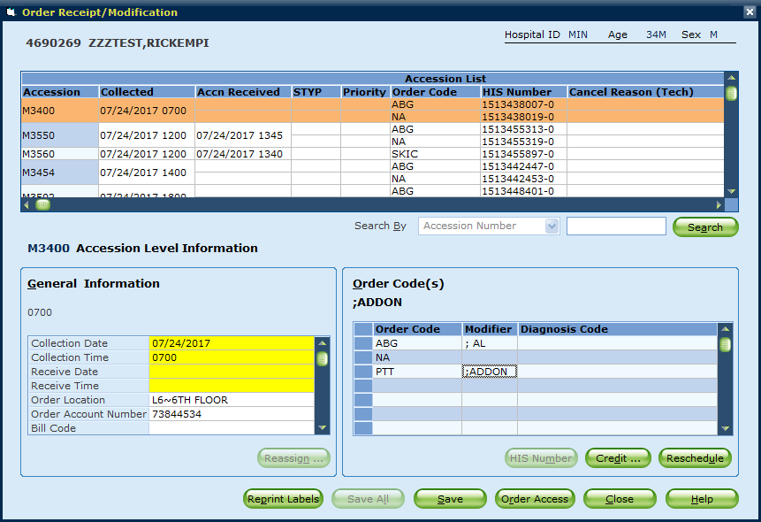
In the example above, a PTT was added the original order of ABG and NA. Click SAVE to complete the added order.
Note: Using the F3 key in any field will bring up a Search box.
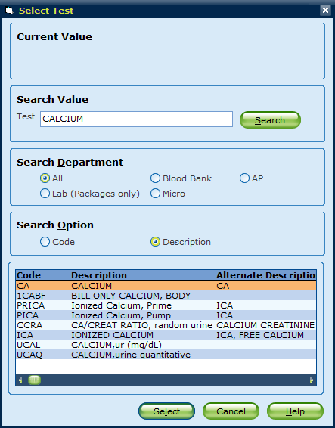

References | Sunquest 7.2 Manual
Training Plan/  Competency  Assessment | iMentor self-paced classes  New employee training  Upgrade Training  LIS Competencies
Historical Record | Version |  | Written/Revised by: | Effective Date: | Summary of Revisions
 | 1 |  | P. Mattson | 7/18/2017 | Initial Version
 | 1 |  | Roxann Gulke | 8/8/2017 | Approved

