Unlocking Patient From Lock Table

Purpose | This document provides instructions for UNLOCKING PATIENT FROM LOCK TABLE.  Occasionally CCLCK does not release the lock from a patient. Selected staffs such as LIS, Evening OPS supervisors and charge techs have access to the LOCK table to release these locks.
Policy  Statements | - The Lock table is a restricted function that only selected staff can access. It is used by staff only when CCLCK fails to release a lock. Whenever you use the LOCK table you must send a message (e-mail or mailbox) to the LIS group.
Procedure | Follow the activities in the table below for UNLOCKING PATIENT FROM LOCK TABLE:
 | Step | Action
 | 1 | Always start by using CCLCK  In SmartTerm  Function: LOCK – LOCK TABLE
 | 2 | Select Display lock table  Would you like to filter the IXPROC locks? (Y/N) Y
 | 3 | A list of all patients/accession numbers locked in Sunquest will display  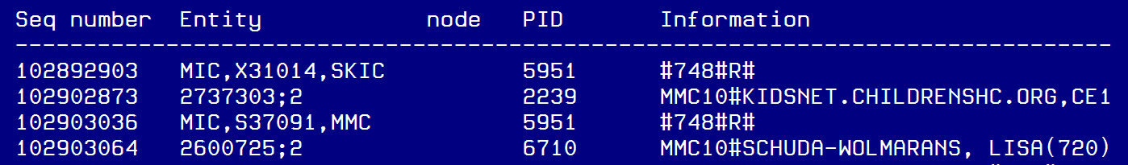  A .MMC10.kisnet…. indicates clinical collect locks  B. There could be multiple patients locked by clinical collect so you need to confirm the patient MRN  C. Use the Entity to unlock the patient.  You can copy and paste this into the next step  Press any key to return to the menu.
 | 4 | Use the down arrow or enter U to move to Unlock an entity from the main menu and hit enter
 | 5 | Paste the ENTITY copied in step 3 and enter  The following message appears:  Process appears to be hung in MMC10. Process is held by tech code  KIDSNET.CHILDRENSHC.ORG,CE001314(736).  Attempt to stop the process? (Y/N)  Enter Y  You will see a message like as this:  Please wait up to 48 seconds.  Process removed.  Lock released  Press any key to return to the menu.
 | 6 | Enter and E or arrow down to exit and Enter
References | Sunquest Version Manual
Training Plan/  Competency  Assessment | Procedure review  LIS Competency
Historical Record | Version |  | Written/Revised by: | Effective Date: | Summary of Revisions
 | 1 |  | Roxann Gulke | 11/14/2017 | Initial Version

