Thyroxine Free (FT4)

Purpose | This procedure provides instructions for performing THYROXINE FREE (FT4) on the Dimension Vista® System. The FT4 method is an in vitro diagnostic test for the quantitative measurement of Free Thyroxine in human serum and plasma.
Policy Statements | This procedure applies to all personnel who perform the Free Thyroxine test on the Dimension Vista® System.
Principle | The FT4 method is a homogeneous, sequential, chemiluminescent immunoassay based on LOCI® technology. The LOCI® reagents include two synthetic bead reagents and a biotinylated anti-T4 mouse monoclonal antibody. The first bead reagent (Chemibeads) is coated with triiodothyronine (T3), a naturally occurring, weaker binding analog of T4, and contains chemiluminescent dye. The second bead reagent (Sensibeads) is coated with streptavidin and contains a photosensitizer dye. In a first step, sample is incubated with biotinylated antibody which allows T4 from the sample to saturate a fraction of the biotinylated antibody that is directly related to the free T4 concentration. In a second step, T3 chemibeads are added and form bead/ biotinylated antibody immunocomplexes with the non-saturated fraction of the biotinylated antibody. Sensibeads are then added and bind to the biotin to form bead pair immunocomplexes. Illumination of the complex at 680 nm generates singlet oxygen from Sensibeads which diffuses into the Chemibeads, triggering a chemiluminescent reaction. The resulting signal is measured at 612 nm and is an inverse function of the FT4 concentration in the sample.  Notice: This assay is sensitive to higher than normal levels of supplemented Biotin. Results will be falsely increased in a proportional manner based on concentration of Biotin in circulation.
Clinical Significance | Thyroxine is synthesized in the thyroid gland and once in the circulation, almost all thyroxine (99.97 %) is protein bound. It is only the 0.03% unbound or “free thyroxine” that is capable of binding to cellular receptors resulting in a physiologic response. FT4 concentrations more closely parallel thyroid dysfunction in patients with either hypo- or hyperthyroidism than do the serum levels of total thyroxine.
Instrument | PRIMARY METHOD: Siemens Dimension Vista® 500 System  SECONDARY (BACKUP) METHOD: Siemens Dimension Vista 500 on opposite campus
Sunquest Test Codes | FT4 Free T4 in ng/dL  LFT4 Free T4 Low, reflex to Free T4 by dialysis at Mayo
Specimen | FT4: Lithium heparin plasma, Serum (Gold Top, Marble Top or Red Top). Refer to the Specimen Collection Manual for collection of specimens.  Minimum Volume:  200μL preferred, 100μL minimum, 10 μL actual test volume  Stability:  24 hours/RT, 14 days/2-8°C, or 3 months at -20°C.  Serum samples are stable on the clot at room temperature for up to 24 hours.  Freeze samples only once and mix thoroughly after thawing.  Specimen Rejection:  - Samples and controls stabilized with sodium azide cannot be used  - Unlabeled
Specimen (cont) | LFT4: 2.0 mLs Serum (1.2 mL minimum) (Gold Top, Marble Top or Red Top). Serum must be separated from gel within 4 to 6 hours of draw. Reject samples with gross hemolysis, icterus, or lipids. Stability: 2-8°C / 28 days  Preparation:  - Complete clot formation should take place before centrifugation to prevent the appearance of fibrin in serum samples. Serum or plasma should be physically separated from cells with a maximum limit of 2 hours from the time of collection. Specimens should be free of particulate matter.  - Whole blood specimens should be centrifuged according to Specimen Processing procedures prior to analysis. See Processing Procedure Manual.  - Transfer serum or plasma to a properly labeled Siemens SSC nested on a bar-coded pilot tube. Minimum labeling includes sample accession ID, and/ or patient name, medical record number, collection date and time.  - Very lipemic or frozen samples that become turbid after thawing must be clarified by centrifugation before testing.  - Patients should not receive supplemented Biotin through multivitamins or Biotin supplements within 24 hours prior to testing.
Reagents | Product Description Product Code Stability  FT4 Flex® reagent cartridge All reagents are liquid and ready to use. K6410 Store at: 2 - 8 °C. Unopened: Refer to carton for expiration date of individual unopened reagent cartridges. On-board: Sealed wells on the instrument are stable for 30 days. Open well stability: 7 days for wells 1 - 12.  LOCI 1 CAL (Vista) KC660 Store at: 2 - 8 °C. Unopened: Refer to carton for expiration date. Preparation: Thaw and equilibrate at 22 – 28 C for 30 minutes. Mix by inverting 10 times. On-board: Once the vial stopper is punctured, assigned values are stable for 7 days when stored on board the Dimension Vista® System Opened: Once the cap is removed, the assigned values are stable for 30 days when recapped immediately and stored at 2 - 8 °C. Do not use this vial on board.
Risk and Safety | Irritant. Contains a mixture of 5-chloro-2-methyl-2H-isothiazol-3-one and 2-methyl-2Hisothiazol-3-one (3:1)  - May cause sensitization by skin contact.  - Avoid contact with skin.  - Wear suitable gloves
Calibration | Assay Range: 0.1–8.0 ng/dL  Calibration Material: LOCI 1 CAL (Vista), PN: KC660  Calibration Scheme 5 levels, n = 3  Typical Calibration Levels Level 1 (System Water): 0.0 ng/dL Level 2 (CAL B): 0.8 ng/dL Level 3 (CAL C): 2.0 ng/dL Level 4 (CAL E): 4.0 ng/dL Level 5 (CAL F): 8.4 ng/dL  Calibration Frequency: Every 30 days for any one lot For each new lot of Flex® reagent cartridges After major maintenance or service, if indicated by quality control results As indicated in laboratory quality control procedures
 | Consult the Vista Calibration Procedure or your Vista iGuide for calibration instructions.
Analytical Measuring Range (AMR) | Cal Verification and AMR verification meet regulatory requirements with each calibration using 5 calibrators that span the full measuring range.
Quality Control | Product: Biorad Immunoassay Plus Control in Vista Vials, 2 levels.  Preparation: Allow the frozen control to stand at room temperature (18 to 25°C) until it is completely thawed. Gently swirl the contents of the vial and immediately load the vial onto the instrument.  Frequency: Two levels once each day of patient testing.  Stability: This product will be stable until the expiration date when stored unopened at -20°C to -50°C.  Thawed and stored at 2 to 8°C or on board the Siemens Dimension Vista, all analytes will be stable for 4 days. Once thawed, do not refreeze the control; discard the remaining material.  Sunquest Control Names:  Level 1 = C-IMV1  Level 3 = C-IMV3.  Acceptable Ranges: Ranges are current in Sunquest and the instrument. Refer to the Quality Control in Chemistry Procedure for QC exception codes.
Interferences | Interfering Substances  FT4 method was evaluated for interference according to CLSI/NCCLS EP7-A2.10 The following substances, tested at the concentrations listed, caused elevated FT4 results due to releasing of T4 from serum binding proteins.  Concentration  Substance Units Bias (%)  Carbamazepine 3 mg/dL 13.2  Diclofenac 50 μg/mL 63.2  Furosemide 6 mg/dL 87.7  Ibuprofen 50 mg/dL 34.4  Linoleic acid 2.8 mg/mL 174.4  Mefenamic acid 0.1 mg/mL 177.7  N-acetylcysteine 1.5 mg/mL 14.5  Oleic acid 2.8 mg/mL 57.6  Phenylbutazone 15 mg/dL 93.8  Phenytoin 5 mg/dL 13.0  Salicylic acid 60 μg/mL 25.5  Hemolysis, Icterus & Lipemia (HIL) Index Values:  H I L  - - -  < 10 % bias when tested for hemolysis, bilirubin, or intralipids  FT4 will be falsely elevated in patients with moderate to high concentration of biotin in circulation. At concentrations of 500 ng/mL, the FT4 is elevated 37.6%. At concentrations of 1200 ng/mL, the FT4 is elevated above the analytical range of the analyzer.
Reference Range | 0.8 – 1.8 ng/dL
Critical Values | None specified.
Limitations | - The instrument reporting system contains flags and comments to provide the user with information regarding instrument processing errors, instrument status information and potential errors in FT4 results. Refer to your Dimension Vista® Operator’s Guide for the meaning of report flags and comments. Any report containing flags and/or comments should be addressed according to your laboratory’s procedure manual and not reported.  - Patient samples may contain heterophilic antibodies that could react in immunoassays to give a falsely elevated or depressed result. This assay has been designed to minimize interference from heterophilic antibodies. Nevertheless, complete elimination of this interference from all patient specimens cannot be guaranteed. A test result that is inconsistent with the clinical picture and patient history should be interpreted with caution.  - Thyroid autoantibodies in human serum may interfere and cause falsely elevated FT4 results.  - FT4 is usually measured by automated analog immunoassays. In most instances, this will result in accurate results. However, abnormal types or quantities of binding proteins found in some patients and most often related to other illnesses or drug treatments may interfere in the accurate measurement of FT4 by analog immunoassays. These problems can be overcome by measuring FT4 by equilibrium dialysis, free from interfering proteins.
Dilutions | Do not dilute
Result Reporting | Test Code FT4:  Results between 0.1 to 8.0 ng/dL without error messages are released  Results below 0.1 ng/dL: report as < 0.1 ng/dL instead of the numerical value  Results greater than 8.0 ng/dL: report as > 8.0 ng/dL after repeat analysis  All results will have the following comment appended: “Supplemented Biotin will falsely increase this assay. Repeat the testing 24 hours after the last biotin dose.”  Test Code LFT4:  Results between 0.8 to 8.0 ng/dL without error messages are released  Results greater than 8.0 ng/dL: report as > 8.0 ng/dL after repeat analysis  Results <0.8 will order a new test to be sent to Mayo Laboratory for Free T4 by Equilibrium Dialysis  In OEM: a FT4 below 0.8 ng/dL will cross as:  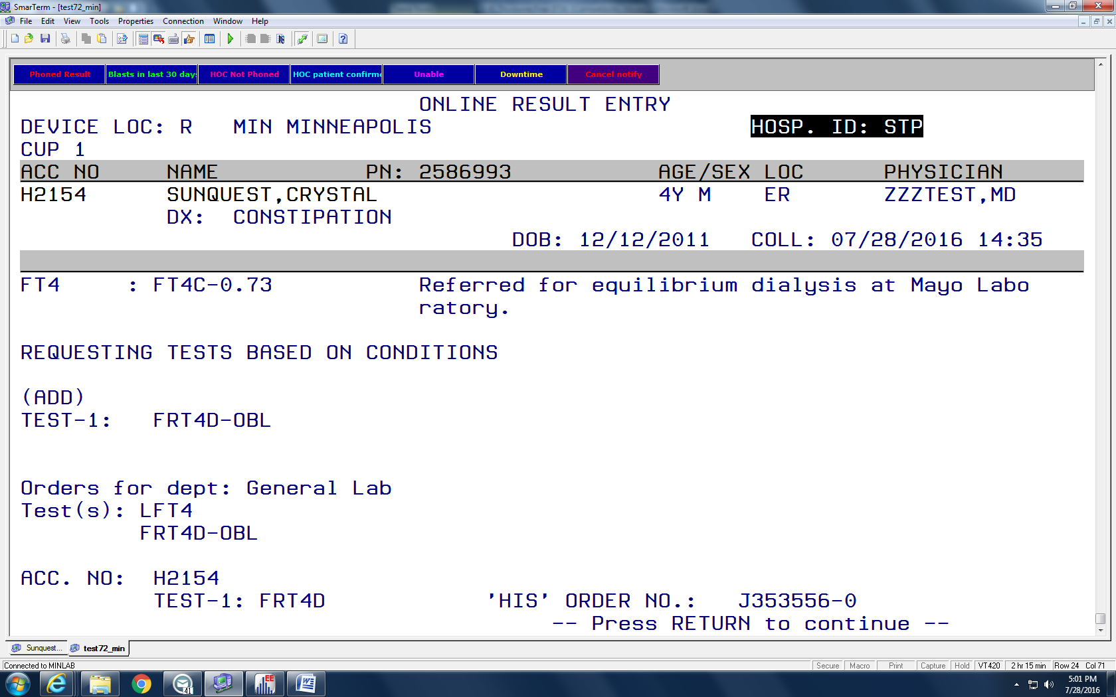  Press return to continue:  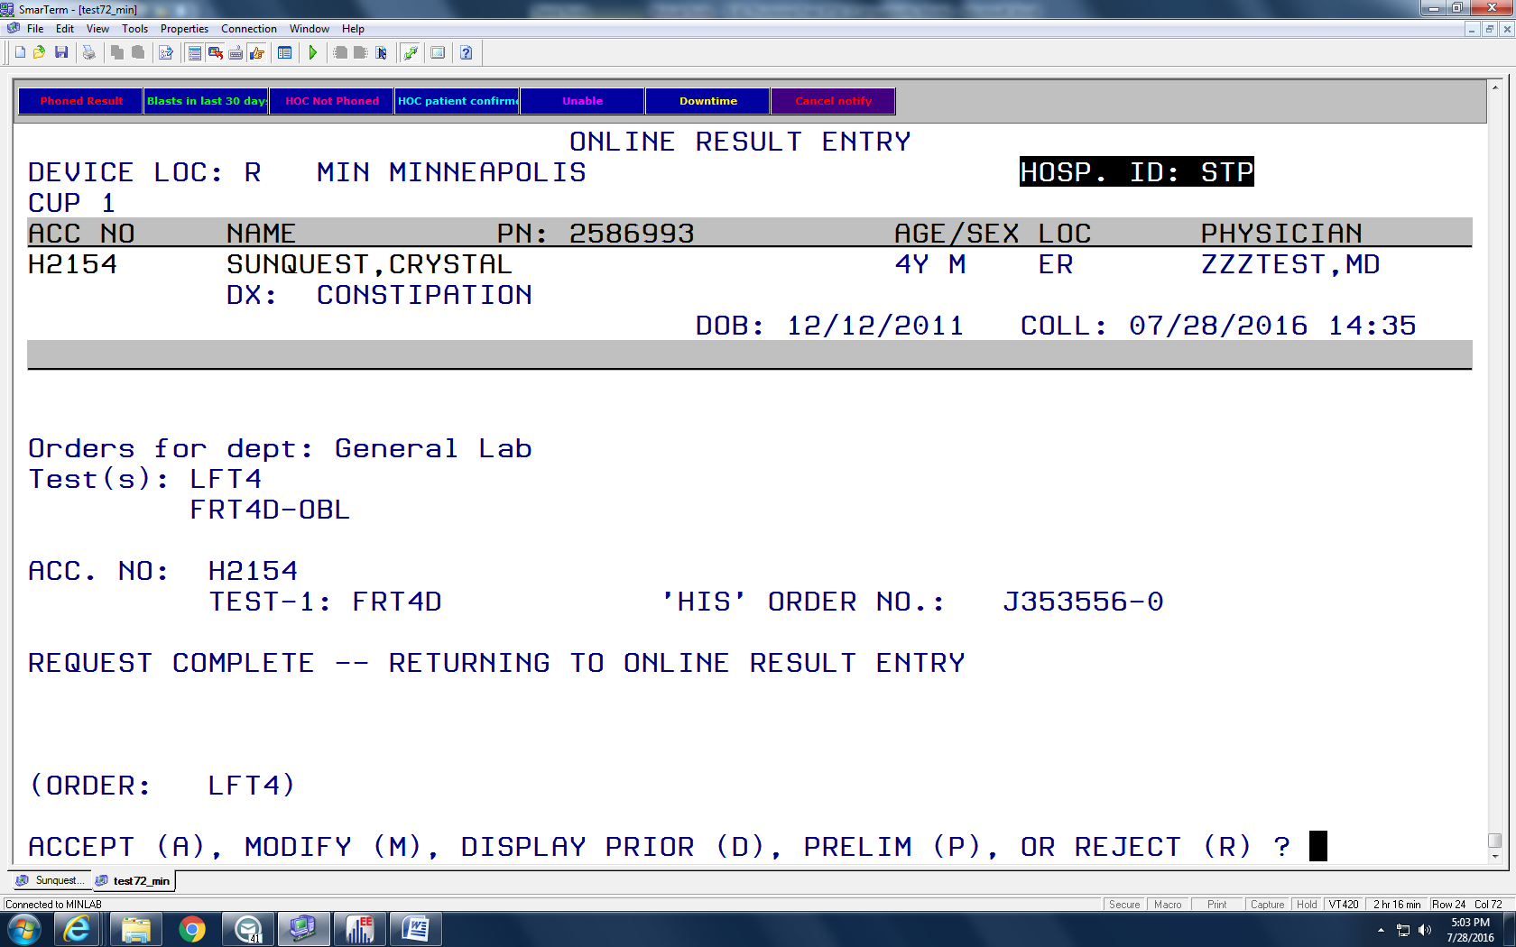
If acceptable Press (A) to Accept the result and new test order. Results appear in Sunquest as:

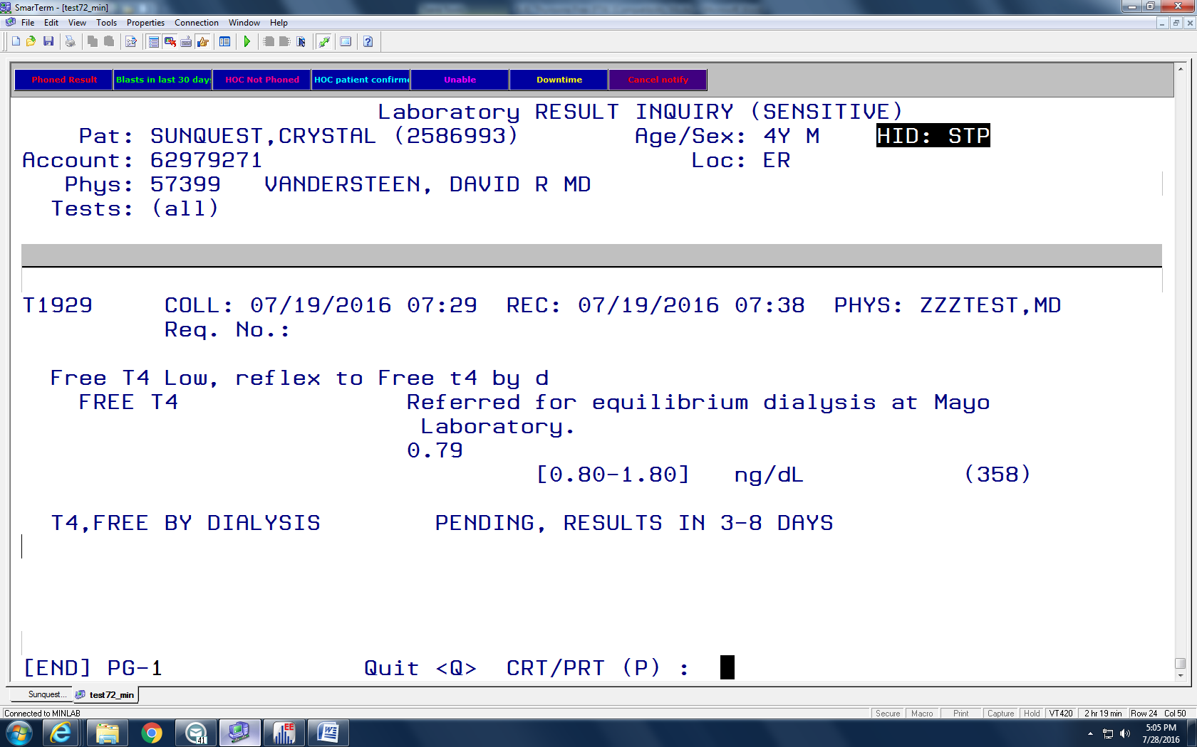

In MEM:
Use Worksheet DIM and test code LFT4
At the FT4 prompt, enter the Vista FT4 result

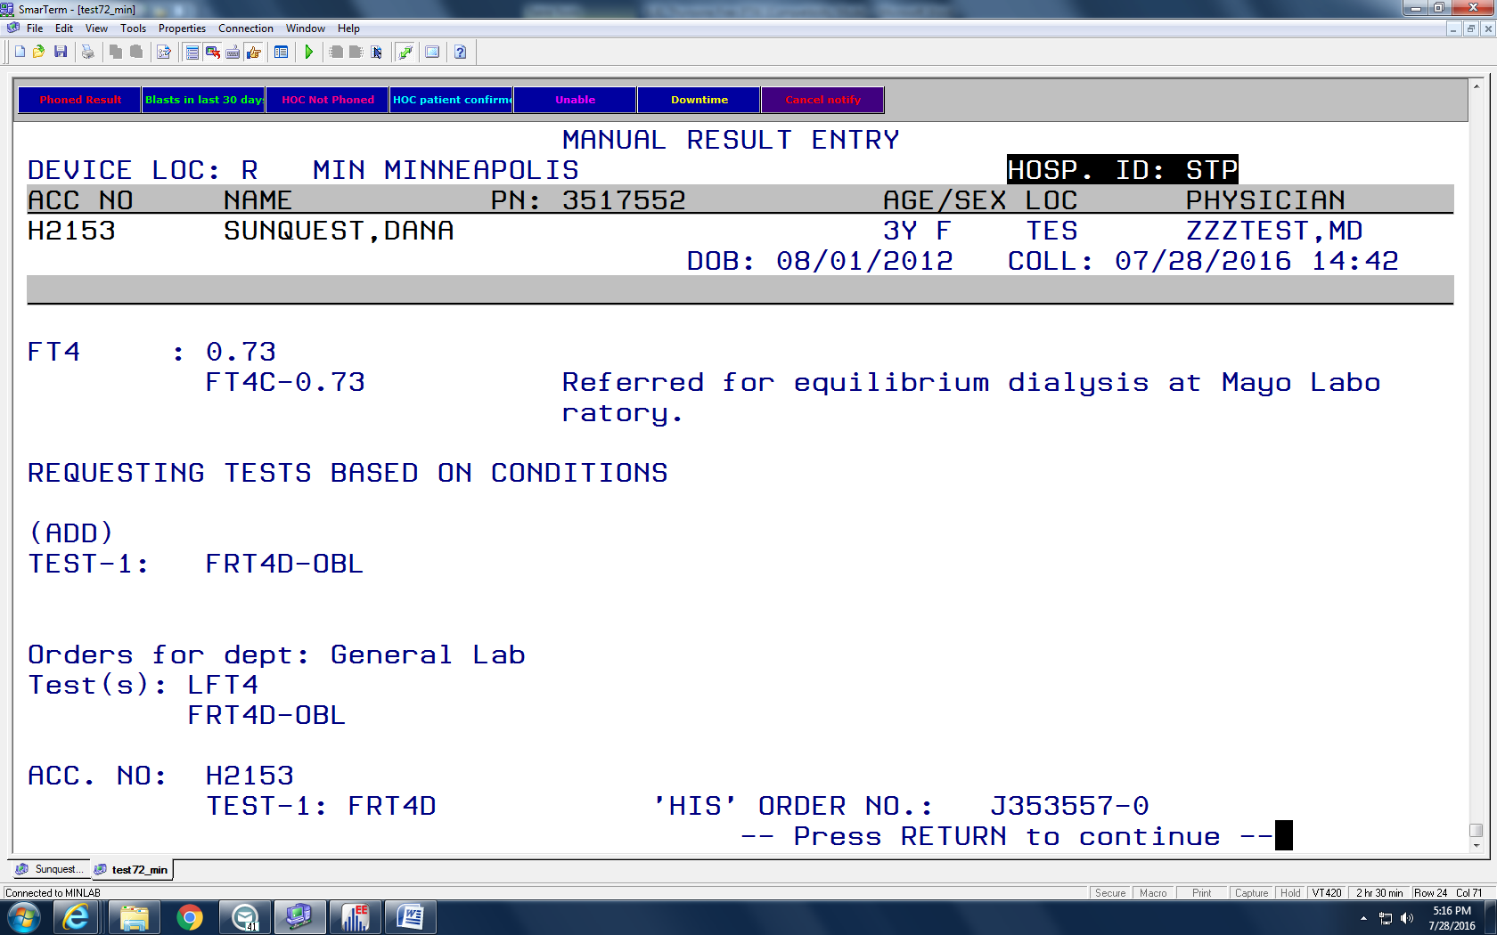

Press Return to continue:
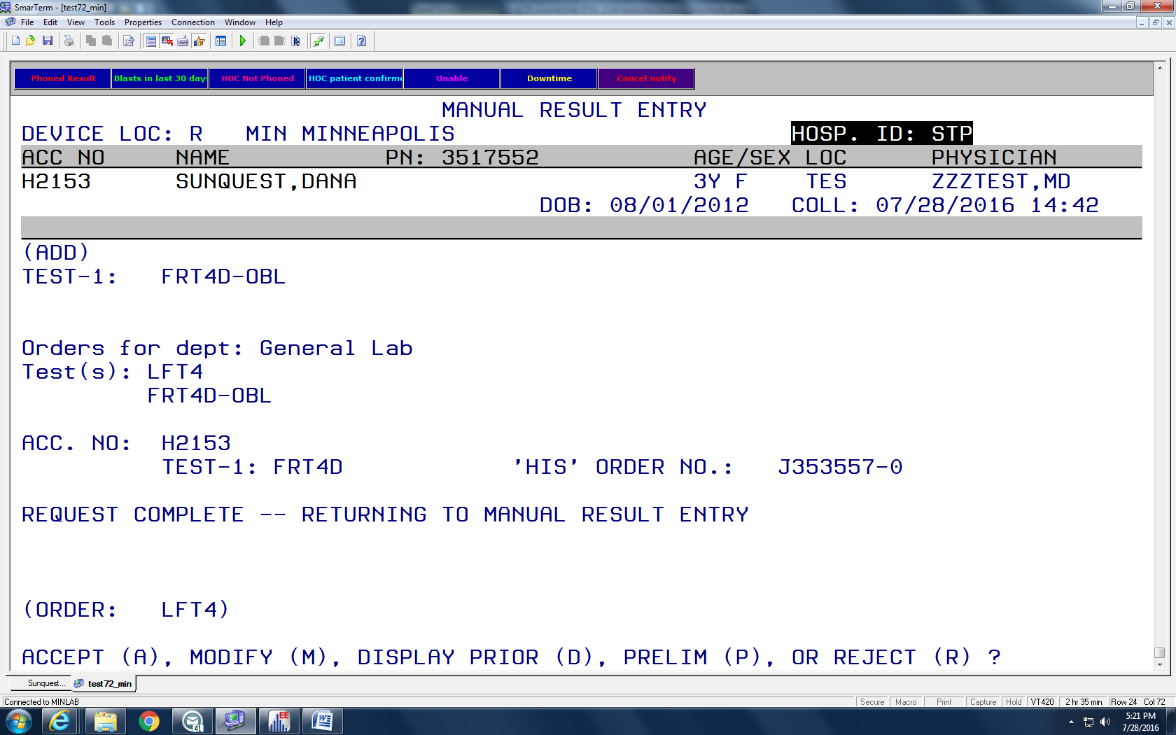

If acceptable Press (A) to Accept the result and new test order.

Specimen Storage | - Give remaining serum sample to the Send Out Department to complete requested testing.  - Promptly stopper tested specimen and store upright in numbered specimen rack by accession number. Every 8 hours remove specimens to refrigerator/freezer storage. Samples are retained 7 days in specimen storage freezer.
References | - Free Thyroxine Flex® reagent product insert for Dimension Vista® System, Siemens Healthcare Diagnostics Inc., Newark, DE 19714, US. PN 781410.001, 2015-03-20 Rev E.  - Siemens Dimension Vista LOCI 1 CAL Product Insert, KC660, 3-13-2014  - Biorad Immunoassay Plus Control Product Insert  - Burtis, CA, Ashwood, ER, Bruns, DE, editors. Tietz Textbook of Clinical Chemistry and Molecular Diagnostics. 4th Edition, Philadelphia: W.B. Saunders, 2006.  - Jacobs and DeMott Laboratory Test handbook, 5th Edition, Lexi-comp Inc. 2001  - Mayo Laboratory Test Catalog, http://www.mayomedicallaboratories.com/test-catalog/Specimen/8859 T4 (Thyroxine), Free by Dialysis, Serum  - Siemens Diagnostics Customer Bulletin, 11313747, Rev. A, 2017
Historical Record | Version | Written/Revised by: | Effective Date: | Summary of Revisions
 |  | C. Bryant/L.Lichty | January 2005 | Replaces Free T4 on ACS180: SE
 |  | L.Lichty | October 2006 | Free T4 on Immulite 2000
 |  | L. Lichty | May 21, 2009 | Revised reagent
 |  | L. Lichty | July 1, 2011 | Updated product insert, renumbered from CH 1.05
 |  | L. Lichty | April 8, 2013 | Discontinue level 2 control
 |  | L. Lichty | July 22, 2014 | Replaces FT4 on Immulite 2000
 |  | L. Lichty | August 3, 2016 | Added reflex test by Dialysis, updated IFU
 |  | Erin Bartos | January 8, 2018 | Biotin Interference added

