Water Cultures (Lab Sterility Test)

Purpose | This procedure provides instructions for WATER CULTURES for the Microbiology Laboratory.
Policy Statements | This procedure applies to Microbiologists/Virologists who perform culture set-up and plate reading.
Principle and Clinical Significance | Millipore Samplers provide a means for microbiological analyses of laboratory grade water. The sampler allows 1 ml of water to affix microorganisms to the membrane filter that is in contact with a nutrient pad. The filter is grid-marked to aid in counting the microbial colonies on the surface.
 | Supplies |  |  | Equipment
Materials | • Millipore Heterotrophic Plate Count Sampler (HPC): color code – Red, cat. no. MHPC10025 |  |  | • Ambient air incubator
Sample | - Type I Water: The source of type I water is the Millipore AFS 8D.  - Type II Water: This water is the result of deionization treatment beds and is available on tap in the dishwashing room, chemistry, micro and histology.
Special Safety Precautions | Microbiologists/virologists are subject to occupational risks associated with specimen handling. Refer to the safety policies:  - Biohazard Containment  - Safety in the Microbiology/Virology Laboratory  - Biohazardous Spills
Procedure | Inoculation  Label 2 Samplers properly with the date, one Millipore and one DI (and location).  Using a ChloroPrep pad, swab the end of the Millipore spigot. Flush the tubing for 30 seconds.  Fill water into the Sampler case, to the upper graduation line (18 ml).  - Insert the Sampler firmly into the case containing the water sample.  - Lay the Sampler face down for 30 seconds to allow water to be drawn through the filter. The filter will draw up 1 ml.  - Remove the paddle and with a firm snap, remove water from the case.  - Insert the paddle back into the case, securing firmly to prevent drying.  - Repeat steps 3-7 for the chosen DI water culture.  - Incubation  - Incubate the Samplers gridded side down for 48-72 h in an ambient air incubator 35ºC.  - Culture examination  - After incubation, remove paddle from case and examine the surface using an illuminated magnifier.  - Most colonies will appear glistening and translucent or transparent. Colors may vary from colorless to white, cream, yellow or red.  - Count the number of colonies and record as colony count/ml.  - If there are more than 1000 colonies, report as >1000 col/ml.  - Record results on the chemistry department water quality log sheet.
Limitations | - Store Millipore samplers at room temperature until expiry date.  - Avoid touching gridded surface.  - Unit should not be agitated after sample liquid is added. Make sure membrane is uniformly wetted. Ensure no more bubbles come out of vent prior to removing paddle.  - Number of colonies observed on the filter will be the number recorded.
Method Performance Specifications | - CAP Specifications:  - Type I : 10 col/ml  - Type II: 1000 col/ml  - Do not immerse the paddle longer than recommended, otherwise a loss of medium through the membrane and into the sample may occur.  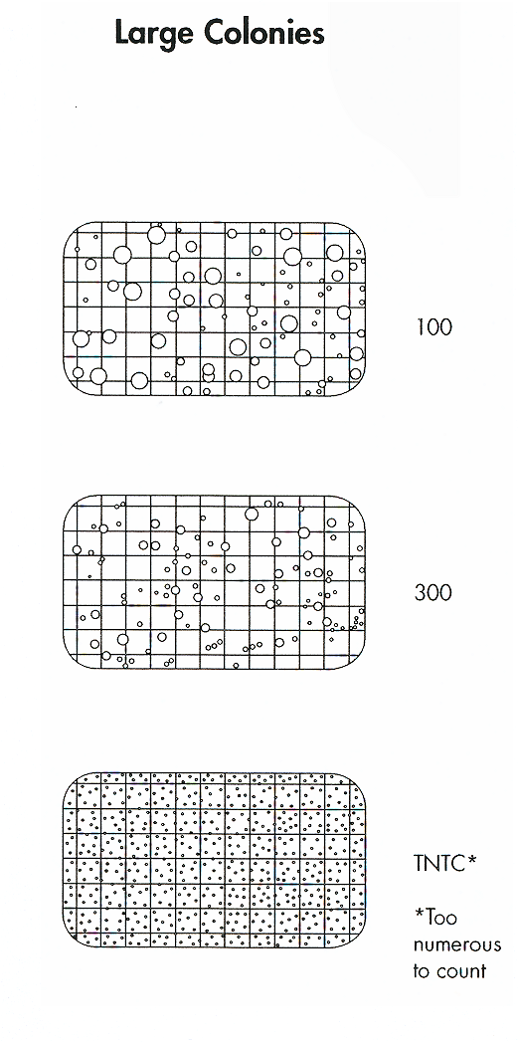
References | - CLSI. Preparation and Testing of Reagent Water in the Clinical Laboratory; Approved Guideline—Fourth Edition. CLSI document C3-A4. Clinical and Laboratory Standards Institute, 940 West Valley Road, Suite 1400, Wayne, PA 19087 USA, 2006.  - Reagent Water Specifications. College of American Pathologists, Commission on Laboratory Inspection and Accreditation. CAP Checklist 4/21/2014. GEN.41500  - Millipore product insert, P15325, Rev. G, 01/2012.
Training Plan/ Competency Assessment | Training Plan |  |  | Initial Competency Assessment
 | - Employee must read the procedure  - Employee will observe trainer performing the procedure.  - Employee will demonstrate the ability to perform procedure and record results after instruction by the trainer. |  |  | - Direct observation
Historical Record | Version | Written/Revised by: | Effective Date: |  | Summary of Revisions
 | 1 | Pat Ackerman | 08/26/1997 |  | Initial Version
 | 1.2 | Pat Ackerman | 09/02/2005 |  | Added interpretation cartoons
 | 1.3 | Becky Carlson | 07/01/2008 |  | Revised sampling time to 60 seconds per Millipore customer info.
 | 1.4 | Becky Carlson | 04/04/2015 |  | Re-numbered from MC 814
 | 2 | Jessica Craig | 04/09/2015 |  | Transferred to new format.
 | 3 | Susan DeMeyere | 3/2/2018 |  | Update logo, revise sampling time to 30 seconds per Millipore User Guide. Update Millipore reference. Added to Limitations section.
 | Archived by: |  | Archived Date:

