Resulting and Archiving RSV & Influenza A/B Results

PURPOSE

This procedure provides instructions for resulting and filing RSV & Influenza A/B results in LIS.

POLICY STATEMENT

- Results will be available within 24 h; refer to the Laboratory Services web page

ABBREVIATIONS

- ASR: analyte-specific reagent  - ABC : Analyzer Before Computer  - BSC: BioSafety Cabinet  - BSL: BioSafety level  - CBA: Computer Before Analyzer  - Ct : crossing threshold  - DAD : Direct Amplification Disc  - FDA: US Food and Drug Administration  - F/T : freeze/thaw  - IC : internal control  - LIS: laboratory information system  - MM : master mix  - NA : Nucleic Acid  - NEGC : negative control | - NP: nasopharyngeal swab  - NW: nasal wash specimen  - PCR: polymerase chain reaction  - POSC: positive control  - PPE: personal protective equipment  - RIP: Simplexa RSV & Influenza A/B PCR  - UNAC: Specimen unacceptable, please recollect  - UTM: universal viral transport media  - Area/Room 1: Clean room  - Area/Room 2: Processing room  - Area/Room 3: Amplification room

DOCUMENTATION/RECORDS

- Simplexa Flu A/B & RSV Direct Segment Report - run-specific
- LIS Incomplete worksheets, Instrument reports
- Pending Log
- Daily Maintenance Log

PROCEDURE A: Follow the activities below for reporting and archiving patient results
Reporting Patient Results

Activity | Step | Action
Export results | 1 | Export patient test results from the Simplexa instrument to LIS; see MB 6.05 procedure H
Computer Entry | 2 | Enter results in Sunquest Result Entry  Step Prompt Action/Entry  a ------ Click on the Sunquest icon to log on  b User CExxxxxx  c Password xxxxxxx  d Location R  e ----- Click OK
 | 3 | Select Result Entry from Menu options
SIM | 4 | Figure 1: Interface Configuration: Select SIM from  drop down box
 | 5 | Click on the button located in the lower left corner
SIM | 6 | If the page says “Waiting for cups….”, the results were not successfully transmitted or the results page was accessed too quickly before the transmission was completed
STYP code or missing code  Review Messages | 7 | STYP codes: This specimen was grayed out and not checked for release because there was a problem with the specimen type code.  Figure 2: Review messages located on the top and results  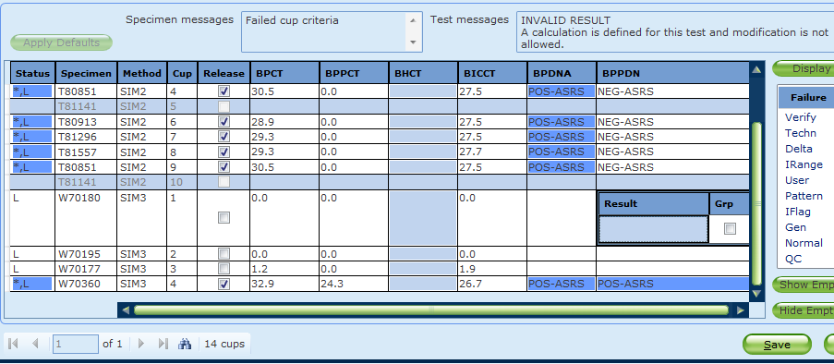
SmarTerm | 8 | Solution: STYP codes can be corrected in Sunquest Order Entry or SmarTerm MEM  Step Prompt Action/Entry  a ------ Fixing specimen type codes in SmarTerm  b FUNCTION MEM  c WORKSHEET NA : Do not enter for manual entry without calculations  d TEST RIP  e ACCEPT A  f ACC. NO. - Enter accession number and missing code: F66931 - Replacing STYP code: M-F66931 (M for modify)  g SAS Replace existing code or enter missing code for specimen source
Duplicate results | 9 | Figure 3: If a run is exported more than once, uncheck the duplicate results and release the checked  results  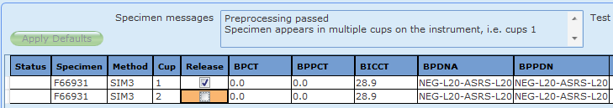
 | 10 | Click button located on the lower left corner
 | 11 | Figure 4: Duplicate Specimens | 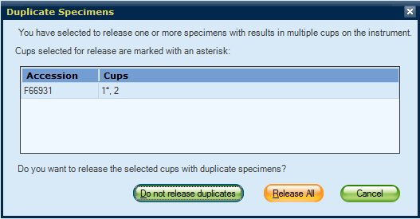
 | 12 | Click Release All
 | 13 | Figure 5: Verify Release to Lab; click  Accept |  |  | 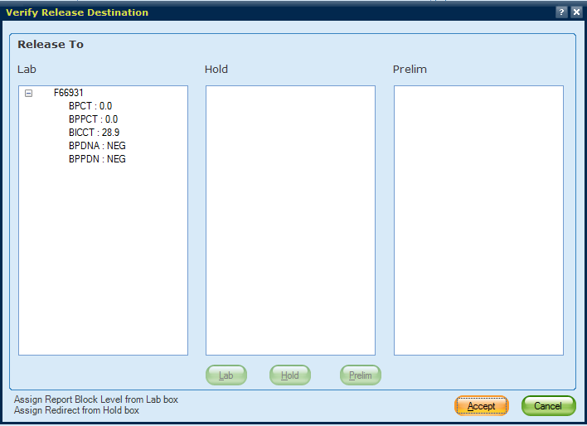
 |  | If |  |  |  |  | Then
No Problems | 14 | - Specimen box reads Preprocessing passed with no further messages  - Test box has no messages  - Sample results are acceptable |  |  |  |  | Click Save and then Accept (Fig. 5)
 | 15 | Record Control results from RIP Segment Report on RIP worksheet  Record positive or negative in POSC and NEGC rows  Interpretation: Valid or Invalid
Archive | 16 | Staple worksheet containing specimen identifiers used during testing and RIP Segment Report together
 | 17 | Place report in the RSV & Influenza result log book

PROCEDURE B: Follow the activities below for result manual entry in function MEM
Manual entry in function MEM for unresolved and diluted specimens.
Activity | Step | Action
 | 1 | If a specimen has failed the cup criteria (Fig. 2) and results do not display, enter results in function MEM
Manual Entry  SmarTerm | 2 | Step Prompt Action/Entry  a ------ Manual entry in SmarTerm  b FUNCTION MEM  c WORKSHEET N/A: Do not enter for manual entry without calculations  d TEST RIP  e ACCEPT A  f ACC. NO. F66931  g SAS NW  h FAPCR NEG-MFDA  i FBPCR NEG-MFDA  j RSVR POS-MFDA  l. ACCEPT A

Table 1: Sunquest Result Codes

Result | Sunquest code | Interpretation
Positive | POS-MFDA  Interface | - Positive  - Modified FDA approved test: The performance characteristics of this test have been determined by Children’s Hospitals and Clinics of MN
Negative | NEG-MFDA  Interface | - Negative  - Modified FDA approved test: The performance characteristics of this test have been determined by Children’s Hospitals and Clinics of MN
Positive results via dilution | POS-DILUT-MFDA  Function MEM  Worksheet: NA  Test: RIP | - Positive  - Sample diluted due to inhibition. Please consider submission of a new sample if clinical suspicion is high.  - Modified FDA approved test: The performance characteristics of this test have been determined by Children’s Hospitals and Clinics of MN
Negative results via dilution | NEG-DILUT-MFDA  Function MEM  Worksheet: NA  Test: RIP | - Negative  - Sample diluted due to inhibition. Please consider submission of a new sample if clinical suspicion is high.  - Modified FDA approved test: The performance characteristics of this test have been determined by Children’s Hospitals and Clinics of MN
Unresolved Results | UNR-MFDA  Function MEM  Worksheet: NA  Test: RIP | - Unresolved: This sample is inhibitory to amplification and the results are inconclusive. Consider repeat collection if clinically indicated.  - Modified FDA approved test: The performance characteristics of this test have been determined by Children’s Hospitals and Clinics of MN  - Phoned Result [Free text name]
Corrected report | Function MEM  Worksheet: NA  Test: RIP | - Modify results in function MEM by typing M followed by a hyphen: M-T54966  - Enter correct numerical result FAPCR, FBPCR, and RSVR field(s). Computer will interpret and automatically put in a correction statement  - Phoned Result [Free text name]

PROCEDURE F: Follow the activities below for modifying results in SmarTerm Function MEM
Corrected Report

Activity | Step | Action
Manual Entry  Modifying results  SmarTerm | 1 | Corrected report: Changing data and interpretation  Step Prompt Action/Entry  a ----- Manual entry in SmarTerm  b FUNCTION MEM  c WORKSHEET N/A: Do not enter for manual entry without calculations  d TEST RIP  e ACCEPT A  f ACC. NO. M – F66931  g SAS NW  h FAPCR NEG-MFDA – enter correct result below previous value POS-MFDA Correction statement will automatically default  i FBPCR POS-MFDA  j. RSVR NEG-MFDA  k. ---- Click  l. NAME Enter name, last initial and credential  m. ---- Click OK, date and time stamp will default  n. ACCEPT A

REFERENCES

- Laboratory for Windows User’s Guide, UD-1599/00-12-GL, Sunquest Information Systems
- CAP Microbiology Checklist, Section Department: Molecular Diagnostics, MIC.64988, 04.21.2014, College of American pathologists, 325 Waukegan Rd, Northfield, IL 60093

Historical Record
 | Version | Written/Revised by: | Effective Date: | Summary of Revisions
 | 1 | Michelle Merryman, Julie Laramie | 03.11.2018 | Initial Version

