MC 7.5 Sterilization of Brinkmann Dispenser

Purpose | The purpose of this procedure is to direct the disassembly, autoclaving, and reassembly of the Brinkmann dispenser.
Policy Statements | The Brinkmann dispenser must be autoclaved when the weekly sterility check shows contamination.
Materials | Reagents |  |  | Supplies
 | - Distilled water |  |  | - Brinkmann dispenser  - Sterile gloves for re-assembly (obtain from Histology)
Special Safety Precautions | Microbiologists/virologists are subject to occupational risks associated with specimen handling. Refer to the safety policies:  - Biohazard Containment  - Safety in the Microbiology/Virology Laboratory  - Biohazardous Spills
Quality Control | Visual blackening of autoclave tape and black line on SteriGage indicator inside autoclave package.
Procedure (computer) | Print a “Request For Sterilization” form from Children’s Intranet under FORMS, CPD.  - On the Children’s intranet, click on “Forms” (upper right hand corner)  - Under Central Processing Department (CPD), click on “Request for Sterilization”  - See example in the bottom drawer by the Vitek  - Make a copy & include picture of the 2 dispenser pieces. (Also in the bottom drawer by the Vitek.
Procedure | Follow these steps to prepare for sterilization.
 |  | Remove dispenser from saline bottle.
 |  | Pump dispenser to discharge all saline from dispenser.
 |  | Rinse dispenser with distilled water.
 |  | Loosen the valve-locking nut at the base of the discharge tube.
 |  | Loosen volume setting knob by sliding to the right.
 |  | Loosen bottle connector.
 |  | Remove the filling tube by pulling out of the dispenser.
 |  | Wrap the dispenser and filling tube in clean towel.
 |  | Take package to CPD department for autoclaving.
 | 10. | Leave note on Desk3 to pick up in CPD in a few days.
To get to CPD decontamination room: B243
- Walk all the way to the end of the hallway & take a right (the only way you can go).
- Walk all the way to the end of the hallway & take a right again (the only way you can go).
- Pick up phone, don PPE and they will let you in.
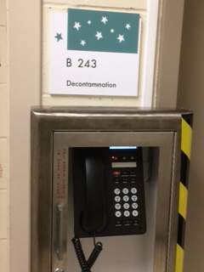

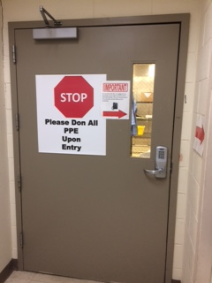

You’ll be in a big, open room. Look for someone to give the contaminated equipment to. (Don’t just leave it there.)

To pick up sterilized equipment:
- Walk down the hallway to room B241
- Pick up sterilized equipment in room marked “Clinic Pick Up”. There will be a bin labeled LAB
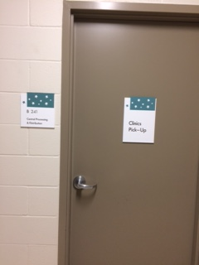

Method Performance Specifications | Autoclaving of the Brinkmann dispenser should be done at 121 degrees C. using steam/gravity for 40 minutes. This information should be filled out on the sterilization form, along with a request for a peel pack.
Post Autoclaving | Reassemble dispenser using sterile surgical gloves, obtained from Histology.
References | Brinkmann Dispensette Operating Manual. Westbury, N.Y.: Brinkmann Instruments Inc.
Training Plan/ Competency Assessment | Training Plan |  |  |  |  | Initial Competency Assessment
 | Employee must read the procedure. |  |  |  |  | Direct Observation
Historical Record | Version |  | Written/Revised by: |  | Effective Date: |  | Summary of Revisions
 | 1 |  | Eileen Brinkman |  | 7/26/2010 |  | Initial Version; re-formatted.
 | 2 |  | Becky Carlson |  | 4/8/2015 |  | Re-numbered from MC 1005
 | 3 |  | Susan DeMeyere |  | 3/5/2018 |  | Removed Call instructions, added leave note in desk3 and pictures. Fix hyperlinks.
 | Archived by: |  |  |  | Archived Date:

