GeneXpert Maintenance

Purpose | This procedure provides instructions for maintenance tasks performed on the GeneXpert system.
Policy Statements | This procedure applies to technical staff performing testing on the GeneXpert.
Special Safety Precautions | Microbiologists/virologists are subject to occupational risks associated with specimen handling. Refer to the safety policies located in the safety section of the Microbiology and Virology Policy Manual:  - Biohazard Containment  - Safety in the Microbiology/Virology Laboratory  - Biohazardous Spills
Materials | Reagents Supplies Equipment  - 10% bleach - 70% ethanol - Lint free wipes - Paper towels - USB thumb drive - Fan filters
Procedure | Daily Maintenance  Cleaning work area:  - Clean work area before and after use.  - Wipe with 10% bleach.  - Wait 2 minutes.  - Follow with 70% ethanol.  Clean GeneXpert counter at end of day  - Wipe with 10% bleach.  - Wait 2 minutes.  - Follow with 70% ethanol.  Discard used cartridge  Close all module doors  Weekly Maintenance  Power down the GeneXpert instrument and computer:  - Shut down the computer from the start menu first, then switch off the instrument (CBA).  - Wait 5 minutes.  - Power on the analyzer before turning the computer back on (ABC).  Monthly Maintenance  Archive and Purge tests:  - In the GeneXpert System window, on the Data Management menu, click Archive Test.  - Select the tests to be archived (all).  - Select Purge selected Tests from List After Archiving.  - Click OK and confirm the archive and purge request.  - Click Proceed.  - Select the folder in which to store the archive (.gxx) file.  - Rename the file according to the month and year.  - Click Save.  - The Archive Test(s) dialog box will be displayed once archiving is complete. Click OK.  - The Purge Tests(s) dialog box will appear. Click Yes to confirm.  Replace Fan Filters:  - Power down the computer and analyzer.  - Gently take the fan filter guards off by unsnapping the guard from the fan housing.  - Remove dirty filter.  - Run the filter under water, set on paper towels, and allow to air dry overnight.  - Place a clean filter into the fan filter guards.  - Position the fan filter guard and filter into place as a unit.  - Press the sides and bottom of the guard firmly onto the fan housing until the grip snaps securely onto the fan.  Quarterly Maintenance (March, June, September, December)  Clean plunger rod and cartridge bays:  - Ensure that there are no cartridges in any of the modules.  - In the GeneXpert System window, click the Maintenance icon  - Click on Maintenance on the Menu Bar, select Plunger Rod Maintenance.  - Click on Wipe with 10% bleach followed with 70% ethanol.  - Click on Clean All in the dialog box.  - The Plunger Rod cleaning dialog box will be displayed – click OK.  - Clean the plunger rods and cartridge bays:  - Thoroughly moisten a lint-free wipe with 10% bleach.  - Vigorously wipe the plunger rod with the lint-free wipe.  NOTE: Wipe hard enough to remove the black debris that accumulate on the rod.  - Using the same wipe: wipe the walls, ceiling, corners and edges of the cartridge bay, then wipe the inside of the door and top lip of the door.  - Discard the wipe.  - Wait 2 minutes.  - Using a new lint-free wipe, complete the cleaning process again.  - Wait 2 minutes.  - Using a new lint-free wipe, complete the cleaning process again.  - Wait 2 minutes  - Thoroughly moisten a lint-free wipe with 70% ethanol.  - Use the lint-free wipe to remove all residual bleach by following the same cleaning process as listed above.  - Once all plunger rods and cartridge bays have been cleaned, return to the Plunger Maintenance dialog box and select the Move Up button.  - Click Close to close the Plunger Maintenance dialog box.  - Make sure all module doors in the instrument are shut.  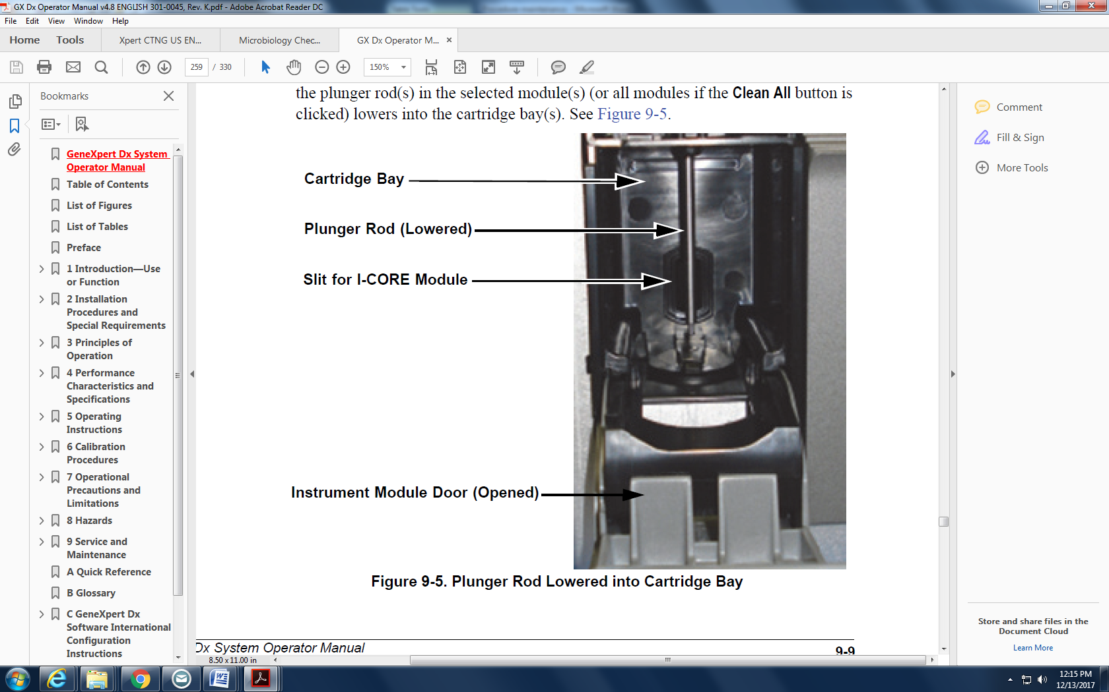  Clean instrument surfaces:  - Wipe with 70% ethanol.  Yearly Maintenance (July)  Perform annual instrument maintenance:  Cepheid recommends that the system be checked for proper calibration on an  annual basis. Based upon the usage and care of each system, calibration checks may be  recommended more frequently.  Request Xpert check kit 2 months prior to calibration expiration (12 months from last calibration check date). Contact Tech Support or Field Specialist (Carolyn.Anderson@cepheid.com).  The Cepheid Field Service Engineer or customer will perform the calibration checks  during annual maintenance or by the field service engineer if responding to a module  failure.  As Necessary  Generate a system log report:  The System Log reports can be used to provide incidents of instrument module self-tests  and errors to Cepheid when a module failure has been encountered.  To generate a system log report:  - In the GeneXpert Dx System window, click Reports on the menu bar, and then click System Log.  - Specify the following criteria to view the trends of interest:  - Date Range  - All—Select to include all of the records.  - Select—Select to filter the records by specifying a range of dates. Entries older than 1 year are automatically removed.  - Modules:  - Currently Connected Modules— Displays modules that are connected to the system and are currently shown on Check Status screen. This is the default option  - All Logged Modules—Displays all modules which have self-test or error entries in this system database within the last 1 year (allows technical support to obtain self-test/error entries for a module that is no longer connected to the system).  - A list of modules is displayed in the table. Select the module to be included in the system by selecting the individual modules one-by-one, or by using one of the available buttons.  - Select the preference for Show:  - Errors Only—Displays only error entries in the generated report file.  - All Entries—Displays all self-test entries and error entries in the report.  - When you finish selecting the log criteria, click one of the following buttons:  - Generate Report File—Creates a PDF file and saves it to the location you specify.  - Click the Generate Report File button on the System Log Report screen (see to create the PDF file of the test report. The Generate Report File dialog box will appear, which enables a file to be saved to a specified location. Click Save after navigating to the specific location.  - Preview PDF—Creates a PDF file and displays the file in the Adobe Reader window. The PDF file can be saved and printed from the Adobe Reader software.  - After printing the System Log report, click Close to close the System Log Report window.  Back up database:  The entire database should be backed up periodically and store the backup on a different  computer or on a different storage medium.  To back up the database:  - Select Database Backup on the Database Management window.  - Click Proceed.  - Locate and select the folder in which you want to store the backup file, type a name for the backup file (or use the default file name), and then click Save.  - The backup process creates a .zip file in the location you specified.
Result Reporting | Record completion of maintenance tasks on the GeneXpert System Maintenance Log.
References | - GeneXpert Dx System Operator Manual: Software Version 4.8, 3010045, Rev. K. In. Sunnyvale, CA: Cephied Inc.; 2016.
Historical Record
 | Version | Written/Revised by: | Effective Date: | Summary of Revisions
 | 1 | Julie Laramie/Helen Stefan | 04.16.2018 | Initial Version
 | Archived by: |  | Archived Date:

